TITLE IMMY Cryptococcal Antigen Lateral Flow Assay (CrAg LFA)

PRINCIPLE/PURPOSE:

The CrAg LFA is an immunochromatographic test system for the qualitative detection of the capsular polysaccharide antigens of *Cryptococcus* species complex (*Cryptococcus neoformans* and *Cryptococcus gattii*) in cerebral spinal fluid (CSF).

The CrAg LFA is a prescription-use laboratory assay, which can aid in the diagnosis of cryptococcosis.

SCOPE:

To provide qualified laboratorians instruction on performing and interpreting IMMY CrAg LFA.

SPECIMEN:

Type:

Cerebral Spinal Fluid (CSF)

Handling Conditions:

Use universal precautions when handling. Use the safety hood when performing test.

EQUIPMENT AND MATERIALS:

Equipment:

Safety Hood

Vortex

Materials:

Disposable tubes

Pipette

Timer

IMMY CrAg LFA kit

Gloves

Lab coat

Storage Requirements:

If specimens are not tested on the day of collection, store the specimens in a sealed, appropriately labeled tube at 2 - 8ºC. Stable for 72 hours.

If longer periods of storage are required, samples may be stored at -20ºC; do not repeatedly thaw and refreeze.

Store all reagents at room temperature. Kits are stable until the expiration date.

Unused test strips should be stored in the LF test strip vial with the desiccant cap firmly attached.

QUALITY CONTROL:

Controls are performed with each new shipment, new lot number, AND every 30 days the kit is put into use.

A positive control is evaluated by adding 1 drop of LF Specimen Diluent followed by 1 drop of CrAg Positive Control to a tube. A negative control is evaluated by adding 2 drops of LF Specimen Diluent to a tube. Insert a test strip into the tubes, and read after 10 minutes.

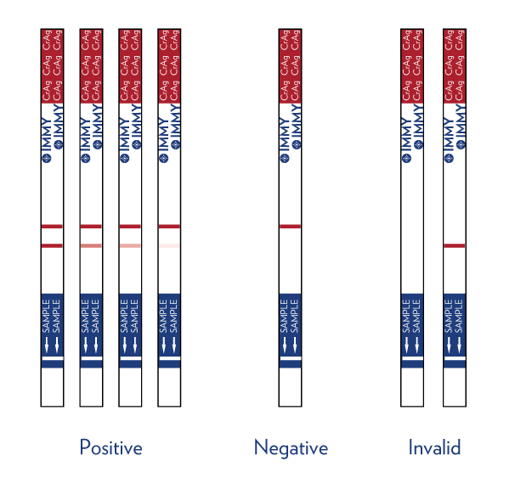

Two (2) lines (test and control) indicate a positive result. One line (control) indicates a negative result. A control line must be present for a valid test. If there is not a control line, repeat the test.

PROCEDURE – STEPWISE:

1. Label a disposable test tube with patient’s name and accession number.
2. Add 1 drop of LF Specimen Diluent to the appropriate test tube.
3. Add 40 µL of specimen to the test tube and mix well.
4. Submerge the white end of a Cryptococcal Antigen Lateral Flow Test Strip into the specimen.
5. Set the timer for 10 minutes.
6. Read and record the results.



Two (2) lines (test and control) indicate a positive result. One line (control) indicates a negative result. A control line must be present for a valid test. If there is not a control line, repeat the test.

INTERPRETATION & REPORTING RESULTS:

Reference Ranges: Negative

Procedures for Abnormal Results: A positive test is considered a critical result and must called to the RN or physician. Document the full name of person the result was given to, date, time, and your initials.

Reporting Format:

In Sunquest:

* + - 1. Go to Result Entry
      2. Resulting Mode - Manual
      3. Check Test Mode box
      4. Enter CCRY in Test Code box
      5. Click ADD
      6. Click RESULT
      7. Enter ACCESSION
      8. Enter test result CALAS:

POS – POSITIVE FOR CRYPTOCOCCAL ANTIGEN

NEG – NEGATIVE FOR CRYPTOCOCCAL ANTIGEN (if negative,

Continue to step 10.

* + - 1. Hit TAB. Enter Called to: name, date, time, and your initials.
      2. TAB to next test line (CATTR) and type HIDE.
      3. SAVE
      4. If positive, pop up box will display stating a reflex FUNGUS culture has been

added. Refer to and follow FUNGUS culture set up procedure.

PROCEDURE NOTES:

1. Specific standardization is necessary to produce the CrAg LFA’s high-quality reagents and materials. The user assumes full responsibility for any modification to the procedures published herein.
2. When handling patient specimens, adequate measures should be taken to prevent exposure to etiologic agents potentially present in the specimens.
3. Always wear gloves when handling reagents in this kit as some reagents are preserved with 0.095% (w/w) sodium azide. Sodium azide should never be flushed down the drain as this chemical may react with lead or copper plumbing to form potentially explosive metal azides. Excess reagents should be discarded in an appropriate waste receptacle.

RELATED PROCEDURES:

QM – 179 Critical Tests and Critical Values

<http://infonet.armc.com/departments/Lab/ARMC%20Lab%20Policies%20and%20Procedures/Quality%20Management/QM-179.docx>

LIMITATIONS OF THE PROCEDURE:

* The assay performance characteristics have not been established for matrices other than serum and CSF.
* Depending on the disease and organism prevalence, testing should not be performed as a screening procedure for the general population. The predictive value of a positive or negative serologic result depends on the pretest likelihood of Cryptococcal disease being present. Testing should only be done when clinical evidence suggests the diagnosis of Cryptococcal disease.
* The performance of this device has not been evaluated with specific HIV therapies. The patient samples included in the study were obtained from patients undergoing HIV therapy, but information on the therapy received was not available.
* This assay was not evaluated for potential interference related to specimen pretreatment with 2-mercaptoethanol or with specimens including the following substances: Bloody CSF, cloudy CSF, white blood cells, xanthochromic CSF, bilirubin, protein, systemic lupus erythmatosus (SLE), sarcoidosis, or *N. meningitides*.
* This assay was evaluated for the potential of interference due to serum conditions including icteric, hemolyzed, and lipemic samples. These samples exhibited no interference in the assay. Hemolyzed samples, however, could lead to false negatives due to the high background color on the strip.

**High Dose Hook Effect (Prozoning)**

Although rare, extremely high concentrations (>0.140 mg/mL) of Cryptococcal antigen can result in weak test lines and, in extreme instances, yield negative test results. If prozoning is suspected in weakly positive or negative test results, the semi-quantitative titration procedure should be followed to rule out false negative results.

SUPPLEMENTAL MATERIALS/ADDENDUM:

REFERENCES:

1. Doering, T. L. 2009. Annu. Rev. Microbiol. 63:223-247.
2. Goodman, J. S., L. Kaufman, and M. G. Koenig. 1971.. N. Engl. J. Med. 285:434-436.
3. Kozel, T. R. 1995. Trends Microbiol. 3:295-299.
4. Lin, X. and J. Heitman. 2006. T. Annu. Rev. Microbiol. 60:69-105.
5. Kambugu, A., D.B. Meya, J. Rhein, M. O'Brien, E.N. Janoff, A.R. Ronald, M.R. Kamya, H. Mayanja-Kizza, M.A. Sande, P.R. Bohjanen, and D.R. Boulware. 2008. Outcomes of cryptococcal meningitis in Uganda before and after the availability of highly active antiretroviral therapy. Clin.Infect.Dis. 46: 1694-1701.
6. Park, B. J., K. A. Wannemuehler, B. J. Marston, N. Govender, P. G. Pappas, and T. M. Chiller. 2009.. AIDS 23:525-530.
7. Rolfes, M., Butler, E., von Hohenberg, M., Nabeta, H., Kwizera, R., Rajasingham, R., Bahr, N., Bohjanen, P., Meya, D., and Boulware, D. Evaluation of a novel point-of-care lateral flow assay to detect cryptococcal antigen in plasma and CSF. Conference on Retroviruses and Opportunistic Infections (CROI) Poster # 953. 2012
8. Zhou, Q. and W. J. Murphy. 2006. Immunol. Res. 35:191-208.

|  |  |  |  |
| --- | --- | --- | --- |
| Review Date | Signature | Mgmt. | Director |
|  |  |  |  |
|  |  |  |  |
|  |  |  |  |
|  |  |  |  |
|  |  |  |  |
|  |  |  |  |
|  |  |  |  |
|  |  |  |  |
|  |  |  |  |
|  |  |  |  |
|  |  |  |  |
|  |  |  |  |
|  |  |  |  |
|  |  |  |  |
|  |  |  |  |
|  |  |  |  |
|  |  |  |  |
|  |  |  |  |
|  |  |  |  |
|  |  |  |  |

SOP HISTORY PAGE

SOP Number: MICRO-740

SOP Title: IMMY Cryptococcal Antigen Lateral Flow Assay (CrAg LFA)

Written By: Jacee Farmer

Manual in which Hard Copy of this SOP is located: Microbiology Procedure Manual

Distribution: No other locations

Supersedes Procedure:

SOP CHANGE CONTROL

|  |  |  |  |  |  |
| --- | --- | --- | --- | --- | --- |
|  | Approvals | |  | Action | In |
| Mgmt. | Date | Director | Date |  | Effect |
|  |  |  |  |  |  |
|  |  |  |  |  |  |
|  |  |  |  |  |  |
|  |  |  |  |  |  |
|  |  |  |  |  |  |
|  |  |  |  |  |  |
|  |  |  |  |  |  |
|  |  |  |  |  |  |
|  |  |  |  |  |  |
|  |  |  |  |  |  |
|  |  |  |  |  |  |
| Date archived: _______________________________ | | | | |  |
| Reason: ____________________________________ Initials:__________ | | | | |  |
|  |  |  |  |  |  |