### Title: FilmArray Blood Culture Identification Panel Testing (BCID)

### Principle/Purpose:

The FilmArray BCID Panel is a multiplexed nucleic acid test intended for use with the FilmArray Instrument for the simultaneous qualitative detection and identification of multiple bacterial and fungal nucleic acids in positive blood culture samples. The FilmArray BCID pouch is a disposable closed system that houses all the chemistry required to isolate, amplify and detect nucleic acid from multiple bloodstream pathogens within a single blood culture sample.

Bloodstream infections are associated with significant morbidity and mortality and successful patient outcomes depend on the rapid detection of bacteremia and organism identification.

The FilmArray BCID Panel also contains assays for the detection of genetic determinants of resistance to methicillin (mecA), vancomycin (vanA and vanB), and carbapenems (blaKPC) to aid in the identification of potentially antimicrobial resistant organisms in positive blood culture samples.

**Scope:**

This procedure provides instructions for testing positive blood culture samples using the FilmArray Blood Culture Identification Panel (BCID) Kit.

The following gram-positive bacteria, gram-negative bacteria, and yeast are identified using the FilmArray BCID Panel:

**Gram-Positive Bacteria**

* *Enterococcus*
* *Listeria monocytogenes*
* *Staphylococcus*
* *Staphylococcus aureus*
* *Streptococcus*
* *Streptococcus agalactiae*
* *Streptococcus pneumonia*
* *Streptococcus pyogenes*

**Gram-Negative Bacteria**

* *Acinetobacter baumannii*
* *Enterobacteriaceae*
* *Enterobacter cloacae* complex
* *Escherichia coli*
* *Klebsiella oxytoca*
* *Klebsiella pneumonia*
* *Serratia marcescens*
* *Proteus*
* *Haemophilus influenza*
* *Neisseria meningitidis* (encapsulated)
* *Pseudomonas aeruginosa*

**Yeast**

* *Candida albicans*
* *Candida glabrata*
* *Candida krusei*
* *Candida parapsilosis*
* *Candida tropicalis*

**Antimicrobial resistance genes**

* *mecA* – methicillin resistance (MRSA)
* *vanA/B –* vancomycin resistance (VRE)
* KPC – carbapenem resistance (KPC)

### Specimen:

Blood culture samples identified as positive by a continuous monitoring blood culture system.

* Sample Volume – 200 uL
* Samples should be collected from a blood culture bottle in a tilted position to allow the bottle resin to settle (approximately 10 seconds)
* Sample should be collected from the blood culture bottle using a syringe that is capable of measuring 200 uL.
* Blood culture samples should be processed and tested as soon as possible after being flagged as positive by the culture instrument. However, samples may be stored for up to 8 hours at room temperature

### EQUIPMENT/MATERIALS:

* Individually packaged FilmArray BCID pouches
* Single-use (1.0 mL) Sample Buffer ampoules
* FilmArray Instrument and software
* FilmArray Pouch Loading Station

### Quality Control:

**Internal Controls:**

Two process controls are included in each pouch.

**1. DNA Process Control**

**2. PCR2 Control**

### EXTERNAL QC:

One external control (Table 1) is performed with each new lot number, new shipment, every 30 days a kit is in use, and with each new operator.

Table 1 Microbiologics

|  |  |
| --- | --- |
| **Organism** | **ATCC Number** |
| Serratia marcescens | 13880 |
| Listeria monocytogenes | 19111 |
| Enterobacter cloacae ssp. Cloacae | 13047 |
| Pseudomonas aeruginosa | 27853 |
| Staphlococcus epidermidis | 12228 |
| Streptococcus pyogenes | 19615 |
| Streptococcus agalactiae | 12386 |
| Haemophilus influenza | 10211 |
| Candida albicans | 10231 |
| Neiserria meningiditis | 13077 |
| Staphylococcus aureus ssp. Aureus | 33591 |
| Klebsiella oxytoca | 13182 |
| Escherichia coli | 11229 |
| Candida parapsilosis | 22019 |
| Candida glabrata | 15126 |
| Candida krusei | 14243 |
| Strepotoccus pneumoniae | 10015 |
| Proteus mirabilis | 35659 |
| Enterococcus faecalis | 51299 |
| Klebsiella pneumoniae | BAA-1705 |
| Candida tropicalis | 1369 |
| Acinetobacter baumannii | 19606 |

### QC Procedure:

1. Inoculate 1 mL of saline with 1 – 2 fresh colonies of organism from the list above. Organisms should be rotated between QC runs. Refer to BioFire QC List.
2. Add 200 µL of whole blood in BACT/Alert blood culture medium to the saline mixture.
3. Continue to Step 1 of patient test procedure below.

**PATIENT TEST PROCEDURE:**

**BCID Reflex Order:**

1. Enter the code BCIDO or the “d” on the ARDE keyboard in the Direct Exam tab in Micro Result entry. (Refer to the Positive Blood Culture Workup procedure for details)

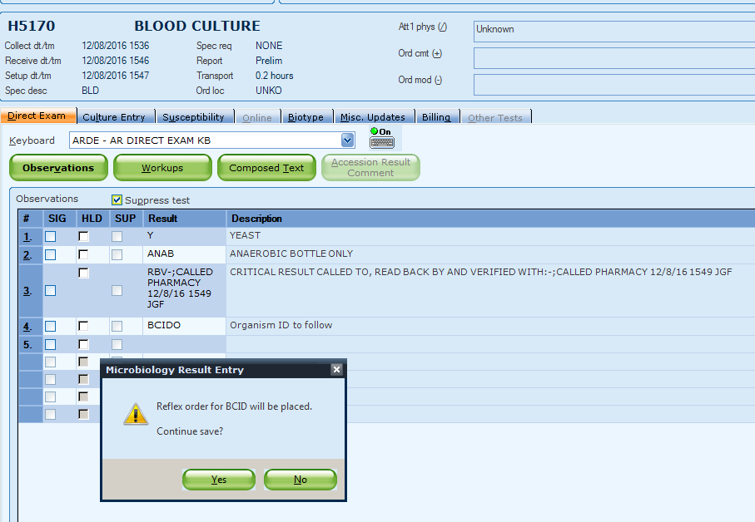

1. Click OK.
2. Label the blood culture bottle with the BCID reflex label. Be sure not to cover any existing labels. (The BCID order will have new accession number; however, the CID number will be the same as the BLC order)
3. Continue to Prepare Pouch.

**NOTE: ONLY WORK UP THE FIRST POSITIVE BOTTLE FOR EACH PATIENT.** Refer to table below.

|  |  |  |  |
| --- | --- | --- | --- |
|  | **Action** | **Setup Media* and Gram Stain?** | **Call BCID and/or Gram Stain?** |
| **Bottle 1** | **Perform and report BCID** | **Yes** | **Yes - Both** |
| **Bottle(s) 2 – 4**  **(Same Gram Stain as Bottle 1)** | **Perform and report Gram Stain ONLY** | **Yes** | **No - Neither** |
| **Bottles(s) 2 – 4**  **(Different Gram Stain from Bottle 1)** | **Perform and report BCID** | **Yes** | **Yes - Both** |
| **Invalid** | **Report Gram Stain Only – DO NOT repeat BCID** | **Yes** | **Yes – Gram Stain** |

**\*Refer to Positive Blood Culture Workup Procedure**

**Prepare Pouch**

1. Thoroughly clean the work area and the FilmArray Pouch Loading Station with freshly prepared ethanol or Sani-cloth.

2. Obtain the following required materials and place in the clean hood:

* FilmArray BCID
* Panel pouch
* Sample Buffer ampoule
* Hydration Injection Vial (blue cap)
* Sample Injection Vial (red cap)
* Transfer Pipette

3. Remove the pouch from its vacuum-sealed package by tearing or cutting the notched outer packaging and opening the protective aluminum canister.

4. Slide the pouch into the FilmArray Pouch Loading Station so that the red and blue labels on the pouch align with the red and blue arrows on the FilmArray Pouch Loading Station.

5. Place a blue-capped Hydration Injection Vial in the blue well of the FilmArray Pouch Loading Station.

6. Place a red-capped Sample Injection Vial in the red well of the FilmArray Pouch Loading Station.

**Hydrate Pouch**

1. Twist and lift the Hydration Injection Vial, leaving blue cap in the well of the FilmArray Pouch Loading Station.
2. Insert the cannula tip into the port in the pouch located directly below the blue arrow of the FilmArray Pouch Loading Station. Push down forcefully in a firm and quick motion until you hear a faint “pop” and feel an ease in resistance. The correct volume of liquid will be pulled into the pouch by vacuum.
3. Verify that the pouch has been hydrated.
4. Flip the barcode label down and check to see that fluid has entered the reagent wells (located at the base of the rigid plastic part of the pouch). Small air bubbles may be seen. If the pouch fails to hydrate (dry reagents appear as white pellets). Repeat Step 2 to verify that the seal of the port was broken or retrieve a new pouch and repeat from Step 2 of the Prepare Pouch section.

**Prepare Sample Mix**

1. Hold the Sample Buffer ampoule so that the tip is facing up.

NOTE: Use care to avoid touching the tip during handling, as this may introduce contamination.

1. Gently pinch the textured plastic tab on the side of the ampoule until the seal snaps.
2. Invert the ampoule over the red-capped Sample Injection Vial and re-position thumb and forefinger to grip the bottom of the ampoule. Dispense Sample Buffer using a slow, forceful squeeze, followed by a second squeeze. Squeezing the ampoule additional times will generate excessive bubbles, which should be avoided.
3. Invert the positive blood culture bottle several times to mix.
4. Wipe the bottle septum with alcohol and air dry.
5. Tilt the bottle and hold in the tilted position to allow the bottle resin to settle (approximately 10 seconds).
6. Using a syringe, withdraw 200 uL of blood culture sample through the bottle septum, taking care to avoid drawing resin beads into the sample, or the formation of bubbles.
7. Add sample directly to Sample Buffer in the Sample Injection Vial. Discard syringe in an appropriate biohazard sharps container and Return the Sample Injection Vial to the FilmArray Pouch Loading Station.
8. Remove the Sample Injection Vial from the FilmArray Pouch Loading Station and gently invert the vial at least three times to mix.
9. Return the Sample Injection Vial to the FilmArray Pouch Loading Station.

**Load Sample Mix**

1. Slowly twist the Sample Injection Vial so it loosens from its red cap and pause for 3-5 seconds. Lift the Sample Injection Vial, leaving the red cap in the well of the FilmArray Pouch Loading Station.

2. Insert the cannula tip into the port in the pouch fitment located directly below the red arrow of the FilmArray Pouch Loading Station. Push down forcefully in a firm and quick motion until you hear a faint “pop” and feel an ease in resistance. The correct volume of liquid will be pulled into the pouch by vacuum.

3. Verify that the sample has been loaded. Flip the barcode label down and check to see that fluid has entered the reagent well next to the sample loading port. If the pouch fails to pull sample from the Sample Injection Vial, the pouch should be discarded. Retrieve a new pouch and repeat from the Prepare Pouch section.

4. Discard the Sample Injection Vial and the Hydration Injection Vial in an appropriate biohazard sharps container.

5. Record the Sample ID in the provided area on the pouch label (or affix a barcoded Sample ID) and remove the pouch from the FilmArray Pouch Loading Station.

**Run Pouch**

The FilmArray software includes a step-by-step on-screen tutor that shows each step of the test.

1. Ensure that the computer and FilmArray instrument(s) are on and the FilmArray software is launched.

2. Open the lid of an available instrument (if not already open).

Note: An available instrument is indicated by a constant green light on the front of

instrument.

3. Insert the pouch into the instrument.

Position the pouch so that the array is on the right with the film directed downward into FilmArray instrument. The red and blue labels on the pouch should align with the red and blue arrows on the FilmArray instrument. The pouch will click into place. If inserted correctly, the barcode is visible and the label is readable on the top of the pouch. The instrument and software must detect that the pouch has been inserted correctly before continuing to the next step.

4. Scan the barcode on the FilmArray pouch using the barcode scanner.

5. Scan the CID (“L” number) barcode for patient identification.

6. Enter a user name and password in the Name and Password fields.

7. Close the FilmArray instrument lid.

8. Click the Start Run button on the screen.

Once the run has started, the screen displays a list of the steps being performed by the instrument and the number of minutes remaining in the run.

10. When the run is finished, follow the on-screen instructions to open the instrument and remove the pouch.

11. Immediately discard the pouch in a biohazard container.

12. Results are automatically printed and displayed in the report section of the screen.

### Interpretation:

The FilmArray Software automatically analyzes and interprets the assay results and displays the final results in a test report (see the FilmArray Blood Culture Identification Panel Quick Guide to view an example of a test report). The analyses performed by the FilmArray Software and details of the test report are described below.

**Resulting in LIS:**

* + - 1. Log into SunQuest
      2. Select “Urinalysis Result Entry”

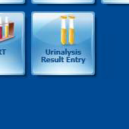

* + - 1. A pop-up box will appear. Select “FA” from the Keyboard dropdown box.

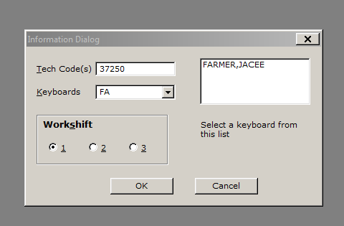

* + - 1. Click OK
      2. A pop-up box will appear. Click OK.

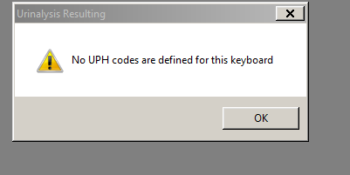

* + - 1. Enter accession number in the yellow highlighted box.

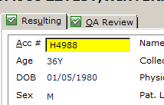

* + - 1. Hit ENTER

Note: You must use the ENTER key; NOT tab.

* + - 1. If no targets are detected, skip to step 15.
      2. If a target is detected, select the detected target using the keyboard. (Refer to table 2 for Key, Codes, and Target Organisms)

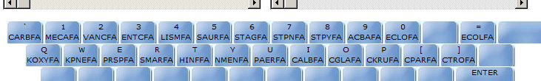

* + - 1. Once the target is selected, hit the “D” Detected key on the keyboard.

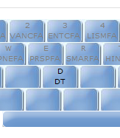

* + - 1. In the box above the keyboard on the screen, highlight the detected target by clicking on the Code.

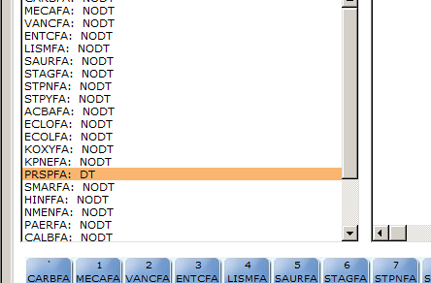

* + - 1. Click on the Edit/Comment button on the screen.

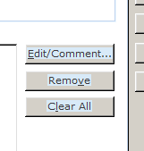

* + - 1. At the bottom of the pop-up box there is a Comment box. Enter the qualified personnel the critical result was called to and read back by, date, time, and your initials.

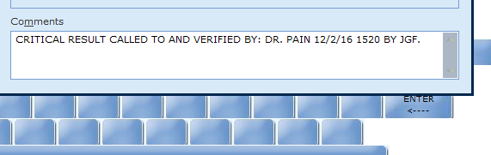

* + - 1. Click OK.
      2. Click on the QA Review Tab.

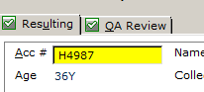

* + - 1. Review results.
      2. If no changes are needed, Click SAVE.

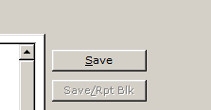

Table 2

|  |  |  |
| --- | --- | --- |
| Key | Code | Organism |
| ` | Carbfa | Carbapenem resistance |
| 1 | Mecafa | Methicillin resistance |
| 2 | Vamcfa | Vancomycin resistance |
| 3 | Entcfa | Enterococcus species |
| 4 | Lismfa | Listeria monocytogenes |
| 5 | SAURFA | Staphylococcus aureus |
| 6 | STAGFA | Streptococcus agalactiae |
| 7 | STPNFA | Streptococcus pnuemoniae |
| 8 | STPYFA | Streptococcus pyogenes |
| 9 | ACBAFA | Acinetobacter baumanii |
| 0 | ECLOFA | Enterobacter cloacae complex |
| = | ECOLFA | Escherichia coli |
| Q | KOXYFA | Klebsiella oxytoca |
| W | KPNEFA | Klebsiella pneumoniae |
| E | PRSPFA | Proteus species |
| R | SMARFA | Serratia marcescens |
| T | HINFFA | Haemophilus influenza |
| Y | NMENFA | Neiserria meningitides |
| U | PAERFA | Pseudomonas aeruginosa |
| I | CALBFA | Candida albicans |
| O | CGLAFA | Candida glabrata |
| P | CKRUFA | Candida krusei |
| [ | CPARFA | Candida parapsilosis |
| ] | CTROFA | Candida tropicalis |

**Interpreting and Reporting Abnormal Results:**

### Detected organism(s) are considered “Critical” results and must be called to the on-site pharmacist. If the pharmacist cannot be reached in a timely manner, call to a qualified healthcare provider (RN or Physician).

### PROCEDURAL NOTES:

* Multiple *Staphylococcus* species may be present in a single sample. The presence of multiple *Staphylococcus* species cannot be determined by BCID Panel test
* Multiple *Streptococcus* species assays may be positive in a single sample. If this occurs, the test result for each species with a positive assay will be reported as Detected.

### References/Related Documents

FilmArray Blood Culture Identification Panel (BCID) Instruction Booklet (RFIT-PRT-0369), BioFire Diagnostics, LLC.

|  |  |  |  |
| --- | --- | --- | --- |
| Review Date | Signature | Mgmt. | Director |
|  |  |  |  |
|  |  |  |  |
|  |  |  |  |
|  |  |  |  |
|  |  |  |  |
|  |  |  |  |
|  |  |  |  |
|  |  |  |  |
|  |  |  |  |
|  |  |  |  |
|  |  |  |  |
|  |  |  |  |
|  |  |  |  |
|  |  |  |  |
|  |  |  |  |
|  |  |  |  |
|  |  |  |  |
|  |  |  |  |
|  |  |  |  |
|  |  |  |  |

SOP HISTORY PAGE

SOP Number: MICRO - 732

SOP Title: FilmArray Blood Culture Identification Panel Testing (BCID)

Written By: Jacee Farmer

Manual in which Hard Copy of this SOP is located: Microbiology

Distribution:

Supersedes Procedure:

SOP CHANGE CONTROL

|  |  |  |  |  |  |
| --- | --- | --- | --- | --- | --- |
|  | Approvals | |  | Action | In |
| Mgmt. | Date | Director | Date |  | Effect |
|  |  |  |  |  |  |
|  |  |  |  |  |  |
|  |  |  |  |  |  |
|  |  |  |  |  |  |
|  |  |  |  |  |  |
|  |  |  |  |  |  |
|  |  |  |  |  |  |
|  |  |  |  |  |  |
|  |  |  |  |  |  |
|  |  |  |  |  |  |
|  |  |  |  |  |  |
| **Date archived: _______________________________** | | | | |  |
| **Reason: ____________________________________ Initials:__________** | | | | |  |
|  |  |  |  |  |  |