**TITLE: FilmArray Gastrointestinal (GI) Panel**

**PRINCIPLE/PURPOSE:**

The FilmArray Gastrointestinal (GI) Panel is a qualitative multiplexed nucleic acid-based *in vitro* diagnostic test intended for use with FilmArray systems. The FilmArray GI Panel is capable of the simultaneous detection and identification of nucleic acids from multiple bacteria, viruses, and parasites directly from stool samples in Cary Blair transport media obtained from individuals with signs and/or symptoms of gastrointestinal infection.

The FilmArray GI Panel is indicated as an aid in the diagnosis of specific agents of gastrointestinal illness and results are meant to be used in conjunction with other clinical, laboratory, and epidemiological data. Positive results do not rule out co-infection with organisms not included in the FilmArray GI Panel. The agent detected may not be the definite cause of the disease.

**SCOPE:**

This procedure provides instructions for testing stool samples using the FilmArray Gastrointestinal (GI) Panel.

The following bacteria, parasites, and viruses are identified using the FilmArray GI Panel:

|  |  |
| --- | --- |
| BACTERIA | VIRUSES |
| Campylobacter (C.jejuni/coli/upsaliensis)  Plesiomonas shigelloides  Salmonella  Vibrio (V.parahaemolyticus/vulnificus/cholerae)  V. cholera  Yersinia enterocolitica | Adenovirus F 40/41  Astrovirus  Norovirus GI/GII  Rotavirus A  Sapovirus (Genogroups I,II,IV, V) |
| DIARRHEAGENIC E. COLI/SHIGELLA | PARASITES |
| Enteroaggregative E. coli (EAEC)  Enterpathogenic E. coli (EPEC)  Enterotoxigenic E. coli (ETEC) It/st  Shiga-like tosin-producing E. coli (STEC) stx1/stx2  E. coli 0157  Shigella/Enteroinvasive E. coli (EIEC) | Cycolspora cayetanensis  Cryptosporidium  Entamoeba histolytica  Giardia lambia |

**SPECIMEN:**

* Stool specimens should be collected in Cary Blair transport media.
* Minimum Volume – 0.2 mL (200 µL)
* Specimens should be processed and testing as soon as possible, though they may be stored at room temperature or under refrigeration for up to 4 days.

**STORAGE REQUIREMENTS:**

* Kits are stored at room temperature. DO NOT refrigerate.
* Specimen can be stored at room temperature or refrigeration for up to 4 days.
* Kits and reagents are stable until the manufacturer’s indicated expiration date.

**EQUIPTMENT/MATERIALS:**

* FilmArray GI Pouches
* Sample Buffer Ampoules
* Hydration Injection Vials
* Sample Injection Vials
* Transfer Pipettes
* FilmArray Loading Station
* FilmArray Modules and Software

**PROCEDURE:**

**Patient Specimen:**

**Prepare Pouch**

1. Thoroughly clean the work area and the FilmArray Pouch Loading Station with ethanol or Sani-Cloth. **Do not wipe hood with bleach.**
2. Obtain the following required materials and place in the clean hood:

* FilmArray GI Panel pouch
* Sample Buffer ampoule
* Hydration Injection Vial (blue cap)
* Sample Injection Vial (red cap)
* Transfer Pipette

1. Place a blue-capped Hydration Injection Vial in the blue well of the Pouch Loading Station.
2. Place a red-capped Sample Injection Vial in the red well of the Pouch Loading Station.
3. Obtain patient sample and place into hood.
4. Remove the FilmArray GI pouch from its vacuum-sealed package by tearing or cutting the notched outer packaging and opening the protective aluminum canister. When the seal is broken, a slight “hiss” should be heard.
5. Slide the pouch into the Pouch Loading Station so that the red and blue labels on the pouch align with the red and blue arrows on the Pouch Loading Station.

Hydrate Pouch

1. Twist the Hydration Injection Vial (blue cap), leaving cap in Pouch Loading Station, and insert the tip of the cannula into the hydration port of the pouch located directly below the blue arrow of the Pouch Loading Station. Push down forcefully in a firm and quick motion until you hear a faint “pop” and feel an ease in resistance. The correct volume of liquid will be pulled into the pouch by vacuum.
2. Verify that the pouch has been hydrated. Flip the barcode label down and check to see that fluid has entered the reagent wells (located at the base of the rigid plastic part of the pouch). Small air bubbles may be seen. If the pouch fails to hydrate (dry reagents appear as white pellets), verify that the seal of the port was broken by ensuring the vial cannula was fully inserted into the hydration port. If the pouch fails to hydrate, retrieve a new pouch and repeat from Step 2 of the Prepare Pouch section.

**Prepare Sample Mix**

1. Hold the Sample Buffer ampoule so that the tip is facing up.

NOTE: Use care to avoid touching the tip during handling, as this may introduce contamination.

1. Gently pinch the textured plastic tab on side of ampoule until the seal snaps.
2. Re-position thumb and forefinger to grip between the textured plastic tab and the bottom of the ampoule, then invert over the red Sample Injection Vial and dispense Sample Buffer using a slow, forceful squeeze, followed by a second squeeze. Avoid generating excessive bubbles.
3. Thoroughly mix the patient specimen.
4. Using the Transfer Pipette provided in the test kit, draw sample to the second line (approximately 0.2 mL). Add sample to the red Sample Injection Vial.

NOTE: DO NOT use the transfer pipette to mix the sample once it is loaded into the Sample Injection Vial.

1. Tightly close the lid of the Sample Injection Vial and mix by gently inverting at

least 3 times.

1. Return the Sample Injection Vial to the Pouch Loading Station.

**Load Sample Mix**

1. Slowly unscrew the Sample Injection Vial from the cap and pause for 3-5 seconds. .
2. Remove Sample Injection Vial leaving cap in Pouch Loading Station and insert the cannula tip into the port in the pouch fitment located directly below the red arrow of the Pouch Loading Station. Push down forcefully in a firm and quick motion until you hear a faint “pop” and feel an ease in resistance. The correct volume of liquid will be pulled into the pouch by vacuum.
3. Verify that the sample has been loaded. Flip the barcode label down and check to see that fluid has entered the reagent well next to the sample loading port. If the pouch fails to pull sample from the Sample Injection Vial, the pouch should be discarded. Retrieve a new pouch and repeat from Step 2 of the Prepare Pouch section.
4. Discard the Hydration Injection Vial and Sample Injection Vial in an appropriate biohazard sharps container.
5. Affix the patient’s barcoded label on the sample pouch in the provided area.

**Run Pouch**

The FilmArray Software includes step-by-step on-screen instructions that guide the operator through performing a run

1. Ensure that the computer and FilmArray instrument(s) are on and the FilmArray software is launched.
2. Open the lid of an available instrument.

NOTE: An available instrument is indicated by a constant green light on the front of the instrument.

1. Insert the FilmArray pouch into the instrument.
2. Scan the barcode on the FilmArray pouch using the barcode scanner.
3. Scan the barcoded patient label.
4. Enter a user name and password in the Name and Password fields.
5. Close the FilmArray instrument lid.
6. Click the Start Run button on the screen.
7. When the run is finished, results are automatically displayed in the report section of the screen. The report is automatically saved into the database.
8. Follow the on-screen instructions to open the instrument and remove the pouch.
9. Immediately discard the pouch in a biohazard container.
10. Report results in LIS.
11. If applicable, call and document results. Refer to Microbiology’s Critical and Call list.
12. If applicable, notify the health department. Refer to Communicable Disease Reporting procedure.

**Resulting in LIS:**

* + - 1. Log into SunQuest
      2. Select “Urinalysis Result Entry”

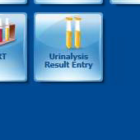

* + - 1. A pop-up box will appear. Select “FA” from the Keyboard dropdown box.

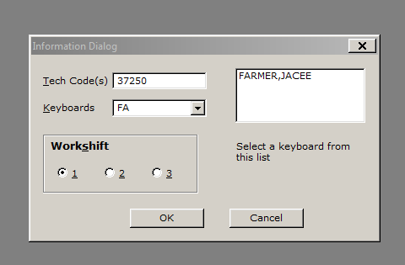

* + - 1. Click OK
      2. A pop-up box will appear. Click OK.

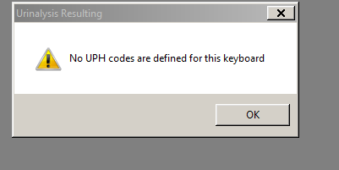

* + - 1. Enter accession number the yellow highlighted box.

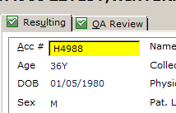

* + - 1. Hit ENTER

Note: You must use the ENTER key; NOT tab.

* + - 1. If no targets are detected, skip to step 16

Note: All results default to NOT DETECTED.

* + - 1. If a target is detected, select the detected target using the keyboard. (Refer to Table 1 for Key, Codes, and Target Organisms)

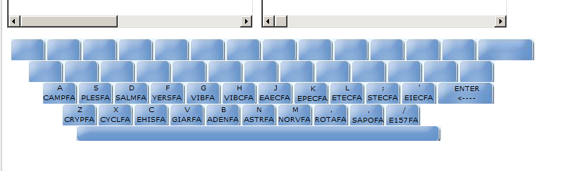

* + - 1. Once the target is selected, hit the “D” Detected key on the keyboard.

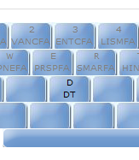

* + - 1. DETECTED Alert Targets, listed on Table 2, must be called to a qualified healthcare provider. In the box above the keyboard on the screen, highlight the detected target by clicking on the Code.

Note: Salmonella, Shigella, and any Diarrheagenic E. coli must be sent to the NC State Laboratory of Public Health for confirmation and serotyping. (Refer to State Laboratory Send Outs Procedure)

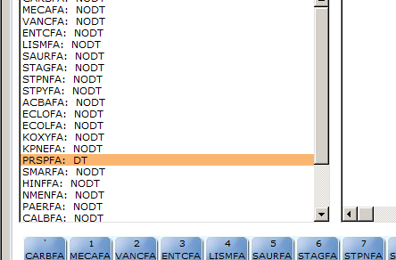

* + - 1. Click on the Edit/Comment button on the screen.

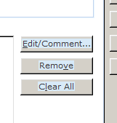

* + - 1. At the bottom of the pop-up box there is a Comment box. Enter the qualified personnel the result was called to and read back by, date, time, and your initials.

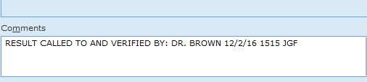

* + - 1. Click OK.
      2. Click on the QA Review Tab.

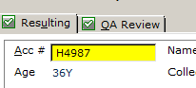

* + - 1. Review results.
      2. If no changes are needed, Click SAVE.

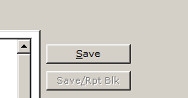

Table 1

|  |  |  |
| --- | --- | --- |
| Key | Code | Organism |
| A | CAMPFA | Campylobacter |
| S | PLESFA | Plesiomonas shigelloides |
| D | SALMFA | Salmonella |
| F | YERSFA | Yersina |
| G | VIBFA | Vibrio |
| H | VIBCFA | Vibrio cholera |
| J | EAECFA | Enteroaggregative E. coli (EAEC) |
| K | EPECFA | Enteropathogenic E. coli (EPEC) |
| L | ETECFA | Enterotoxigenic E. coli (ETEC) |
| ; | STECFA | Shiga-like toxin-producing E. coli (STEC) stx1/stx2 |
| ‘ | EIECFA | Shigella/Enterinvasive E. coli |
| / | E157FA | E. coli 0157 |
| Z | CRYPFA | Cryptosporidium |
| X | CYCLFA | Cyclospora cayetanensis |
| C | EHISFA | Entamoeba histolytica |
| V | GIARFA | Giardia lamblia |
| B | ADENFA | Adenovirus F 40/41 |
| N | ASTRFA | Astrovirus |
| M | NORVFA | Norovirus GI/GII |
| , | ROTAFA | Rotovirus A |
| . | SAPOFA | Saporvirus |

Table 2: DETECTED Alert Targets to be called to a qualified healthcare provider.

|  |
| --- |
| Organism |
| Campylobacter |
| Plesiomonas |
| Salmonella |
| Shigella |
| Yersina |
| Vibrio |
| Vibrio cholera |
| EAEC |
| EPEC |
| ETEC |
| STEC |
| E.COLI 0157 |
| NOROVIRUS |

**Quality Control:**

**Internal Controls:**

Two process controls are included in each pouch.

1. DNA Process Control

2. PCR2 Control

**EXTERNAL QC:**

External controls are performed with each new lot number, shipment, every 30 days a kit is use, and with each new operator.

**QC Procedure:**

1. Inoculate 200 µL of Cary Blair media with the entire contents of 1 vial listed below. Rotate organisms between QC runs. Refer to BioFire GI QC Panel.
2. Continue QC set up procedure beginning at Step on of Prepare Pouch.

ZeptoMetrix

|  |  |
| --- | --- |
| **Panel Member** | **Strain** |
| Salmonella *typhimurium* | Z005 |
| *Escherichia coli* | EDL933 |
| *Escherichia coli* | 92.0147; EAEC* |
| *Escherichia coli* | ETEC; ST+, LT+ |
| *Escherichia coli* | 7.1493; O84:H28; EPEC* |
| *Shigella sonnei* | Z004 |
| *Entamoeba histolytica* | DS4-868 |
| *Vibrio cholerae* | Z133; non-toxigenic |
| *Cryptosporidium parvum* | Iowa |
| *Giardia lamblia* | H3 |
| *Clostridium difficile* | NAP1 |
| *Campylobacter jejuni* | Clinical isolate |
| *Campylobacter coli* | Clinical isolate |
| *Yersinia enterocolitica* | Clinical isolate |
| *Pleisomonas shigelloides* | Z130 |
| *Cyclospora cayetanensis* | recombinant |
| Astrovirus | recombinant |
| Sapovirus | recombinant |
| Rotavirus | WA |
| Norovirus GI | recombinant |
| Norovirus GII | recombinant |
| Adenovirus Type 41 | TAK |
| Negative | N/A |

**PROCEDURAL NOTES:**

1. A trained healthcare professional should carefully interpret the results from the Film Array GI Panel in conjunction with a patient’s signs and symptoms and results from other diagnostic tests.
2. Due to the sensitive nature of the FilmArray, it is important to guard against contamination of the work area by carefully following the testing process outlined in the procedure section of this procedure.

**RESULTS INTERPRETATION:**

**Detected** = The target organism was detected.

**Not Detected** = No target organisms were detected.

**Invalid** = One or more of the internal controls failed. Repeat FilmArray test with a new pouch.

**Error** = The BioFire FilmArray dectected an error with the test run. Repeat FilmArray test with a new pouch.

Any DETECTED target must be called to a qualified healthcare provider.

The following DETECTED targets must be reported to the appropriate Health Department within 24 hours. (Refer to the Communicable Disease Reporting procdure)

Campylobacter

Salmonella

Shigella

Any of the Diarrheagenic E. coli (STEC, EAEC, EPEC, ETEC, EIEC)

Yersina

Vibrio

**LIMITATIONS:**

• This test is a qualitative test and does not provide a quantitative value for the organism(s) in the sample.

• Virus, bacteria, and parasite nucleic acid may persist *in vivo* independently of organism viability. Additionally, some organisms may be carried asymptomatically. Detection of organism targets does not imply that the corresponding organisms are infectious or are the causative agents for clinical symptoms.

• There is a risk of false negative values due to the presence of sequence variants in the gene targets of the assay, procedural errors, amplification inhibitors in specimens, or inadequate numbers of organisms for amplification.

• The performance of this test has not been evaluated for immunocompromised individuals.

**EXPECTED VALUES**

Not Detected.

**RELATED/SUPPLEMENTAL PROCEDURES:**

1. Communicable Disease Reporting
2. List of Microbiology results to be called to RN or physician.
3. State Laboratory Send Outs

|  |  |  |  |
| --- | --- | --- | --- |
| Review Date | Signature | Mgmt. | Director |
|  |  |  |  |
|  |  |  |  |
|  |  |  |  |
|  |  |  |  |
|  |  |  |  |
|  |  |  |  |
|  |  |  |  |
|  |  |  |  |
|  |  |  |  |
|  |  |  |  |
|  |  |  |  |
|  |  |  |  |
|  |  |  |  |
|  |  |  |  |
|  |  |  |  |
|  |  |  |  |
|  |  |  |  |
|  |  |  |  |
|  |  |  |  |
|  |  |  |  |

SOP HISTORY PAGE

SOP Number: MICRO - 731

SOP Title: FilmArray Gastrointestinal (GI) Panel

Written By: Jacee Farmer

Manual in which Hard Copy of this SOP is located: Microbiology

Distribution:

Supersedes Procedure:

SOP CHANGE CONTROL

|  |  |  |  |  |  |
| --- | --- | --- | --- | --- | --- |
|  | Approvals | |  | Action | In |
| Mgmt. | Date | Director | Date |  | Effect |
|  |  |  |  |  |  |
|  |  |  |  |  |  |
|  |  |  |  |  |  |
|  |  |  |  |  |  |
|  |  |  |  |  |  |
|  |  |  |  |  |  |
|  |  |  |  |  |  |
|  |  |  |  |  |  |
|  |  |  |  |  |  |
|  |  |  |  |  |  |
|  |  |  |  |  |  |
| **Date archived: _______________________________** | | | | |  |
| **Reason: ____________________________________ Initials:__________** | | | | |  |
|  |  |  |  |  |  |