Title: URINE C & s (Culture and sensitivity) tRANSFER STRAW KIT

PRINCIPLE / PURPOSE: Bacteria quantification in urine is widely used as an aid in evaluating a patient for urinary tract infections. Colony forming units (CFU) of 100,000 microorganism or greater per milliliter or urine are generally considered indicative of infection.

Urine frequently supports the proliferations of bacteria, which may multiply at the same rate as in the nutrient broth. Therefore, a urine sample delayed in transit or left at room temperature for an extended period of time may give an erroneous result.

As means of preventing growth of the microorganisms from sources exogenous to the bladder, refrigeration or culturing within 2 hours of micturition is recommended.

SCOPE: This procedure applies to the transporting of urine specimens from the original collection container to a C&S Transfer Tube.

SAFETY:

* The required personal protective equipment for this procedure:
  + Gloves
  + Safety shield
* Gloves are to be worn at all times during analysis of the samples
* Transfer of urine from sterile container to a transfer tube should be done so behind a safety shield.

SPECIMEN:

* Clean Catch
* Indwelling Cath
* In/Out Cath
* Suprapubic tap
* Nephrostomy
* Ureterostomy
* Urostomy
* Ileostomy
* Cystoscopy

EQUIPMENT AND MATERIALS:

Equipment:

Gloves

Safety Shield

C&S Transfer Straw Kit

Storage Requirements:

Urine should be transferred to the C&S tube as soon as possible. Specimens in

the tube are stable for up to 48 hours. If there is a delay in transfer from sterile

container to C&S tube, refrigerate the urine specimen.

PROCEDURE:

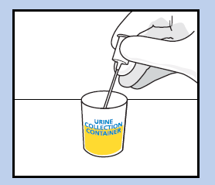

1. Submerge tip of transfer straw in specimen

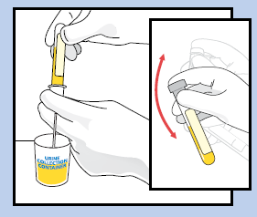

2. Push tube into the transfer straw.

3. Hold in position until flow stops.

4. Remove tube, leaving transfer straw in specimen container.

5. Invert tube 8 – 10 times to mix sample.

6. Label tube appropriately using LIS barcoded label.

7. Dispose of the transfer straw in sharps container.

PROCEDURAL NOTES:

Specimen must be added to the minimum volume line on the tube.

Specimens with volume unable to reach the minimum fill line should remain refrigerated and transported in sterile container for culture.

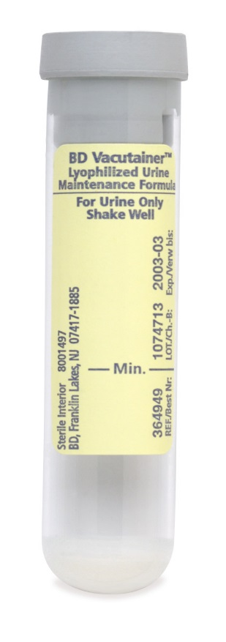

RELATED PROCEDURES:

Specimen Collection and Labeling

LIMITATIONS OF PROCEDURE:

1. The quantity of specimen drawn varies with altitude, ambient temperature, barometric pressure, tube age, and filling technique.

2. Urine specimen must be drawn to the minimum fill line.

3. It is not recommenced to manually fill tubes. Removing the rubber stopper will compromise the sterility of the tube.

4. The maintenance formula will not inactivate antibiotics.

5. The microbial load in urine from a given patient may be influenced by the time of collection and fluid intake.

REFERENCES:

1. BD Vacutainer Urine Products product insert. April 2016 version.

|  |  |  |
| --- | --- | --- |
|  | Signature Date | |
| Medical Director Approval –  ARMC Cancer Center  ARMC Main Lab |  |  |
| Medical Director Approval –  MedCenter Mebane |  |  |

|  |  |  |  |
| --- | --- | --- | --- |
| Review Date | Signature | Mgmt. | Director |
|  |  |  |  |
|  |  |  |  |
|  |  |  |  |
|  |  |  |  |
|  |  |  |  |
|  |  |  |  |
|  |  |  |  |
|  |  |  |  |
|  |  |  |  |
|  |  |  |  |
|  |  |  |  |
|  |  |  |  |