INPATIENT LAB CULTURE ORDER CHANGES
Effective Tuesday 6/6/2017
Audience: CHL Providers, OR Techs, Imaging Techs and Nurses
To clarify when an anaerobic work-up is performed, 3 inpatient culture orders (Tissue, Abscess, and Wound) are being replaced in CHL with:
- AEROBIC / ANAEROBIC CULTURE (SURG SPECIMEN) [LAB9434]
- AEROBIC CULTURE (SUPERFICIAL SPECIMEN) [LAB9435]
- For questions please call the Microbiology Lab at 336-832-7821
- This affects CHL inpatient orders placed via OpTime or Radiant specimen collection navigators, along with Manage Orders activity facility/preference lists & order sets

Try it Out

CHL Specimen Collection Navigators:

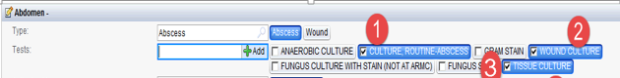

The 3 orders above will be replaced. Culture, Routine-Abscess & Tissue Culture will be replaced with AEROBIC/ANAEROBIC CULTURE (SURG SPECIMEN). Wound Culture will be replaced with AEROBIC CULTURE (SUPERFICIAL SPECIMEN).

New Orders:
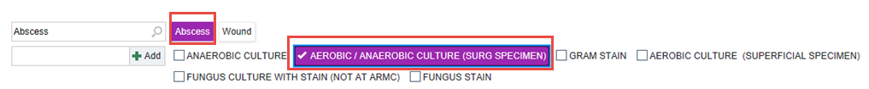

Manage Orders Activity:

