TITLE: RESULT REPORTING AND REPORT FORMAT

Principle / PURPOSE: Cone Health labs strive to report reliable, accurate and useful laboratory results and to make reports timely, legible, accurate, and with clearly designated units of measurement.

SCOPE: This procedure is intended for all ARMC laboratories, ARMC main lab, ARMC Cancer Center lab and MedCenter Mebane laboratory.

REPORT REQUIREMENTS: Laboratory reports, paper and electronic, are reviewed for format and content by an individual meeting CAP or CLIA Laboratory Director qualification at least every two years. This is to ensure that the reports effectively communicate patient test results and that they meet the needs of the medical community served.

Laboratory reports shall include:

1. Patient name,
2. Patient identification number (hospital or laboratory) or another unique identifier

(examples include SSN, accession number, requisition number),

1. Name of the ordering physician, physician of record or legally authorized person

ordering test as appropriate,

1. Date and time of specimen collection when appropriate,
2. Date and time the report was released (if not on the report, this information

should be readily accessible)

1. Specimen source, when applicable
2. Test result(s) and unit(s) of measurement when applicable,
3. Conditions of specimen that may limit adequacy of testing,
4. Reference intervals (normal ranges) for the reported test, when possible,
5. Name and address of the testing laboratory, including referral laboratories

RESULTS REVIEW – PRIOR TO REPORTING

Proper investigation and subsequent corrective action is to be taken. Should the tech conducting the review feel that the corrective action or problem solving is out of the realm of their knowledge or responsibility, the situation is to be referred to a section leader or a supervisor. Staff follow the QM-170 Report Review Criteria procedure for result reporting.

RELEASING RESULTS: Results are released automatically, via result interface method, via middleware, or manually. Autoverification is addressed in LIS-109-CH. Middleware is addressed in CHEM-305-CH. All blood bank result release is addressed in blood bank specific procedures and does not follow the format below.

Manual Result Entry

Use of keyboard reporting is part of the manual result entry process, however it is addressed in test specific procedures.

1. Select Result Entry tab
2. Select MANUAL as the Resulting Mode.

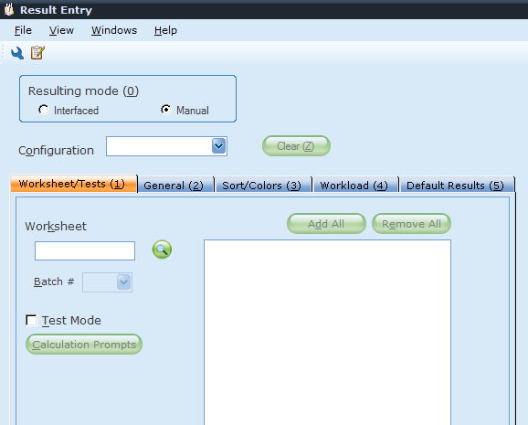

1. Enter Worksheet Code from Manual Worksheet Table and Tab to display tests available for resulting on that worksheet. ONLY INDIVIDUAL WORKSHEET CODES WILL WORK.

|  |  |  |  |
| --- | --- | --- | --- |
| **GROUP WORKSHEET CODE** | **GROUP WORKSHEET DESCRIPTION** | **INDIVIDUAL WORKSHEET CODE** | **INDIVIDUAL WORKSHEET DESCRIPTION** |
| ARAMEB | AR ALL MEBANE | ARCHM | AR CHEMISTRY (MEBANE) |
| ARMHE | AR HEMATOLOGY (MEBANE) |
| ARURM | AR URINALYSIS (MEBANE) |
| ARACC | AR ALL CANCER CENTER | ARCCHE | AR HEMATOLOGY (CANCER CENTER) |
| ARCCHM | AR CHEMISTRY (CANCER CENTER) |
| ARAMN | AR ALL MAIN (GENLAB ONLY) | ARABG | AR BLOOD GAS |
| ARCHE | AR CHEMISTRY (MAIN) |
| ARCHE1 | AR HEMOGLOBIN A1Cs (MAIN) |
| ARCOAG | AR COAGULATION (MAIN) |
| ARFCT | AR FLUID CELL COUNTS |
| ARHEM | AR HEMATOLOGY (MAIN) |
| ARREV | ARMC PATH REVIEWS |
| ARTDM | AR TDM TESTING (MAIN) |
| ARUCHM | ARMC URINE CHEMISTRIES |
| ARUDS | AR URINE DRUG SCREENS (MAIN) |
| ARURIN | AR URINALYSIS (MAIN) |
| ARMIC | AR MICRO GROUP WORKSHEET | ARAER | AR AEROBIC CULTURE |
| ARANAC | AR ANAEROBIC CULTURE |
| ARBETA | AR BETA STREP CULTURE |
| ARBLC | AR BLOOD CULTURE |
| ARCTC | AR CATHETER TIP CULTURE |
| ARDE | AR DIRECT EXAM WRKSHEET |
| AREARC | AR EAR CULTURE |
| ARENVC | AR ENVIRONMENTAL CULTURE |
| AREYEC | AR EYE CULTURE |
| ARFC | AR FUNGUS CULTURE |
| ARFLDB | AR FLUID CULTURE(BOTTLE) |
| ARFLDC | AR BODY FLUID CULTURE |
| ARGCCX | AR GC CULTURE |
| ARGENC | AR GENITAL CULTURE |
| ARRESP | AR RESPIRATORY CULTURE |
| ARBBKG | AR BLOOD BANK ALL | Listed in BB specific procedures | Listed in BB specific procedures |
| LCALL | LABCORP SENDOUTS ALL | LCAMB | LABCORP SENDOUTS AMBIENT |
| LCFRZN | LABCORP SENDOUTS FROZEN |
| LCMISC | LABCORP MISC TESTING |
| LCMIXD | LABCORP SENDOUTS MIXED TEMPS |
| LCREF | LABCORP SENDOUTS REFRIGERATED |
| LCREF1 | LABCORP SENDOUTS REFRIGERATED |

1. Select RESULT from bottom right hand side of the page to enter resulting mode.
2. Select the BINOCULAR ICON from the bottom of the page to access the search window.



1. Enter the ACCESSION NUMBER into the Specimen ID field and select SEARCH.

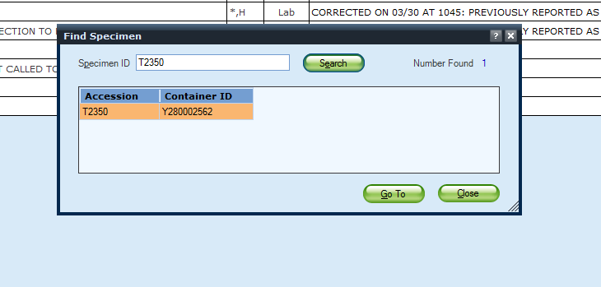

1. The Accession number and Container ID will display. Select GO TO to enter the manual result entry screen.
2. Enter the appropriate results for the ordered test.
3. Check for QA failures. If a critical value or result that requires a call, enter RBV or RCRV, respectively with your call information.
4. If all entered information is correct, select SAVE.

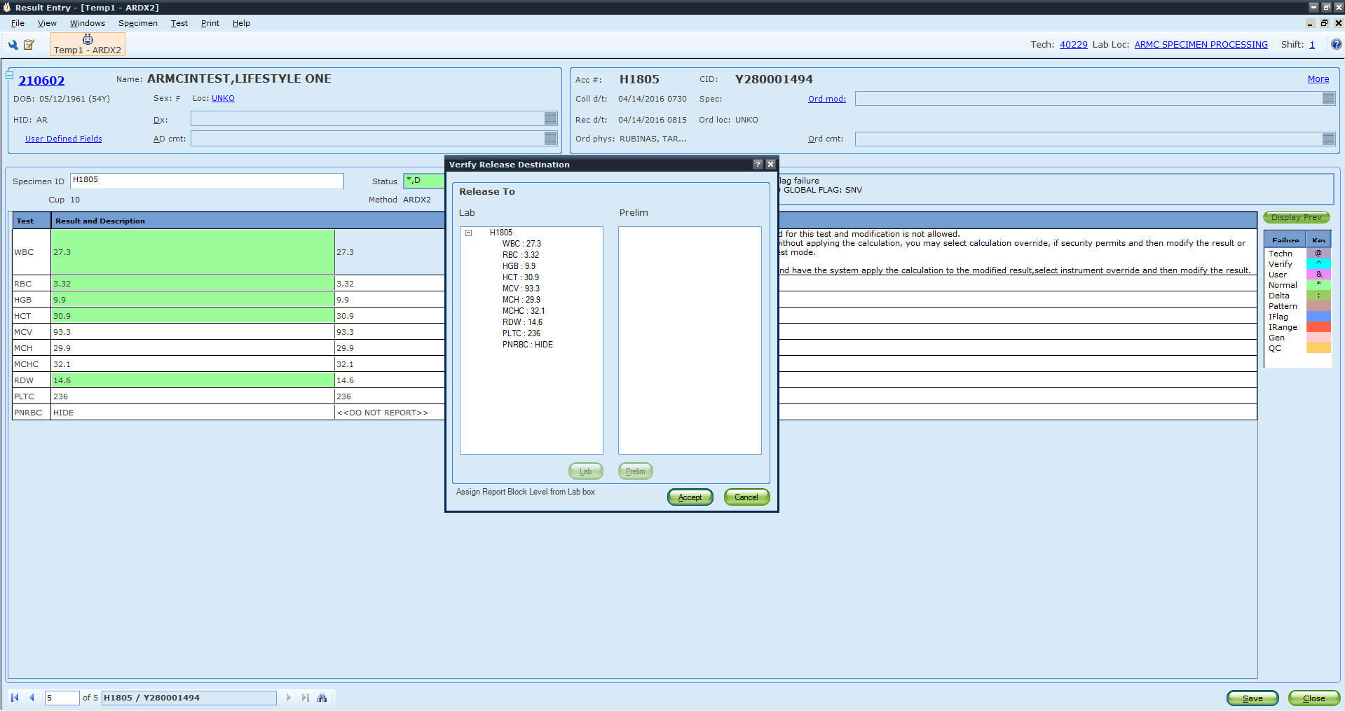

1. The Verify Release Destination Screen appears.
2. Select ACCEPT to post results to the patient chart.

Interface Result Entry

1. Select Result Entry tab
2. Select Interfaced as the Resulting Mode.

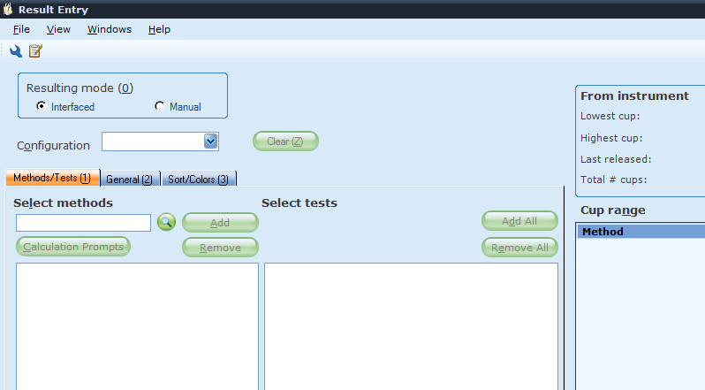

1. Enter the correct method code in the Select methods field and click ADD.

ALAMANCE MAIN LAB

|  |  |  |  |  |
| --- | --- | --- | --- | --- |
| **Method** | **Instrument** |  | **Method** | **Instrument** |
| ARDX1 | DxH 800 1 |  | ARREM | REMISOL CHEM |
| ARDX2 | DxH 800 2 |  | ARSTA1 | STAGO 1 |
| ARGXP | GENE XPERT |  | ARSTA2 | STAGO 2 |
| ARIRIS | IRIS |  | ARECHO | ECHO |
| ARFA | BIOFIRE FILM ARRAY |  |  |  |

CANCER CENTER

|  |  |
| --- | --- |
| **Method** | **Instrument** |
| ARDXC | DxH 800 |
| ACC600 | CC REMISOL |

MEDCENTER MEBANE

|  |  |
| --- | --- |
| **Method** | **Instrument** |
| ARDXM | DxH 800 |
| MUCREM | REMISOL CHEM |

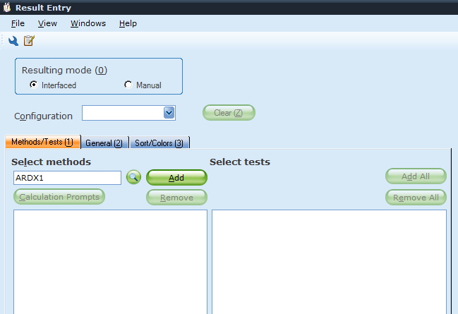

1. Once the method is activated, select Results at the bottom right of the screen.
2. Select the BINOCULAR ICON from the bottom of the page to access the search window.



1. Use the barcode scanner to scan the CID and access patient results.



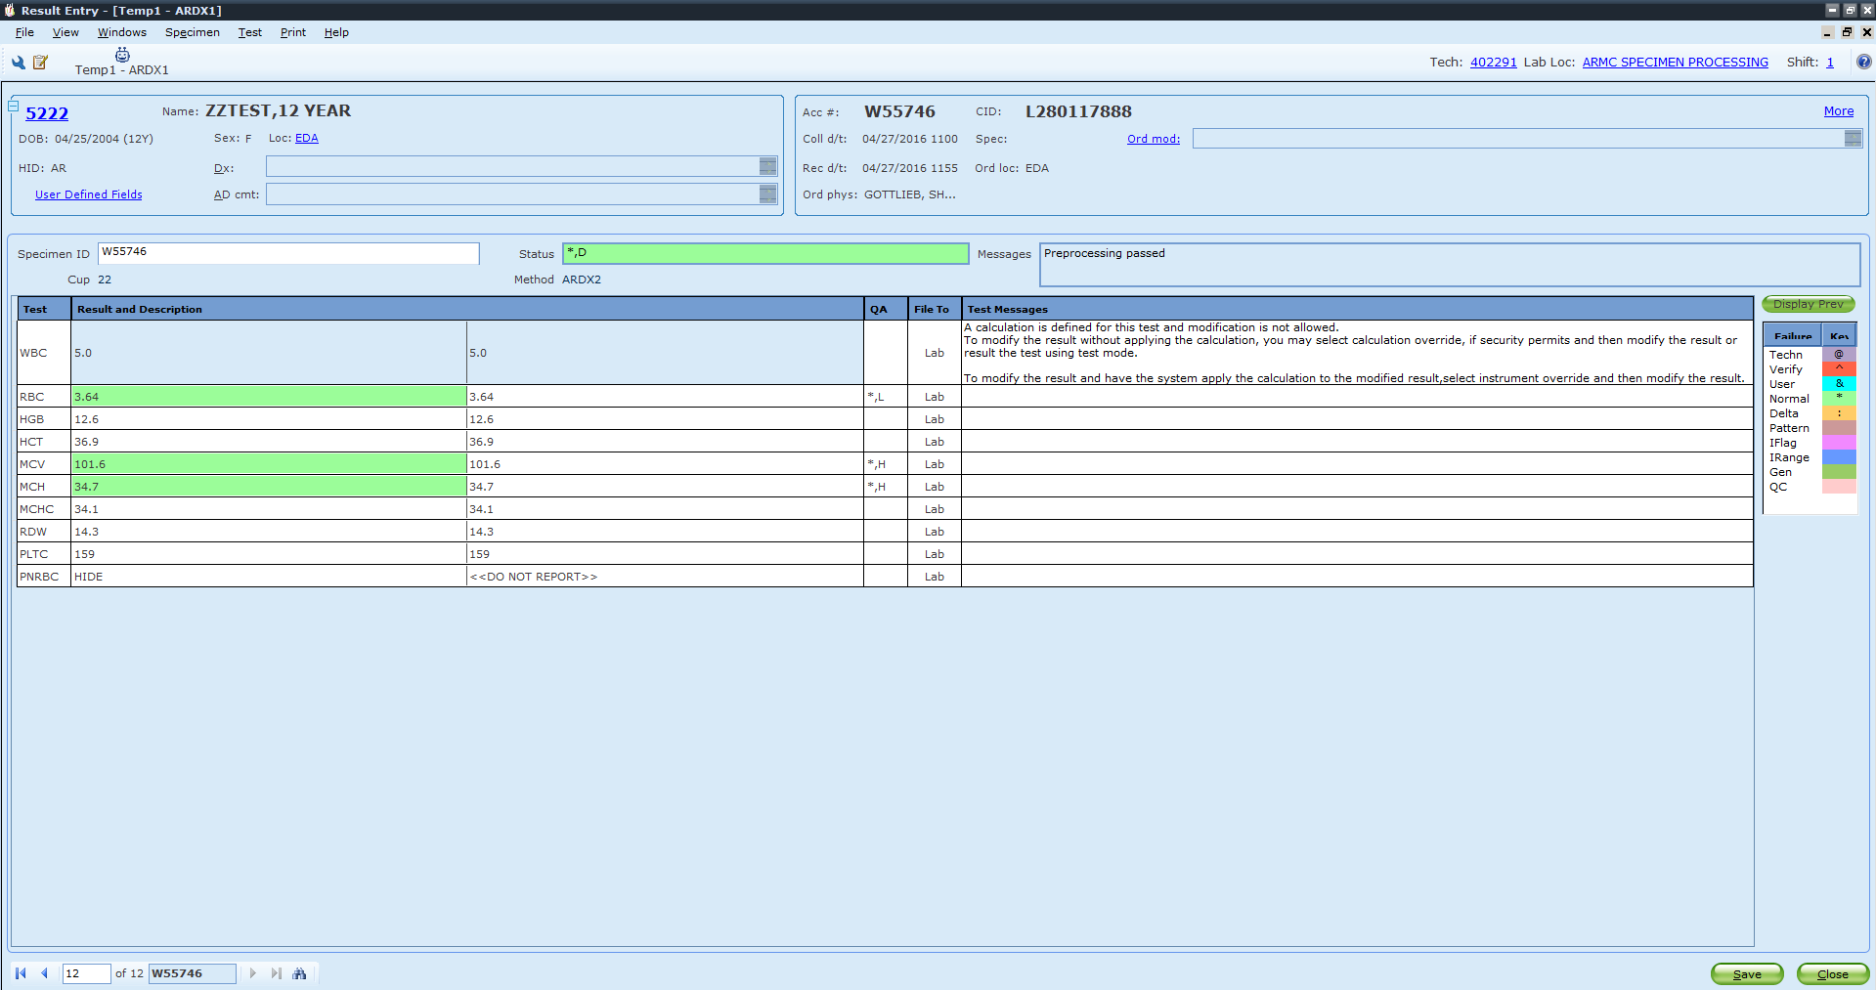

1. Review the results and check for QA failures. If there is a critical value or result that requires a call, enter RBV or RCRV, respectively with your call information.
2. Select Save.

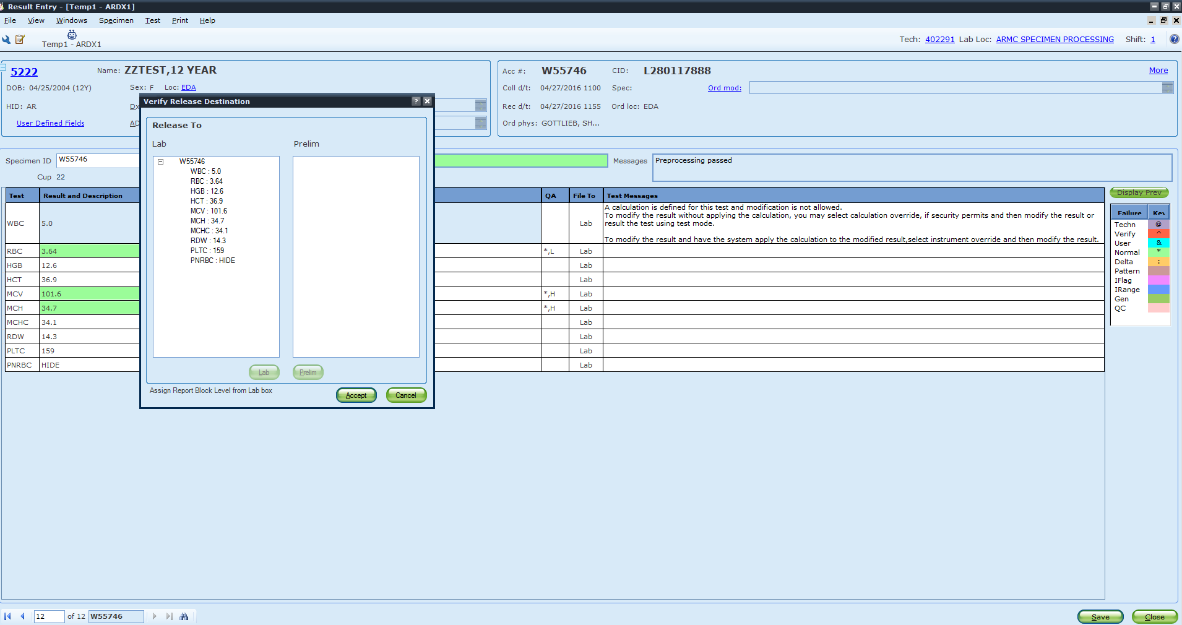

1. The Verify Release Destination box appears.
2. Select ACCEPT to release Results to the patient chart.
3. If the Automated Differential box appears, Select ACCEPT to release the automated differential to the patient chart.

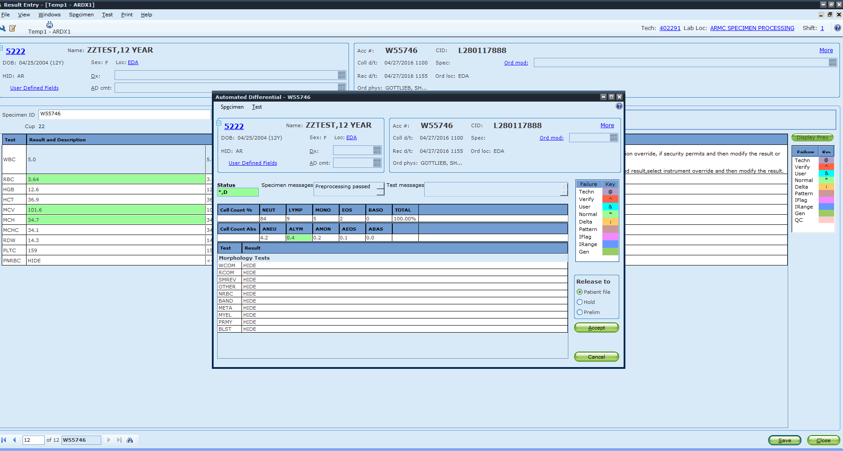

REVISED REPORTS:

1. Lab values or test interpretations that are released to a clinician for clinical decision-making and subsequently changed shall be clearly designated on the lab report.
2. The LIS must flag changed results with a canned message, e.g., “amended result” or “corrected result”. The appended message serves to alert the clinician that a revised result is replacing a previously reported and incorrect result.
3. Revised results shall be flagged on paper reports and on data that is displayed to LIS monitors or monitors of office systems that receive patient data from a LIS.
4. Corrected or revised results shall be called to the clinician if the revised result is significant and changes the clinical interpretation of the test result. Calls and call attempts shall be documented in the LIS.

REPORTING OUTSIDE RESULTS: Outside laboratory results shall not be integrated into the laboratory’s primary reporting system from facilities that have not been selected

as Reference Laboratories by Cone Health Laboratories. Reports, however, may be scanned into appropriate sections of the electronic medical record (EMR). See QM-172

REPORT RETENTION: Copies and/or files of reports are legible and are retained by the laboratory in a manner that permits prompt retrieval of the information. The length of time that reports must be retained may vary.

REFERENCES

Commission on Laboratory Accreditation Inspection Checklist, Laboratory General.

Current version. College of American Pathologists. Northfield, Illinois.

Medicare, Medicaid, and CLIA Programs; Laboratory Requirements Relating to Quality

Systems and Certain Personnel Qualifications; Final Rule. January 2003. CMS.

QM-170 Report Review Criteria

QM-172 Lab Policy on Reporting Outside Lab Results

QM-189 Corrected Reports

LIS-109-CH AutoVerification Validation

CHEM-305-CH Remisol Reporting

|  |  |  |
| --- | --- | --- |
|  | Signature Date | |
| Medical Director Approval –  ARMC Cancer Center  ARMC Main Lab |  |  |
| Medical Director Approval –  MedCenter Mebane |  |  |

|  |  |  |  |
| --- | --- | --- | --- |
| Review Date | Signature | Mgmt. | Director |
|  |  |  |  |
|  |  |  |  |
|  |  |  |  |
|  |  |  |  |
|  |  |  |  |
|  |  |  |  |
|  |  |  |  |
|  |  |  |  |
|  |  |  |  |
|  |  |  |  |
|  |  |  |  |
|  |  |  |  |
|  |  |  |  |
|  |  |  |  |
|  |  |  |  |
|  |  |  |  |
|  |  |  |  |
|  |  |  |  |
|  |  |  |  |

HISTORY PAGE

SOP Number: LIS-113-CH

SOP Title: Result Reporting and Report Format

Written By: Sigrid Kesler-Cribb, Wendy Turner

Manual in which Hard Copy of this SOP is located: LIS/IT Manual

Distribution: no other locations

Supersedes Procedure:

SOP CHANGE CONTROL

|  |  |  |  |  |  |
| --- | --- | --- | --- | --- | --- |
|  | Approvals | |  | Action | In |
| Mgmt. | Date | Director | Date |  | Effect |
| W Turner | 8/14/17 |  |  | Added releasing results steps | 8/14/17 |
|  |  |  |  |  |  |
|  |  |  |  |  |  |
|  |  |  |  |  |  |
|  |  |  |  |  |  |
|  |  |  |  |  |  |
|  |  |  |  |  |  |
|  |  |  |  |  |  |
|  |  |  |  |  |  |
|  |  |  |  |  |  |
|  |  |  |  |  |  |
| Date archived: _______________________________ | | | | |  |
| Reason: ____________________________________ Initials:__________ | | | | |  |
|  |  |  |  |  |  |