**TITLE: Beckman Airfuge: Ultracentrifuge**

**Operation and Maintenance**

**Principle / PURPOSE:** The tabletop Airfuge Ultracentrifuge is a miniature air turbine capable of accelerating rotors up to 110,000 rpm in only 30 seconds. The instrument uses no vacuum or high-speed bearings; the rotor is supported and turned by streams of air. Rotor speed can be determined by conversion of the applied air pressure, as read on the instrument gauge, to rpm. Rotor speed is controlled by pressure regulator knob on top of the unit. The applied air pressure is provided at 35 psi, however the instrument must not be operated above 30 psi.

This laboratory uses the ACR-90 rotor which is used to clarify lipemic serum by flotation of the chylomicron.

The sample is carried in disposable polyethylene liners that fit into the cavity of the rotor base. The liners are formed into two chambers and have a dome with a filling hole at the top. The inner and outer chambers are sealed from each other when the liner is compressed by the rotor lid. During acceleration, fluid pressure develops and opens the seal. The lightest particles in the sample, the chylomicrons, float into the inner chamber. During deceleration the chambers are sealed again, and the chylous material is isolated in the inner chamber. The 3.5mL liner yields about 2.6mL of clarified specimen; the 2.4mL liner yields about 1.4mL.

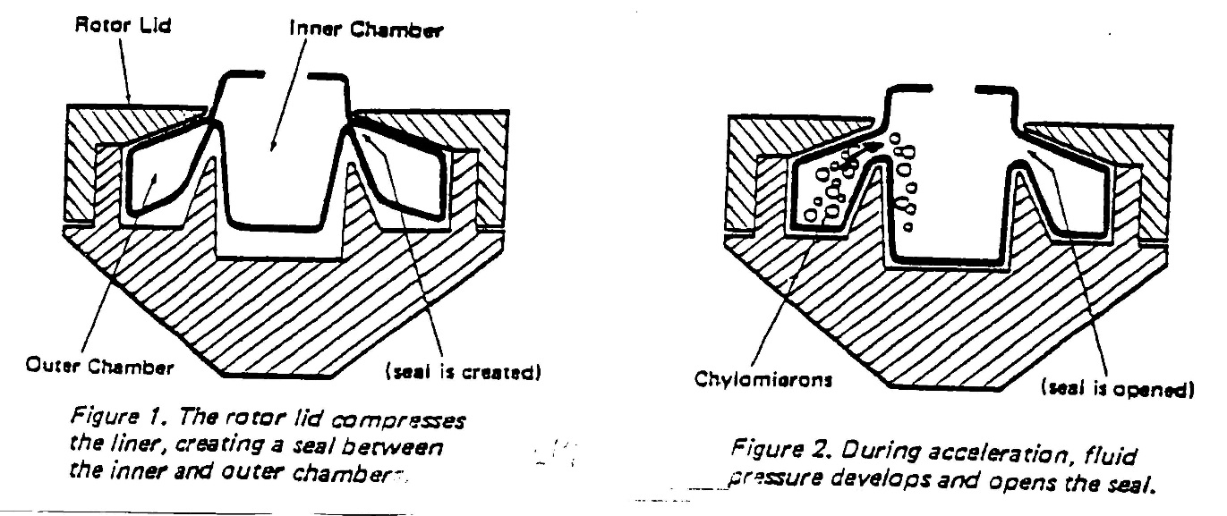

**SCOPE:** This procedure gives the operator a basic guideline in utilizing this equipment.

**Safety:**

The required personal protective equipment for this procedure

* Gloves
* Approved lab coat, worn closed
* Shield and/or approved protective eyewear

**Specimen:** Lithium heparin plasma or serum that was previously tested on the chemistry instruments that indicated a need for ultracentrifugation based on serum indices or error codes.

**Equipment AND Materials:**

Polyethylene liner

Rotor Base

Rotor Stand

Rotor Lid

Stator Pads

Adapter

Disposable Transfer pipettes (Fine Tipped)

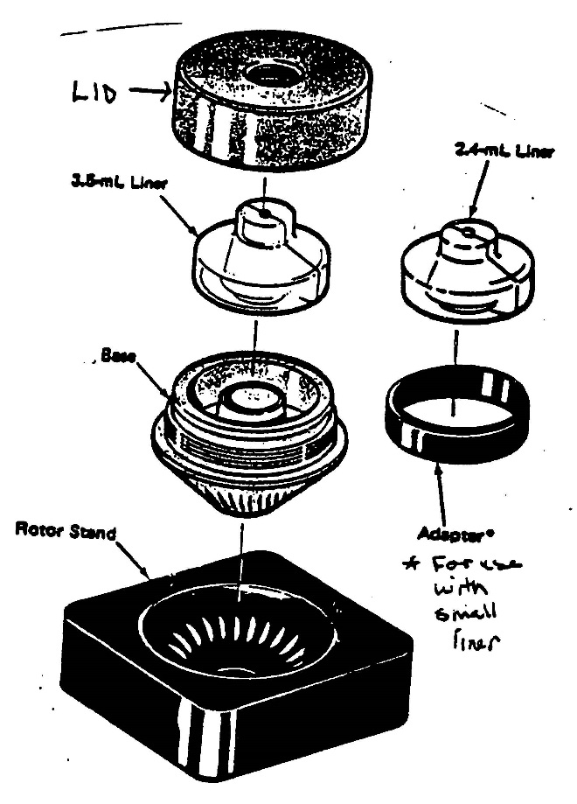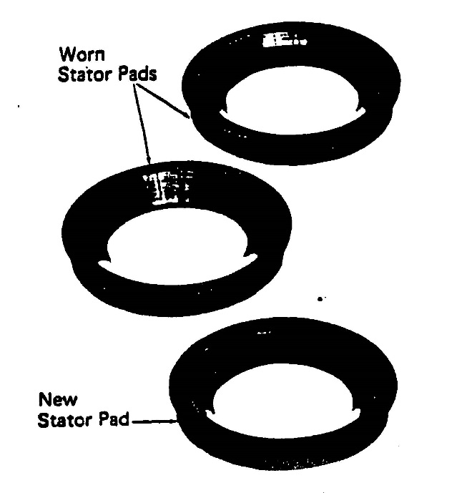

**Maintenance Materials:**

Beckman Solution 555 detergent

Distilled Water

Spinkote Lubricant

Alcohol Pads

Isopropyl Alcohol

**Procedure:**

1. Pre-Run Checks:
2. Touch the brake pin lightly to be sure it operates freely (located in the very center of the instrument).
3. Check the stator pad: it must be clean and in good condition. If the pad is dirty (especially the white circles on the bottom of the pad), clean with alcohol. REPLACE A WORN STATOR PAD. (See Operating Precautions and Maintenance Section)
4. Inspect the rotor bushing. Replace worn bushing (refer to the maintenance section of the Instrument Instruction Manual).
5. Starting the Run:
6. Place the rotor base in the rotor stand.
7. Install liner in the cavity of the base.

* 3.5 mL liner - Install the liner in the cavity of the base. Press the liner down firmly into the cavity.
* 2.4 mL Liner - Place the adapter in the cavity (there is no right or wrong side of the adapter), then install the liner in the adapter. Press the liner down firmly into the cavity.

1. Insert a pipet loaded with the serum or plasma specimen into the outer chamber of the liner. The 343779 plastic loading pipet is recommended; however, a disposable pipet for general laboratory use is acceptable.
2. Fill the outer chamber until sample just overflows into the inner chamber.
3. Screw the lid onto the rotor base.
4. **Do not put serum/plasma in the Inner Chamber.**
5. Place the rotor on the stator pad.
6. Secure the instrument door after closing it by turning the pressure regulator knob clockwise, pushing down, until the air pressure indicated on the pressure gauge brings the rotor up to the desired run speed. The ONLY recommended air pressure for the ACR-90 rotor is 30 psig.
7. Set the TIME dial for 10 minutes by turning dial past 30 then back to 10 minutes. Each line is 5 minute increment. DO NOT SPIN LONGER THAN 12 MINUTES TO PREVENT SIGNIFICANT EVAPORATIVE LOSS.
8. As the airfuge motor begins to runs, observe the pressure gauge and make any adjustments necessary to maintain 30 psi. Note: some low-speed rotor wobble is normal at the beginning of the run.
9. Set a manual timer for 10 minutes to keep with you to avoid excessive run times and evaporative loss of specimen.

**CAUTION:** If the rotor makes an unusual noise, wait until the rotor has accelerated to full speed, then turn the time to zero. When the rotor stops, open the chamber door and remove the rotor. Check to see if the rotor was loaded correctly. Correct the problem before restarting the run (refer to troubleshooting guide in manual).

When the timer reaches zero, Do NOT change the air pressure or turn it off until the rotor has stopped. Changing the pressure knob while the rotor is moving may result in damage to the rotor and stator pad.

Do NOT open the instrument door until the rotor has stopped.

1. When the timer is turned to zero or reached zero automatically, the rotor will coast for about 2 minutes. After the 2 minute delay, the run light will go out and the brake pin will engage the rotor. The rotor will stop about 1 to 3 minutes later. (If coasting time is too short – 45 seconds or less – check the time – delay relay setting and/or adjust the flow of levitation air; refer to the instrument manual). If the timer is no longer operational, a manual timer will need to be set.
2. After the rotor has stopped, turn the pressure knob counterclockwise until the PRESSURE gauge on the instrument is zero (Do not tighten the pressure regulator knob between runs).
3. Remove the fully assembled rotor and place in the stand.
4. Pipette the chylous material from the inner chamber and discard while the lid is in place.
5. Unscrew the rotor lid.
6. Using a new pipet, extract the clarified specimen from the outer chamber. Be careful not to mix any fatty material left on the wall of the inner chamber with the clarified specimen. The clarified specimen can now be used for testing. Do not use for **Cholesterol, HDL or Triglyceride** assays.
7. Dispose the liner after use.

**NOTE:** If the rotor lid is difficult to loosen after a run and the sample cannot be removed, do not use metal tools on the rotor; as it can be damaged. Do one of the following:

* Seat the rotor in the stand and wrap a rubber tourniquet to grasp the lid firmly and then twist the lid off OR
* Place the rotor in the freezer for a few minutes. The aluminum base will contract more than the stainless steel lid. Remove the rotor, place in the stand and unscrew the lid.

**Operating Precautions:** Unusual noise during centrifugation is an indication of rotor imbalance. Make certain the rotor is properly loaded. Frequently inspect the ultracentrifuge stator pad. Proper deceleration of the rotor, i.e., allowing the rotor to come to a complete stop before opening the instrument door, will increase pad life. A worn pad is smooth and shiny on the upper half of the inside surface: A shiny pad has lost its cushioning effect and will eventually cause rotor failure. A worn pad MUST be replaced. Consult Scheduled Maintenance section.

Handle the rotor carefully. Sharp tools should not be used on the rotor base, as scratches may lead to corrosion.

**Sample Analysis:** Analysis of the clarified sample may now be tested on Chemistry analyzers per individual analyzer procedure.

**INTERPRETING AND REPORTING RESULTS:** Attach “ULTRA” comment to individual tests released post ultra-centrifugation.

If the testing analyzer gives a result & still persists with an error code, attach a comment to the result stating that “Lipemia at this level may affect results”. Use code **LIPRA**.

If other error codes are unresolved and/or invalid results obtained release as follows:

Free text in Remisol middleware “Unable to report due to Lipemic interference”.

**Maintenance:**

**Quarterly**

1. Wash rotor in mild detergent (i.e., Beckman solution 555).
   1. Dilute the detergent 1 part concentrate with 10 parts water.
   2. Clean the rotor groove and tube cavities with a cotton-tipped swab.
2. Rinse the clean rotor with distilled water and DRY THROUGHLY.
3. Clean the threads of the base with alcohol and then lightly coat them with Spinkote lubricant. Unlubricated threads may result in a stuck rotor lid.
4. Clean stator pad with alcohol.
5. Check for worn stator pad (shiny inside indicates worn pad). Replace as necessary.
6. Clean the channel of the stator, the air jets, and the brake pin with isopropyl alcohol to prevent accumulation of oil and dirt.
7. Lubricate the threads of the pressure regulator knob with Spinkote lubricant.
8. Clean instrument surfaces with a mild detergent solution.

**Troubleshooting:**

Refer to the Airfuge instruction manual for complete troubleshooting guide. If the problem cannot be resolved, contact the Beckman hotline:

1-800-854-3633

Model CLS, CAT No. 362781

Airfuge serial #AAY95B06

**References:**

The Beckman Airfuge Ultracentrifuge Instruction Manual ACF-90 Rotor, 2007.

|  |  |  |
| --- | --- | --- |
|  | **Signature Date** | |
| **Medical Director Approval –**  ARMC Main Lab |  |  |

|  |  |  |  |
| --- | --- | --- | --- |
| **Review Date** | **Signature** | **Mgmt.** | **Director** |
|  |  |  |  |
|  |  |  |  |
|  |  |  |  |
|  |  |  |  |
|  |  |  |  |
|  |  |  |  |
|  |  |  |  |
|  |  |  |  |
|  |  |  |  |
|  |  |  |  |
|  |  |  |  |
|  |  |  |  |
|  |  |  |  |
|  |  |  |  |
|  |  |  |  |
|  |  |  |  |
|  |  |  |  |
|  |  |  |  |
|  |  |  |  |
|  |  |  |  |
|  |  |  |  |

**HISTORY PAGE**

**SOP Number:** CHEM-602-AR

**SOP Title:** Beckman Airfuge: Ultracentrifuge Operation And Maintenance

**Written By:** Myra Buff, Demetria Singletary

**Manual in which Hard Copy of this SOP is located:**  Chemistry

**Distribution:** none

**Supersedes Procedure:**

**SOP CHANGE CONTROL**

|  |  |  |  |  |  |
| --- | --- | --- | --- | --- | --- |
|  | **Approvals** | |  | **Action** | **In** |
| **Mgmt.** | **Date** | **Director** | **Date** |  | **Effect** |
|  |  |  |  |  |  |
|  |  |  |  |  |  |
|  |  |  |  |  |  |
|  |  |  |  |  |  |
|  |  |  |  |  |  |
|  |  |  |  |  |  |
|  |  |  |  |  |  |
|  |  |  |  |  |  |
|  |  |  |  |  |  |
|  |  |  |  |  |  |
|  |  |  |  |  |  |
| Date archived: _______________________________ | | | | |  |
| Reason: ____________________________________ Initials:__________ | | | | |  |
|  |  |  |  |  |  |