**TITLE: Carryover Check for Automated Samplers**

**Principle / PURPOSE:** Analyzers that have automatic sampler systems are checked semi-annually for carryover potential. Additionally, carryover studies must be performed after major maintenance or repair to the pipetting assembly.

**Safety:**

* The required personal protective equipment for this procedure
  + - Gloves
    - Approved lab coats, worn closed
    - Shield
    - Approved protective eyewear
* Gloves and lab coats should be worn at all times during analysis of the samples.
* Samples must be opened behind a safety shield.

**Specimen:** See instrument for the analyte being tested.

**Equipment and Materials:**

See instrument for the analyte being tested.

Use the Carryover Check Worksheet to record results.

# **Procedure:**

*Each Run* of Quality Control–Urine Drugs of Abuse

1. Program all known positive controls first (POS)
2. Program known negative controls in the second position for sampling.
3. Run the controls
4. Review control results
5. Results that do not exceed the defined control level indicate the absence of carryover.
6. Low controls that do exceed the defined control level indicates possible carryover and requires investigation.
   1. Repeat the outlier by running the known high sample first (POS), followed by known low (NEG). Recalibrate if outlier remains unacceptable.
   2. Rerun controls after calibration. If QC continues to fail, notify service.
   3. Determine if outlier is analyte specific or a carryover problem by testing five more analytes. (Run the known high sample first, followed by known low). Carryover issues would yield sporadic outliers, analyte specific would have one analyte consistently falling out of defined range.
7. Document all conclusions and corrective actions with quality control documentation. Notify section lead or supervisor.

Semi-Annual /Major maintenance or repair to the pipetting assembly:

1. Select an analyte that is most sensitive to slight variations in performance. Suggested analytes include:

* Assays with wide range of concentrations, e.g. HCGQN, BNP.
* Drugs of abuse, e.g. cocaine
* Certain enzymes, e.g. CK.
* Assays with small reagent and/or sample volumes

1. All pipettors must be assessed, e.g. both chemistry and immunoassay sides of an integrated platform.

**Note: If performing study due to maintenance or repair, select analyte performed with same pipetting assembly.**

1. Set up the selected analyte’s controls in consecutive sample positions using the following diagram as guide:

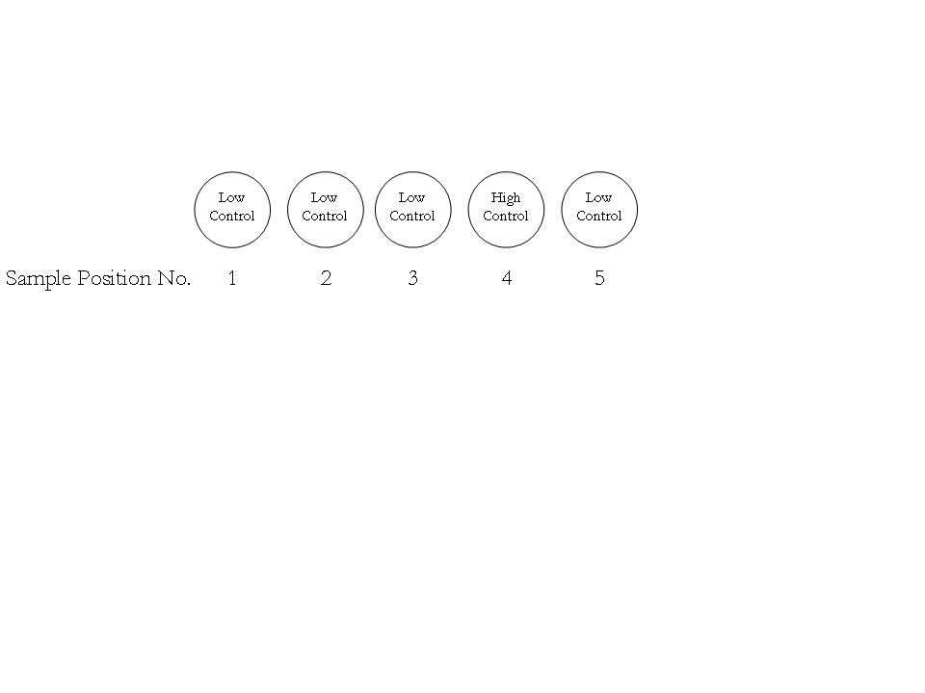

1. After results from the five Sample Positions are obtained, use the Carryover Check Worksheet to record the results.
2. First, obtain the mean of the first three sample positions using the following formula:



1. Calculate the percent carryover (% Carryover) using the following formula:



1. Acceptable results are ± 10% Carryover. % Carryover results greater than ± 10% require troubleshooting.
2. The supervisor, site director, and performing tech should sign off on the Carryover Check Worksheet and results should be filed for easy reference.

**References:**

CAP Chemistry Inspection Checklist, current version.

Quality Control Plan #1508

|  |  |  |
| --- | --- | --- |
|  | Signature Date | |
| **Medical Director Approval** –  ARMC Cancer Center ARMC Main Lab |  |  |
| Medical Director Approval – MedCenter Mebane |  |  |

|  |  |  |  |
| --- | --- | --- | --- |
| **Review Date** | **Signature** | **Mgmt.** | **Director** |
|  |  |  |  |
|  |  |  |  |
|  |  |  |  |
|  |  |  |  |
|  |  |  |  |
|  |  |  |  |
|  |  |  |  |
|  |  |  |  |
|  |  |  |  |
|  |  |  |  |
|  |  |  |  |
|  |  |  |  |
|  |  |  |  |
|  |  |  |  |
|  |  |  |  |
|  |  |  |  |

**SOP HISTORY PAGE**

**CLINICAL LABORATORY ALAMANCE REGIONAL MEDICAL CENTER**

**SOP Number:** CHEM-133-CH

**SOP Title**: Carryover Check for Automated Samplers

**Written By:** Demetria Singletary, Wendy Turner, Derick Lane

**Manual in which Hard Copy of this SOP is located:** Clinical Chemistry General Procedure Manual

**Distribution:** no other locations

**Supersedes Procedure:**

**SOP CHANGE CONTROL**

|  |  |  |  |  |  |
| --- | --- | --- | --- | --- | --- |
|  | **Approvals** | |  | **Action** | **In** |
| **Mgmt.** | **Date** | **Director** | **Date** |  | **Effect** |
|  |  |  |  |  |  |
|  |  |  |  |  |
|  |  |  |  |  |  |
|  |  |  |  |  |
|  |  |  |  |  |  |
|  |  |  |  |  |
|  |  |  |  |  |  |
|  |  |  |  |  |
|  |  |  |  |  |  |
|  |  |  |  |  |
|  |  |  |  |  |  |
| **Date archived: _______________________________** | | | | |  |
| **Reason: ____________________________________ Initials:__________** | | | | |  |
|  |  |  |  |  |  |