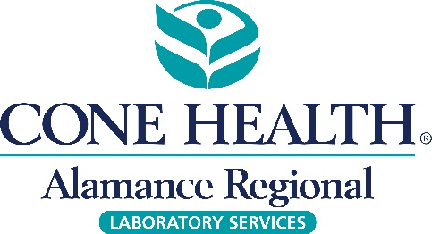

To: Alamance Regional Medical Staff

From: Joshua Kish, MD, FCAP, FASCP

Chief of Pathology, Cone Health

Date: June 19, 2018

Subject: Discontinue FDP testing at Alamance Regional

**Alamance Regional Clinical Laboratory will no longer offer Fibrinogen Degradation Products (FDP) test as of June 26, 2018.**

Activation of the coagulation cascade results in the generation of Fibrin Degradation Products (FDPs). The FDPs are fragments of different molecular weights, which includes D-Dimer.

The current FDP test that will be discontinued is a semi-quantitative assay that uses latex agglutination as a screening aid for disseminated intravascular coagulation. This test is capable of detecting the presence of all major breakdown products of fibrin or fibrinogen.

D-Dimer is presumed to be a better indicator of fibrinolysis than FDPs. The measurement of D-Dimer levels by ELFA (enzyme immunoassay sandwich assay with fluorescent detection) has more advantages than the measurement of plasma FDPs by latex agglutination.

Our current D-Dimer Exclusion is indicated for use in conjunction with a clinical pretest probability assessment model to exclude deep vein thrombosis (DVT) and pulmonary embolism (PE) in outpatients suspected of DVT or PE. It is not safe to use D-Dimer for exclusion of DVT and PE in the inpatient population due to high pre-test probability, long duration of symptoms associated with these disorders, and the high proportion of comorbid conditions associated with elevated D-Dimer levels. The current test also gives a quantitative result for physicians to use in conjunction with various other factors to determine fibrin degradation.