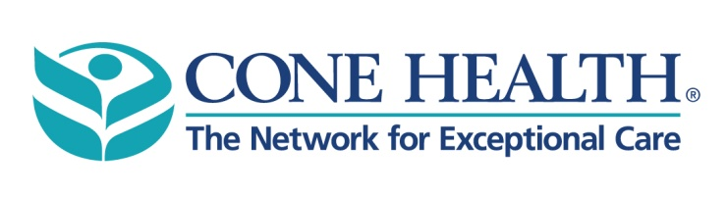

TO: Cone Health Hospital Providers

FROM: Joshua B. Kish, MD, FCAP, FASCP

Chief of Pathology, Cone Health

John Patrick, MD, FCAP

Medical Director, Clinical Pathology, Cone Health

Tara C. Rubinas, MD, FCAP, FASCP, Medical Director, Anatomic and Clinical Pathology Laboratories, Alamance Regional – Cone Health

DATE: October 26th, 2017

SUBJECT: **New Flu PCR Assay and Updated Specimen Requirements**

The Cone Health hospital laboratories will convert to the Cepheid Xpert Xpress Flu PCR assay on October 31st, 2017. This new assay provides early assay termination for positive results and will reduce turnaround times on Flu A and Flu B PCR.

On site testing will be available at Alamance Regional, Annie Penn, Moses Cone, and Wesley Long.

This new assay has only been approved by the FDA for testing on nasopharyngeal swabs. **The laboratories will no longer accept nasal washings for Flu PCR testing.**

For further information, please contact the following:

Dr. Joshua Kish: [jbkish@auroradx.com](mailto:jbkish@auroradx.com) or 336-832-7533

Dr. Tara Rubinas: [tara.rubinas@conehealth.com](mailto:tara.rubinas@conehealth.com) or 336-538-7832

Dr. John Patrick: [jdpatrick@auroradx.com](mailto:jdpatrick@auroradx.com) or 336-832-7531