**TITLE: EPIC/CHL INQUIRY PROCEDURE**

**PRINCIPLE / PURPOSE:** Epic is an electronic medical record system that is used by Cone Health. It can also be a useful tool when investigating patient information such as history, results and diagnosis.

**SCOPE:** This procedure applies to Cone Health Laboratory staff working in the Cone Health Clinical Laboratories accessing patient information from Epic (also known as Cone HealthLink or CHL).

**PROCEDURE:**

1. Find the Patient Chart within Epic/Cone Health Link (CHL)
2. At the top of the screen, select Patient Station.

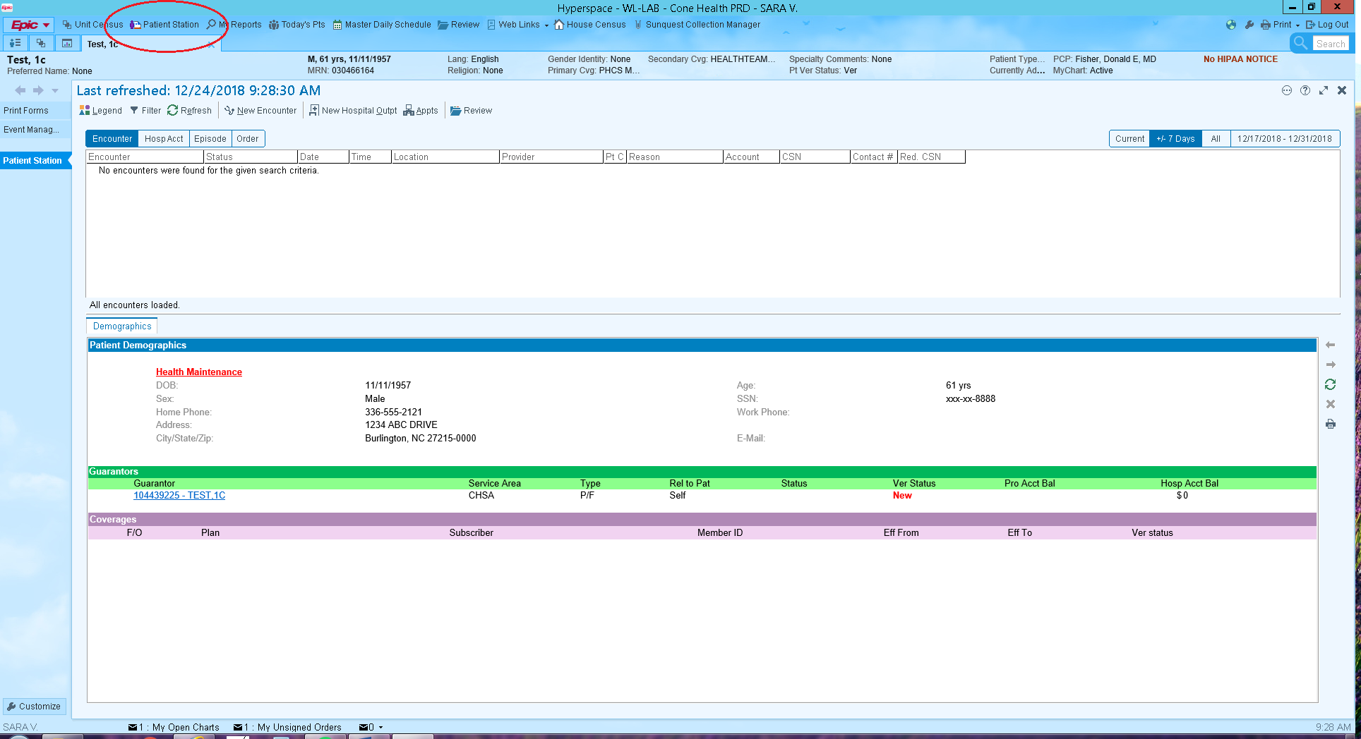

1. Enter the patient’s 9 digit MRN (use leading zeros as necessary), or name and birthdate. Click Find Patient.
2. Select Chart Review button (folder icon).

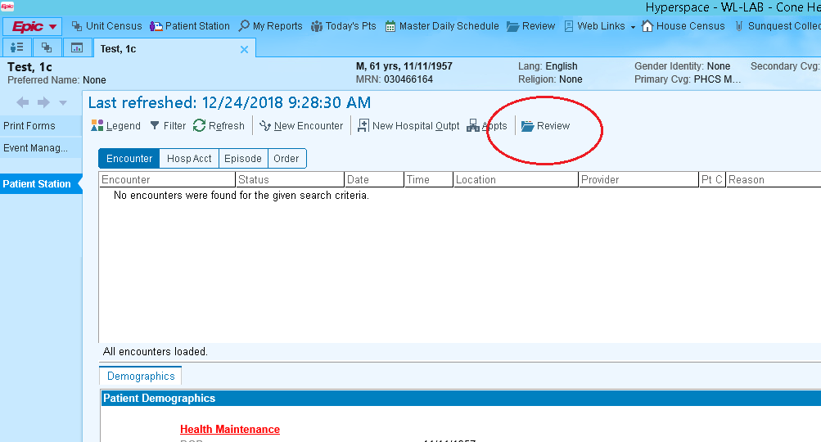

1. Search for information
2. Look up **patient history**:

* Clicking on the Chart Review button will bring you to the Encounters tab. This tab lets you see recent visits at different specialties and the description and diagnosis of each encounter.
* Click on event to see more information (optional)

1. Look for previous **LABs orders/results:** Most of the Pathology and Cytology orders/results are not visible in Sunquest, but are visible in Epic.

* Select the Labs tab.

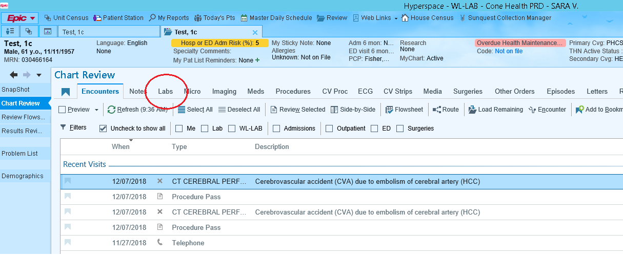

* Select the Path/Cyto check box if you would like to filter to just pathology and cytology orders (optional).
* Click on order to view results (optional).
* If results or orders were scanned in, they can be found under the Media tab.

1. Find medication under **MEDs:**

* Select the Meds tab.

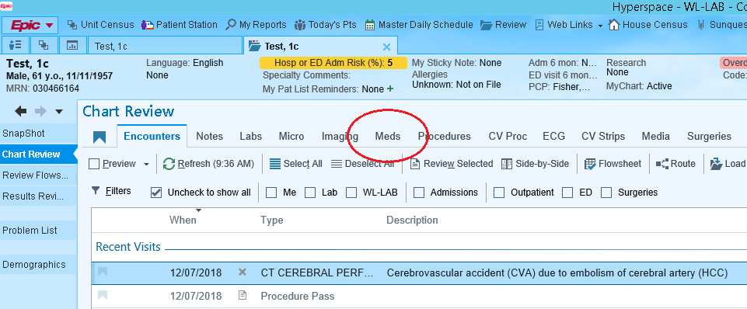

* Current meds will be listed.

1. Look up to see if patient is on dialysis/see other **Procedures:**

* Select the Procedures tab.

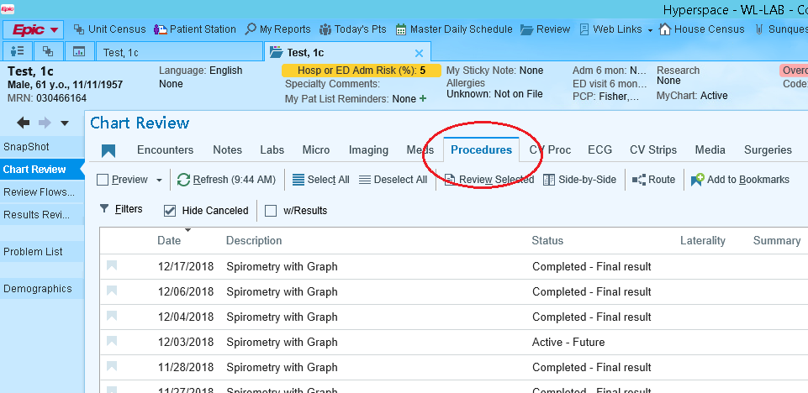

* Click on each procedure to see more information.

1. The **NOTES** tab is also useful for searching additional information
   * Assessment and procedure notes
   * Provider and nurse documentation
   * Notes from other facilities
2. The **Media** tab holds scanned documents (results, orders, etc.)
3. Staff with access may also view records from outside facilities that use Epic Charting System by viewing **Care Everywhere**

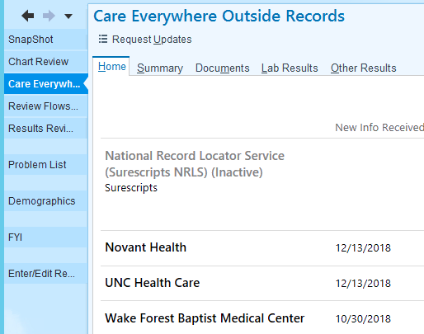

**REFERENCES:** N/A

|  |  |  |
| --- | --- | --- |
|  | **Signature Date** | |
| **Medical Director Approval –**  ARMC Main Lab |  |  |
| **Medical Director Approval –**  ARMC, WL, HP  Cancer Center |  |  |
| **Medical Director Approval –**  MedCenter Mebane |  |  |

|  |  |  |  |
| --- | --- | --- | --- |
| **Review Date** | **Signature** | **Mgmt.** | **Director** |
|  |  |  |  |
|  |  |  |  |
|  |  |  |  |
|  |  |  |  |
|  |  |  |  |
|  |  |  |  |
|  |  |  |  |
|  |  |  |  |
|  |  |  |  |
|  |  |  |  |
|  |  |  |  |
|  |  |  |  |
|  |  |  |  |
|  |  |  |  |
|  |  |  |  |
|  |  |  |  |
|  |  |  |  |

**HISTORY PAGE**

**SOP Number:**  IT-705

**SOP Title**: Epic/CHL Inquiry Procedure

**Written By:** Sarah VanHoorne, effective date 1/29/2019

**Manual in which Hard Copy of this SOP is located:** IT/LIS Manual

**Distribution:** All Cone Health Labs (including Mebane, ARMC, AR/HP/WL CCtr)

**Supersedes Procedure:**

**SOP CHANGE CONTROL**

|  |  |  |  |  |  |
| --- | --- | --- | --- | --- | --- |
|  | **Approvals** | |  | **Action** | **In** |
| **Mgmt.** | **Date** | **Director** | **Date** |  | **Effect** |
|  |  |  |  |  |  |
|  |  |  |  |  |  |
|  |  |  |  |  |  |
|  |  |  |  |  |  |
|  |  |  |  |  |  |
|  |  |  |  |  |  |
|  |  |  |  |  |  |
|  |  |  |  |  |  |
|  |  |  |  |  |  |
|  |  |  |  |  |  |
|  |  |  |  |  |  |
| **Date archived: _______________________________** | | | | |  |
| **Reason: ____________________________________ Initials:__________** | | | | |  |
|  |  |  |  |  |  |