MESOTHELIAL VS. MONOCYTES/MACROPHAGES

Coming soon…. Body fluid differential separation of mesothelial cells from monocytes/macrophages.
The following cell types are enumerated in a body fluid differential: neutrophils, lymphocytes, eosinophils, basophils and monocyte/macrophage. Mesothelial cells should be counted and now included as “other”. In the even there are additional “other” cells types present, please note for the provider what is seen (another cell type or unknown cell type present).
Should be entered in the OTHER field as “ ;# mesothelial “

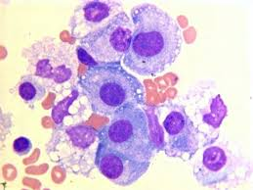 MESOTHELIAL CELLS
MACROPHAGE
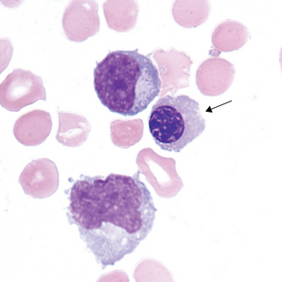

LYMPHOCYTE

MONOCYTE

