Morphological Classification of Variant Lymphocytes

**NORMAL LYMPHOCYTE** 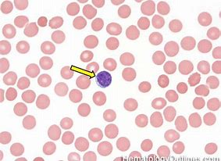

**Round to ovoid shape**

**High N:C ratio**

**Chromatin is diffusely dense or coarse with clumping; scant cytoplasm**

**Round-oval nuclei with or without indentation**

**Nucleoli, if present, are small and inconspicuous**

**LARGE GRANULAR LYMPHOCYTE** 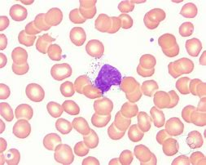

**They are NOT reactive, atypical, or variant**

**Dense chromatin and pale blue, transparent cytoplasm**

**Distinct large reddish purple azurophilic granules**

**Normal range: Up to 15% of circulating lymphs (<600/uL); Should comment if appear increased.**

**Reactive Lymphocytes**

An atypical lymphocyte is non- malignant condition of the lymphocyte that is characterized by large abnormal structure of the lymphocytes.

**ATYPICAL (“REACTIVE”) LYMPHOCYTES**

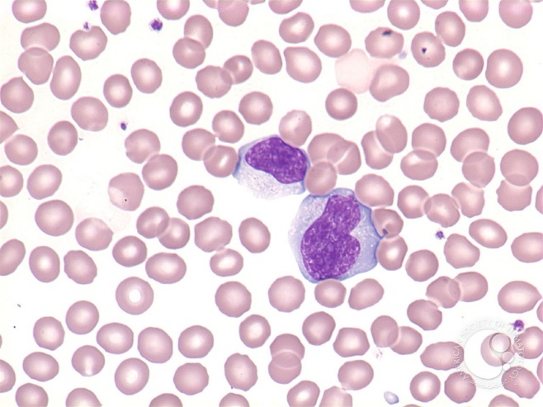

**Heterogeneous population**

**Variable N:C ratio**

**Abundant cytoplasm; variable deep basophilia and may contain vacuoles**

**Cytoplasm may be indented by adjacent red cells, dark periphery**

**Variable nuclear shapes: notched, indented, cleaved, folded or lobulated**

**Nucleoli often present**

|  |  |  |
| --- | --- | --- |
| Feature | Normal Lymphocyte | Reactive Lymphocyte |
| Size | 7-15μm | 10-25μm |
| N:C Ratio | 5:1-2:1 | 3:1-1:2 |
| Cell Shape | Round to oval; uniform in size | Round, oval, or irregular; exhibit wide range of morphologies |
| Nuclear Shape | Round to oval; may have small indentation or notch | Variable |
| Chromatin | Dense, clumped | Variably condensed |
| Nucleoli | Normally not present | None to multiple |
| Cytoplasm | Scant to moderate; pale to moderately basophilic with no vacuoles  **\*\*** Large granular lymphs have moderately abundant cytoplasm with scattered azurophilic granules | Moderate to abundant; pale to deeply basophilic with occasional vacuoles |

**Variant Lymphocytes**

**Homogeneous population**

**High N:C ratio**

**Variably clumped chromatin**

**Morphology consistent with type of neoplasm**

**•Frayed cytoplasm**

**•Single prominent nucleolus**

**•Cerebriform nuclei**

**•Irregular nuclear contours; bizarre shapes; clefted**

|  |  |
| --- | --- |
| Feature | Lymphoma Cell |
| Size | 8-30μm |
| N:C Ratio | 7:1-3:1 |
| Cell Shape | Round or oval; can be irregular |
| Nuclear Shape | Round, oval or angulated, dependent on type of lymphoma; usually clefted, folded, convoluted or lobulated |
| Chromatin | Condensed to dispersed, dependent on type of lymphoma; ranges from compact and clumped to fine and open |
| Nucleoli | Absent to present; may be very prominent |
| Cytoplasm | Variable; ranging from scant and pale blue to moderate and deeply basophilic; vacuoles may be present; usually agranular |

**ABNORMAL/VARIANT LYMPHOCYTES**

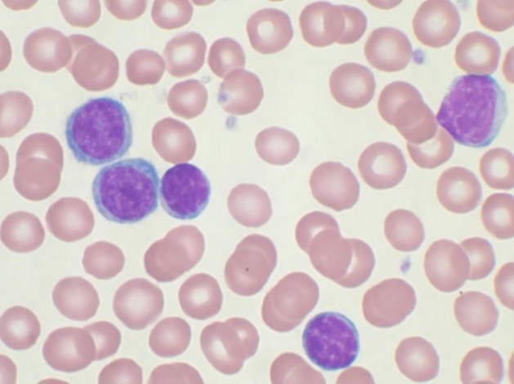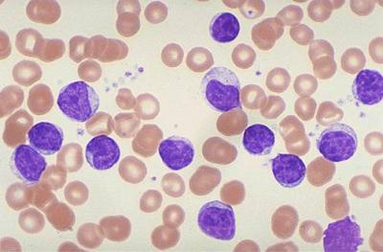

**ACUTE LYMPHOCYTIC LEUKEMIA CHRONIC LYMPHOCYTIC LEUKEMIA**

The neoplastic cells are generally small with round to oval nuclei, compact and coarse chromatin that may have a “crack appearance, and scant basophilic cytoplasm. Slightly larger than normal lymphocyte with a possible small nuclear indentation and no nucleoli.

******HAIRY CELL LEUKEMIA**

Blood usually shows pancytopenia, marked monocytopenia, with a few circulating hairy cells. Hairy cells are 1.5-2 times the size of regular lymphocytes with round, oval, bean shaped or indented nuclei and subtle or absent nucleoli. They contain moderate pale blue cytoplasm that exhibit numerous hair-like projections that extend around the circumference of the cell.

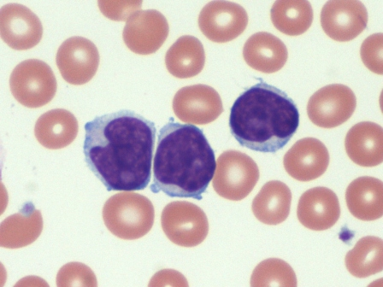

**MANTLE CELL LYMPHOMA**

The circulating lymphocytes are slightly to moderately enlarged with round to irregular nuclei, occasionally indented or folded. The chromatin is often moderately clumped; although some may have a more dispersed chromatin and almost “blast-like”.

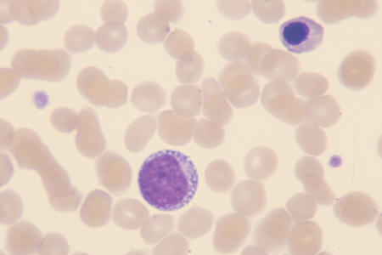

**BURKITT LYMPHOMA**

Cells are medium to large and often uniform in size and shape. Nuclei are round to oval with a smooth contour, moderately coarse chromatin, and one or more nucleoli. The cytoplasm is moderately abundant and characteristically dark blue with frequent round vacuoles. Found in pediatric patients or patients with HIV.

**T-CELL LEUKEMIA/LYMPHOMA**

The lymphocytes are usually medium to large; commonly referred to as “flower cells” due to pleomorphic nuclei with many lobules. The chromatin is coarsely clumped, and visible nucleoli are common. The cytoplasm is typically deeply basophilic.

**SEZARY SYNDROME**

Sezary cells are round, oval or irregular in shape. They are slightly larger than regular lymphocytes with a N:C ratio that varies from 7:1 to 3:1. Their characteristic folded, grooved, or convoluted nuclear membranes give a cerebriform appearance. Their pale, blue to gray cytoplasm is scant and may contain few vacuoles.

**Lymphocytes in Body Fluids**

Like peripheral blood, lymphocytes in fluids come in all sizes; however, a larger lymphocyte is not necessarily an abnormal or atypical lymphocyte.

In the image below, there is an atypical lymphocyte (blue arrow) adjacent to the monocyte at the top of the smear. The atypical lymphocyte is almost as big as the monocyte; however, the nucleus s more regular. The amount of cytoplasm is similar between the cells, but the atypical lymphocyte has a deep blue shade along the edge. Though there are nucleoli present in this atypical lymphocyte, it *does not necessarily mean that this is a malignant cell*. Cytocentrifugation can expose nucleoli in cells that may not appear in the cells on a peripheral blood smear. The balanced amount of cytoplasm compared to the nucleus and the size of the cell are consistent with the range of variation found with atypical lymphocytes. Also, in this smear, there is an atypical (plasmacytoid) lymph in the lower left of the cluster (green arrow) and a basophil in the lower right (orange arrow).