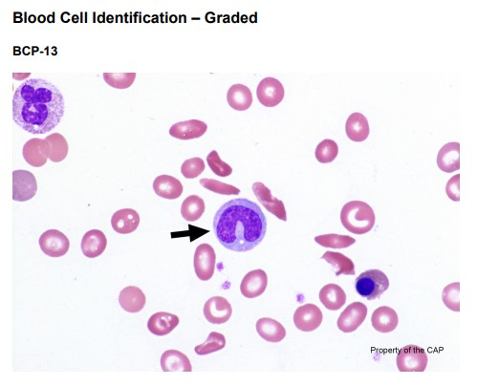

The arrowed cell is a monocyte, as correctly identified by 74% of referees and 75% of participants. Monocytes are slightly larger than neutrophils, ranging from 12 to 20 μm in diameter. Most monocytes are round with smooth edges, but some may have pseudopod-like cytoplasmic extensions. The cytoplasm is abundant, with a gray or gray-blue ground-glass appearance, and may contain vacuoles or fine, evenly distributed azurophilic granules. The N:C ratio ranges from 4:1 to 2:1. The nucleus is usually indented, often resembling a three-pointed hat, but it can also be folded or band-like. The chromatin is condensed but is usually less dense than that of a neutrophil or lymphocyte. Nucleoli are generally absent, but occasional monocytes may contain a small, inconspicuous nucleolus.

Approximately 22.7% of referees and 21.3% of participants identified the arrowed cell as a neutrophil, segmented/band. Segmented neutrophils and their immediate precursors, bands, constitute 12% to 25% of the nucleated cells in the bone marrow. Band neutrophils, also known as stabs, constitute 5% to 10% of the nucleated cells in the blood under normal conditions. The band is round-to-oval and 10 to 18 μm in diameter. The N:C ratio is 1:1.5 to 1:2 and the nuclear chromatin is condensed. The nucleus is indented to more than half the distance to the farthest nuclear margin, but the chromatin is not condensed to a single filament (as is the defining feature of the fully mature neutrophil). The arrowed cell lacks the typical cytoplasmic appearance of neutrophils as its cytoplasm is not pale pink and specific granules are absent. Moreover, the chromatin pattern is finer than a typical neutrophil. Compare the arrowed cell in BCP-13 to the white blood cell in the upper left corner. The white blood cell has coarser chromatin, pink cytoplasm, and specific granules. These features distinguish the arrowed monocyte in BCP-13 from neutrophils. Therefore, the choice of neutrophil, segmented/band is incorrect.