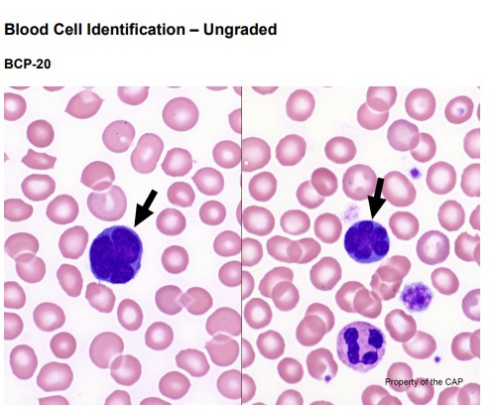

The arrowed cells are malignant lymphoid cells, as correctly identified by 80.5% of referees and 77.7% of participants. Lymphoma cells exhibit a variety of appearances depending on the lymphoma subtype, and definitive diagnosis can be difficult. Regarding the present case, however, these cells have such a characteristic morphology as to raise high suspicion for adult T-cell leukemia/lymphoma (ATLL). These so-called “flower cells” feature deeply convoluted nuclear contours which mimic flower petals or a clover-leaf pattern. The chromatin in these cells is coarsely clumped, with variably visible nucleoli. Some cells may display finely textured, blast-like chromatin. The cytoplasm is typically scant and basophilic. Supplemental studies, such as immunophenotyping, are necessary to arrive at a diagnosis.

Although these “flower-like cells” are technically lymphocytes (as classified by 1.1% of referees and 2.4% of participants), the best response is “malignant lymphoid cells.” In reviewing the clinical vignette that was provided, this patient of Japanese ancestry has a history of mature T-cell leukemia/lymphoma. In the context of these abnormal cells, this clinical history provided should raise one’s suspicion for a particular lymphoma (see the Continuing Education material for further discussion). The designation of “lymphocyte” or “lymphocyte, reactive (includes plasmacytoid and immunoblastic forms)” [erroneously identified by 6.0% of referees and 6.8% of participants presumes that such cells are non-neoplastic. The key distinguishing feature of reactive lymphocytes is their wide range of cellular sizes and shapes, as well as nuclear sizes, shapes, and chromatin patterns. This feature is a reflection of lymphocytes reacting to an immune stimulus and are frequently increased in viral illnesses. In contrast, while lymphoma cells can exhibit a wide range of morphologic appearances, any individual case tends to show a more monotonous population of abnormal cells. In this photomicrograph, although the 2 lymphoma cells vary in size (the one on the left is larger than the one on the right), the Committee contends that the two cells are actually strikingly similar in their flower-like nuclear contours, coarsely clumped chromatin, and scant basophilic cytoplasm. Another important distinction between a reactive lymphocyte versus lymphoma cell is the difference in their N:C ratios. The N:C ratio tends to be low in reactive lymphocytes, while it is high in lymphoma cells.