What is Changing? | Examples of Changes | SQ Parameter Changes | Changes need?
Icon Change |  |  | Visual change only, no SOP update needed.
New application | 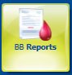 | - Blood Utilization Report  - Finalized/Issue Units Summery(BBR16)  - Quality Assurance Report (BBR7) | SOPs need to be created and/or updated.
Blood Inventory Search |  | - Displays actual expiration date/time of unit expiration. | Visual change only, no SOP update needed.
Transfusion History Display Change | Transfusion History accessed through Blood Bank Inquiry | The following fields have been added.  - Issue time,  - Status Includes both Issue and Issue Final  - Ability to sort by clicking on column headers | Visual change only, no SOP update needed.
Antibody Panel reflex test |  | - ABI will reflex when AS screen is positive on the same order. | SOPs need to be created and/or updated.
Electronic Crossmatch Eligibility field. |  | - Will only update after saving  - Click on the N to review message why unit is not eligible | Visual change only, no SOP update needed.
New QA warning for Plts | 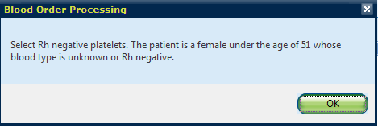 | - For Rh neg females ≤ 50 years old when allocating plts a QA warning will pop up to remind staff to set-up Rh neg plts.  - This is only a warning and will not prevent staff from allocating Rh pos platelets to those patients. | SOPs need to be created and/or updated.
Unable to BPE units with same Unit number but different blood types. |  | - Only for those with a security level of less than 77 | Only assigned individuals will have access.
New QA failures which will not block electronic crossmatch |  | - Selected unit's Rh does not match specimen's Rh  - Specimen testing Rh does not match linked patient's permanent Rh  - Linked patient/unit attribute incompatibility | Train staff of the change.
After saving in Blood Order Processing the action box is visually different. | 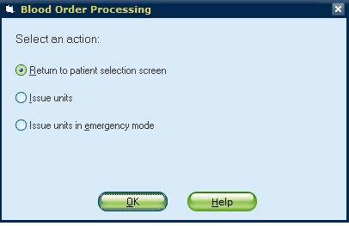 |  | Visual change only, no SOP update needed.
Unit allowed to be allocated to multiple orders | 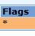  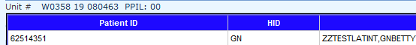 | - At issue a flags box will have an *  - A box with the second patient information will show in the lower half of the screen | Visual change only, no SOP update needed.
Prompt for add on billing after issue |  | - The Add Billing window will no longer come up at Issue. | Visual change only, no SOP update needed.
ABO discrepancy between unit’s label ABO type and unit’s type confirmation testing. | 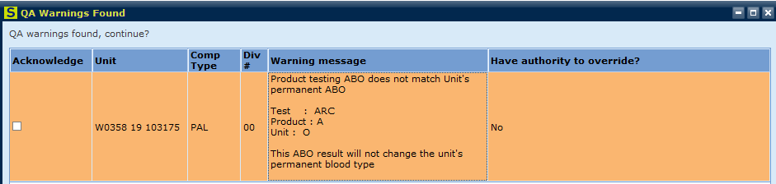  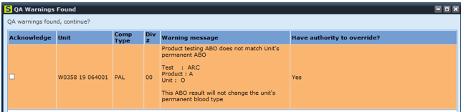 | - Only those who have a security level of 66 or higher can override.  - This should not be overridden, instead stop and investigate why there is an ABO discrepancy during unit typing. | This is not a new process but a reminder since it could lead to an incompatible unit being administered to a patient.

Bug fix from v8.0 –Unit tag will not be generated automatically when adding tests to Specimen Test field in BOP |  | - No longer require billing/credit charges to be added to Add Specimen Test in BOP to avoid print of duplicate compatibility tags. | Resume adding antigen charges and special unit charge corrections, as needed to each unit usingAdd unit Test field
Visual Inspection field in Blood Product Entry is a required field |  | - Visual Inspection field in BPE is highlighted yellow, requiring an entry | Answer field with Pass or Fail
Temperature field in Blood Status Update is a required field |  | - Temperature field in BSU is highlighted yellow, requiring an entry | Answer field with neumonic established in return SOP or Pass/Fail for units beingreturned to supplier

