**INVESTIGATIONAL COVID 19 CONVALESCENT PLASMA**

**Overview:**

* COVID-19 Convalescent Plasma is being made available through a collaboration between the U.S. Food and Drug Administration and the Mayo Clinic through an accelerated Extended Access Program (EAP) to the **Mayo Clinic Clinical Trial**.
* People who've recovered from COVID-19 have antibodies to the virus in their blood. Doctors call this convalescent plasma. Researchers hope that convalescent plasma can be given to people with severe COVID-19 to boost their ability to fight the virus.
* Donors of COVID-19 Convalescent Plasma have previously tested positive for COVID-19 or have antibodies to COVID-19, and have been symptom-free for at least 14 days.

**COVID 19 Convalescent Plasma Administration:**

* Administration of COVID 19 Convalescent Plasma should follow the same current workflow used for Blood Product administration and documentation.
* **Exception:** COVID 19 Convalescent Plasma is infused over 2 hours

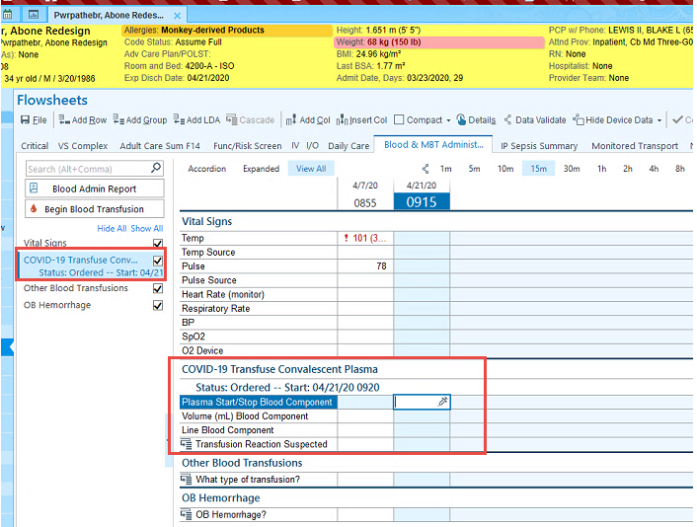

* The labels below display the Investigational COVID-19 Convalescent Plasma Identification:

