Immunology, Flow and Molecular Meeting
Nov 28, 2012
1:00 PM
Immunology Lab

- Announcements:
  - Lab Coats – check lab coats on the 3rd floor.

- Open Forums with Rick D’Aquila
  - Open Forum w/ Rick
    - November 30 9:00 am Park St. Auditorium
    - December 3 6:00 pm Park St. Auditorium
    - December 6 3:00 pm Cronin Auditorium (SRC)
    - December 11 9:30 am Cronin Auditorium (SRC)
    - December 17 7:00 am Park St. Auditorium

- Benefits
  - 2013 PTO Cash-In Program
    - The PTO Cash-In Election period begins on Monday, November 19 and runs through Friday, December 14.
    - PTO Elections made through ESS
  - HR to send confirmation letter week of Nov 26, 2012
    - Will be opened for changes next week - www.ynhhsbenefits.com/

- EPIC training
  - ELearning classes are prerequisites before the in person training.
    - Laboratory 100:
      - AMB001: Office Visit Demonstration
      - AMB006: Placing Orders
      - INP000: Overview Of Hyperspace
      - INP135: Managing Orders
    - Laboratory 200:
      - AMB001: Office Visit Demonstration
      - AMB006: Placing Orders
      - INP000: Overview Of Hyperspace
      - INP135: Managing Orders
    - Instructions on how to access the files:
      - Open Internet Explorer
      - Type in “intranet”
      - Click Applications
      - Select EPIC Training: Skillport Registration
      - Login w/ your Network ID and password is epictrain
      - Click catalog
      - Select E-learning folder
      - Find the appropriate class (see above)
      - Highlight the class and select “LAUNCH”
- Fleece Order
  - Charcoal or Navy – due by 12/7
  - $20.74- $26.59 ($0.50 increase if min order of 36 is not met)
  - Yale New Haven Logo and “Laboratory Medicine” embroidery.
  - Cash or write check to Teodorico Lee.
    - Questions people are asking: color of embroidery? Finding out answer.
    - Sizes? – asking to see if we can get samples.

- MT Students
  - 4 UCONN students will begin on Jan 7th
    - UCONN students will have 3 weeks in BB, 4 weeks in Heme (includes 2 days in flow cytometry), Chem, and Micro, 1 week in Immunology, 2 days in Virology, and 2 days in Molecular
  - 4 UVM students will begin on the 14th.
    - UVM students will have 3 weeks in Chem, Heme, BB, and Micro, and the other 2 weeks splt between Virology, Molecular, POCT, Blood Gas, and Tumor Profile Lab.

  - The 3rd of May will be the final day for both groups

- SRC Send out Project
  - Tumor Markers – CA125, CA153, CA199, CA27.29, CEA
  - Full listing being reviewed for Immunology
    - Cat 1 – easily entered values (i.e. numerical values, pos/neg).
    - Cat 2 – interpretation (molecular tests, IFEs)

- Holiday Information
  - Adopt a family for the Holidays – see attachment.
    - Berni will spearhead this drive in our Dept. Please consult with her for any questions.
  - Departmental Party
    - Harkness – Dec. 17th
    - Staff only
    - Nov 20, 2012 – volunteers needed to organize party
  - Holiday Party
    - Where: Anthony’s Ocean View
    - When: Wed. Dec. 19th, 2012 Time: 6:00pm-10:00pm
    - Price: $50
    - Space Is limited (60)
    - Make checks payable to Jessica Williams or Jennifer Trick in Chemistry
    - Sign up by Dec 6th

- Ergonomic Evaluation for the labs
  - Evaluate use of new pipettes
  - Increase utilization of instruments like the Assist and Tosoh 900 to limit manual dilution and pipetting

- Laboratory Manual
  - Open Internet Explorer – type CWS – Click L – Click Laboratory Manual
    - Use Control F – to search for tests
  - Initiative to create a section for MISC tests – this will be tests that are currently pending Soft build (code has not yet been assigned) but is currently being sent out.

- Quality Event Forms
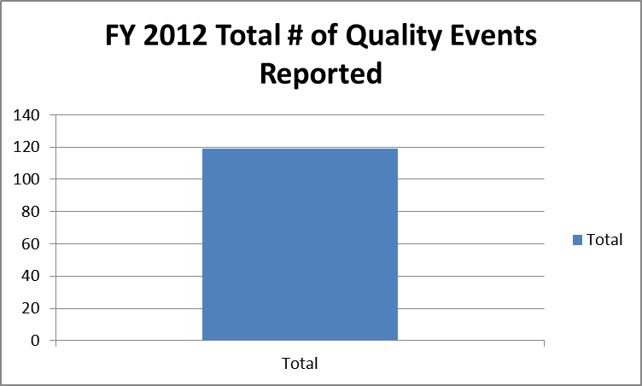

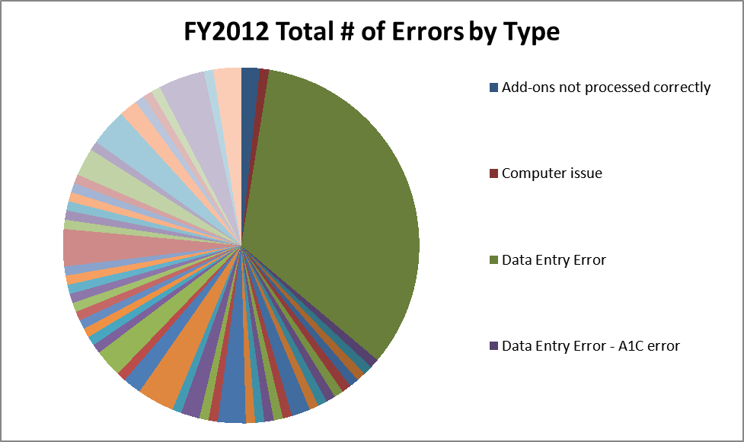

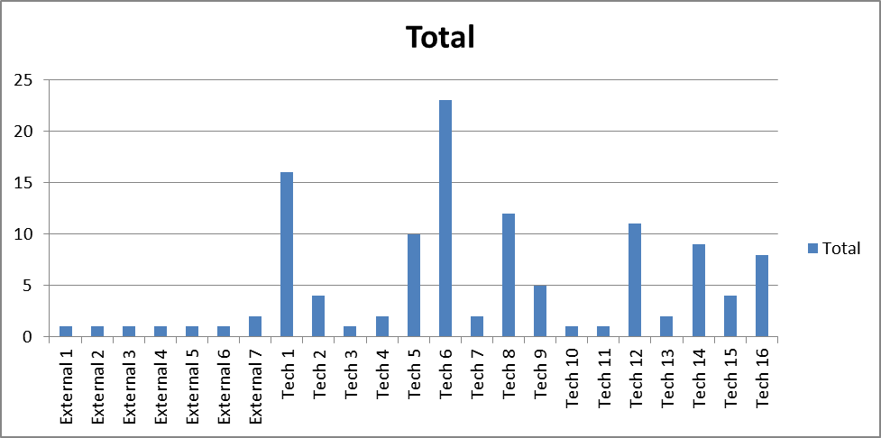

Questions:
1. Are gently used items ok to donate for Adopt a family program? JR to follow up
2. Installation of coat hooks? JR to follow up.

Attachments:

