Immunology, Flow and Molecular Meeting
Dec 12, 2012
1:00 PM
Immunology Lab

- Announcements:
  - Be Kind to Your Co-Workers
  - Rose transfer to Immunology Jan 3, 2013
  - PIP -2.23% (Checks to be distributed tomorrow – Dec 13, 2012)
  - Retirement Party – Priscilla Washington (see attachment for flyer)
    - Dec 20, 2012, 1-3 PM PS230.
    - Tammy, Meeok or Connie if you wish to contribute towards a gift
  - Scheduled air-conditioning Shut Down for Park Street
    - Thursday (12/13) from 6:30 am - 7 am
    - FOR 3RD FLOOR ONLY: HOT WATER WILL BE SHUT OFF FROM 6 AM TO 9 AM ON THURSDAY 12/13.
    - All hoods and walk-in refrigerators and freezers will NOT be affected by either shutdown.
  - Day off or Schedule changes – NO TEXT MESSAGES. CALL Manager – 688-

- Open Forums with Rick D’Aquila – December 17 7:00 am Park St. Auditorium

- “Fresh Inspirations” food court/cafeteria Ribbon Cutting with Reception - Dec 17th @ 2:30 PM

- Fleece Order - 23 Total Ordered.

- MT Students
  - 4 UCONN students will begin on Jan 7th
  - 4 UVM students will begin on the 14th.
  - The 3rd of May will be the final day for both groups

- EPIC training
  - ELearning classes are prerequisites before the in person training.
    - Laboratory 100 & 200:
      - AMB001: Office Visit Demonstration
      - AMB006: Placing Orders
      - INP000: Overview Of Hyperspace
      - INP135: Managing Orders
    - Instructions on how to access the files:
      - Open Internet Explorer
      - Type in “intranet”
      - Click Applications
      - Select EPIC Training: Skillport Registration
      - Login w/ your Network ID and password is epictrain
      - Click catalog
      - Select E-learning folder
      - Find the appropriate class (see above)
      - Highlight the class and select “LAUNCH”

Total Registration for Epic Training Classes Nov. 4th through Dec. 1st
Total Attended | 90% | 7713
Total No Shows | 10% | 856
Grand Total | 100% | 8569
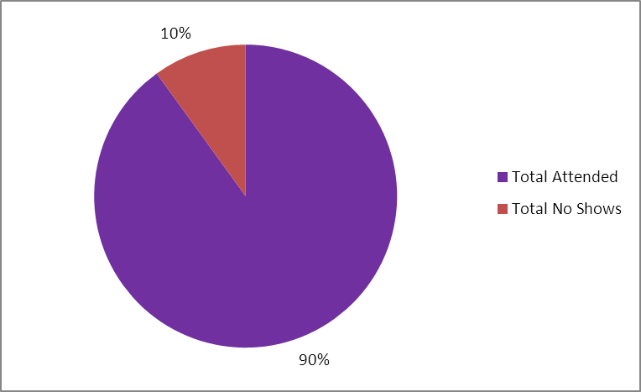

- SRC Send out Project – SRC is now accessioning their own samples
  - Tumor Markers – CA125, CA153, CA199, CA27.29, CEA
  - Flow Cytometry – thyroids (+/- 10 per month)
  - A1C is with YSC until further notice
  - Full listing being reviewed for Immunology – will be scheduling a meeting w/ SRC managers to come up w/ a plan and schedule.
    - Cat 1 – easily entered values (i.e. numerical values, pos/neg).
    - Cat 2 – interpretation (molecular tests, IFEs)

- Holiday Information
  - Adopt a family for the Holidays – collected close to $200 in cash donations, $100 in gift cards, and numerous gift items.
  - Departmental Party – see attachment
    - Dec 17th – Monday – 3:30 – 6:30 PM.
    - Volunteers needed to clean up, setup, and Immunology has been ask to provide music.
    - RSVP by Dec 7th – call 688-2450 and sign up on the list for dessert
    - $1 donation to be entered into drawing. Proceeds to go to Adopt a family.
    - Optional – Bring an unwrapped toy for the toy closet
  - Dec 20th – Immunology – 9:30 AM
  - Old Fashioned Holiday Party
    - Jan 5th @ 5 pm – Penny’s House
    - RSVP with Penny.smith@ynhh.org
  - YNHH’s Holiday Reception (see attachment)
    - December 19th – Wednesday – East Pavillion Cafeteria:
      - 2-4 PM
      - 10:30 PM – 12:30 AM
    - Other hospital celebrations
      - Tree Lighting Ceremony
      - Hanukkah – Menorah Lighting
  - Holiday Party
    - Where: Anthony’s Ocean View
    - When: Wed. Dec. 19th, 2012 Time: 6:00pm-10:00pm
    - Price: $50
    - Space Is limited (60)
    - Make checks payable to Jessica Williams or Jennifer Trick in Chemistry
    - Sign up by Dec 6th

- Ergonomic Evaluation for the labs
  - See Virgilio for demonstration or trial of new automated Eppendorf pipettes.

- Laboratory Manual
  - Open Internet Explorer – type CWS – Click L – Click Laboratory Manual
    - Use Control F – to search for tests
  - Initiative to create a section for MISC tests – underway!

- New Tests & Instrumentation
  - Novaview & BioFlash
    - Redoing ACA & B2GPS Algorithm
    - Automated ANA
    - TTG IgG to be brought in-house
  - IL28B – Tentative Go-Live is Jan 7, 2013

- Capital 2013: $12k out of the $250k.

Questions from previous minutes:
1. Are gently used items ok to donate for Adopt a family program? No.
2. Installation of coat hooks? JR to follow up – no updates.

Attachments:

