Immunology, Flow and Molecular Meeting
Jan 9, 2013
1:00 PM
Immunology Lab

- Announcements:
  - Evening Coordinator for Specimen Processing Area
  - PGM Sequencing for Molecular Diagnostics
  - 5-10 minute future presentations – topic suggestions welcomed
  - Per Diem position for MT
  - Temperature – check & fill out action log. Notify supervisor.

- Immunology Lab Meetings
  - 1 pm @ PS230 & 3 pm @ PS408
  - See Schedule
- Kronos
  - Password is “i”
  - Red – payperiod
  - Blue – Holidays
  - Initials required in Kronos

- Adopt a Family Update – see attachment

- Additional Medicare & FICA Tax Withholding
  - Additional Medicare tax withholding of 0.9% for wages in excess of $200kor Married Filing separately @ $125k.
  - Middle Class Tax Relief and Job Creation Act of 2012 expired. All employees FICA tax goes from 4.2% to 6.2%

- New Instrumentation
  - BioFlash
  - Novaview
  - Quantalink interface

- New Tests and protocols in the Horizon
  - Tosoh 900 implementation
  - TPPA
  - Adamst13
  - IL28B
  - The new CD34 assay
  - New Stainer
  - TTG IgG implementation
  - Reformatting algorithms for ACA Screen and B2 Glycoproteins Screen
  - RPR
  - SPEP
  - New Autoblotter and Scanning equipment for the Lyme Western Blot
  - New Lyme Western Blot Kit validation

- EPIC training
  - ELearning classes are prerequisites before the in person training.
    - Laboratory 100 & 200:
      - AMB001: Office Visit Demonstration
      - AMB006: Placing Orders
      - INP000: Overview Of Hyperspace
      - INP135: Managing Orders
    - Instructions on how to access the files:
      - Open Internet Explorer
      - Type in “intranet”
      - Click Applications
      - Select EPIC Training: Skillport Registration
      - Login w/ your Network ID and password is epictrain
      - Click catalog
      - Select E-learning folder
      - Find the appropriate class (see above)
      - Highlight the class and select “LAUNCH”

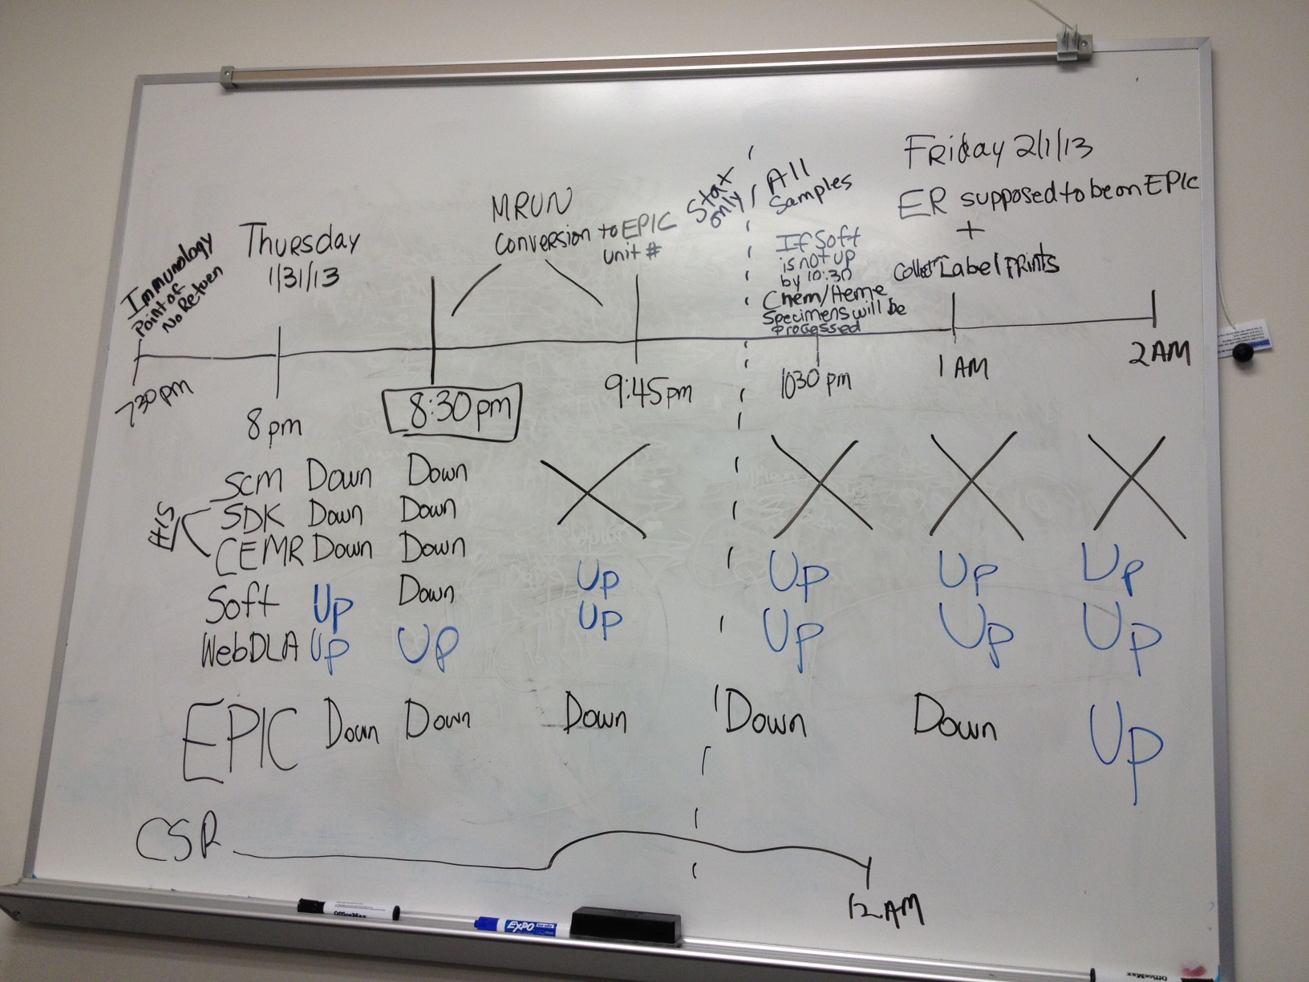

- SRC Send out Project – SRC is now accessioning their own samples
  - Tumor Markers – CA125, CA153, CA199, CA27.29, CEA
  - Flow Cytometry – thyroids (+/- 10 per month)
  - A1C is with YSC until further notice
  - Lyme consolidation – received shipment may have ELISA supply till Mar/Apr
  - Lyme WB can be switched
  - RPR – 4500/year using the BD kit
  - Flow Cytometry – received 1 Lymph node sample
  - List of Top 10 Test by Revenue:
 |  | October 2012 |  |  | November 2011 to October 2012
Test Number | LIS Name | Volume | Average | Revenue | Volume | Average | Revenue | Category
 | Grand Totals: |  |  |  | 5,947 |  | $135,845.09
0050618 | Bence Jones Protein, Quantitative, Urine | 17 | $72.24 | $1,228.08 | 200 | $71.51 | $14,301.60 | 2
0055167 | Kappa-Lambda Quant FLC with Ratio | 15 | $89.60 | $1,344.00 | 96 | $80.15 | $7,694.40 | 1
0051729 | Quantiferon-TB Gold in Tube | 0 | $0.00 | $0.00 | 156 | $48.25 | $7,527.00 | 2
0060068 | Aspergillus Galactomannan Antigen | 9 | $89.60 | $806.40 | 67 | $79.90 | $5,353.60 | 1
0099359 | Helicobacter pylori Antibody, IgG | 24 | $12.80 | $307.20 | 473 | $11.28 | $5,336.00 | 1
2001933 | Cystic Fibrosis (CFTR) 32 Mutations | 2 | $132.30 | $264.60 | 41 | $119.65 | $4,905.60 | 2
0097720 | Factor V Leiden (F5) R506Q Mutation | 6 | $77.18 | $463.08 | 65 | $68.12 | $4,427.88 | 1
0081135 | Oligoclonal Bands in CSF and Serum | 6 | $62.72 | $376.32 | 76 | $55.50 | $4,217.92 | 2
2002569 | B2glycoprotein 1 Abs, IgG, IgM, IgA | 9 | $49.49 | $445.38 | 75 | $53.99 | $4,048.98 | 1
0050272 | Immunofix Electrophoresis Gel | 21 | $21.44 | $450.24 | 212 | $19.03 | $4,033.40 | 2
0050640 | Protein Electrophoresis, Serum | 26 | $11.00 | $286.00 | 351 | $11.04 | $3,875.40 | 2

- Ergonomic Evaluation for the labs
  - New automated Eppendorf pipettes are being deployed – IFE bench

- Vacation Selection - February

Questions from previous minutes:
1. Installation of coat hooks? Waiting from Rodney Robinson for any updates

Attachments:

