I. Purpose:
To define the Soft computer process when resulting CBC’s.

II. Procedure:
Orderable Tests:
CBCNO- CBC with no Differential
CBCWD – CBC with Differential
PLT – Platelets
RETIC – Reticulocyte Count
HH – Hemoglobin and Hematocrit
HPCA- Hematopoietic Progenitor Cells, Apheresis
HPCM- Hematopoietic Progenitor Cells, Marrow
HPCCB- Hematopoietic Progenitor Cells, Cord Blood
PBSC – Stem Cell Collection
MDIFF – Manual Differential (when automated differential not reported)
DIFF2 – Manual Differential (when automated differential reported and for HPCA, HPCM, HPCCB)

Resulting Templates:
MCBC – Resulting Template for Main Lab CBC’s
MPEND– Resulting Template for Main Lab Pending CBC’s
MDIFF – Resulting Template for Main Lab Differential
DIFF2 – Resulting Template for Main Lab Added Differential
YCBC – Resulting Template for YPB CBC’s
YDIFF – Resulting Template for YPB Differential
YDIF2 – Resulting Template for YPB Added Differential
SDIFF – Resulting Template for Shoreline Differential
LDIFF – Resulting Template for Smilow Differential
NDIFF – Resulting Template for North Haven Differential

Canned Messages:
@PLSM - Platelet count verified by smear
@PLCL - Platelets are clumped
@SMES - Smear estimate
@GPLT - Giant platelets
@PREV - See previous report.
@HIST - History of lymph proliferative disease
@INCO - Inconsistent results
@SH - Spun HCT
@WARM - CBC repeated after warming for cold agglutinin.

Cancellation Comments:
|X#01 Sample clotted
|X#02 Quantity not sufficient
|X#04 Laboratory accident
|X#05 Accessioning error
|X#06 Incorrect tube/container type
|X#08 Does not meet clinical time requirements
|X#10 Broken/spilled in transit
|X#11 Duplicate test
|X#13 IV contamination
||XH08 MPV not reported due to platelet artifact.

Pending test list from Instrument:
- Open Resulting Worklist:
- Double click on Resulting Worklist on main screen
- Result Worklist box will appear:
    - Template: type in or MCBC, MPEND, or YCBC
- Status: Pend and Nonver
- From order # - leave as default to see yesterdays and todays
- pending orders (or can adjust date and order numbers to see only
- today or previous days)
- Any order #’s that appear on the list have pending tests

Pending test list for Manual Differential
Pending manual differential, white count, platelet, etc. list:
- Open Resulting Worklist:
- Double click on Resulting Worklist on main screen
- Result Worklist box will appear:
- Template: type in MDIFF or YDIFF or SDIFF or LDIFF or NDIFF,
- Status: Pend and Nonver
- From order # - leave as default (current orders)
- Any order #’s that appear on the list have pending tests

Workflow of Instrument Resulting/Verifying
Samples to run and be verified on Sapphires:
- Sample arrives at bench
- Check Soft label to make sure patient last name is near cap, label is not skewed, no writing on barcode, etc. Reprint label if need
- Place sample in blue Sapphire rack and run on Sapphire
- Open Instrument Menu
- Double click Instrument Menu on main screen
- Under Select Instrument: Choose either Sapphire #1,
- Sapphire #2, Sapphire #3 or YPB Sapphire
- Under Select Date: Choose Loadlist and today’s results
- Under How to Display: Choose By Sequence
- Click OK
- Tests that are pending are under Test List
- Tests that are ordered will be bolded
- Select the Order # you want to verify
- Ask yourself “what caused this sample to not autoverify?”

  - In Instrument Tab look for the following
- Look for Flags from the Instrument i.e. (BLAST, IMMG, VRLYM, PLTCL , etc)
- Check specific Test Results i.e. >88% SEGA, >50% LYPMA> 20.0 WBC
- Check for =Delta Checks i.e. “%D
- Check for “X or W” in Errors column i.e. X or W = invalid data
- Check for Problem Patient comment in Comment box i.e. Cold agglutinin, CLL patient, patient has clumped platelet s, etc.
- Look in Lab Results tab for previous differential
- In Lab Results tab via Instrument Menu
- Check previous results in Lab Results tab on ALL CBCs THAT DO NOT AUTOVERIFY
- Check ABNOR for PREV ABN CELLS reported in past 5 days
- Check for PREVD – DIFF indicates a diff performed in past 24 hours
- Identify Previous Man diff results -Look at Prev Res column
Tests SEGM, LYMPM, MONOM, EOSM, BASOM, and other tests reported (ex. ATLYM, BLAST, BAND)
- Select Scan, Manual Diff, or Hemogram Only if applicable
- Click on Instrument tab and click “Yes” to pop-up

Checking Previous Results in Instrument Menu

- To see if a sample has a previous manual differential in the past 24 hours:
- Click on Lab Results tab
- Look at test PREVD
- If the sample has not had a diff in the last 24 hours the result will be No Diff
- If the sample has had a diff in the last 24 hours the result will be Diff

- To see if a sample has previous abnormal cells in Instrument Menu
    - Click on Lab Results tab
    - Look at Test ABNOR
    - If any of the tests were resulted then the test ABNOR will have a result of
“PREV ABN CELLS” on the current sample.
    - Previous Abnormal Cells include looks for blasts, immature lymphs, immature monos, abnormal lymphs and abnormal mononuclear cells that were resulted in the past 5 days.

- To see what cells were in the previous manual differential in Instrument Menu:
- From Instrument Menu, Click on Lab Results tab
- Look at Prev Res column
- Tests SEGM, LYMPM, MONOM, EOSM, BASOM, and other tests reported (ex. ATLYM, BLAST, BAND) show the previous manual diff

- Check for Problem Patients:
- Click on Comment box
- -A Comments box will pop-up
- The top of the box will display Patient Comment:
- If there is a Problem Patient comment there will be a ? in front of it
- Example: ?TTP patient – do not sent platelet count from instrument
- Click OK after looking at comment

Verifying Results in Instrument Menu
- If all results are OK to release:
- Click on Post All to verify all CBC results (Tech initials, date verified
and time verified will autofill) and Click Yes to “Do you want to verify
results with posting?”

- If sample needs to be scanned:
- Click on Lab Results tab
- Click on the result box for test SCOPE
- A keypad will appear: Type in S for Scan or Click on Scan
- Click Yes to “Do you want to save the changes on Lab Results page?”
- Click on Part Post and YES to “Do you want to verify results with posting?”

- If sample needs ONLY a manual differential
- Click on Lab Results tab
- Click on the result box for test SCOPE
- A keypad will appear: Type in D for Manual Diff or Click on Manual Diff
- Click ok to Result Information Pop-up
- Click on Verify all and go back to Instrument tab.
- Click Yes to “Do you want to save the changes on Lab Results page?”
- Click on Part Post and YES to “Do you want to verify results with posting?”

- If only the autodiff needs to be cancelled:
- Click on Lab Results tab
- Click on the result box for test SCOPE
- A keypad will appear: Type in H for Hemogram Only or Click on Hemogram Only
- Click on Ver All and YES to “Do you want to save the changes on Lab Results page?”
- Click on Instrument tab
- -Click on Post all and YES to “Do you want to verify results with posting?”

- If Platelet count is low and MPV gives >>> result:
    - If there is a >>> result: the MPV is not ok to be released
    - Click on the Lab Results tab
    - Select (left click) the result box of MPV
    - Right Click and choose cancel or Press F4
    - Click on CanMesg and choose XH08 “MPV not reported due to platelet artifact.”
    - Click OK
    - Click on Instrument tab and click Yes to “Do you want to save the changes on Lab Results page?”

- If ONLY White Count and/or Platelet needs to be looked at:
- Select (left click) the result box of WBCI and/or PLTI in Instrument menu
- Press F4 to cancel each test
- There will be a C in the status box of the test canceled and also in the Results box in the Results area
- Click on Post All to verify results
*F4 doesn’t cancel the test but cancels it from the instrument menu so it can be performed manually and then entered from differential area

- If sample needs to be repeated:
- Shift+F4 results
- Click
- Rerun sample on instrument
- If there’s a rack and tube:
- Click on specimen in the Sapphire computer screen that has a rack and tube
- (Example r59t06)
- Click on Edit Demographics
- Delete rack and tube from Specimen ID
- Scan in the correct Specimen ID
- Click on Save
- Click on View Record
- Click on Transmit
- Click on Data Log to go back to the main screen (Data Log)

Cancelling CBCWD
- If only part of the CBC needs to be cancelled (ex. cannot report HGB):
- Click on the result box of the test to be cancelled
- Right Click and choose cancel or Click F4
- Click CanMesg
- Choose the correct cancellation comment
- Click OK
- Continue to verify the CBC as needed

- If CBCWD needs to be cancelled by a tech:
- F4 all results in the Instrument menu and Click
- Go into Order Entry
- Click on Test ID CBCWD
- Click the Cancel button
- Click YES to cancel the CBCWD
- Click on CanMesg and choose the correct cancellation comment
- Click OK
- Click OK to “You are about to modify verified results” pop up
- Click YES to “Do you want to save the changes made to order #”
- Go back into Order Entry
- Enter called to comment in OrderComm using CanMesg |O#01: Cancelled
  - test called to. Make sure to include Test ID of the test being cancelled.

Click
- Click YES to “Do you want to save the changes made to order #”

- If CBCWD needs to be cancelled by tech and results already verified in computer (i.e. I.D. error):
- Go to Result Entry
- Enter by template MCBC
- Enter specific order #
- In CBC field that says “See Below” Hit F4 and select canned message for reason test is canceled (i.e. ID error) Document the full name and title of the licensed care provider that took the call for the cancelled result, click date, time, and enter tech initials.
- Must enter .CANCELLED (all CAPs) in all fields with reported result (i.e. WBCI, WBCR, etc)
- Put a “?” in each pop-up after entering the .CANCELLED for each reported result
- Highlight .CANCELLED hit Ctrl C to copy “.CANCELLED” and use Ctrl V to enter each field with a reported result.
- Once all complete click “Verify All”
- Click ok and click Save

- How to run a Hematopoietic Progenitor Cells sample:
- Enter the order number in the Sapphire and do not enter any spaces
Example: order # 402000004
- Run the sample open tube
  - Perform calculation of WBC and PLT for necessary dilution if applicable
  - Go into Instrument menu
  - For ALL tests in Instrument menu: Select Shift and F4 all test results
  - The Status column for all tests should be C
  - Go into Results tab
  - Enter results for WBCI
  - Enter results for PLTI
  - Click Verify All and click YES to “Do you want to save the changes on Lab Results page?”
    - The manual differential will already be pending
*Note all Hematopoietic Progenitor Cell diffs must be performed on DIFF2 template.

- How to run a Platelet count on a blue top tube
- Enter the order number in the Sapphire and do not enter any spaces
- Example: order # 731900004 would be entered as X1.1731900004
- Run the sample
- Go into Instrument menu
- For ALL tests in Instrument menu:
- Select (left click) the result box of each test and press F4
- The Status column for all tests should be C
- Go into Resulting Worklist
- Find the Order #
- Enter Comment:
      - Select (left click) the result box of PLTI
      - Click on Comment and a Results Comment box will appear. Free text in “Platelet count performed on blue top tube”.
      - Click OK
      - An M will appear in the M column meaning that there is a message
attached to the test.
- How to Report Platelet count on blue top tube:
  - If there are no flags→multiply the platelet count by 1.1 and enter the result in Resulting Worklist under PLTI (Example platelet is 100 multiply by 1.1 so result 110)
  - If there are flags→Select (left click) the result box of PLTI and Hit F4 to
cancel the test so it can be performed manually
  - Click Verify and Click

Resulting from the Diff Pad
- Samples that need Platelet, White Count and/or a Manual Differential:
  - Open Resulting Worklist:
    - Double click on Resulting Worklist on main screen
    - Result Worklist box will appear:
      - Template: type in MDIFF or YDIFF
      - Status: Pend and Nonver
      - From order # - leave as default (current orders)
    - Any order #’s that appear on the list have pending tests
*Platelet counts and White counts should be performed before the differential

- Perform a platelet count only:
- Select the Order # to have a platelet count performed
- Click on the Diffpad so it’s highlighted
- Click on the Diffpad Limit icon→enter a high number (ex. 500 or 900) and Click OK
- Perform a platelet count using key C (PLT1) and key V (PLT2)
- When the platelet count is tallied→select the Result box next to PLTI, type in the platelet count and hit Enter.
- A Result Information box will appear if the result entered is a critical value, out of normal range and/or is a delta check. Click OK to close.
- Add necessary platelet comments i.e. “Platelet count verified by smear”
- Click Verify all
- Click Yes to “Do you want to save changes made to the order?”

- Perform a white count only:
  - Select the Order # to have a platelet count performed
  - Click on the Diffpad so it’s highlighted
  - Click on the Diffpad Limit icon→enter a high number (ex. 500 or 900) and Click OK
  - Perform a white count using key Z (WBC1) and key X (WBC2)
  - When the white count is tallied→select the Result box next to WBCI, type in the white count and hit Enter. (The results in WBCI will autofill into WBCIR).
  - A Result Information box will appear if the result entered is a critical value, out of normal range and/or is a delta check. Click OK to close.
  - Add necessary platelet comments to WBCIR i.e. “Verified by smear”
  - Click Verify All
  - Click Yes to “Do you want to save changes made to the order?”

- If sample is sent for a Scan and needs a manual differential:
  - Click on Result box for test SCOPE
  - Change the result from Scan to Manual Diff
  - When pop-up box “Enter result change reason for test SCOPE” type in
manual differential needed
- Enter See Manual diff in the SMREV Result box

- Enter manual differential results:
- Select the Order # to have a manual differential performed

- Click on the Diffpad so it’s highlighted
- Perform a differential using keys that correspond to the cell that’s being counted (ex. m = seg, n = band, . = monocyte)
  - If differential will be done on 25 cells:
    - Click on the Change Diffpad Limit icon and change the limit from 100 to 25 then Click OK
- If differential will be done on Stem Cell Collection or WBC>50.0:
  - Click on the Change Diffpad Limit icon and change the limit from 100 to 200 then Click OK (the diff will be averaged to a 100 cell diff)
- If NRBC are to be manually counted:
  - Clear the diffpad before beginning so NRBC is at 0

- If too many of a type of cell was counted in the diffpad and needs to be taken out: Press the – (DEC) button on the keyboard and Press the key that corresponds to the cell type to decrease (Toggle between keys or press both at the same time)
  - When the differential limit is met the diffpad test and results will become bolded
  - Click on the Verify Diffpad Results icon to verify the differential (the icon will become “pushed down” on the diffpad and Ver. will go from N to Y)

- If “Other” was resulted on the diffpad (OTHER or OTHR) then the cell type needs to be defined.
  - Select (left click) the result box of either OTHR or OTH2R on the Resulting Worklist (OTHER→OTHR and OTHR→OTH2R)
  - Click on Comment and a Results Comment box will appear. Free text in the cell type and click OK
  - An M will appear in the M column meaning that there is a message attached to that test.
- To enter morphology results:
  - Select the result box of the morphology to be resulted
  - A keypad will appear in the upper right hand corner of the screen
    - Choose the key that corresponds with correct result
  - If the morphology is normal: Select the result box of MWNL and choose key N to correspond with Normal morphology
  - If the morphology is NOT normal: Select the result box of the correct morphology and choose the corresponding key from the keypad (Example MTEAR choose A for ABNORMAL or M for MKD ABNORMAL
  - MORCO will be above MWNL on MDIFF. This indicates that morphology is pending and will not show up on any reports.
  - When morphology is resulted, test MORCO will automatically be resulted and verified.
- To see if sample has a previous manual differential in Lab Results Query:
- Copy the patients MRN number from instrument menu
- Open Lab Results Query from main screen
- Paste the patients MRN or type it into MRN
- Type MORCO into Test
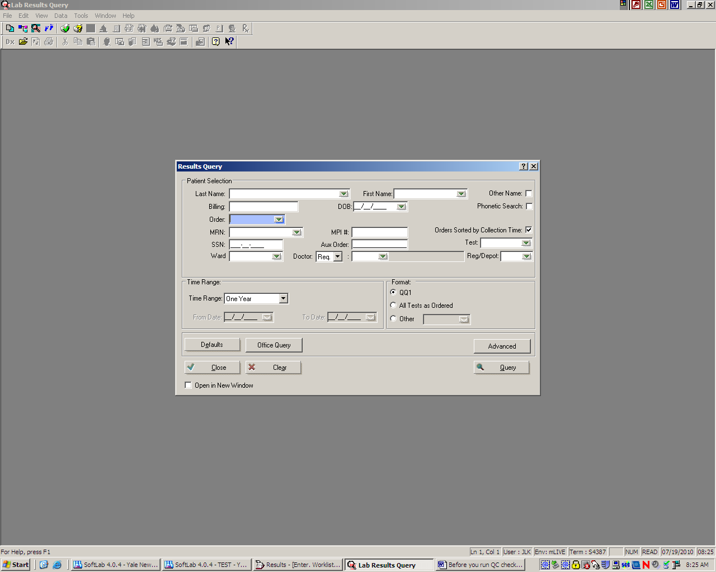

- Click on Query
- Click on + next to the top folder
- All of the patients orders will be listed with the date, time and tests ordered
- Look for test MORCO to see when the last manual differential was performed
- Click on the order number of the order with test MORCO to see what the manual differential results were

How to Add a Manual Differential for Newborns <3 months of age and when cleared by the Clin Path Resident (when the autodiff has already been released):
- How to add the differential
- Go into Order Entry (Either bridge to OE by using the icon from Instrument menu, Lab Query or Resulting Worklist or from the main screen
- Add test DIFF2 under ID in the test ordering area and Save
- How to Open Resulting Worklist
  - Double click on Resulting Worklist on main screen
  - Result Worklist box will appear:
    - Template: type in DIFF2 (main lab) or YDIF2 (YPB)
    - Status: Pend and Nonver
    - From order # - leave as default (current orders)
  - Click OK
  - Any order #’s that appear on the list have a pending DIFF2

- How to perform the DIFF2 differential
  - Select the Order # to have a manual differential performed
  - Click on the Diffpad so it’s highlighted
  - If differential will be done on 25 cells:
    - Click on the Change Diffpad Limit icon and change the limit from
    - 100 to 25 then Click OK
  - Perform a differential using keys that correspond to the cell that’s being counted (ex. m = seg, n = band, . = monocyte)
    - This differential will have SEG2, LYM2, etc. on the Diffpad but still represent and will be reported as segs, lymphs, etc.
    - If the differential limit is not 100: Click on the Change Diffpad
    - Limit icon→enter the current diff limit and Click OK.

Instrument Flags:
NVWBC = Nonviable WBC’s
FBLAS = Blasts
VRLYM = Variant Lymphoids
IMMG = Immature Granulocytes
UIDFC = Unidentified Fluorescent Cells
RERBC = Resistant RBC’s
ASRBC = Asymmetric RBC’s
IMRET = High Number Immature Reticulocytes
PLTCP = Platelet Clumps
PLTCL = Platelet Clump Flag
FSP1 = SP1 Flag
FPLTR = Platelet Flag
FSP2 = SP2 Flag

Data Invalidation Instrument Flags:
FL06 = Short Sample
FL17 = Impedance Aperature Clog
FL02 = Aspiration Probe not up
FL01 = Aspiration Deposition Pump failed to home
FL18 = Laser Current too high
FL23 = HGB Dilution Syringe failed to home
FL10 = PLTi Count Rate error
FL12 = CD61 Opt PLT Stream mismatch
FL11 = PLTo Count Rate error
FL29 = Pneumonics Failure in high pressure range
FL31 = Pneumonics Failure in low pressure range
FL30 = Pneumonics Failure in medium pressure range
FL00 = Pneumonics Failure in vacuum range
FL09 = RBCi Count Rate error
FL26 = RBC Reagent Syringe failed to home
FL07 = RETC Count Rate error
FL03 = Insufficient Reticulocyte Reagent
FL27 = RETC Reagent Syringe failed to home
FL13 = Incorrect Reagent Tube
FL05 = Missing Reagent Tube
FL21 = Hot Pot Speed Error
FL20 = Hot Pot Temperature Error
FL04 = VPM Communications failure
FL08 = WBC Count Rate error
FL28 = WBC Reagent Syringe failed to home
________________________________________________________________________

O=Orderable
R=Reportable
- =Not Orderable or Reportable
Test ID Test Name Orderable/Reportable
CBCWD CBC with Differential (group) O
CBC CBC with Differential (header) R
CBCNO CBC with No differential (group) O
HH Hemoglobin and Hematocrit (group) O
PLT Platelets (group) O
MPV MPV R
WBCI White Blood Cell Count (instrument) -
WBCIR White Blood Cell Count (reportable) R
HGB Hemoglobin R
HCT Hematocrit R
MCV MCV R
RBC Red Blood Cell Count R
MCH MCH R
MCHC MCHC R
ANC ANC (Absolute Neutrophil Count) R
ANCR ANC (Absolute Neutrophil Count) R
RDW RDW R
PLTI Platelet Count R
CBCND CBC Only -
CBCP CBC with Platelet - No Differential R
SEGA % Neutrophils (individual) -
LYMPA % Lymphocytes (individual) -
MONOA % Monocytes (individual) -
EOSA % Eosinophils (individual) -
BASOA % Basophils (individual) -
NRBC Nucleated Red Blood Cell R
SEGR Neutrophils R
LYMPR Lymphocytes R
MONOR Monocytes R
EOSR Eosinophils R
BASOR Basophils R
MDIFF Manual Differential (group) O
SEGM Segmented Neutrophil (individual) -
LYMPM Lymphocyte (individual) -
MONOM Monocyte (individual) -
EOSM Eosinophil (individual) -
BASOM Basophil (individual) -
ATLYM Atypical Lymphocytes (individual) R
META Metamyelocytes (individual) R
MYELO Myelocytes (individual) R
PROMY Promyelocytes (individual) R
BLAST Blast (individual) R
ABLYM Abnormal Lymphocytes (individual) R
OTHER Other (individual) R
IMMON Immature Monocytes (individual) R
IMLYM Immature Lymphocytes (individual) R
ABMON Abnormal Mononuclear (individual) R
SMCEL Smudge Cells R
PLAS Plasma Cells R
RETIC Reticulocyte Count O/R
DIFF2 Manual Differential (group) O
SEG2 Neutrophils -
LYM2 Lymphocytes -
MON2 Monocytes -
EOS2 Eosinophils -
BAS2 Basophils -
SEG2R Neutrophils R
LYM2R Lymphocytes R
MON2R Monocytes R
EOS2R Eosinophils R
BAS2R Basophils R
ANCM ANC (Absolute Neutrophil Count) (from manual diff)-
ANCR ANC (Absolute Neutrophil Count) (reportable) R
CHECK CBC Check Test -
WBC1 WBC1 -
WBC2 WBC2 -
PLT1 Platelet 1 -
PLT2 Platelet 2 -
ABSLC Absolute Lymphocyte Count -

ID Name Test Name
MORCO Morphology (Reflex test)
MWNL Normal RBC Morphology
MCOL Morphology Color
MOVAL Ovalocytes
MSPH Spherocytes
MTARG Target Cells
MTEAR Teardrops
MSICK Sickle Cells
MSCH Schistocytes
MSPIC Spiculated Cells
MPAPP Pappenheimer bodies
MROUL Rouleaux
MAUER Auer Rods
MTOX Toxic Granulation
MDOHL Dohle bodies
MPOIK Poikilocytosis
MBASO Basophilic Stippling
MHOJO Howell-Jolly bodies

III. HISTORY:
H-1 This procedure was written by Jesica Kaul on 3/27/2010.
H-2 This procedure was revised by Jessica Kaul on 4/12/2011.
H-3 This procedure was revised by Elizabeth Degano on 12/14/12.
H-4 This procedure was revised by Elizabeth Degano on 3/5/2013.

