I. PRINCIPLE:

A supravital stain (New Methylene Blue) is mixed with blood. This stain enters the RBC and precipitates any residual RNA. A smear can then be made and the cells with the stained RNA can be counted.

II. SPECIMEN:

Whole blood (EDTA tube or microtainer) less than 24 hours old are acceptable..

IlI. PROCEDURE:

- Filter the New Methylene Blue stain using filter paper, and filter the stain into a
plastic tube.
- Add 2 drops of the filtered New Methylene Blue into small plastic vials.
- Add 2 drops of blood and mix
- Incubate mixture 15 minutes at room temperature.
- Remix with applicator sticks and make smears following procedure for peripheral smear preparation and let air dry.
- Count number of retics per 1000 RBCs using 97/100x oil objective. Report as a percentage.

IV. PROCEDURAL NOTES:

A Low RBC counts require more blood to be mixed with the dye to give enough RBC to count.
B. For an accurate count, RBCs should not be overlapping, in clumps or in Rouleaux
formation.
C. New Methylene Blue is not specific for RNA. A majority of the red cell inclusions will stain with New Methylene Blue. Heinz bodies, siderotic granules, Howell Jolly bodies, basophilic stippling, and Pappenheimer bodies will take up this stain. See special chart for Differential morphology Agreement between retic count may be off (e.g. retic is higher) in cases where there are a large number of basophilic stippled cells or pappenheimer bodies present. These inclusions are difficult to distinguish from retics.

RBC Inclusion | Wrights stain | New Methylene blue
RBC (hemoglobin) |  | 
Heinz bodies |  | 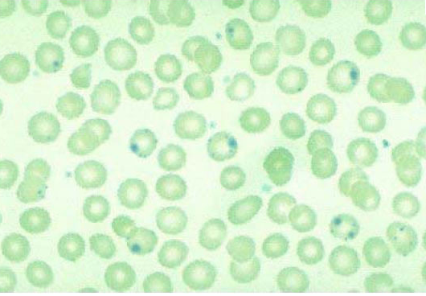
Retics |  | 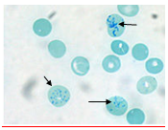
 | Wrights stain | New Methylene blue
Basophilic Stippling (RNA) | 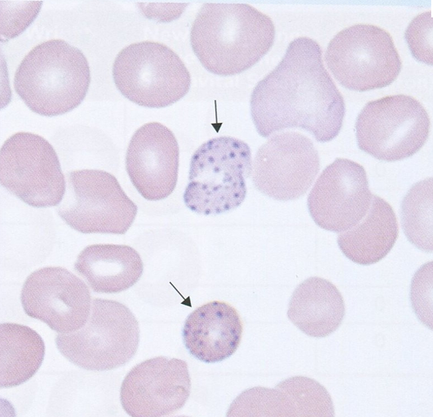 | 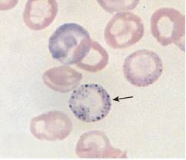
Howell Jolly Bodies | 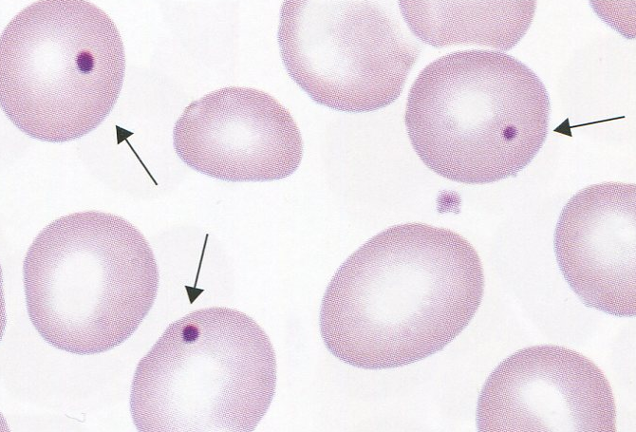 | 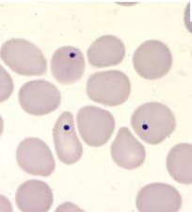

V. NORMAL RANGE:

A. Normal Range: 0.6-2.7%
.
VI. REAGENTS AND EQUIPMENT:

A. Commercially prepared New Methylene Blue N, Brecher formula
B. Applicator sticks
C. 3x1 glass slides
D. laboratory microscope
E. plastic tubes or vials

VII. SIGNIFICANCE:

A. The reticulocyte count is used as an index of erythropoiesis including normal bone marrow status and therapeutic trials.

VIII. SAPPHIRE RETICULOCYTE COUNT REVIEW PARAMETERS:

A. All Retics results that equal 0.0 must be reviewed by manual Retic method
B. All starred “*” Retic results should be repeated, if still starred * review count with
manual Retic count.
1. Manual Retic count matches cell-dyn count - report cell-dyn count
2. Manual Retic count different from cell-dyn count - report manual count
3. Log results of manual plus automated in the Retic log so that we can use the data for correlations.
4. Inform a supervisor of any trends or perceived problems with manual or cell-dyn retic counts.

IX. REFERENCES:

1. Brecher and Schneiderman: National Institute of Health, Bethesda Maryland
Davidshon and Henry: Clinical Diagnosis and Management by Laboratory Methods 1991.

X. HISTORY:

H-1 This procedure was written by N. Ortoli-Drew on 10-1994.
H-2 This procedure was revised by N. Ortoli-Drew 3-2011.
H-3 This procedure was revised by E. Degano 3-7-2012.
H-4 This procedure was revised by E. Degano 4-2013.

