I. Purpose:
To define the Soft computer process when resulting Sedimentation Rate QC.
II. Procedure:
A. Test Rack must be run before proceeding to QC and patient (each rack is specifically initialized for each specific instrument).Test rack run should be run and entered during the scheduled times per shift, If not the test rack run will be overdue in Soft total QC.
  - Day shift 7:00am : (Enter between 6:30am-9:00am)
  - Evening shift 3:00pm: (Enter between 2:30pm-5:00pm)
  - Night shift 11:00pm: (Enter between 10:30pm-1:00am)
B. To Enter Test Rack in Total QC
- Log-in to Soft Total QC LIVE
- Under Results, select Result Entry
- Type in MRACKTEST (in capital letters) in QC item (MRACKTEST is ordered automatically.)
- Click the search button at bottom of the screen.
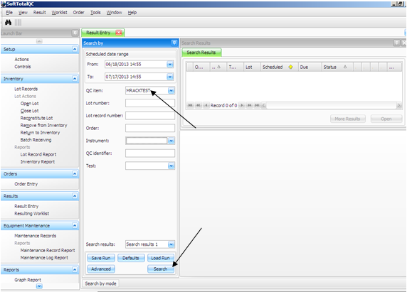

5. Select the MRACKTEST according to the current date and current (shift) time, and Click Open.
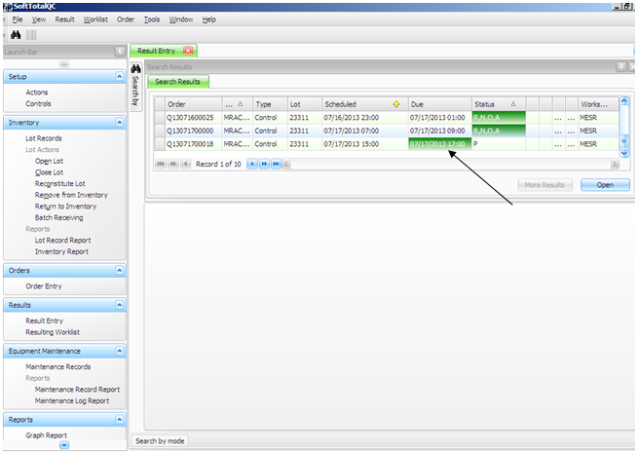
6. Enter the Rack Test result as OK or Failed. NOTE: If Rack Test Failed, verify results and comment the action taken. A new MRACKTEST rder will automatically be generated and MRACKTEST should be re-run and entered.
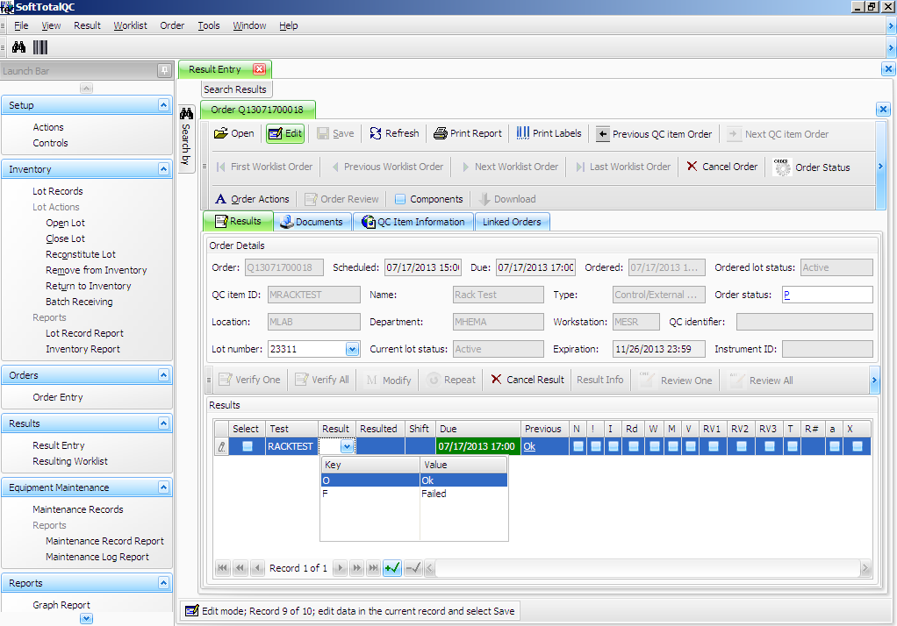
7. Click on Order Actions and Select the green plus sign
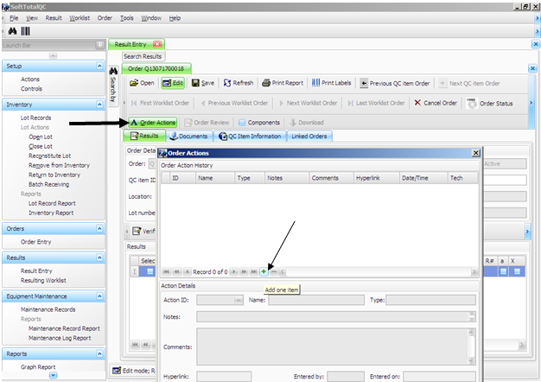
8. Click ID and select MESR1 for instrument #1 test rack and/or MESR2 for instrument #2 test rack. Click ok. Click Verify All and Save .
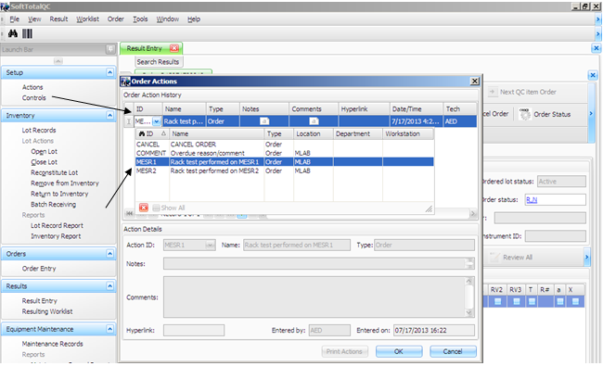
C. Run QC – (QC is ordered automatically in Soft Total QC)
- At ”NEXT SAMPLE and time” on the ESR instrument, manually enter the # 1 for the L1 control and press the green check button.
- Instrument will read "Insert in a Free Position".
- Insert control sample into first free position.
- At ”NEXT SAMPLE and time” on the ESR instrument manually enter the # 2 for the L2 control and press the green check button. Repeat Steps 4-5.
- QC must be run, and results must be in range and entered into soft prior to patient samples being run.
- After 30 minutes when ESR QC run is complete post the QC results from the Instrument Menu
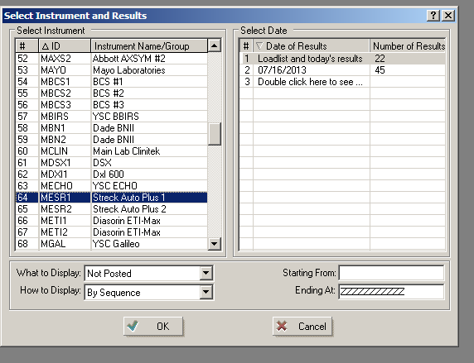
  - Instrument menu->MESR1 (Instrument #1) MESR2 (Instrument #2)

  - Click QC Post all Tests for 1 (L1 control)
  - Click QC Post all Tests for 2 (L2 control)
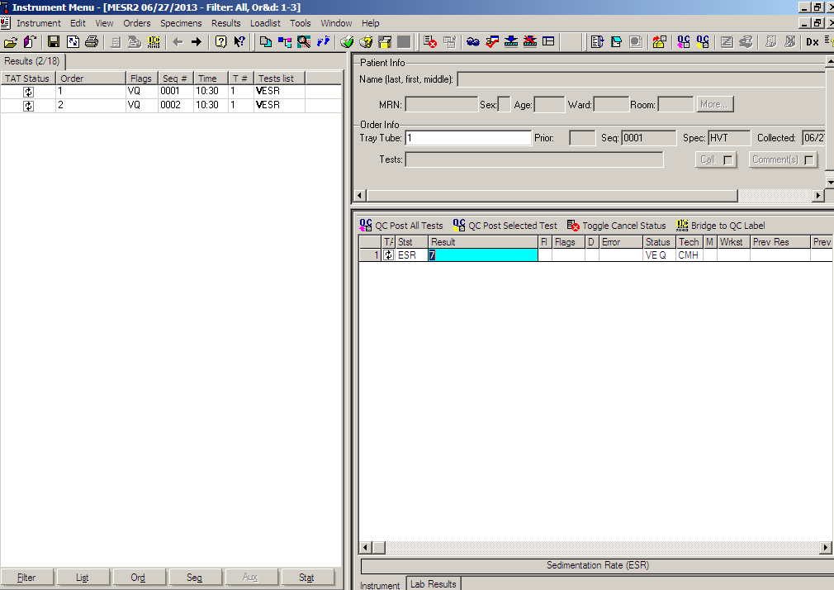
- QC must be run, and results in range and posted into Soft Total QC prior to patient samples being run.
- If control was out of range, post results and comment the action taken after control is out of range. A new QC order will automatically be generated and QC should be re-run posted.

III. HISTORY:
H-1 This procedure was written by Jessica Kaul on 3/7/2010.
H-2 This procedure was revised by Jessica Kaul on 7/20/2010.
H-3 This procedure was revised by Elizabeth Degano 7/18/2013.

