I. Purpose:
To define the Soft computer process when resulting Urinalysis QC.

II. Procedure:

How to Order Urinalysis QC:
-Click on v next to Orders
-Click on Order Entry
-Click on Blank Document icon
-Enter Item Type: Control
-Enter Item ID: MUA-1
-Leave checkmarks selected for tests and workstation that controls are to be run on
∙Example: Controls are to be run on Atlas #1, Multistix reagent strip and Confirmatory:
-Tests UAPP, UBIL, UBLD, UCOLR, UGLU, UKET, ULEU, UNITR,
UPH, UPRO, UUROB and USPG for Workstation MATL1 should be check
marked.
-Tests UAPP, UBLD, UCOLR, UGLU, UKET, ULEU, UNITR, UPH,
UUROB and UPRO for Workstation MCLIN should be check marked.
-Tests UCLIN, USSA and USPG for Workstation MUA should
be check marked.
-Click
-Click YES to “Do you want to save changes?”
-The page will bridge to Result Entry
-Close Result Entry tab
-Click on v next to Orders
-Click on Order Entry
-Click on Blank Document icon
-Enter Item Type: Control
-Enter Item ID: MUA-3
-Leave checkmarks selected for tests and workstation that controls are to be run on
∙Example: Controls are to be run on Atlas #1, Multistix reagent strip and Confirmatory:
-Tests UAPP, UBIL, UBLD, UCOLR, UGLU, UKET, ULEU, UNITR,
UPH, UPRO, UUROB and USPG for Workstation MATL1 should be
check marked.
-Tests UAPP, UBLD, UCOLR, UGLU, UKET, ULEU, UNITR, UPH,
UUROB and UPRO for Workstation MCLIN should be check marked.
-Tests UCLIN, USSA and USPG for Workstation MUA should
be check marked.
-Click
-Click YES to “Do you want to save changes?”
-The page will bridge to Result Entry
-Close Result Entry tab
-Example: Controls are to be run on Atlas #1 only for tests UAPP, UBIL, UBLD, UCOLR, UGLU, UKET, ULEU, UNITR, UPH, UPR, UUROB and USPG.

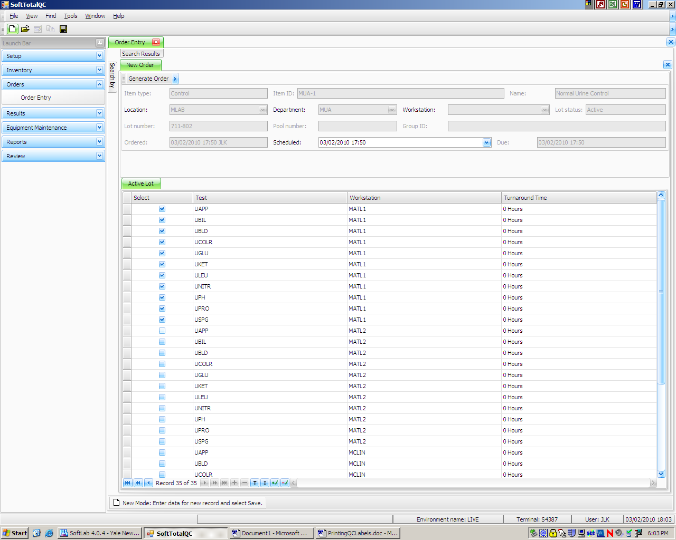

How to Run and Result Urinalysis QC:

Controls
MUA-1 – Normal Urine Control
MUA-3 – Abnormal Urine Control

To Print QC Identifier Labels
- Click on v next to Inventory
- Click on Lot Records
- Enter Item ID: Either MUA-1 or MUA-3
∙Enter the first few characters of the ID and use the drop down list
∙Choose the one with NO WORKSTATION
- Open the record by clicking on from the top toolbar (Lot record information will appear)
- Click Barcode icon from the top toolbar
**Click NO to the “Do you want to copy the parameter information from test…”**
- Click Barcode icon
- Go to bottom part of the screen and click on QC Identifier Labels tab
- Go to the top of the screen and select the workstation to print labels for (put a √ in the box under Select)
- Change the Layout to LotQCIdentifier_labelLBL
- Click Network Printer
- Choose label printer from the drop down list
- Click Run

Atlas
- Labels will have the Control ID, Name, Instrument ID, Workstation and QC Identifier
-Example: Control ID: MUA-1
Name: Normal Urine Control
Instrument ID: MATL1
Wrk: MATL1
QC Identifier: a11a
- Place the Normal Urine Control label on the conical tube containing the normal control
- Place the Abnormal Urine Control label on the conical tube containing the abnormal control
- Place tubes on the Atlas and run controls
- If the barcode does not read manually enter a11a for the normal control and a12a for the abnormal control into the Atlas
- Go into Instrument menu
- Highlight Order 11
- Click
- If any results are out the screen will bridge to TQC
- Choose Action from Action ID then Click OK
- When all results are posted a popup will appear stating “11 test(s) were posted to QC order #”
- If QC is out a new QC order will be generated and linked to the original QC order
- Click OK
- Highlight Order 12
- Click
- If any results are out the screen will bridge to TQC
- Choose Action from Action ID then Click OK
- When all results are posted a popup will appear stating “11 test(s) were posted to QC order #”
- If QC is out a new QC order will be generated and linked to the original QC order
- Click OK
- If all QC was in range:
-Patient samples can be run
- If any QC was out of range:
-Rerun the control
-Go into Instrument menu
-Click on the result(s) that was out of range
-Click on QC Post Selected Test
-When the result is posted a popup will appear stating “1 test was posted to QC order #”
-F4 results that were already posted in QC
-Click
- When both controls are in patient samples may be run

Ordering and Running Controls after Reagent Change:
- Order Urinalysis QC for MUA-1
-Click on v next to Orders
-Click on Order Entry
-Click on Blank Document icon
-Enter Item Type: Control
-Enter Item ID: MUA-1
-Leave checkmarks selected for tests and workstation that controls are to be run on
∙Example: Controls are to be run on Atlas #1:
-Tests UAPP, UBIL, UBLD, UCOLR, UGLU, UKET, ULEU, UNITR,
UPH, UPRO, UUROB and USPG for Workstation MATL1 should be check marked.
-Click
-Click YES to “Do you want to save changes?”
-The page will bridge to Result Entry

- Add New Reagent Result Action to the Order
-Click on Result Action
-Click on green +
-Click on v under ID
-Click on ID: NewReagent
-Click on Comment box and type in new lot number and expiration date
-Click OK
-Click

- Order Urinalysis QC for MUA-3
-Click on v next to Orders
-Click on Order Entry
-Click on Blank Document icon
-Enter Item Type: Control
-Enter Item ID: MUA-3
-Leave checkmarks selected for tests and workstation that controls are to be run on
∙Example: Controls are to be run on Atlas #1:
-Tests UAPP, UBIL, UBLD, UCOLR, UGLU, UKET, ULEU, UNITR,
UPH, UPRO, UUROB and USPG for Workstation MATL1 should be
check marked.
-Click
-Click YES to “Do you want to save changes?”
-The page will bridge to Result Entry

- Add New Reagent Result Action to the Order
-Click on Result Action
-Click on green +
-Click on v under ID
-Click on ID: NewReagent
-Click on Comment box and type in new lot number and expiration date
-Click OK
-Click

- Run Controls as described in above procedure for running and resulting QC on the Atlas

Multistix Reagent Strips
- Runs controls 11 and 12 on Multistix reagent strips
- In TQC, Click on the v next to Results
- Double click on Result Entry
- Type in MUA-1 next to QC item:
- Click Search
- Find the current order number under Search Results for MCLIN
- Click Open
- Click on Test UAPP
- Highlight the result to be entered and Click on it
- Click on Test UBLD
- Highlight the result to be entered and Click on it
- Click on Test UCOLR
- Highlight the result to be entered and Click on it
- Click on Test UGLU
- Highlight the result to be entered and Click on it
- Click on Test UKET
- Highlight the result to be entered and Click on it
- Click on Test ULEU
- Highlight the result to be entered and Click on it
- Click on Test UNITR
- Highlight the result to be entered and Click on it
- Click on Test UPH
- Highlight the result to be entered and Click on it
- Click on Test UPRO
- Highlight the result to be entered and Click on it
- Click on Test UUROB
- Highlight the result to be entered and Click on it
- Click on Verify All
- Click
- Click YES to “Do you want to save changes?”

- Type in MUA-3 next to QC item:
- Click Search
- Find the current order number under Search Results for MCLIN
- Click Open
- Click on Test UAPP
- Highlight the result to be entered and Click on it
- Click on Test UBLD
- Highlight the result to be entered and Click on it
- Click on Test UCOLR
- Highlight the result to be entered and Click on it
- Click on Test UGLU
- Highlight the result to be entered and Click on it
- Click on Test UKET
- Highlight the result to be entered and Click on it
- Click on Test ULEU
- Highlight the result to be entered and Click on it
- Click on Test UNITR
- Highlight the result to be entered and Click on it
- Click on Test UPH
- Highlight the result to be entered and Click on it
- Click on Test UPRO
- Click on Test UUROB
- Highlight the result to be entered and Click on it
- Click on Verify All
- Click
- Click YES to “Do you want to save changes?”

Confirmatory Tests
- Perform the confirmatory tests for both normal and abnormal controls
- Click on the v next to Results
- Double click on Result Entry
- Type in MUA-1 next to QC item:
- Click Search
- Find the current order number under Search Results for MUA
- Click Open
- Click on Test UCLIN
- Highlight the result to be entered and Click on it
- Click on Test USSA
- Highlight the result to be entered and Click on it
- Click on Test USPG
- Type in Specific Gravity
- Click on Verify All
- Click
- Click YES to “Do you want to save changes?”
- Rerun controls and repeat above steps if needed

- Click on the v next to Results
- Double click on Result Entry
- Type in MUA-3 next to QC item:
- Click Search
- Find the current order number under Search Results for MUA
- Click Open
- Click on Test UCLIN
- Highlight the result to be entered and Click on it
- Click on Test USSA
- Highlight the result to be entered and Click on it
- Click on Test USPG
- Type in Specific Gravity
- Click on Verify All
- Click
- Click YES to “Do you want to save changes?”
- Rerun controls and repeat above steps if needed
- When both controls are in patient samples may be run

QC is out of Range
- If the result is out the Action screen will appear
- Choose Action from Action ID then Click OK
- Rerun the control
- If QC was run on an Atlas
-Go into Instrument menu
-Click on the result(s) that was out of range
-Click on QC Post Selected Test
-When the result is posted a popup will appear stating “1 test was posted to QC order #”
-F4 results that were already posted in QC
-Click

- If QC was repeated on Multistix or Confirmatory
-Follow procedure for entering QC results

III. HISTORY:
H-1 This procedure was written by Jessica Kaul on 3/7/2010.
H-2 This procedure was revised by Jessica Kaul on 7/1/2011.
H-3 This procedure was revised by Donna Fico on Aug. 2013.

