I. PRINCIPLE:
Whole blood is introduced into a capillary tube which is coated with acridine orange stain and anticoagulants, spun by centrifugation and examined utilizing fluorescence microscopy for the presence of blood parasites (malaria, babesia and micro-filaria). Parasite diagnosis by the QBC method is more sensitive than the conventional blood-film thick smear due to the concentration of a larger volume of specimen analyzed. In addition the acridine orange stain permits rapid unambiguous detection of distinctly stained parasites.

II. SPECIMEN:
EDTA anticoagulated blood <24 hours old is acceptable.

III. REAGENTS AND EQUIPMENT:
QBC parasite tube
Coated with acridine orange (a carcinogen). Potassium oxalate, sodium heparin and K₂EDTA
Plastic float and clay seal
Capillary tube reader slide
Hematocrit centrifuge
Fluorescence microscope
Immersion oil

IV. PROCEDURE:
A. QBC tube preparation:
1. fill the QBC tube from the end nearest the white and blue lines
2. fill tube by capillary action to between the 2 blue lines, roll tube to mix
with anticoagulant
3. wipe off any blood on outside of tube
4. tilt the tube allowing the blood to flow into the “orange-stained area” and roll the tube 5 times to mix blood with acridine orange stain
5. tilt tube slightly so blood flows from end leaving a “clear’ space
6. place finger over end nearest blue lines and insert opposite end into clay seal
7. check clay sealed end to assure total seal
8. roll tube horizontally between palms of hand 5 times
9. insert float into unsealed end, rotate tube to vertical position and tap sealed end on counter to assure float seated
10. place tube into microhct centrifuge head, sealed end towards outside, insert empty tube as balance, affix safety head shield and spin for 5 minutes
11. read QBC tube in fluorescent microscope (we use one in microbiology lab)
B. QBC tube reading: (refer to diagram for separation and orientation of layers)
1. remove tube from microhct centrifuge
- examine tube to be sure specimen separated correctly; place QBC tube
in brown plastic tube. Specimen may be held overnight in cold room.
( Flourescent microscope is in mircolab.)
3. turn on fluorescent microscope and allow to warm-up for 2-4 minutes
4. place tube in slot on reader slide and place on microscope stage
5. focus under 10x objective
6. locate the leukocyte/buffy coat layer (a bright green band)
7. put oil over this area and examine the rbc layer which is just under the rbc/granulocyte layer with the 50x objective
8. examine the whole area from rbc/granulocyte layer to closure for the presence of parasites
9. examine the granulocyte/monocyte/lymphocyte interface for the presence of schizonts and gametocytes of Plasmodia
10. refer to the QBC atlas, and diagrams for identification of parasites when present
11. Malaria and Babesia appear as bi-colored signet rings (the ring green and the stone red) Gametocytes of P falaciparum will appear as green “banana-shaped” Schizonts and merozoites characteristically show dark brown pigment
12. record results in parasite log in supervisor smear sign-out notebook

C. Procedural notes:
○ Howell Jolly bodies and Pappenheimers will also stain and interfere with QBC reading interpretation and invalidate QBC reading
○ Exposure of the QBC tube to fluorescent light will ‘bleach’ the staining
○ QBC results are performed in conjunction with smear review for morphologic examination and speciation of Plasmodia or micro filaria
○ QBC preparation may be stored up to 24 hours- tube must be kept upright, in a cool environment in the dark

V. RESULTING
A. Negative analysis:
○ As per CDC recommendation if negative a patient should be screened, x3 (on 3 different days) to truly verify negative parasitemia
○ Smears and QBC are reviewed by a supervisor after tech screening
○ Completion of morphologic resident/attending sheet
○ Add BSINT and Flow#, affix labels to instrument print-out
○ Slides (3) and morphologic sheet are placed in resident review slot
- negative results are entered into laboratory computer

B. Positive analysis:
○ Speciation is made utilizing the Wright Giemsa stained smear and the BinaxNow malaria kit. (refer to BinaxNow procedure)
○ Notify lab supervisor or clin path resident of result
○ Complete morphologic resident/attending sheet
○ Add BSINT into the lab computer
○ Complete all necessary paperwork for reporting to state public health department refer to procedure for “Reportable diseases”
○ Quantitation of parasitemia on Wright Giemsa smear (refer to manual retic method) Results reported as rare, <1.0% or whole % (no decimal place)
○ Once resulted as positive, QBC not repeated on subsequent specimens until no parasites seen on smear. When no parasites are seen on smear a QBC is performed to confirm no residual parasitemia

VI. SIGNIFICANCE:
The QBC malaria test is a rapid qualitative method for diagnosing malaria, microfilaria and babesia. The test provides a sensitive positive or negative result for the presence of blood parasites, more specific and sensitive than the “traditional thick smear” for the detection of parasites. The Binax NOW malaria kit (refer to BinaxNow procedure)
discriminates malaria from Babesia and speciates Falciparum vs mixed malarial
infection.

VII. ULTRAVIOLET SAFETY:
UV light is harmful and over-exposure can cause serious skin and eye damage. Skin will become reddened 1-8 hours after exposure; sandy or gritty eyes and painful inflammation of conjunctiva and cornea after 3-12 hours. All UV devices are to be labeled with warning label. Any lamp device area is to be cleaned only after lamp turned off and cooled. Laboratory exposure is to be minimal and in compliance with all regulations and OSHA standards.

VIII. REFERENCES:
QBC Malaria test QBC Diagnostics 2005
Yale New Haven Hospital Research, Stephen Wardlaw MD, et al.
OSHA UV light recommendations
Binax Now Malarial Kit

IX. HISTORY:
H-1 This procedure was written by N. Ortoli-Drew on 1995.
H-2 This procedure was revised by N. Ortoli-Drew 3-2011.
H-3 This procedure was revised by N. Ortoli-Drew 6/2013.

Reporting in Soft Lab
- *Changes to parasite tests in soft, test codes for Parasite Malaria and Parasite Babesia are as follows*
    - PMALA test code is replacing PMAL
    - PBABE test code is replacing PBAB
- Orderable test codes
- PMALA: Malaria Detection and Quantitation
- PBABE: Babesia Detection and Quantitation
- Reportable test codes
    - PMAL: Malaria Smear
    - MQUAN: Malaria Quantitation
    - BINAX: Malaria Binax
- Resulting a PMALA
- In resulting worklist Test PMAL will always be required.
  - Select positive or negative from the keypad
- If result is negative
  - Tests MQUAN and BINAX will already have "." in the resulting field, then simply click Verify all when resulting PMAL.

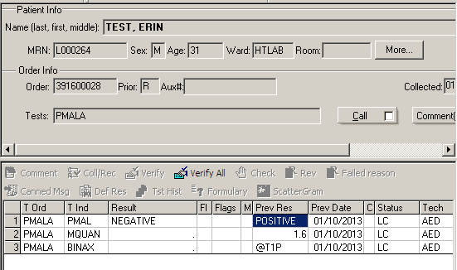
- If result is positive
  - needs Quantitation enter the % in MQUAN and Click Verify & Save
  - needs Binax select the appropriate interpretation comment in BINAX from the keypad then Click Verify & Save
    - @T1P Positive result for P. falciparum
    - @T2P Positive result for P. vivax or P. malariae or P. ovale
    - @T12 Positive result for P. falciparum, possibly a mixed infection of P. falciparum with another species
    - @NO12 Negative – no malaria antigens were detected
- If both MQUAN and BINAX needs to be resulted enter results and click verify all
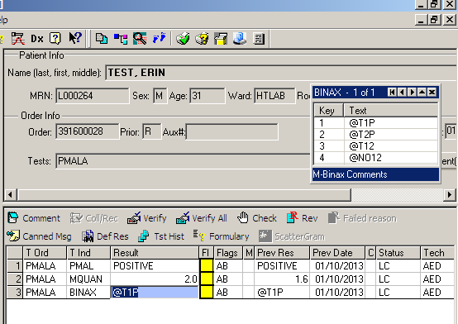
- Resulting a PBABE
  - In resulting worklist Test PBABE will always be required.
  - Select positive or negative from the keypad
  - If result is negative
    - Tests BQUAN and BINAX will already have "." in the resulting field, then simply click Verify all when resulting PBAB.
- If result is positive
  - needs Quantitation enter the % in BQUAN (rare, <1%, actual % no decimals if >1% and Click Verify & Save
  - needs Binax select the appropriate interpretation comment in BINAX from the keypad then Click Verify & Save
    - @T1P Positive result for P. falciparum
    - @T2P Positive result for P. vivax or P. malariae or P. ovale
    - @T12 Positive result for P. falciparum, possibly a mixed infection of P. falciparum with another species
    - @NO12 Negative – no malaria antigens were detected
- If both BQUAN and BINAX needs to be resulted enter results and click verify all

Note: if results invalid and/or uninterpretable enter @INV as a result, click verify and save.

