I. Purpose:
To define the Soft computer process when resulting from the ESR template.

II. Procedure:
Orderable Tests:
BSINT = Blood Smear Interpretation
ESR = Sedimentation Rate (ESR)
RETIC = Reticulocyte Count
PMALA = Malaria Detection and Quantitation
PBABE = Babesia Detection and Quantitation
PEHRL = Ehrlichia Smear
ESR (Day shift) Resulting Template: for ESR, RETIC, BSINT and Parasites
MESRE (Off shifts) ESR Resulting Template: for ESR, RETIC, BSINT and Parasites (main lab, Smilow lab, and North Haven lab locations)

A. How to check and print pending results:
- Open Resulting Worklist: template - ESR
status - Pend and Nonver
from order # - current orders
- Any orders on the resulting worklist have either an ESR, RETIC, BSINT or Parasite pending
- Click on the printer icon and Click on Worklist
- A Print Worklist box will appear
-Choose the correct printer to print to by clicking on the ▽ and then
clicking on the printer name
-Leave the default layout as Horizontal
-Click OK

B. To Verify ESR Results:
- Results will auto-verified with the exceptions of results < 5, >120, with error flags, and samples not collected and received.
    - Results >20 will flag AB (abnormal) and have a yellow box
    - Results that are >120 from the instrument will appear automatically as >120 in instrument menu.
- For samples not auto-verified, follow the ESR-Auto Plus procedure for checking the ESR sample tube prior to verifying the result
    - Open Instrument Menu, Select Instrument MESR1 (ESR instrument #1) or MESR2 (ESR instrument #2), Click OK.
    - Select order number to be verified and Click Post All on the Instrument Tab
C. To Verify Parasites:
- Open Resulting Worklist: template – ESR
- status - Pend and Nonver
- from order # - current orders
- Select order # for results to be entered
1. Resulting a PMALA
- In resulting worklist Test PMAL will always be required.
  - Select positive or negative from the keypad
- If result is negative
  - Tests MQUAN and BINAX will already have "." in the resulting field, then simply click Verify all when resulting PMAL.
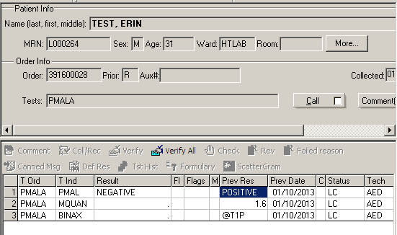
- If result is positive
  - Needs Quantitation enter the % in MQUAN and Click Verify & Save
  - Needs Binax select the appropriate interpretation comment in BINAX from the keypad then Click Verify & Save
    - @T1P Positive result for P. falciparum
    - @T2P Positive result for P. vivax or P. malariae or P. ovale
    - @T12 Positive result for P. falciparum, possibly a mixed infection of P. falciparum with another species
    - @NO12 Negative – no malaria antigens were detected
- @INV Invalid and/or uninterpretable results
- If both MQUAN and BINAX needs to be resulted enter results and click verify all
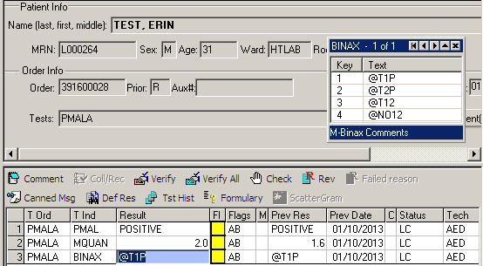
2. Resulting a PBABE
  - In resulting worklist Test PBAB will always be required.
  - Select positive or negative from the keypad
  - If result is negative
    - Tests BQUAN and BINAX will already have "." in the resulting field, then simply click Verify all when resulting PBAB.
- If result is positive
  - needs Quantitation enter the % in BQUAN and Click Verify & Save
  - needs Binax select the appropriate interpretation comment in BINAX from the keypad then Click Verify & Save
    - @T1P Positive result for P. falciparum
    - @T2P Positive result for P. vivax or P. malariae or P. ovale
    - @T12 Positive result for P. falciparum, possibly a mixed infection of P. falciparum with another species
    - @NO12 Negative – no malaria antigens were detected
- @INV Invalid and/or uninterpretable results
- If both BQUAN and BINAX needs to be resulted enter results and click verify all
3. Resulting Ehrlichia
- Enter results using the keypad
- Click N for Negative or Click P for Positive on the Key Pad
- Click Verify and save to verify the order

III. HISTORY:
H-1 This procedure was written by Jessica Kaul on 3/7/2010.
H-2 This procedure was revised by Jessica Kaul on 3/8/2011.
H-3 This procedure was revised by Elizabeth Degano 7/19/2013.

