Immunology, Flow and Molecular Meeting
Sept 18, 2013
1:30 & 3:00 PM
Immunology Lab

- Announcements:
  - Retirement Party for Rex P. Oct 4 – PS230 2-4 pm.
  - Retirement – Congratulations to Joann G. who is retiring Nov 24, 2013
  - Tech B Announcement – Congratulations to Kate M. who has been promoted to Med Tech B.
  - Infant & Child Security Healthstream Class due Nov 1, 2013

- Compensation Update – see handout.

- Communication Logs – read at the start of your shift

- Errors
  - Aliquoting and Direct Entry Errors
  - Policy
    - Input will be solicited from staff

- State Inspection Results
  - Tumor Profiling – need CT license # in the patient report

- Healthstream
  - Service Excellence and the Patient Experience: Creating a Patient and Family Centered Healing Environment – 89.29% (3 more)

- HIPAA Compliance – Fair Warning Program
  - Make sure to log off once done using a computer
  - Internal audit showed an employee accessed a patient record using their fellow employee’s log in.

- Lounge Theft
  - Report all thefts to JR.
  - Make sure doors are locked – especially on evening.
  - JR to speak w/ Mike T. about keeping the doors locked

- CAP Inspection window:

  - Blackout dates are Aug 21, 22, Sept 18, 19, Oct 16, 17, 30, 31, and Nov 5,6
  - Reagent bottles – need to have open dates
  - Check Expired reagents
  - Validation Kits - make sure labeled w/ Research Use Only and separated from main reagent supply
  - Maintenance Charts
  - Temp Charts

- Work Flow Changes:
  - Immunology Workflow Changes
    - Quantalink Interface
      - Bioflash – live with TTG IgG, validating MPO, PR3, and ACA IgA and B2GPA
  - Molecular IT Workflow Changes – no update
    - Final Stages of Celiac Genetics Validation

- Delta Checks
  - Repeat from Clot
  - Use Criteria set for Reagent Verification
  - Consult supervisor

- Financials
IMMUNOLOGY GO GREEN Campaign!

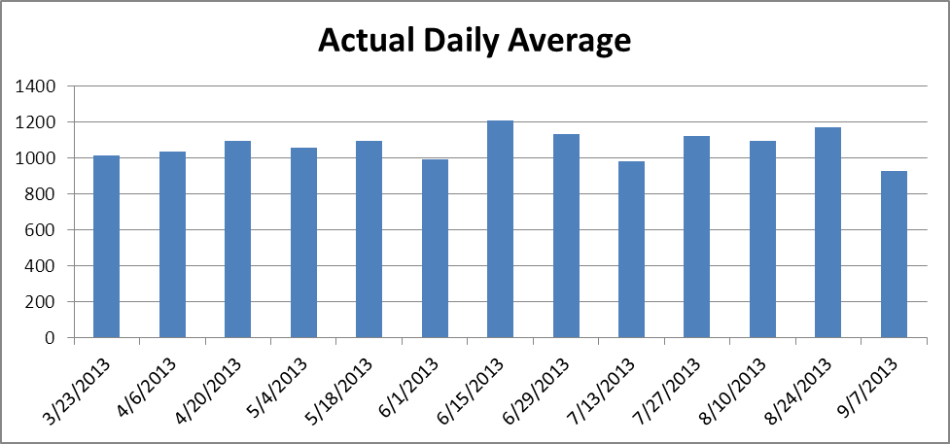

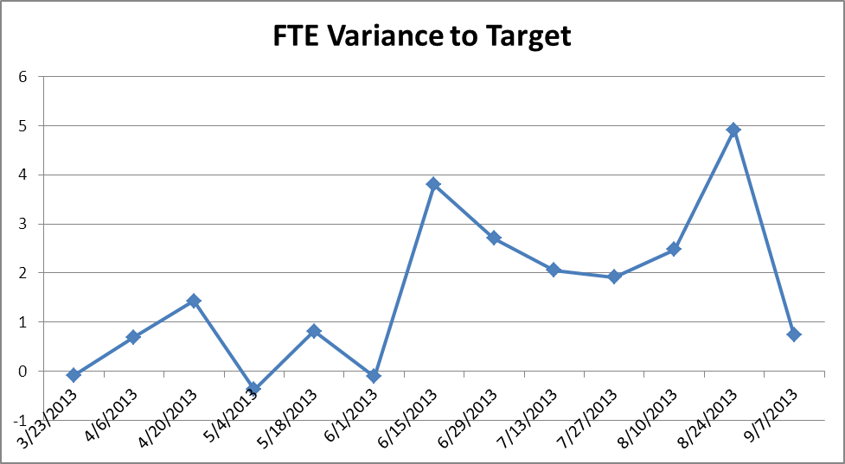

TUMOR PROFILING
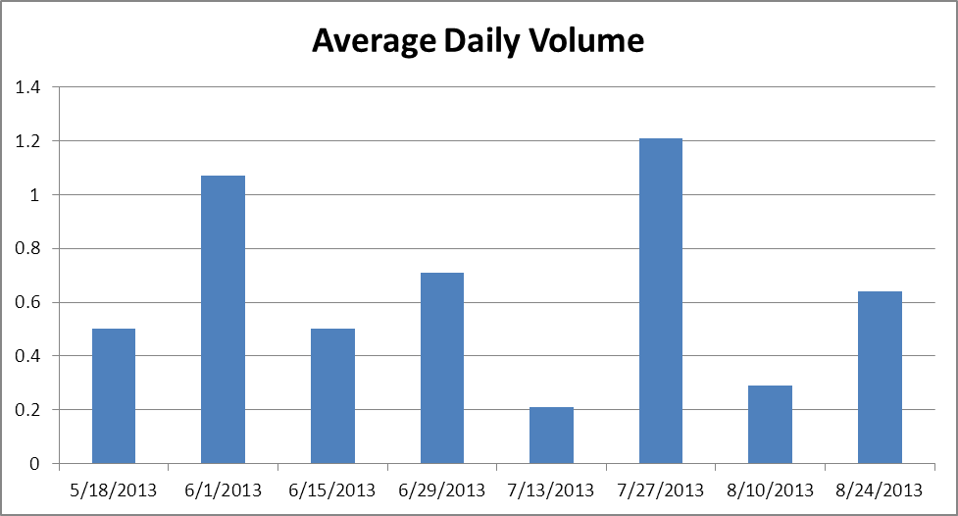

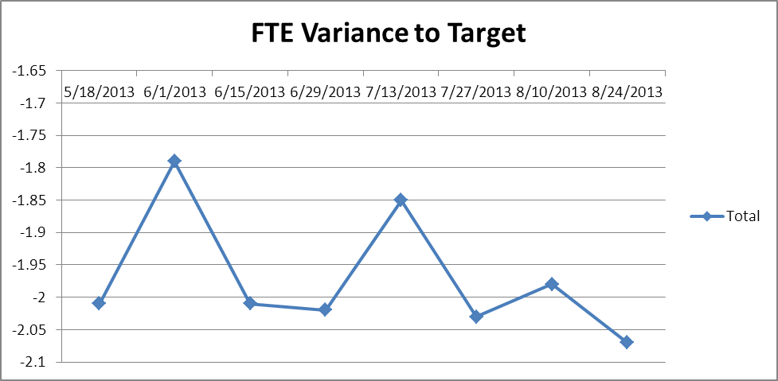

Presentation: TBD

New Test: No updates

Questions and Concerns:
1. Parking & Exiting Air Rights Garage – concern was brought up about Air Rights Garage and the difficulty of exiting. Could be potential mental and health issue.

