Immunology, Flow and Molecular Meeting
Nov 27, 2013
1:30 & 3:00 PM
Immunology Lab

- Announcements:
  - Susan G. - Congrats

- Open Forums:
  - Dec 6 – 12 – 1pm Harkness Auditorium – Light Lunch Provided

- Air Rights Garage – Dec 15, 2013 – Pay-on-foot machines to vend exit gate should allow for quicker exit.

- Employee Engagement Survey – met target at 86% participation

- Chemistry Leadership Change
  - Dr. McClaskey – Director of all the Outreach Labs
  - Dr. Hodsdon – new Director of Chemistry
  - Dr. Malkus’ replacement – active recruitment ongoing

- Kronos Sign offs – need to countersign

- CEU excel file – L drive.

- Tube Conversion
  - Gold Top Chems to Light Green Top
  - Red Top to Gold Top

- Events:
  - 3rd annual Immunology/Flow Cytometry/Molecular Diagnostics/Tumor Profiling Holiday Party!!
    - Jan 4 6 pm – whenever, @ the Richardsons - 585 Alpine Drive Cheshire, CT 06410
  - Holiday Festival
    - December 16th 3:30 pm to 6:30 pm, Park St Seminar Room 202
    - YNHH and YSM Lab Medicine Staff only
    - Light Buffet Dinner
    - Bring Your Favorite Dessert
    - Please Bring A New Unwrapped Toy For the Toy Closet
  - YNHH Lab Medicine Holiday Party
    - Dec 6, 6:30 pm – Amarante’s Sea Cliff – 62 Cove Street New Haven
  - Immunology Breakfast/Lunch - TBD
  - Adopt a Family
    - See Berni C. & Pat Lenz
    - Deadline – Dec 15, 2013

- New Tests – Immunology crew please consult email.

- Samples not collected and received
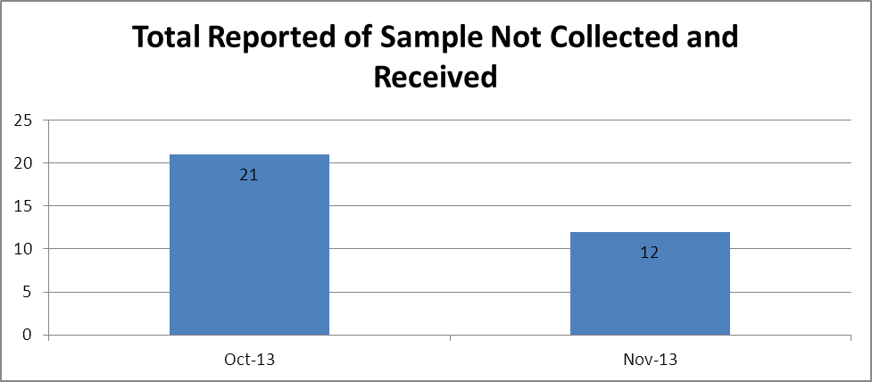

- Manual Requisitions
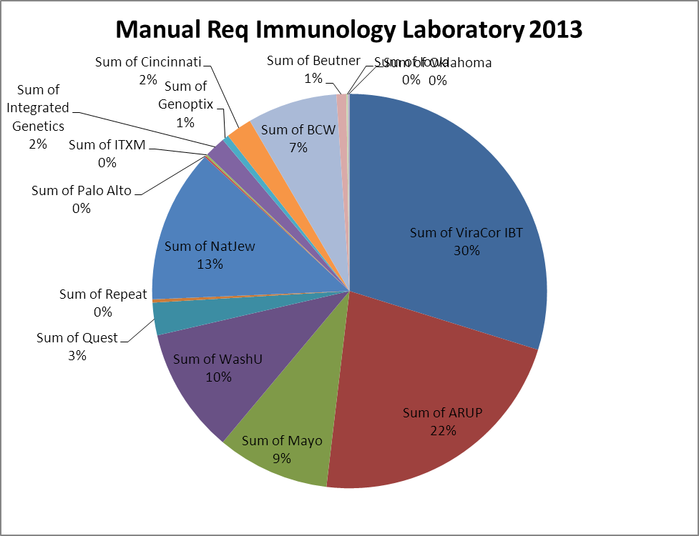

- Financials
IMMUNOLOGY

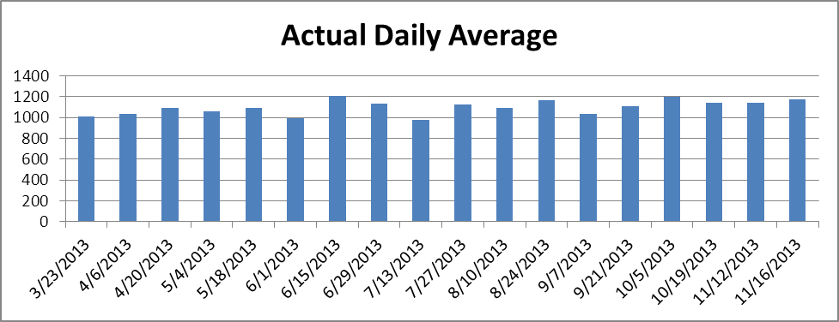

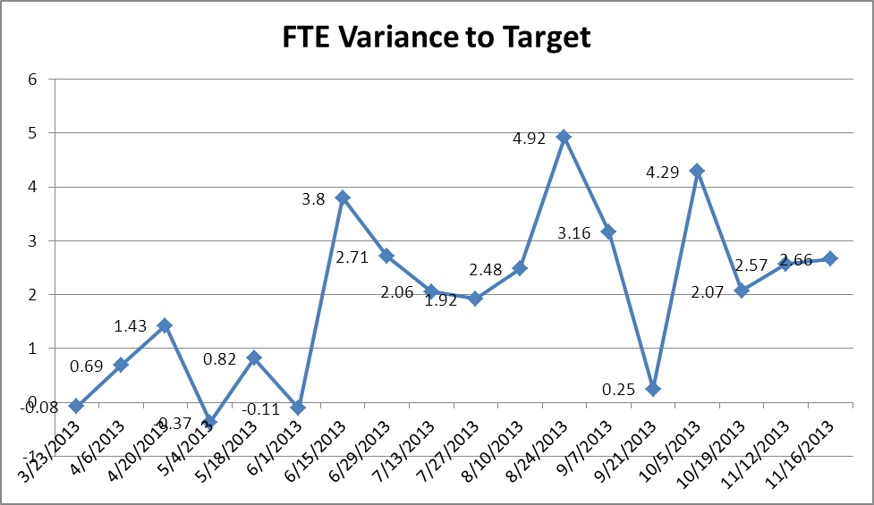

TUMOR PROFILING
