I. Purpose:
To define the Soft computer process of disabling then restarting instrument
autoverification.

II. Procedure
- How to Stop Autoverification on an Instrument:
-On the main screen go to Interfaces
-Choose Interface Setup
-Under Instruments Lab choose the instrument you need to stop autoverification on
(refer to Hematology Main Lab Instruments with Autoverification list at end of
procedure)
-Click the box next to Autopost so there is no √ in the box (refer to screenshot 1)
-Save changes by clicking on
∙ Click YES to “Do you want to save changes?”
∙ Click NO to “Update QC Database?”
∙ Click OK to “Flags 34-39, 48, 49 won’t affect processing if autopost flag
(main setup menu ) is set to “N””
Screenshot 1:
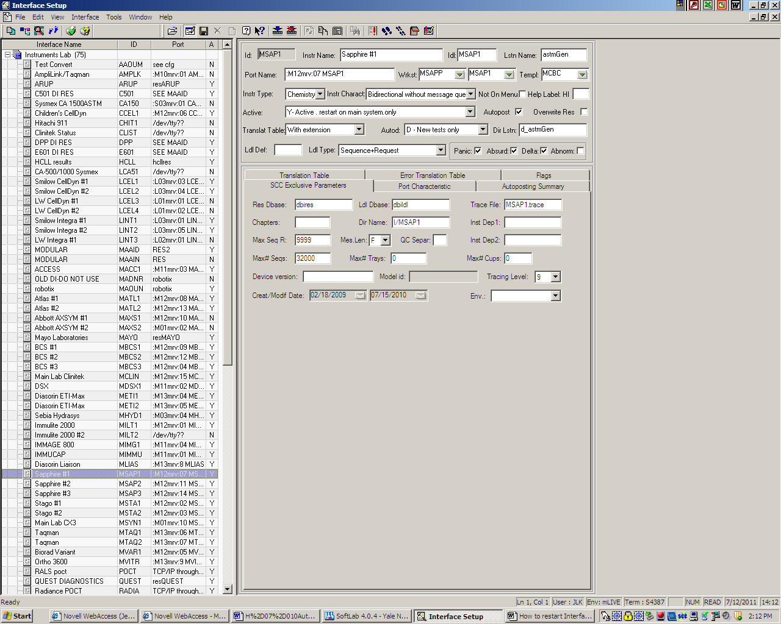
(refer to screenshot 2 for following procedure)
-Under Instruments Lab choose the instrument you need to stop autoverification on
∙ Click the box next to Autopost so there is a √ in the box
∙ Click on the icon with a Blue Arrow with a Red X thru it (stops the
interface)
∙ Click OK when the popup saying the program was killed comes up
∙ Click on the icon with a Blue Arrow (starts the interface)
∙ Click OK to start the interface
∙ Click OK when the popup for the action report comes up
-Select AutoDownload Intfr under Autodownloading
∙ Click on the icon with a Blue Arrow (restarts the interface)
∙ Click OK to start the interface
∙ Click OK when the popup for the action report comes up
-Select Inst AutoPosting under Autoposting
∙ Click on the icon with a Blue Arrow (restarts the interface)
∙ Click OK to start the interface
∙ Click OK when the popup for the action report comes up
-Select Lab AutoReporting AUTLM under Autoreporting Lab
∙ Click on the icon with a Blue Arrow (restarts the interface)
∙ Click OK to start the interface
∙ Click OK when the popup for the action report comes up
-Select Lab AutoReporting AUTLP under Autoreporting Lab
∙ Click on the icon with a Blue Arrow (restarts the interface)
∙ Click OK to start the interface
∙ Click OK when the popup for the action report comes up
-Select Lab AutoReporting AUTLS under Autoreporting Lab
∙ Click on the icon with a Blue Arrow (restarts the interface)
∙ Click OK to start the interface
∙ Click OK when the popup for the action report comes up
-Select Lab AutoReporting AUTOR under Autoreporting Lab
∙ Click on the icon with a Blue Arrow (restarts the interface)
∙ Click OK to start the interface
∙ Click OK when the popup for the action report comes up

Screenshot 2:
1
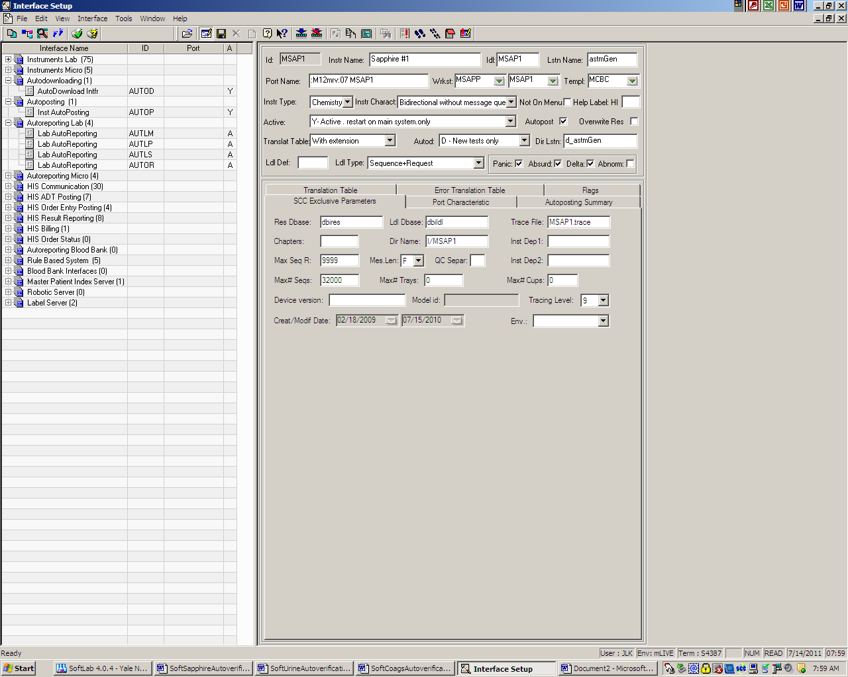
2
3
4
Key:
1 - Blue Arrow to restart
2 – Autodownloading
3 – Autoposting
4 – Autoreporting Lab

- How to Restart Autoverification on an Instrument:
-On the main screen go to Interfaces
-Choose Interface Setup
-Under Instruments Lab choose the instrument you need to restart
autoverification on
∙ Click the box next to Autopost so there is a √ in the box
∙ Click on the icon with a Blue Arrow with a Red X thru it (stops the
interface)
∙ Click OK when the popup saying the program was killed comes up
∙ Click on the icon with a Blue Arrow (starts the interface)
∙ Click OK to start the interface
∙ Click OK when the popup for the action report comes up
-Select AutoDownload Intfr under Autodownloading
∙ Click on the icon with a Blue Arrow (restarts the interface)
∙ Click OK to start the interface
∙ Click OK when the popup for the action report comes up
-Select Inst AutoPosting under Autoposting
∙ Click on the icon with a Blue Arrow (restarts the interface)
∙ Click OK to start the interface
∙ Click OK when the popup for the action report comes up
-Select Lab AutoReporting AUTLM under Autoreporting Lab
∙ Click on the icon with a Blue Arrow (restarts the interface)
∙ Click OK to start the interface
∙ Click OK when the popup for the action report comes up
-Select Lab AutoReporting AUTLP under Autoreporting Lab
∙ Click on the icon with a Blue Arrow (restarts the interface)
∙ Click OK to start the interface
∙ Click OK when the popup for the action report comes up
-Select Lab AutoReporting AUTLS under Autoreporting Lab
∙ Click on the icon with a Blue Arrow (restarts the interface)
∙ Click OK to start the interface
∙ Click OK when the popup for the action report comes up
-Select Lab AutoReporting AUTOR under Autoreporting Lab
∙ Click on the icon with a Blue Arrow (restarts the interface)
∙ Click OK to start the interface
∙ Click OK when the popup for the action report comes up

III. HISTORY:
H-1 This procedure was written by Jessica Kaul on 3/7/2010.
H-2 This procedure was revised by Jessica Kaul on 7/2010.

