Purpose

This document describes a procedure for the quantitative measurement of lamellar bodies in amniotic fluid using the Beckman Coulter Ac*T diff 2 hematology analyzer.

Principle

The lamellar body count is a rapid and quantitative method for assessing Fetal Lung maturity. Lamellar bodies are densely packed layers of phospholipid that represent a storage form of pulmonary surfactant. The similarity of lamellar body diameter to platelet diameter allows the rapid enumeration of lamellar bodies in amniotic fluid by using the platelet impedance channel of the Coulter Ac*T diff 2 Hematology Analyzer.

Clinical Significance

Respiratory distress syndrome (RDS) syndrome of the newborn is the seventh most common cause of newborn mortality in the United States. It is caused by a deficiency in the quantity and/or composition of pulmonary surfactant produced by the neonatal lung, which leads to alveolar collapse and neonatal hypoxia shortly after birth. The incidence of RDS decreases with increasing gestational age such that the risk is less than 5% at gestational ages of 37 weeks or more. Decisions regarding treatment and management rely partially on the results of fetal lung maturity tests. The lamellar body count is a rapid and quantitative method for assessing fetal lung maturity. Lamellar bodies are densely packed layers of phospholipid that represent a storage form of pulmonary surfactant.

Specimen

Minimum 1 mL amniotic fluid in a plastic tube. Do not centrifuge.

Unacceptable Conditions: Mucoid samples; samples that are grossly bloody(RBC ≥0.30x10⁶) or that contain meconium; frozen samples. Samples that have been centrifuged.

Stability

Samples are stable at ambient temperature or refrigerated at 2-8 C for 7 days

Reagents

- Diff AcT Pak (Cat. #8547134) Store at room temperature (20-25 C). Ready to use after install. Beckman Coulter

Equipment

- Coulter Ac*T diff 2 Hematology Analyzers, Serial # AV30432 and # AV30434
- Tube Rocker

Quality Control

- Streck LBC-ChexTM
Reference: 200098

This is a tri-level quality control consisting of mammalian cells in a preservative medium. This is intended to be used as an assayed control material for evaluating the accuracy and precision of hematology analyzers that are being used to measure lamellar body counts.

To Run QC (Closed mode only)(Three levels minimum per shift when testing is required)
- Perform instrument startup
- Remove the three control vials from the refrigerator. It is not necessary to warm the controls to room temperature before using
- To mix:
- Hold vial horizontally between the palms of the hands and roll the vial back and forth for 20 to 30 seconds
- Hold vial on cap end and mix by rapid inversion, using 20 quick flicks of the wrist, to ensure the cells are completely re-suspended
- Invert the vials 8 to 10 times immediately before sampling
- Print the result and verify it in the instrument menu.

Procedure
Running Samples (Patient or QC)
- Perform background from main screen with
Acceptable platelet limits for background are less than 8. The background can be rerun if not acceptable. If background is not acceptable, see Obtaining an acceptable background below. After background is acceptable, proceed to step 2.
Obtaining an acceptable background

- If the instrument has been idle for an extended amount of time, instrument maintenance may be required for the background to be within limits. These steps can be followed in this order with background tests between each step.
  - Run a reagent prime
  - Run a diluent and a lyse prime
  - Run a peripheral blood sample 5-10 times, and try again.
  - Zap the apertures
  - Follow the cleaning the baths procedure.
  - If background still out, consult supervisor and proceed on second instrument.


- At main screen, choose mode of testing

under the analyzing mode icon

(either closed vial or open vial). DO NOT use predilute mode

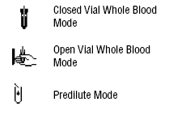
- Touch sample results screen (bottom right) 

- Click bottom right to enter sample ID. (QC results should be entered as 1,2 ,or 3 for the respective low, normal and high levels)

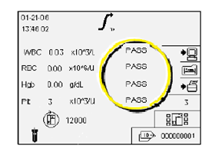

- Click save and exit icon when done


- Mix sample prior to aspiration (See quality control for quality control instructions). Amniotic fluid samples must be mixed on the rocker for five minutes prior to analysis. Aspirate sample in closed mode by placing sample in the door and closing it (closed vial mode on samples with acceptable caps for piercing) or placing the sample under the probe and clicking the button located behind the probe for open mode. The probe will aspirate the sample and retract up into the instrument.

- the result.

- Go to instrument menu for the Ac*T diff 2
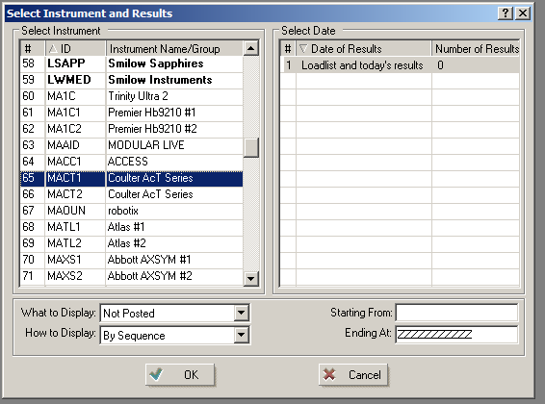
- Post the results by hitting post all for samples or “QC post all” for QC samples

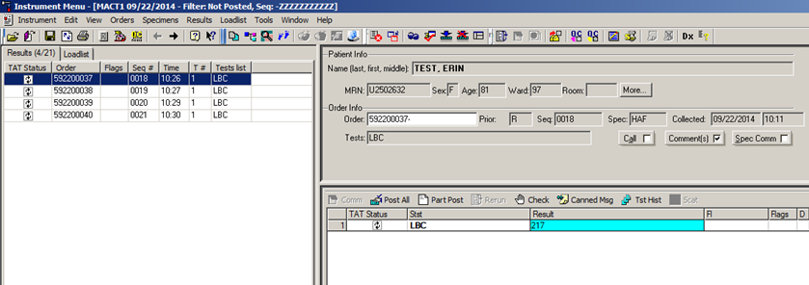

Result Interpretation and Reporting

A lamellar body count result greater than or equal to 50 k/uL is consistent with fetal lung maturity. Because there is no lamellar body count below which fetal lung immaturity can be identified with high certainty, a result less than 50 k/uL can only be interpreted as “not mature.”

This test was developed and performance characteristics determined by Yale-New Haven Hospital's Clinical Laboratories using "analyte specific reagents". It has not been cleared or approved by the U.S. Food and Drug Administration. The FDA has determined that such clearance or approval is not necessary. This report is used for clinical purposes. It should not be regarded as investigational or for research. This laboratory is certified under the Clinical Laboratory Improvement Amendments of 1988 (CLIA) as qualified to perform high complexity clinical laboratory testing.

Clinical Reportable Range
0-450 k/uL

Analytical measurement range
0-450 k/uL

Method Limitations

Mucoid samples; samples that are grossly bloody or that contain meconium; frozen samples

References

- Beckman Coulter. Coulter Ac*T diff 2 Hematology Analyzer Operator’s Guide. August 2010.

- Lockwood, Christina et al. Validation of Lamellar Body Counts Using Three Hematology Analyzers. American Journal of Clinical Pathology. 2010; 134:420-428

- Streck. LBC-ChexTM Package insert. Version 2013-09

H-1 This procedure was written 8/13/2014 by Andrew Link
H-2 This procedure was revised on 10/16/2014 by Andrew Link

