Purpose

This document describes a procedure for the operation of a Coulter Ac*T diff 2 analyzer. This includes routine maintenance and troubleshooting procedures.

Reagents

- Diff AcT Pak (Cat. #8547134) Store at room temperature (20-25 C). Ready to use after install. Beckman Coulter

Equipment

- Coulter Ac*T diff 2 Hematology Analyzers, Serial # AV30432 and # AV30434

Validation of Unassayed Controls

The tri-level control is run over a period of several days in order to create an appropriate mean. The range used is set by Streck for Coulter instrumentation.

Sampling Mode Correlation

The same pathway is used for open and closed modes. Sampling mode correlations are not necessary.

Maintenance

Obtaining an acceptable background

- Sometimes when the instrument has been idle for an extended amount of time, instrument maintenance may be required for the background to be within limits:
  - Run a reagent prime
  - If that does not work, run a peripheral blood sample 5 times, and try again.
  - If that does not work, zap the apertures
  - If that does not work, follow the cleaning the baths procedure below.
  - If background still out, consult supervisor and proceed on second instrument.

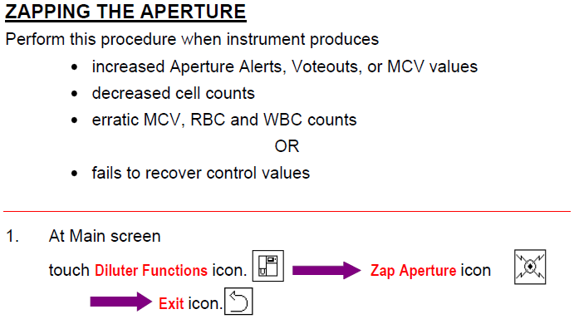
Cleaning the Baths
- Fill a tube with more than 1 mL of high-quality, fragrance-free, gel-free bleach (5 to 6 % of sodium hypochlorite)
- At the main screen touch diluter functions and clean baths icon
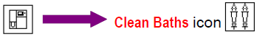
- Place the tube of bleach at probe so that tip is well into bleach, and press aspirate switch. The instrument cleans the baths.
- This takes 15 minutes, do not hit the stop icon
- When complete, touch Exit icon

Calibration
To prepare the instrument, before calibrating, perform:
Precalibration checks
Reproducibility
Carryover
Precalibration checks:
-Required maintenance
-Perform cleaning the baths procedure
-Check for sufficient reagent
-Perform startup
Reproducibility:
- Select closed vial whole blood mode.
Choose a sample that meets the following criteria:
WBC at 6.0-15.0 x10³ cells/µL
RBC at 3.00-6.00 x10³ cells/µL
Hgb at 12-18 x10³ cells/µL
MCV at 80-100 fL
Plt at 200-500 x 10³ cells/µL
- Touch QA icon
- Touch reproducibility icon
- Thoroughly mix sample. Remember to mix sample gently between each cycle.
- Analyze sample in whole blood mode
- When reproducibility sample result displays, touch trash icon to delete the first (prime) sample manually.
- Repeat step 4 until an N of 11 is reached (Look at the upper left corner of screen for n#)
- Verify passed for all parameters
- Print the summary and file
Carryover:
- Select closed vial whole blood mode
- Touch QA icon
- Touch carryover icon
- Thoroughly mix sample and cycle in whole blood mode two times
- Run a blank sample by closing the tube holder
- Repeat step 5 for a total of three blank samples
- Touch summary icon to view carryover summary screen
- Print summary icon and file
Auto calibration with Coulter S-Cal Calibrator
- Prepare S-CAL calibrator according to instructions in S-CAL package insert. Confirm that lot number and expiration date on the vial match information in table of assigned vials. Do not use the calibrator if it is expired.
- Print the calibration setup report
  - Touch setup icon from main screen
  - Touch setup repot icon
  - After it prints, hit the exit icon
- At the main screen select, closed whole blood mode
- Touch QA icon . Then calibration icon
- Enter table of assigned values into the instrument
- Touch continue when complete Mix S-CAL according to package insert
- Run Calibrator 11 times in whole blood mode mixing gently between each cycle
- After 11 results, the summary icon will appear
- Touch the paper icon to view the calibration summary screen
- Print the report summary
- Review results status.
- If calibration necessary, touch save and exit icon to automatically recalibrate with the new factors
- Print the new factors and file
- Verify calibration through analysis of the calibrator material as a patient.
- If Failed appears, the % diff and/or %CV exceeds the high acceptable limit. Do NOT CALIBRATE and contact Beckman Coulter

References

Beckman Coulter. Coulter Ac*T diff 2 Hematology Analyzer Operator’s Guide. August 2010.

Coulter Ac*T diff 2 Hematology Analyzers
Serial number:
Month:
 | 1 | 2 | 3 | 4 | 5 | 6 | 7 | 8 | 9 | 10 | 11 | 12 | 13 | 14 | 15 | 16 | 17 | 18 | 19 | 20 | 21 | 22 | 23 | 24 | 25 | 26 | 27 | 28 | 29 | 30 | 31
Daily( every other day if <5 samples run)
Startup
Shutdown
As needed
Aperture Zap
Cleaning the baths
Non-listed maintenance/ reagent change/problems

