I. Purpose
To define the Soft computer process when resulting Fluids.

II. Procedure

Orderable Tests: Reflex Tests:
CSFH = CSF Cell Count CSFC1 = CSF Tube #1 Count Calculations
CSFC4 = CSF Tube #4 Count Calculations

FCC = Fluid Cell Count FLCT = Fluid Cell Count Calculations

FCRYS = Joint Crystals FURAC = Uric Acid Crystals
FCAPY = Calcium Pyrophosphate Crystals

Resulting Templates:
MCSF – Hematology CSF Tube 1 and Tube 4 – All Pending CSF’s
MCSF1 – Hematology CSF Tube 1 – Pending Tube 1 CSF’s
MCSF4 – Hematology CSF Tube 4 – Pending Tube 4 CSF’s
MFLD – Hematology Fluids

Canned Messages:
@INBA - Intracellular bacteria
@EXBA - Extracellular bacteria
@INEX - Intracellular and extracellular bacteria.
@INCO - Inconsistent results
@IWBC - Inadequate WBC for differential (used when Dialysate <100)
@FLCL - Clot present – estimated counts.
@XAN - Sample xanthochromic
@HEXA - Sample hemolyzed and xanthrochromic.
@GHOS - Ghost cells present. Cell count may be inaccurate.

Cancellation Messages:
|X#02 Quantity not sufficient
|X#04 Laboratory accident
|X#05 Accessioning error
|X#10 Broken/spilled in transit
|XH06 - Cell Count Cancelled; first cell count below threshold.
|XH10 - No CSF tube received in Hematology laboratory

Tube label number doesn’t match tube number:
- There should be a comment in against either test HCSF1 or HCSF4 stating what tube number the count is being performed on
- If there is no comment, enter a comment against test HCSF1 or HCSF4 stating what tube number the count is being performed on

Manual CSF cell count results to be verified for Tube 1:
- Open Resulting Worklist: template – MCSF1
status - Pend and Nonver
from order # - current orders
- Select order # for results to be entered
- CSFH will be under Tests column and in Order Info Tests
- Count red cells and nucleated cells and report
-Click on the Diffpad so it’s highlighted
-Click on the Diffpad Limit icon→enter 500 and Click OK
-Count cells using the keypad. Test RRAW1 (R) is for red cells and WRAW1 (W) is for nucleated cells
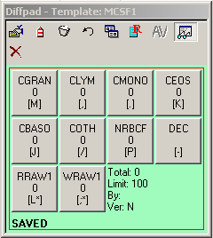

For all fluid counts, Raw cell counts, dilution, # of squares counted and square size should be recorded on log sheets.
Count side 1 of the chamber and record RRAW and WRAW on log sheets. Clear DIFFPAD and count side 2 of the chamber and record RRAW and WRAW on log sheets. Counts should be within 10% of each other. Select one count for entry.
Note: Rbc and Wbc counts processed from the Fluid Sapphire, will be manually entered in Resulting Worklist.
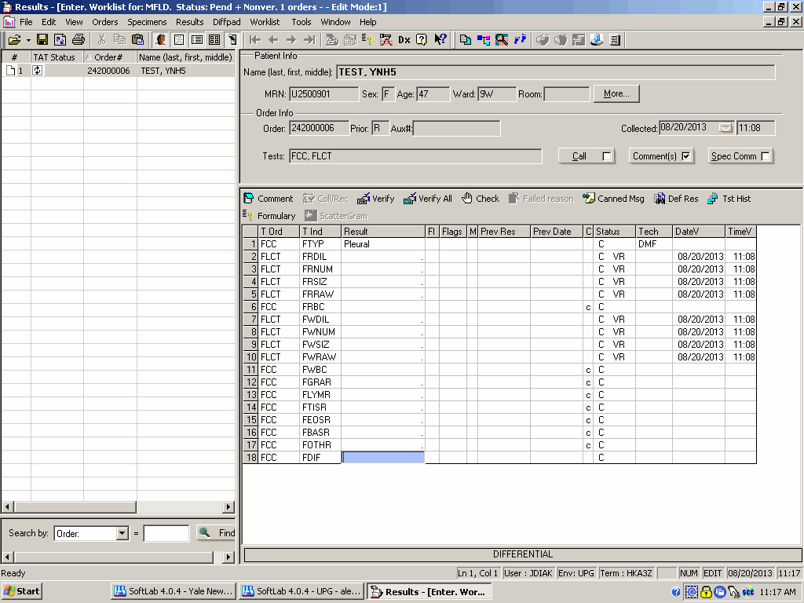

SCREEN SHOT

-Once cells are counted, enter RBC count( from either information:
∙Click on the Result box for CRDL1. Enter the dilution using the keypad choices. If no dilution was used enter NONE.
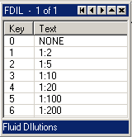

∙Click on the Result box for CRNU1 and enter the number of squares counted. (1, 4 or 9 for large squares, 10 for small squares)
∙Click on the Result box for CRSZ1 and enter the square size using
the keypad choices.

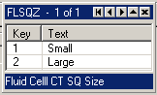

∙Click on the Result box for CRRW1 and enter the value you got
counting the RBC’s from the keypad (test RRAW1).
∙The result for test CRBC will automatically calculate the RBC
count.
**Important – use caution when entering square size and number of squares counted, the system will not prevent discrepancies and invalid cell counts can be resulted. (Example: 10 squares counted vs. large size squares). 10 squares counted should always be matched with small square size.

-Enter nucleated count information:
∙Click on the Result box for CWDL1. Enter the dilution using the keypad choices. If no dilution was used enter NONE.
∙Click on the Result box for CWNU1 and enter the number of squares counted.
∙Click on the Result box for CWSZ1 and enter the square size using the keypad choices.
∙Click on the Result box for CWRW1 and enter the value you got
counting the WBC’s from the keypad (test WRAW1).
∙The result for test CWBC will automatically calculate the WBC
count.
-Clear diffpad results by Clicking on the garbage can icon
-Click Verify All
-Click on the Save icon and click Yes to “Do you want to save the changes you made to the order?”

-If Tube 4 had a differential and Tube 1 does not have a differential:
∙Click on the Result box next to CDIF, Ctrl+K to remove keypad
for test CDIF and enter “.” result
∙Click Save
-Test CSFH1 will be resulted with See Below when test CRBC is verified

Manual CSF cell count results to be verified for Tube 4:
- Open Resulting Worklist: template – MCSF4
status - Pend and Nonver
from order # - current orders
- Select order # for results to be entered
- CSFH will be under Tests column and in Order Info Tests
- Count red cells and nucleated cells and report
-Click on the Diffpad so it’s highlighted
-Click on the Diffpad Limit icon→enter 500 and Click OK
-Count cells using the keypad. Test RRAW1 (R) is for red cells and WRAW1 (W) is for nucleated cells.
-Once cells are counted, enter RBC count information:
∙Click on the Result box for CRDL4. Enter the dilution using the keypad choices. If no dilution was used enter NONE.
∙Click on the Result box for CRNU4 and enter the number of squares counted.
∙Click on the Result box for CRSZ4 and enter the square size using
the keypad choices.
∙Click on the Result box for CRRW4 and enter the value you got
counting the RBC’s from the keypad (test RRAW4).
∙The result for test CRBC4 will automatically calculate the RBC
count.
-Enter nucleated count information:
∙Click on the Result box for CWDL4. Enter the dilution using the keypad choices. If no dilution was used enter NONE.
∙Click on the Result box for CWNU4 and enter the number of squares counted.
∙Click on the Result box for CWSZ4 and enter the square size using the
keypad choices.
∙Click on the Result box for CWRW4 and enter the value you got
counting the WBC’s from the keypad (test WRAW4).
∙The result for test CWBC4 will automatically calculate the WBC
count.
-Clear diffpad results by Clicking on the garbage can icon
-Click Verify All
-Click on the Save icon and click Yes to “Do you want to save the changes you made to the order?”

If 2 CSF Tubes are sent and lowest number tube cell counts within normal limits:
- Count the lowest numbered tube first
- If the cell counts are within normal limits (RBC <5 and nucleated cells <10) the second tube is not counted and should be cancelled
- To cancel the second tube:
- To cancel tube 1, open Resulting Worklist: template – MCSF1
-Enter a “.” result for tests: CRBC, CWBC and CDIF
(Ctrl+K to remove keypad for test CDIF)
-Cancel test CSFH1 by clicking on the result box and hitting F4: Use
cancellation reason |XH06: Cell Count Cancelled; first cell count below
threshold.
-Click Verify All and Save

- To cancel tube 4, open Resulting Worklist: template – MCSF4
-Enter a “.” result for tests: CRBC4, CWBC4 and CDIF4
(Ctrl+K to remove keypad for test CDIF4)
-Cancel test CSFH4 by clicking on the result box and hitting F4: Use
cancellation reason |XH06: Cell Count Cancelled; first cell count below threshold.
-Click Verify All and Save

CSF Differential to be performed and resulted for Tube 1:
- Open Resulting Worklist: template – MCSF1
status - Pend and Nonver
from order # - current orders
- Select order # for results to be entered
- CSFH will be under Tests column and in Order Info Tests
- A Diffpad will display in the lower left hand corner of the screen
-Perform the differential using the diffpad
-Change diffpad limit to desired limit if needed by clicking on the Change Diffpad Limit icon. Type in the limit and click OK.
-If the limit is changed from 100, when the results are verified from the
diffpad they will adjust to be a 100 cell differential.
- Click Verify Diffpad Results to verify the differential
-Results from the diffpad will autofill into results column to corresponding
tests
- Click on the Result box next to CDIF and hit key P (results from the keypad will autofill with Diff Performed)
- Click Verify All and then click YES to “Do you want to save the changes you made to the order #?”
- When the sample is complete there will be a blue checkmark and a pencil by the order #

CSF Differential to be performed and resulted for Tube 4:
- Open Resulting Worklist: template – MCSF4
status - Pend and Nonver
from order # - current orders
- Select order # for results to be entered
- CSFCC will be under Tests column and in Order Info Tests
- A Diffpad will display in the lower left hand corner of the screen
-Perform the differential using the diffpad
-Change diffpad limit to desired limit if needed by clicking on the Change Diffpad Limit icon. Type in the limit and click OK.
-If the limit is changed from 100, when the results are verified from the
diffpad they will adjust to be a 100 cell differential.
- Click Verify Diffpad Results to verify the differential
-Results from the diffpad will autofill into results column to corresponding
tests
- Click on the Result box next to CDIF4 and hit key P (results from the keypad will autofill with Diff Performed)
- Click Verify All and then click YES to “Do you want to save the changes you made to the order #?”
- When the sample is complete there will be a blue checkmark and a pencil by the order #

If Only CSF Tube 1 is Received:
- In Order Entry, check if Tube 4 (Workstation MFLD, Type H4C) has been collected/received by another lab
- If it has been collected/received check to see if it’s a shared sample
- If it has not been collected/received then collect/receive Tube 4 only and Save
- Open Resulting Worklist MCSF4
- Enter a “.” result for tests: CRBC4, CWBC4 and CDIF4 (Ctrl+K to remove keypad for test CDIF4)
- Cancel test CSFH4 by clicking on the result box and hitting F4: Use cancellation reason |XH10: No CSF tube received in Hematology laboratory
- Click Verify All and Save

If Only CSF Tube 4 is Received:
- In Order Entry, check if Tube 1 (Workstation MFLD, Type HC1) has been collected/received by another lab
- If it has been collected/received check to see if it’s a shared sample
- If it has not been collected/received then collect/receive Tube 1 only and Save
- Open Resulting Worklist MCSF1
- Enter a “.” result for tests: CRBC, CWBC and CDIF (Ctrl+K to remove keypad for test CDIF)
- Cancel test CSFH1 by clicking on the result box and hitting F4: Use cancellation reason |XH10: No CSF tube received in Hematology laboratory
- Click Verify All and Save

Manual fluid cell count results to be verified:
- Open Resulting Worklist: template - MFLD
status - Pend and Nonver
from order # - current orders
- Select order # for results to be entered
- FCC will be under Tests column and in Order Info Tests
- Click on the Result box that’s next to FTYP
-A keypad will appear in the upper right hand corner of the screen with a
list of fluids
-Press the key that corresponds with the fluid type being tested
-If Surgical Drain is the fluid type a comment can be entered in Comment that it is, for example, Jackson Pratt
-Peritoneal is one in the same as Ascites
-The name of the fluid type chosen will be in the Result box
- If a Joint Fluid is ordered then Uric Acid Crystals and Calcium Pyrophosphate Crystals are automatically reflexed onto the order
- Count red cells and nucleated cells and report
-Count cells using the keypad. Test FRRAW (R) is for red cells and FWRAW (W) is for nucleated cells. (See images above for reference)
-Once cells are counted, enter RBC count information:
∙Click on the Result box for FRDIL. Enter the dilution using the keypad choices. If no dilution was used enter NONE.
∙Click on the Result box for FRNUM and enter the number of squares counted.
∙Click on the Result box for FRSIZ and enter the square size using
the keypad choices.
∙Click on the Result box for FRBC and enter the value you got
counting the RBC’s from the keypad (test FRRAW).
∙The result for test FRBC will automatically calculate the RBC
count.
**Important – Use caution when entering square size and number of squares counted, the system will not prevent discrepancies and invalid cell counts can be resulted. . (Example: 10 squares counted vs. large size squares). 10 squares counted should always be matched with small square size.

-Enter nucleated count information:
∙Click on the Result box for FWDIL. Enter the dilution using the keypad choices. If no dilution was used enter NONE.
∙Click on the Result box for FWNUM and enter the number of squares counted.
∙Click on the Result box for FWSIZ and enter the square size using the keypad choices.
∙Click on the Result box for FWBC and enter the value you got
counting the WBC’s from the keypad (test FWRAW).
∙The result for test FWBC will automatically calculate the WBC
count.
-Clear diffpad results by Clicking on the garbage can icon
-Click Verify All
-Click on the Save icon and click Yes to “Do you want to save the changes you made to the order?”

- How to report ANC if needed:
-Select (left click) on the FWBC result box
-Click on Comment
-A Results Comment box will appear. Free text in ANC
-Click OK

- If no differential is needed:
-Click on the FWBC Result box. Click next to the FWBC result so the
cursor is next to the result. Click on Comment, Result comment box will appear: Click on Canned Msg, Select inadequate WBC for differential comment and click OK. There will be an M in the M column meaning that there is a comment attached to the result.
-Click on the Result box next to CDIF and hit key N (results from the
keypad will autofill with No Diff Done)
-Click on the Verify All icon the verify both cell counts

Fluid cell counts and differential results to be verified:
- Open Resulting Worklist: template - MFLD
status - Pend and Nonver
from order # - current orders

- Select order # for results to be entered
- FCC will be under Tests column and in Order Info: Tests meaning that the cell counts are pending

- A Diffpad will display in the lower left hand corner of the screen
-Perform the differential using the diffpad
-Change diffpad limit to desired limit if needed by clicking on the Change
Diffpad Limit icon, entering limit and click OK
-If the limit is changed from 100, when the results are verified from the
diffpad they will adjust to be a 100 cell differential.

- Click Verify Diffpad Results to send Diffpad results into the Result boxes
- Results from the diffpad will autofill into the corresponding test to be
verified in the resulting worklist.
- Click Verify All to verify the differential
- Click on the Result box next to FDIF and hit key P (results from the keypad will autofill with Diff Performed)
- When the sample is complete there will be a blue checkmark and a pencil by the order #

To send out ONLY cell counts (but the differential and/or crystals need supervisor review):
- Verify red cell count and nucleated cell count by Clicking Verify for each test result box
- Perform differential on Diffpad
- Click the Save icon
*The differential will save on the diffpad for supervisor review

To send out cell count and differential but not crystals:
- Verify red cell count and nucleated cell count by Clicking Verify for each test result box
- Perform differential on Diffpad and Verify Diffpad results
- Verify each reported cell type by Clicking Verify for each test result box
- Enter Crystal results but DO NOT verify results
- Click the Save icon

Diffpad - Template: MCSF1 Diffpad - Template: MCSF4
CGRAN→CGRAR CGR4→CGR4R
CLYM→CLYMR CLY4→CLY4R
CMONO→CMONR CMO4→CMO4R
CEOS→CEOSR CEO4→CEO4R
CBASO→CBASR CBA4→CBA4R
COTH→COTHR COT4→COT4R
NRBCF→NRBCR CRB4→CRB4R

Diffpad – Template: MFLD
FGRAN→FGRAR
FLYM→FLYMR
FTISS→FTISR
FEOS→FEOSR
FBASO→FBASR
FOTH→FOTHR

*Each test component (except CDIF and CDIF4) will have a “.” in the Result box. The “.” must remain in the Result box unless there is a result to be entered. If it is removed, highlight the Result box that needs the “.”, click on the Default Result icon and it will go back in the Result box. If the sample is verified with no “.” and no result the test will appear as pending.
*When “verify diffpad tests” icon is clicked the results from the diffpad will autofill into the corresponding test to be verified in the resulting worklist

III. HISTORY:
H-1 This procedure was written by Jessica Kaul on 3/7/2010.
H-2 This procedure was revised by Jessica Kaul on 3/29/2011.
H-3 This procedure was revised by Jerry Diakonikolas on 8/14/2013.

