Hematology Lab Weekly Meeting
January 15th, 2015
- Terry from the storage room is out on Medical leave and there’s been request to help Sam out. If you deal with empty boxes please make sure that you put them by the door of LL25, thanks.
- Sunday morning Epic and Soft are going to be down and we need extra people to help on the night shift. This is the usual Epic maintenance that is every third Sunday from 2 to 6 am.
- One of the Surgical Pathology Physician heard that we are making the bone marrow kits and giving the good samples to Flow Cytometry, leaving worse ones for Surg. Path. Just as a reminder if we only have 1 good one send it to flow and let them know to send it to Surg. Path. Surg. Path is trying to make diagnosis on the same materials that Lab Medicine is using. We need to share the good slides with surg. Path also.
- If you have been in Urines and you are running low on MUA-3s’s you may have noticed the abnormal control delivery has been delayed. Donna made some homemade MUA-3 that will get us thru tomorrow or early Saturday. The homemade MUA-3 is in the urine fridge with the #14 labels, Order the testing lot in TQC , run them through the Atlas and post as usual. See screenshot below for ordering in TQC, step 1 –Click on Order Entry, 2 Select the new file by clicking the paper icon, 3 select Item type : Control, Item –ID: MUA-3, and Change Status from Active to Testing, proceed as normal to order QC.
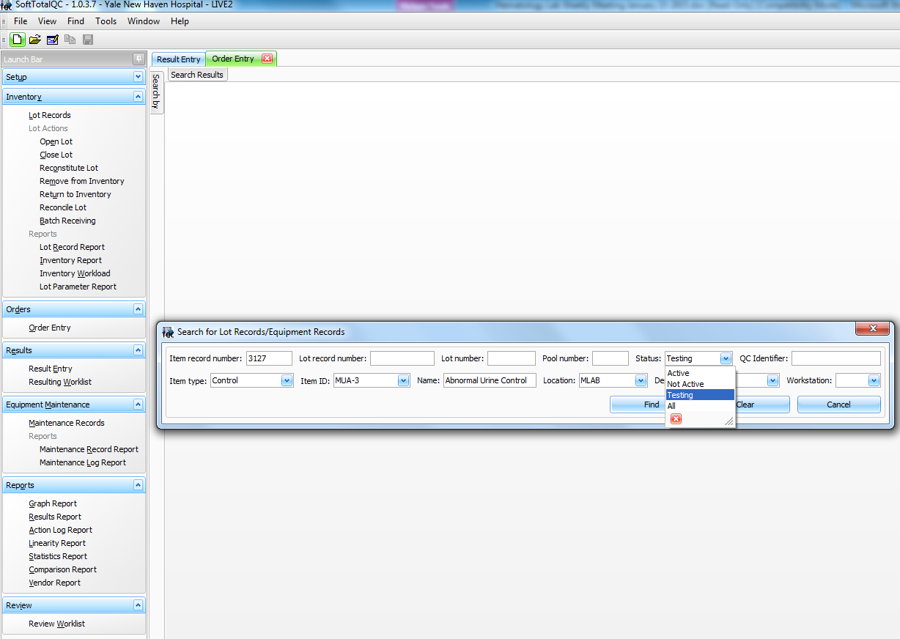
1
2
3

- If any kind of adjustments are made for the centrifuge, temp, etc. You need to write it on the temperature log under comments and what the follow up measurement was after the adjustment was made. Make sure that the temperature is correct on the thermometers and/or the RPM is correct on the centrifuges and within the stated ranges.
- When are CAP inspected Remember to only answer the questions they ask. And if they want a procedure have them see Pat. Remember what to do in case of a fire drill and where to exit in case of an evacuation. RACE, PASS, 155 for emergency number.
- We have a new student, Ashley is from UVM. Let’s welcome her and she will be with us for 3 or 4 weeks.
- The administration is going to be locking more doors for security reasons. Make sure that you have your ID with you at all times.
- Just as a reminder according to our manual differential procedure hypochromia on RBC morphology should only be reported when the MCHC is less than 32.0
- Thank you ALL for your hard work!

