|  |  |  |  |
| --- | --- | --- | --- |
|  | TITLE:  **PROTHROM8675BIN TIME FACTOR ASSAYS (Factors II, V, VII, and X)—ACL TOP 750** | | **DEPT OF LAB MEDICINE**  **CLINICAL HEMATOLOGY**  **Policy and Procedure Manual** |
| **DOCUMENT # HEM 216** |
| **WRITTEN BY:**  Parveen Bahel, MT(ASCP) | **EFFECTIVE DATE:** | **REVIEW/REVISION**  H-1 (New); 08/2019 | **Pages 1-14** |

1. **Intended Use**

Quantitative determination of PT factor assays (Factor II, V, VII, and X) in citrated plasma, based on the prothrombin time (PT assay), on IL coagulation systems.

1. **Purpose**

This procedure provides instructions for the quantitative determination of Factor II, V, VII or X in citrated plasma based on the Prothrombin Time (PT) assay using HemosIL reagents on the ACL TOP instruments.

1. **Principles of the Procedure**

Factor II, V, VII or X activity in a patient’s plasma is determined by performing a modified PT. Patient plasma is diluted and added to plasma deficient in the appropriate factor. Correction of the clotting time of the deficient plasma is proportional to the concentration (% activity) of that factor in the patient plasma interpreted from a calibration curve.

1. **Interpretation of Results**

Decreased levels of Factor II, V, VII or X may be found in congenital deficiency of each Factor or may be acquired secondary to other diseases such as liver disease, hyperfibrinolysis or Disseminated Intravascular Coagulation (DIC) or due to a specific Factor Inhibitor.

FII: Congenital deficiency of FII is a very rare inherited disorder that causes, in general, a mild to moderate bleeding tendency. Patients receiving oral anticoagulant therapy or with a Vitamin K deficiency due to intake or absorption abnormalities will have reduced plasma levels of FII, a Vitamin K dependent clotting factor. Please refer to FII Deficient Plasma (0020012200) insert sheet for further details.

FV: Congenital deficiency of FV leads to Owren’s disease (or parahemophilia), which is a rare inherited disorder that causes mild to severe bleeding. Please refer to FV Deficient Plasma (0020011500) insert sheet for further details.

FVII: Congenital deficiency of FVII is a rare inherited disorder that causes in general mild bleeding. Patients receiving oral anticoagulant therapy or with a Vitamin K deficiency due to intake or absorption abnormalities will have reduced plasma levels of FVII, a Vitamin K depending clotting factor. Please refer to FVII Deficient Plasma (0020011700) insert sheet for further details.

**FX**: Congenital deficiency of FX is a rate inherited disorder that may cause bleeding after dental extractions and other surgery. FX deficiencies may also be acquired secondarily due to systemic amyloidosis, liver diseases, hyperfibrinolysis, and Disseminated Intravascular Coagulation (DIC). Patients receiving oral anticoagulant therapy or with a Vitamin K deficiency due to intake or absorption abnormalities will have reduced plasma levels of FX, a Vitamin K depending clotting factor. Please refer to FX Deficient Plasma (0020010000) insert sheet for further details.

1. **Safety Precautions**

All patient specimens should be considered potentially infectious and must be handled with precautions used for human blood, as described in CDC recommendations and in compliance with the Federal OSHA Bloodborne Pathogen Standard, 29CFR part 1910.1030. Follow specimen handling, use of standard precautions; proper PPE wears gloves and a lab coat. Wear safety glasses if there is a risk of splashing.

1. **Specimen Type**

Mix nine parts of freshly collected blood with one part of 3.2% sodium citrate anticoagulant.

Invert the tube gently three or four times immediately after venipuncture to ensure proper mixing of blood and anticoagulant.

A syringe or evacuated tubes (blue top) may be used for collection. If multiple specimens are collected; the coagulation sample should be the second or third tube collected. If only coagulation testing is to be performed, a red-top tube, which has no additives, should be drawn first and discarded prior to drawing the blue-top coagulation tube.

The patient cannot be on anti-coagulants when the test specimen is collected. Sufficient time after discontinuance of heparin should be allowed for heparin to be cleared from the patient’s blood, usually 6 hours.

If blood is drawn from an indwelling catheter, the line should be flushed with 5.0 mL saline and the first 5 mL of blood or six dead space volumes of the catheter discarded or used for other laboratory tests.

The citrate concentration must be adjusted in patients who have hematocrit values above 55%.

Specimens that are clotted, collected in the wrong tube or serum, overfilled or have less than the 90% expected fill should be rejected.

1. **Handling Condition and Stability**

The whole blood specimen is checked for clot formation by gentle inversion and observation. Centrifuge the capped blood specimen to produce platelet-poor plasma (platelet count <10x109/L for **10** minutes at **4000** g. Patient plasma should be tested within 4 hours. If immediate testing is to be done, the plasma may remain on the packed cells. For special coagulation testing, spin samples **20 minutes at 4000 g**, separate plasma into plastic tubes, label and freeze all aliquots at –70C located in Special coag area until ready to use. Always track aliquots in BEAKER under YH Coag Hold before freezing them. A frost-free freezer should not be used. Frozen plasma samples must be rapidly thawed at 37°C while gently mixing and tested immediately after thawing. If testing is delayed, the sample may be held for 2 hours at 4°C until tested immediately after thawing. If testing is delayed, the sample may be held for 2 hours at 4°C until tested.

**Specimen stability** at ambient temperature: 4 hours; Frozen at -70° C 6 months.

**Specimen Labelling:** Specimen should be properly labeled with at least 2 unique patient identifiers.

1. **Environmental Operating Conditions**

The instrument functions correctly in an ambient temperature of 15° C to 32° C (59° F to 89° F) with a relative humidity of 15% to 85% (non-condensing).

In accordance with the IEC regulations, no instrument failures occur in the presence of short-term ambient temperatures as low as 5° C or as high as 40° C.

The ACL TOP Family 50 Series is compliant with IEC 60068-2-40 to 2000 meters. The instrument should not be used at an altitude greater than 2000 meters.

The instrument should be placed in an area free from dust, fumes, vibrations and excessive variations of temperature.

The heat generated by the instrument during normal operation is exhausted from the bottom, the front-right, and the left side of the unit.

According to IEC 61010-1, the maximum audible noise emission should be 80 dBA. The ACL TOP Family 50 Series is compliant with IEC 61010-1 Third Edition.

The room temperature and humidity percent are monitored and documented on the Routine Coagulation checklist.

1. **Product Information**

**HemosIL RecombiPlasTin 2G** contains lyophilized recombinant human tissue factor, synthetic phospholipids with stabilizers, preservative and buffer and an aqueous diluent

**HemosIL Factor II Deficient Plasma: L**yophilized human plasma that has been artificially depleted of FII, containing buffer and stabilizers. The residual FII activity < 1%, whereas all other factors have normal levels.

**HemosIL Factor V Deficient Plasma L**yophilized human plasma that has been artificially depleted of FV, containing buffer and stabilizers. The residual FV activity < 1%, whereas all other factors have normal levels.

**HemosIL Factor VII Deficient Plasma L**yophilized human plasma that has been artificially depleted of FVII, containing buffer and stabilizers. The residual FVII activity < 1%, whereas all other factors have normal levels.

**HemosIL Factor X Deficient Plasma** Lyophilized human plasma that has been artificially depleted of FX, containing buffer and stabilizers. The residual FX activity < 1%, whereas all other factors have a normal level.

1. **Equipment and Materials** 
   1. **Supplies**
      * Nerl Water: pH 7.0
      * Gauze
      * Citrated blue top tubes
      * Frosted tubes for aliquots
      * Cuvettes
      * ACL Top sample cups
      * HemosIL Cleaning solution Clean A and Clean B
      * HemosIL Rinse and waste
      * HemosIL factor Diluent
   2. **Reagents**

* RecombiplasTin G
* HemosIL factor Diluent
* HemosIL Calibration Plasma
* HemosIL Normal Control Assayed
* HemosIL Special Test Control Level 2
* Factor deficient plasma for FII, FV, FVII and FX

1. **Reagent Preparation**

**RecombiPlasTin 2G:** Allow each vial of reagent and diluent to equilibrate at 15-25˚C for at least 15 minutes before reconstitution.

Pipette the exact amount required **8 mL** of diluent into the vial of reagent. **DO NOT POUR** the contents of the diluent vial into the vial of RecombiPlasTin. Replace the stopper and swirl gently. Let sit for 15 to 20 minutes at 15-25˚C and invert to mix before use.

**Factor Deficient plasmas:** Dissolve the contents of each required vial with 1 mL of Nerl water. Replace the stopper and swirl gently. Ensure the complete reconstitution of the product. Keep at 15-25˚C for 30 minutes and invert to mix before use. Do not shake. Avoid foam formation.

**Cleaning Agent** (Clean B Diluted): Make fresh Clean B Diluted every day, 1 Part Clean B + 7 parts of Nerl water).

**HemosIL Calibrator Plasma (Lyophilized):** Reconstitute with 1 mL of Nerl water. Used for calibration, if needed.

**HemosIL Normal control Assayed** **(Lyophilized):** Reconstitute with 1 mL of Nerl water.

**HemosIL Special control level 2 (Lyophilized):** Reconstitute with 1mL of Nerl water.

1. **Reagent Storage and Stability**

**NOTE: After opening any vial to place onto the instrument, label that vial with the open and expiration date, referring to the stability information provided here. Discard reagent when expired.**

Unopened reagents are stable until the expiration date shown on the vial when stored at 2-8°C.

**RecombiPlasTin 2G:** Stability after reconstitution:

10 days at 2-8°C,

5 days at 15-25°C in the original vial or 10 days at 15°C on the instrument.

**Factor Deficient plasmas:** Stability after reconstitution:

24 hours at 2-8˚C in the original vial or

24 hours at 15˚C on the instrument.

**For optimal stability, remove reagents from the system and store them at 2-8°C in the original vial.**

**Calibrator, Control Storage:** Unopened calibration plasma and controls are stable until the expiration date shown on the vial when stored at 2-8˚C.

Stability of HemosIL Calibrator after reconstitution is 8 hours at 2-8˚C in the original vial. Use reconstituted calibrator within 2 hours for assay calibration

Stability of **Normal and abnormal controls** after reconstitution are 24 hours at 15°C on the instrument.

1. **Calibration Details**

Calibration or recalibration frequency is based on Policy # HEM 179 (Calibration and Analytical measurement Policy).

Calibration and storage of a valid specific Factor Assay calibration curve are required to obtain Factor results. Calibration is performed:

* With a change of reagent lot numbers
* With a change of major instrument components
* To satisfy local regulatory requirements
* At laboratory discretion

**Refer to test feasibility screen for loading of reagents, calibrators, and controls.**

**Steps to follow calibration:**

1. ALWAYS check maintenance log before calibration and make sure all maintenance is current (not overdue) and replace Factor diluent with fresh from a new bottle.
2. Choose **Setup, Materials List, Click Scan** and Scan to 2D barcode on the top of the box of the calibrator if a new lot. This will upload all the information about lot number, expiration date, and assay values **(Skip step c – g below).** Repeat for all reagents if the 2D barcode is not on the box, double-click on the appropriate calibrator to open the **Materials** **Definition** screen.
3. Choose the **Lot Specific Information** tab and enter the Calibrator Lot Number and Expiration Date.
4. Enable **Lot Management** from the Lot Specific Information tab.
5. Select the **Save** icon to store the lot number. Once the lot number is saved, the **Assign Values** icon becomes available.
6. Select the **Assign Values** icon.
7. Enter the calibration value from the package insert. Press **OK**.
8. Choose the **Previous Screen** icon to exit. Load the specific Factor Test PT Reagents, Calibration Plasma, Factor Deficient Plasma(s), Factor Diluent, and Diluted Clean B onto the ACL TOP instrument. **Always use fresh Factor Diluent on-board. Refer to test feasibility screen for loading of reagents/ calibrator and controls. Review the Reagent Area** to verify all materials areloaded correctly.

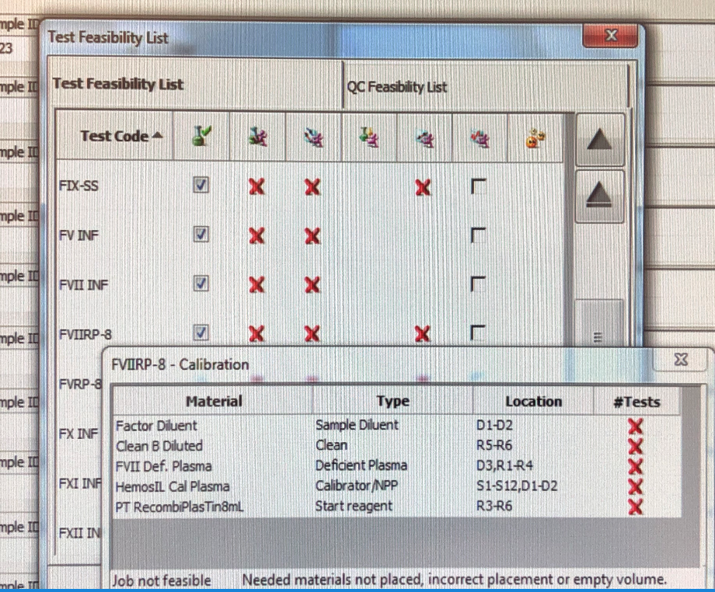

1. Select **Calibration, Status List**.
2. Double-click on the appropriate Factor Assay (FII-RP, FV-RP, etc) to be calibrated to open the **Calibration Details** screen.
3. Single-click the **Run** icon.
4. Select **OK** at the “Do you confirm the operation?” prompt.
5. Choose the **Previous Screen** icon to exit.
6. Verify the Job Status for the Factor Assay test code says **Active.**
7. Once the calibration is complete, review calibration results. The Instrument will fail the calibration if the r2 value is less than 0.985.
8. Choose the **Calibration Information** tab to ensure that no errors or warnings. If there are no errors/failures or flags and the calibration is acceptable, single click **Validate** icon to validate the calibration curve.
9. Always **print Calibration Curve** and put it in the ACL TOP Calibration binder with initial and date.
10. **Quality Control**

HemosIL Normal Control Assayed and Special Test Control Level 2 are to be tested with each factor deficient plasma being used.

* 1. Reconstitute RecombiPlasTin 2G reagent with 8.0 mL RecombiPlasTin 2G Diluent. Replace the stopper and swirl gently. Keep at room temperature for 15 minutes and gently invert to mix before use. The reconstituted reagent is good for 10 days at 2-8°C or at 15°C on the TOP 750.
  2. Before loading QC rack or reagents, make sure the analyzer is in Ready mode.
  3. Load RecombiPlastin G I track R3-R6 and Factor Deficient Plasma(s) specific to the Factor Test in track D3, R1-R4.
  4. Load a Clean B Diluted vial in any available track, D2 or R1-R4. To make Clean B Diluted, add 1 mL Cleaning Agent to 7 mL of Nerl water.
  5. Pour Factor Diluent into a Factor Diluent barcoded vial in a diluent rack. Load into track D1 or D2.
  6. Place QC materials with the barcodes facing out in a Diluent Rack and load the rack in track position D1 or D2.
  7. Review the **Diluent Area** screen to ensure that the controls were identified.
  8. To run QC, choose **QC** from the Main Menu and select **Test Status List**.
  9. Double-click on a test code to open the **Materials / Test Definition tree** in the **QC statistics screen**.
  10. Clear the previous selection by single-clicking box next to Material / Test. to remove checkmark or else all tests from the last run will be repeated (system remembers last QC programming).
  11. Select the checkbox in front of the Factor Assay QC Control
  12. Single-click the **Program QC** **page1image3415738016** icon (Run icon). This will run all QC levels for that test.
  13. To Review QC, a single click on the **Previous screen (back arrow)** will return to **QC Result list.** If the control is acceptable, click on the **page5image3395804144** **data** point, click on the comment icon **page5image3395808928,** and type your initials in the comment box. If control is outside the acceptable range, the Status of the QC in red ‘failed’ and QC alarm at the bottom will alert you. Take an appropriate QC corrective action below.
  14. Controls should be prepared and tested once each 8-hour shift and tested again whenever reagents are added or changed and after each new calibration curve. Tech has to review shift control and placed an initial in the comment box under each control.
  15. Controls should be run in the same manner as the test samples, and by all techs that perform special coagulation testing.
  16. Control tolerance limits--the range is calculated based on +/-2SD from the mean control value. For specific control, plasma values see manufactured assigned values for the respective lot. Initially, the lab will use manufactured assigned values for Factor assays QC and will revise after 6 months accumulating enough data points.

**Corrective action when tolerance limits are exceeded**:

* + 1. Rerun control after swirling QC and reagents.
    2. If still out, check reagent expirations; make new if indicated. Ensure fresh Factor Diluent is on-board and change if necessary (if not changed during set up). Perform Enhanced clean for all the probes.
    3. If control still out, prepare new controls or reagents depending on one level of QC is out or both levels, allow to sit for 20 minutes, mix gently, and rerun.
    4. If controls still out, Recalibrate the assay and notify the supervisor.
    5. Remove the results that are outside the acceptable range by clicking on the unacceptable point and then clicking the omit icon. On the next data point, indicate the corrective action that was performed in the comment box along with your initials. The control results are recorded in the ACL TOP 750 QC files and are reviewed monthly by the supervisor.

**Note: All factor assay controls for the ACL TOP 750 are not formatted in the BEAKER QC program but set up and reviewed in the instrument QC Software file.**

**Add Comment to a QC Data Point**

1. Go to QC that has a failed result in any view mentioned above.
2. **Select page5image3395804144**the data point.
3. Single-click or touch **Comment page5image3395808928.**
4. Enter **“Repeat the same vial of control.”** and your initials then choose **OK.**

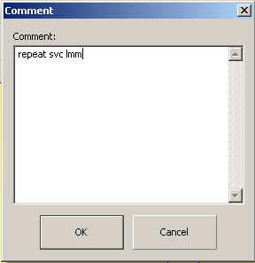

**Omit and Restore a QC Data Point**

* + 1. Verify the Levey-Jennings is displayed for any level.
    2. A single click on the last data point (far right) to **Select** it.
    3. Single-click or touch **Omit** page6image3395713136to omit the result from the statistics.
    4. Choose **OK** at the **Do you confirm to omit selected results?** prompt.
    5. Enter a comment as to why the result was omitted in the **Comment** dialog box and choose **OK.**
    6. Single-click or touch **Switch View** to display the **Split Screen View.**
    7. A page6image3355123184in the **Omit column** indicates the result has been removed from the statistics.

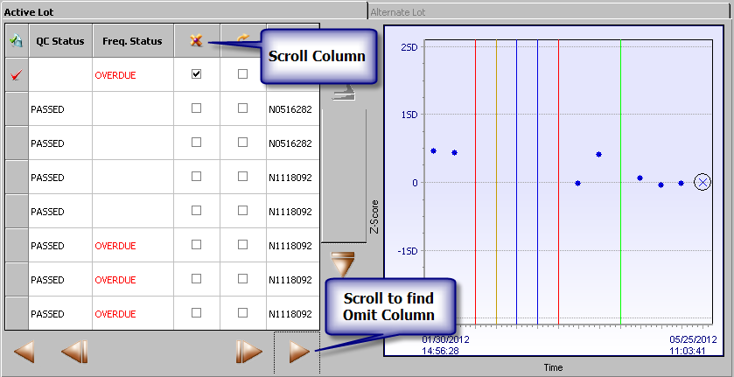

1. **Select page7image3395932048**the same point again then choose **Action ► Results ► Restore Point ► OK** to restore it.
2. Add an additional **comment** in the Comment dialogue box as to why and choose **OK.**
3. **To Run Patient Samples with barcode**
   1. Place sample tubes in a sample rack with barcodes facing outwards.
   2. Select an available sample track and load the sample rack when the barcode reader is in position. It will upload the patient ID. Order the test manually. Double click on the box to the right. Choose the test in the Tests and profile box. For example, factor [FII(P), FV(P), FVII(P), FX(P)] will be under the PT Factors tab.
   3. Verify the samples have been identified and have a test ordered. If not, program the sample ID manually, order the test manually and/or order the Parallelism from the test and programming window.
   4. Choose the **Run** icon if the instrument is not currently running.
4. **To Run Patient Samples with barcode**
   1. Place sample cup in sample rack and label with sample name.
   2. Click on the sample area icon. Double click on the rack to the left.
   3. Enter the sample ID.
   4. Double click on the box to the right. Choose the factor [FII(P), FV(P), FVII(P), FX(P)] under the PT Factors tab in the Tests and Profiles box.
   5. Click the **insert rack icon**. Load into an available track, S1-S12.
   6. If the instrument is currently running and the run icon is greyed out, the sample(s) will be added to the active list and will be run. If the run icon is purple, click it to start the test(s).
5. **Calculations and Reporting Results**

Results of the factor assay testing should be reported in % normal. These results should be related to the reference interval for the factor.

All factor assay patients should be run for three dilutions 100%, 50%, and 25%. The three dilutions can be viewed by clicking on the result. The individual curves can be seen by clicking on the 100%, 50%, and 25% tabs.

**Under the sample list,** highlight the desired patient.

Results will display at the bottom of the screen or by clicking the sample details icon.

Results will also be posted to the right of the patient id if the PT factor sample list setting is chosen under Setup: Display.

Always look under **Corrected results** for all three dilutions and %age CV. The acceptable % CV is <=20%. Since the instrument takes the CV of all three, any result with a CV of 15% or more must be reviewed. Check for a **dilutional effect** (see Reporting Results).

**Mean CR 100%** will display the average of all three dilutions if all the results are within the linear range.

**Mean CR** will display the average of two dilutions if first dilution (100%) is above the linear range which is approximate >150).

1. **Reporting of Factor Assay results:** Results of the factor assay testing should be reported in % normal **rounded to the nearest whole number.**
2. If the result is close to the low end of the normal range, review the results. Report the average of all the dilution results (Mean CR 100%) as long as % CV is <=20%.
3. If all three dilutions are not normal or abnormal, average the 2 results (Mean CR) that are within the same category (normal or abnormal) as long as % CV is <=20% and report.

**Procedures for Abnormal Results:**

1. Normally, all corrected results for a sample should be within 20% (i.e. similar).

Factor levels less than 5% of normal (first time) must be phoned to the patient’s caregiver as a critical value.

1. A sample that falls below 1% is reported out as <1%
2. On occasion, a circulating inhibitor such as a strong lupus anticoagulant or—less frequently—a strong inhibitor to a factor other than the one being analyzed will affect the factor assay results. This is an artifact of the assay system, and the results will appear low (even markedly low) at the 100 dilutions, somewhat higher at the 50 dilutions, and normal or near-normal at the 25 dilutions (as the inhibitor is diluted out –dilutional effect). In this case, none of the three dilutions are within the range, the highest level obtained should be reported out with comment, “ Dilutional effect seen—factor assay result (e.g.FX) showed non-linearity, so reported as the highest value (--%) with a comment, “Cross reacts LAC if Lupus +ve or specific inhibitor or medication effect”.

Patients with a dilutional effect, defined as a 40% or greater increase in the corrected result between consecutive dilutions,

(Note: Sample may need to be auto-diluted and rerun at 12.5% and 6.25% dilutions. This will run 100%, 12.5%, and 6.25%. print report and leave it on supervisor desk for further validation)

If a patient value is >150% in the first two dilutions, report the Highest dilution value at 25% dilution.

Record results in the computer system; most results auto-post. Post through outstanding list / manual reporting referring to the Beaker bench manual as needed.

Hemolyzed, lipemic, or icteric samples must be noted with the result.

1. **Reflex Criteria**

PT / PTT tests will be auto reflexed when any PT Factor assay is requested.

All abnormal results reflex MD Interpretation.

1. **Reference Intervals**

Normal range data for the adult population was validated by the Hematology lab from the hospital and non-hospital patients while the age-specific ranges are from the literature available by

*Age dependency for coagulation parameters in paediatric populations-Pierre Toulon, Micheline Berruyer, Marie Brionne-Francois Grand, Dominique Lasne, Caroline Telion, Julien Arcizet, Roberta Giacomello, Neila De pooter;* *Thromb Haemost 2016; 116; 9-16*

*Development of the hemostatic system in the neonate and infants. Am J pediatr Hematol Oncol 12:95.1990*



**Adult Normal Ranges:**

|  |  |
| --- | --- |
| **Assay** | **Range (%)** |
| Factor II | 56 - 108 |
| Factor V | 65 - 136 |
| Factor VII | 56 - 102 |
| Factor X | 64 - 136 |

1. **Critical Results:**

Any PT factor assay <5.0% should be called to the caregiver (First occurrence only).

1. **Procedural note:**

Overall performance of factor assay testing is dependent on reagent and instrument performance. Acceptable variability (imprecision) should be such that the total coefficient of variation (CV) of the analytic system is less than <=10% on the same lot of Normal control plasma and <=14.0% on the same lot of abnormal control plasma.

The measuring range is defined by the concentration of the calibrators used and the extrapolation limits set

1. **Specific Performance Characteristics**

Within-run and total (run to run and day to day) precision was assessed over multiple runs using both normal and abnormal control samples with a specific lot of PT reagent.

Please refer to the appropriate package insert for precision study results.

1. **Limitations and Interference substances**

Samples with excessive hemolysis, icterus, or lipemia, should not be used.

Fibrinogen assay results (PT-based method) may be affected by degradation products (fibrin or fibrinogen) in the plasma assayed.

1. **References**
2. HemosIL SynthASil (PN 0020006800) package insert
3. ACL TOP® Family On-Line Help Manual
4. Clinical and Laboratory Standards Institute. Collection, Transport, and Processing of Blood Specimens for Testing Plasma-Based Coagulation and Molecular Hemostasis Assays; Approved Guideline - Fifth Edition, CLSI Document H21-A5; Vol. 28 No. 5
5. Westgard JO, and Barry PL. Cost-Effective Quality Control; Managing the Quality and Productivity of Analytical Process, AACC Press, 1986
6. Clinical and laboratory Standards Institute. One Stage Prothrombin Time (PT) Test and Activated Partial Thromboplastin Time (APTT) Test; Approved Guideline – Second Edition, CLSI Document H47-A2; Vol. 28 No. 20
7. HemosIL Factor VIII Deficient plasma (PN 0020011800) package insert
8. HemosIL Factor IX Deficient plasma (PN 0020011900) package insert
9. HemosIL Factor XI Deficient plasma (PN 0020011300) package insert
10. HemosIL Factor XII Deficient plasma (PN 0020011200) package insert
11. Age dependency for coagulation parameters in paediatric populations-Pierre Toulon, Micheline Berruyer,Marie Brionne-Francois Grand, Dominique Lasne, Caroline Telion, Julien Arcizet, Roberta Giacomello, Neila De pooter, Thromb Haemost 2016; 116; 9-16
12. Development of the hemostatic system in the neonate and infants. Am J pediatr Hematol Oncol 12:95.1990
13. **History**

This procedure was written by P Bahel on 9/14/2019