|  |  |  |  |
| --- | --- | --- | --- |
|  | TITLE:  **Activated Protein C Resistance (APCR-V)** - **ACL TOP 750** | | **DEPT OF LAB MEDICINE**  **CLINICAL HEMATOLOGY**  **Policy and Procedure Manual** |
| **DOCUMENT # HEM222** |
| **WRITTEN BY:**  Parveen Bahel, MT(ASCP) | **EFFECTIVE DATE:** | **REVIEW/REVISION**  H-1; (New) 10/2019 | **Pages 1-11** |

1. **Intended Use**

For determination of resistance to activated Protein C, caused by the Factor V:Q506 (Factor V Leiden) mutation, in plasma from untreated individuals and from patients on oral anti-coagulant (OAT) or heparin therapy.

1. **Purpose**

This procedure provides instructions for the analysis of APCR-V using the HemosIL Factor V Leiden (APCR-V) Kit on the ACL TOP® Family.

1. **Summary and Principles**

The APC resistance phenotype is, in more than 90% of cases, due to a mutation in the Factor V gene, resulting in a replacement of Arg 506 (R) with Gln (Q) in the Factor V protein. The selectivity for the Factor V:Q506 or other mutations in the Factor V gene rendering the protein resistant to inactivation by APC is increased by normalizing the concentrations of other plasma proteins involved in the formation and regulation of thrombin. By performing the APTT-based APC resistance assay in the presence of an excess of Factor V Reagent Plasma, the sensitivity and specificity for the Factor V:Q506 mutation is significantly increased. Further, this modification allows for the analysis of plasma from patients who are on OAT

Sample plasma is prediluted with Factor V Reagent Plasma and incubated with the APTT reagent for a standard period of time. Coagulation is triggered by the addition of CaCl2 in the absence and presence of APC and the time of clot formation is recorded.

1. **Interpretation of Results**

The APC Resistance phenotype is, in more than 90% of cases, due to a mutation in the Factor V gene (Factor V Leiden). This results in the Factor V gene making the protein resistant to inactivation by Activated Protein C, thus creating a higher risk of thrombosis.

The abnormal values have APCR-V ratios which are below or equal to the cut-off value.

1. **Specimen Type**

Mix nine parts of freshly collected blood with one part of 3.2% sodium citrate anticoagulant.

Invert the tube gently three or four times immediately after venipuncture to ensure proper mixing of blood and anticoagulant.

A syringe or evacuated tubes (blue top) may be used for collection. If multiple specimens are collected; the coagulation sample should be the second or third tube collected. If only coagulation testing is to be performed, a red-top tube, which has no additives, should be drawn first and discarded prior to drawing the blue-top coagulation tube.

The patient cannot be on anti-coagulants when the test specimen is collected. Sufficient time after discontinuance of heparin should be allowed for heparin to be cleared from the patient’s blood, usually 6 hours.

If blood is drawn from an indwelling catheter, the line should be flushed with 5.0 mL saline and the first 5 mL of blood or six dead space volumes of the catheter discarded or used for other laboratory tests.

The citrate concentration must be adjusted in patients who have hematocrit values above 55%.

1. **Handling Condition and Stability**

The whole blood specimen is checked for clot formation by gentle inversion and observation. Centrifuge the capped blood specimen to produce platelet-poor plasma **(platelet count <10x109/L** for 10 minutes at 4000 g. Patient plasma should be tested within 4 hours. If immediate testing is to be done, the plasma may remain on the packed cells. **For special coagulation testing, spin samples 20 minutes at 4000 g,** separate plasma into plastic tubes, label and freeze all aliquots at –70C located in Special coag area until ready to use. Always track aliquots in BEAKER under YH Coag Hold before freezing them. A frost-free freezer should not be used. Frozen plasma samples must be rapidly thawed at 37°C while gently mixing and tested immediately after thawing. If testing is delayed, the sample may be held for 2 hours at 4°C until tested immediately after thawing. If testing is delayed, the sample may be held for 2 hours at 4°C until tested.

**Specimen stability** at ambient temperature: 4 hours; Frozen at -70° C 6 months.

**Specimen Labelling:** Specimen should be properly labeled with at least 2 unique patient identifiers

1. **Environmental Operating Conditions**

The instrument functions correctly in an ambient temperature of 15° C to 32° C (59° F to 89° F) with a relative humidity of 15% to 85% (non-condensing).

In accordance with the IEC regulations, no instrument failures occur in the presence of short-term ambient temperatures as low as 5° C or as high as 40° C.

The ACL TOP Family 50 Series is compliant with IEC 60068-2-40 to 2000 meters. The instrument should not be used at an altitude greater than 2000 meters.

The instrument should be placed in an area free from dust, fumes, vibrations and excessive variations of temperature.

The heat generated by the instrument during normal operation is exhausted from the bottom, the front-right and the left side of the unit.

According to IEC 61010-1, the maximum audible noise emission should be 80 dBA. The ACL TOP Family 50 Series is compliant with IEC 61010-1 Third Edition.

The room temperature and humidity percent are monitored and documented on the Routine Coagulation checklist.

1. **Equipment and Materials**
   1. **Supplies**
      * Nerl Water: pH 7.0
      * Gauze
      * Citrated blue top tubes
      * Frosted tubes for aliquots
      * Cuvettes
      * ACL Top sample cups
      * ACL TOP 750
   2. **Reagents**

* The **HemosIL** **Factor V Leiden (APCR-V)** Kit
* HemosIL Cleaning solution Clean A and Clean B
* HemosIL Rinse and waste

1. **Product Information**

The **HemosIL** **Factor V Leiden (APCR-V)** Kit (PN 0020008700) consists of

* 1. **APTT Reagent**: 2 vials of purified phospholipids with colloidal silica as contact activator.
  2. **Factor V Reagent Plasma**: 2 vials of lyophilized human plasma with a low level of Factor V activity and filler.
  3. **APC/Calcium Chloride**: 2 vials of human activated Protein C co-lyophilized with CaCl2.
  4. **Calcium Chloride**: 2 vials of calcium chloride in Tris buffer containing bovine serum albumin.
  5. **APC Control Plasma Level 1**: 2 vials of lyophilized human normal plasma.
  6. **APC Control Plasma Level 2**: 2 vials of lyophilized human abnormal plasma

**Note: APTT reagent and APC/CaCl2 are not interchangeable between lots.**

1. **Reagent Preparation**
   1. **APTT Reagent**: Mix thoroughly before use.
   2. **Factor V Reagent Plasma**: Dissolve the contents of each vial with 4 mL Nerl water. Replace the stopper and swirl gently. Ensure complete reconstitution of the product. Keep the reagent at 15-25˚C for 30 minutes and invert to mix before use. Do not shake.
   3. **APC/Calcium Chloride**: Dissolve the contents of each vial with 2 mL Nerl water or equivalent. Replace the stopper and swirl gently. Ensure complete reconstitution of the product. Keep the reagent at 15-25˚C for 30 minutes and invert to mix before use. Do not shake.
   4. **Calcium Chloride**: Ready for use.
   5. **APC Control Plasma Level 1 & 2**: Dissolve the contents of each vial with 1 mL Nerl water. Replace the stopper and swirl gently. Ensure complete reconstitution of the product. Keep at 15-25˚C for 30 minutes and invert to mix before use. Do not shake.
   6. **Cleaning Agent** (Clean B Diluted): Make fresh Clean B Diluted every day, 1 Part Clean B + 7 parts of Nerl water.
2. **Reagent Storage and Stability**

Unopened reagents are stable until the expiration date shown on the vial when stored at 2-8°C.

For optimum stability, remove reagents and calibrator from the system and store them at 2-8°C.in the original vial.

**APTT Reagent:** Opened reagent is stable

1 month at 2-8°C in the original vial or

3 days at 15°C on the ACL TOP. Do not stir. Do not freeze.

**Factor V Reagent Plasma**: Stability after reconstitution

3 months at -20˚C or

3 days at 15˚C on the ACL TOP or

24 hours at 2-8˚C. Do not stir. Frozen reagent should be thawed at 37˚C and gently mixed before use. Do not refreeze.

**APC/Calcium Chloride:** Stability after reconstitution

3 months at -20˚C or below in the original vial (Do not stir. Do not refreeze)or

3 days at 15˚C on the ACL TOP.

5 days at 2-8˚C,

**Calcium Chloride:** Opened reagent is stable

1 month at 2-8°C in the original vial or

3 days at 15˚C on the ACL TOP® Family. Do not stir.

**APC Control Plasma Level 1 & 2:**

6 hours on board and 3 months at -20˚C

|  |
| --- |
| **NOTE: After opening any vial to place onto the instrument, label that vial with the open and expiration date, referring to the stability information provided here. Discard reagent when expired.** |
|
|

1. **Calibration Details :**

No calibration of the system is necessary for performing Activated protein C resistance.

1. **Quality Control**
   1. Load Reagents APTT Reagent, Factor V Reagent plasma, APC/CaCl2, and Calcium Chloride along with Diluted Clean B onto the instrument. Before loading the reagent rack, make sure the analyzer is in Ready mode.

**Refer to the test feasibility screen for the loading of reagents and controls.**

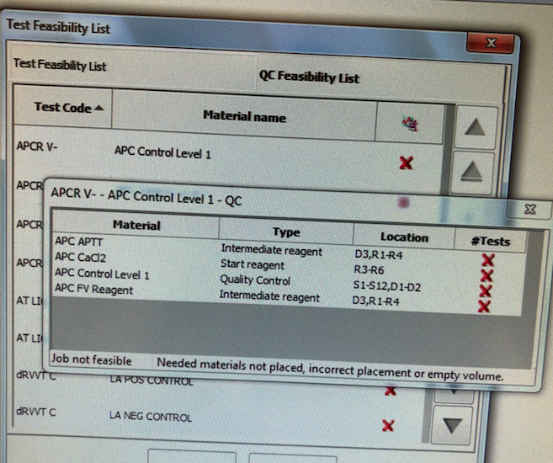

* 1. Place APC 1 and APC 2 controls with the barcodes facing out in a Diluent Rack and load on the instrument in a Diluent track D1 or D2.
  2. Choose **QC** from the Main Menu and select **Test Status List**.
  3. Double-click on a test code to reveal the Test Materials Definition tree in the **QC statistics screen**.
  4. Select the box in front of APCR-V+ and APCR-V- for both levels of QC and choose the **Program QC** icon. This will run all QC levels for that test.

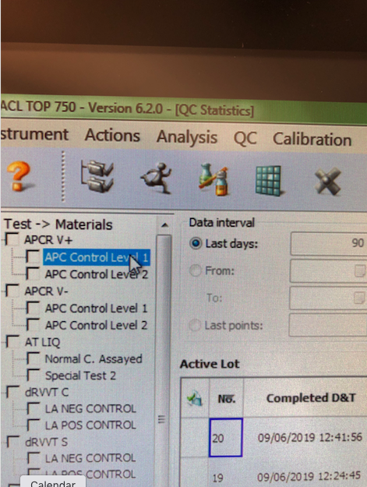

* 1. To Review QC, single click on the **Previous screen (back arrow)**   will return to **QC Result list**
  2. If the control is acceptable, click on the page5image3395804144**data** point, click on the **comment icon** page5image3395808928, and type your initials in the comment box. If control is outside the acceptable range, Status of the QC in red ‘failed’ and QC alarm at the bottom will alert you. Take an appropriate QC corrective action below.
  3. Controls should be prepared and tested once each 8-hour shift and tested again whenever reagents are added or changed. Tech has to review shift control and placed an initial in the comment box under each control.
  4. Controls should be run in the same manner as the test samples, and by all techs that perform special coagulation testing.
  5. Control tolerance limits--the range is calculated based on +/-2SD from the mean control value.

**Corrective action when tolerance limits are exceeded**:

* + 1. Rerun control after swirling QC and reagents.
    2. If still out, check reagent expirations; make new if indicated. Ensure fresh Factor Diluent is on-board and change if necessary (if not changed during set up). Perform Enhanced clean for all the probes.
    3. If control still out, prepare new controls or reagents depending on one level of QC is out or both levels, allow to sit for 20 minutes, mix gently, and rerun.
    4. Verify reagent performance.
    5. Check instrument performance
    6. Document actions are taken to identify and correct the problem before reporting any patient data.
    7. Remove the results that are outside the acceptable range by clicking on the unacceptable point and then clicking the omit icon. On the next data point**, indicate** the corrective action that was performed in the comment box along with your initials. The control results are recorded in the ACL TOP 750 QC files and are reviewed monthly by the supervisor.
    8. If the problem cannot be resolved.Call for Service if necessary and properly document in troubleshooting log.Notify supervisor

**Note: APC controls for the ACL TOP 750 are not formatted in the BEAKER QC program but set up and reviewed in the instrument QC Software file.**

1. **Procedure**
2. **Establish QC ranges for unassayed HemosIL APC control plasma Level 1 and Level 2**

* **Sample procedure to Establish QC range for the new lot of APC kit.** For rollover of an established assay, new lots of QC or reagents are validated by running APC 1 and APC 2 controls daily over 8-days or twice daily over a 5-days period on ACL TOP 2.
* **Calculate QC range (Mean+/- 2SD) using** the above data: Combine data points from the instrument to find the Mean, SD. Our QC range is defined as the mean +/- 2SD.

1. **Procedure for running patient correlation samples**

* Over the course of 4-6 weeks, while a single lot # of APC resistance reagent is being used, approximately 10-15 samples from non-Leiden and 2-3 abnormal samples should be collected which have been run on the instrument with a current lot of reagent.
* After a new lot number of reagent has been obtained, pick a day to run normal/abnormal samples. This should be a day when the instrument is working well, controls are within acceptabl e ranges, and maintenance is up to date.
* Prepare a worksheet with date, sample #, patient #, test result from old lot #, and test result from new lot #. Record results appropriately. Tolerance limit for the cut-off to be kept which is >=2.37.
* Prepare a regression curve for the ratio with old results on the x-axis, and new results on the y-axis. R-value should be > 0.85 to consider the results in correlation, or it is a semi-quantitative test, APCR-V is reported as a ratio. Compare positive patient as positive and Negative patient as negative. If there is a discrepancy in the co-relation study, cut-off should be re-established and has to be approved by Medical Lab Director.

1. **Procedure to establish the Cut-Off Value:** A cut-off value is that value which distinguishes the abnormal from normal samples and must be established for each instrument. APC Resistance is indicated when the APCR-V ratio is below or equal to the cut-off value. Confirm that the inter and intra assay variation is below 7%
2. Over the course of 4-6 weeks, while a single lot # of APC resistance reagent is being used, approximately 15-20 normal samples from individuals in the age range of 20 - 65 years should be collected to validate Cut-off.
3. After a new lot number of reagent has been obtained from the manufacturer, pick a day to run normal samples. This should be a day when the instruments are working well, controls are within acceptable ranges, and maintenance is up to date.
4. Determine the APCR-V ratio. Include HemosIL APC Control Plasma Level 1 and Level 2 for assay validation.
5. Verify that APCR-V ratios for the APC Control Plasmas are within the range on the insert sheet.
6. Calculate the median APCR-V ratio of the 15-20 samples.
7. Calculate the Factor V related APC Resistance cut-off value as follows: if the median is <2.8: 0.8 x median APCR-V ratio (calculated in #4); if the median is >2.8: 0.75 x median APCR-V ratio (calculated in #iii).

The APCR-V ratio for APC Control Plasma Level 1 should be higher than the established cut-off value. The APCR-V ratio for APC Control Plasma Level 2 should be lower than the calculated cut-off value.

1. **Testing Samples and Controls**
2. Load the APC APTT, APC F V, APC APC/CaCl2, APC CaCl2, and Clean B Diluted materials onto the ACL TOP
3. Place QC materials with the barcodes facing out in a Diluent Rack and load onto an instrument Diluent track.
4. Choose **QC** from the Main Menu and select **Test Status List.**
5. Double-click the test code item to reveal the Test Materials Definition tree mentioned above in the Quality control section.
6. Select the box in front of APCR-V+ and APCR-V- for both levels of QC and choose the **Program QC** icon. This will run all QC levels for that test.
7. Place sample tubes in a sample rack with barcodes facing outwards.
8. Select an available sample track and load the sample rack when the barcode reader is in position.
9. Verify the samples **have been identified and have a test ordered. If not, program the sample ID manually** and order the test manually from the test and programming window.
10. Choose the **Run** icon if the instrument is not currently running.

**To Run Patient Samples without barcode**

* + 1. Place sample cup in sample rack and label with sample name.
    2. Click on the sample area icon. Double click on the rack to the left.
    3. Enter the sample ID.
    4. Double click on the box to the right. Choose the APCR-V+ and APCR-V- **under Thrombophilia** tab in the Tests and Profiles box.
       - 1. 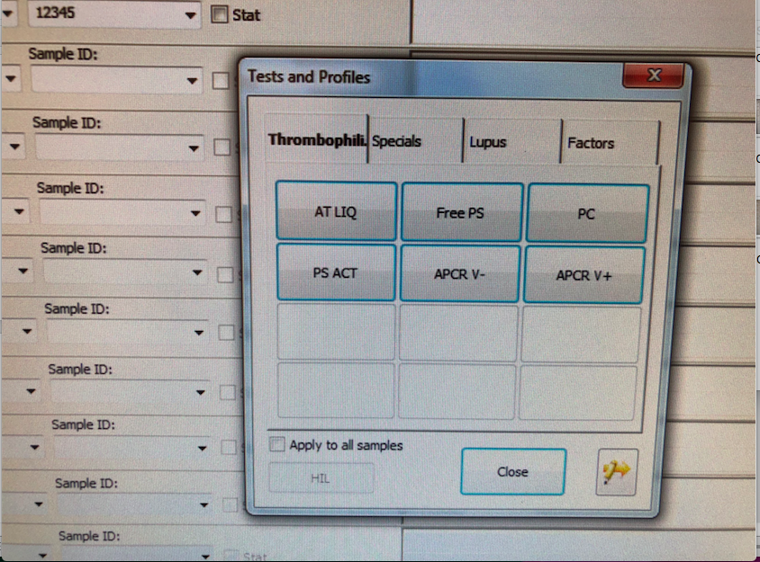
    5. Click the **insert rack** icon. Load into an available track, S1-S12.
    6. If the instrument is currently running and the run icon is greyed out, the sample(s) will be added to the active list and will be run. If the run icon is purple, click it to start the test(s).

1. **Reporting Results**

After the run has completed, check patient ratios for abnormal. The cutoff value is >=2.37. Patients with an APC resistance ratio of 2.37 or higher should be considered normal, and those with a ratio of <2.37 should be considered abnormal.

Record results in the computer system; Post results through the outstanding list.

**Reference Interval:** Normal range cut-off was validated by the Hematology lab from the Hospital and Non-Hospital patients.

The Cut-off for APCR-V is >=2.37

1. **Reflex Criteria** All abnormal results reflex to MD Interpretation.
2. **Critical Results:** No critical result for the procedure.
3. **Procedural note:**

Overall performance of Activated Protein C Resistance testing is dependent on reagent and instrument performance. Acceptable variability (imprecision) should be such that the total coefficient of variation (CV) of the analytic system is less than <=10% on the same lot of APC Level 1 control and <=10% on the same lot of APC Level 2 control

1. **Limitations and Interference substances**

APCR-V Results on the ACL TOP® Family are not affected by:

Hemoglobin up to 500 mg/dL,

Bilirubin up to 18.8 mg/dL,

Triglycerides up to 1791 mg/dL.

Patients with known high inhibitor activity (e.g., phospholipids antibodies) may give an abnormal APTT and thus possibly misleading results. In such cases, increasing the dilution factor (e.g. 1+9 or 1+19) may correct the test result

1. **References**
2. HemosIL Factor V Leiden (APC Resistance V, PN 0020008700) package insert
3. ACL TOP® Family On-Line Help Manual
4. Clinical and Laboratory Standards Institute. Collection, Transport, and Processing of Blood Specimens for Testing Plasma-Based Coagulation and Molecular Hemostasis Assays; Approved Guideline - Fifth Edition, CLSI Document H21-A5; Vol. 28 No. 5
5. Westgard JO, and Barry PL. Cost-Effective Quality Control; Managing the Quality and Productivity of Analytical Process, AACC Press, 1986
6. Clinical and laboratory Standards Institute. One Stage Prothrombin
7. Time (PT) Test and Activated Partial Thromboplastin Time (APTT) Test; Approved Guideline – Second Edition, CLSI Document H47-A2; Vol. 28 No. 20
8. Reference Clinical and Laboratory Standards Institute.Preparation and Testing of Reagent Water in the Clinical Laboratory;Approved Guideline. Fourth,Edition, CLSI Document C3-A4;Vol.26 No.22
9. **History**

This procedure was written by P Bahel on 10/11/2019