|  |  |  |  |
| --- | --- | --- | --- |
|  | TITLE:  **PROTEIN S (Free)—ACL TOP 750** | | **DEPT OF LAB MEDICINE**  **CLINICAL HEMATOLOGY**  **Policy and Procedure Manual** |
| **DOCUMENT # HEM226** |
| **WRITTEN BY:**  Parveen bahel, MT(ASCP) | **EFFECTIVE DATE:** | **REVIEW/REVISION**  H-1(New); 9/2019 | **Pages 1-11** |

1. **Intended Use**

Automated coagulation functional assay for the quantitative determination of free Protein S in human citrated plasma on the ACL TOP 750 Systems as an aid in the diagnosis of hereditary and acquired Protein S deficiency.

1. **Purpose**

This procedure provides instructions for the analysis of Free Protein S (FPS) using HemosILFree Protein S Kit on the ACL TOP® Family.

1. **Summary and Principles**

This test is a latex ligand immunoassay used to quantify FPS in plasma. The presence of FPS is determined by measuring the increase of turbidity produced by the agglutination of two latex reagents. Purified C4BP adsorbed onto the first latex reagent reacts with a high affinity for FPS in patient plasma in the presence of Ca2+ ions. The FPS adsorbed on the C4BP latex triggers the agglutination reaction with the second latex reagent which is sensitized with a monoclonal antibody directed against human Protein S. The degree of agglutination will be directly proportional to the FPS concentration in the test sample.

1. **Interpretation of the Results**

This Vitamin K-dependent protein is present in plasma in two forms, Free Protein S (40%) and Protein S bound to C4b Binding Protein (C4BP). Only Free Protein S has functional cofactor activity.

Protein S deficiency may be hereditary or acquired. Acquired deficiency may be observed during pregnancy, oral anticoagulant therapy, oral contraceptive use, in liver disease, in newborn infants as well as in other clinical conditions. Deficiency of Protein S has been associated with a high risk of developing venous thromboembolism, especially in young people.

1. **Specimen Type**

Mix nine parts of freshly collected blood with one part of 3.2% sodium citrate anticoagulant.

Invert the tube gently three or four times immediately after venipuncture to ensure proper mixing of blood and anticoagulant.

A syringe or evacuated tubes (blue top) may be used for collection. If multiple specimens are collected; the coagulation sample should be the second or third tube collected. If only coagulation testing is to be performed, a red-top tube, which has no additives, should be drawn first and discarded prior to drawing the blue-top coagulation tube.

The patient cannot be on anti-coagulants when the test specimen is collected. Sufficient time after discontinuance of heparin should be allowed for heparin to be cleared from the patient’s blood, usually 6 hours.

If blood is drawn from an indwelling catheter, the line should be flushed with 5.0 mL saline and the first 5 mL of blood or six dead space volumes of the catheter discarded or used for other laboratory tests.

The citrate concentration must be adjusted in patients who have hematocrit values above 55%.

Specimens that are clotted, collected in the wrong tube or serum, overfilled or have less than the 90% expected fill should be rejected.

1. **Handling Condition and Stability**

The whole blood specimen is checked for clot formation by gentle inversion and observation. Centrifuge the capped blood specimen to produce platelet-poor plasma **(platelet count <10x109/L** for 10 minutes at 4000 g. Patient plasma should be tested within 4 hours. If immediate testing is to be done, the plasma may remain on the packed cells. **For special coagulation testing, spin samples 20 minutes at 4000 g,** separate plasma into plastic tubes, label and freeze all aliquots at –70C located in the Special coag area until ready to use. Always track aliquots in BEAKER under YH Coag Hold before freezing them. A frost-free freezer should not be used. Frozen plasma samples must be rapidly thawed at 37°C while gently mixing and tested immediately after thawing. If testing is delayed, the sample may be held for 2 hours at 4°C until tested immediately after thawing. If testing is delayed, the sample may be held for 2 hours at 4°C until tested.

**Specimen stability** at ambient temperature: 4 hours; Frozen at -70° C 6 months.

**Specimen Labelling:** Specimen should be properly labeled with at least 2 unique patient identifiers

1. **Environmental Operating Conditions**

The instrument functions correctly in an ambient temperature of 15° C to 32° C (59° F to 89° F) with a relative humidity of 15% to 85% (non-condensing).

In accordance with the IEC regulations, no instrument failures occur in the presence of short-term ambient temperatures as low as 5° C or as high as 40° C.

The ACL TOP Family 50 Series is compliant with IEC 60068-2-40 to 2000 meters. The instrument should not be used at an altitude greater than 2000 meters.

The instrument should be placed in an area free from dust, fumes, vibrations and excessive variations of temperature.

The heat generated by the instrument during normal operation is exhausted from the bottom, the front-right and the left side of the unit.

According to IEC 61010-1, the maximum audible noise emission should be 80 dBA. The ACL TOP Family 50 Series is compliant with IEC 61010-1 Third Edition.

The room temperature and humidity percent are monitored and documented on the Routine Coagulation checklist.

1. **Equipment and Materials**
   1. **Supplies**
      * Nerl Water: pH 7.0
      * Gauze
      * Citrated blue top tubes
      * Frosted tubes for aliquots
      * Cuvettes
      * ACL Top sample cups
      * ACL TOP 750
   2. **Reagents**

* HemosIL Calibrator Plasma
* HemosIL Normal control Assayed
* HemosIL test Control level 2
* HemosIL Free Protein S kitwhich contain protein S reagent, protein S deficient plasma and Calcium Chloride
* HemosIL Cleaning solution Clean A and Clean B
* HemosIL Rinse and waste

1. **Product Information**

The **HemosIL Protein S Activity kit (**PN 0020302000) contains

**C4BP Buffer: 3** vials of Borax buffer containing bovine serum albumin, stabilizers and preservative.

**C4BP Latex Reagent: 3** vials vials of a lyophilized suspension of polystyrene latex particles coated with purified human C4BP. It also contains bovine serum albumin, stabilizers and preservative.

**Anti-PS MAb Latex Reagent:** 3 vials of a suspension of polystyrene latex particles coated with a monoclonal antibody directed against human Protein S containing bovine serum albumin, stabilizers and preservative

1. **Reagent Preparation**

**C4BP Buffer:** Ready for use.

**C4BP Latex Reagent:** Dissolve the contents of each vial by pouring the entire contents of one vial of C4BP Buffer into one vial of C4BP Latex Reagent.

Replace the stopper and swirl gently for a minimum of 20 seconds to completely dissolve the lyophilized latex.

Ensure complete reconstitution of the product. It must appear as a homogenous and slightly milky suspension.

Keep the reagent at 15-25˚C for 30 minutes and invert to mix before use. Do not shake.

**Anti PS MAb Latex Reagent:** Invert to mix before use. Do not shake.

**Note:** Avoid foam formation when homogenizing reconstituted reagents. Bubbles on top of the liquids may interfere with the instrument liquid sensors

**Cleaning Agent** (Clean B Diluted): Make fresh Clean B Diluted every day, 1 Part Clean B + 7 parts of Nerl water.

**HemosIL Calibrator Plasma (Lyophilized):** Reconstitute with 1 mL of Nerl water. Used for calibration, if needed.

**HemosIL Normal control Assayed** **(Lyophilized):** Reconstitute with 1 mL of Nerl water.

**HemosIL test control Level 2 (Lyophilized):** Reconstitute with 1mL of Nerl water.

1. **Reagent Storage and Stability**

Unopened reagents are stable until the expiration date shown on the vial when stored at 2-8°C.

For optimum stability, remove reagents and calibrator from the system and store them at 2-8°C.in the original vial.

**C4BP Latex Reagent** is stable after reconstitution,

1 month at 2-8 °C in the original vial or

1 week at 15°C on the ACL TOP. Do not freeze.

**Anti PS MAb Latex Reagent** is stable after opening,

1 month at 2-8˚C in the original vial or

1 week at 15˚C on the ACL TOP. Do not freeze

**Important Notes:**

Frozen reagent and plasmas should be thawed at 37C and gently mixed before use. Before freezing they can be aliquoted using plastic tubes and stoppers. Do not refreeze.

**Calibrator, Control Storage:** Unopened calibration plasma and controls are stable until the expiration date shown on the vial when stored at 2-8˚C.

Stability of HemosIL Calibrator after reconstitution is 8 hours at 2-8˚C in the original vial. Use reconstituted calibrator within 2 hours for assay calibration

Stability of Normal and abnormal controls after reconstitution are 24 hours at 15°C on the instrument.

1. **Calibration Details**

Calibration or recalibration frequency is based on Policy # HEM 179 (Calibration and Analytical measurement Policy).

Calibration and storage of a valid Free Protein S calibration curve are required to obtain Free protein S results. Calibration is performed:

* + - With a change of reagent lot numbers
    - With a change of major instrument components
    - To satisfy local regulatory requirements
    - At laboratory discretion

**Refer to test feasibility screen for loading of reagents, calibrators, and controls.**

**Steps to follow calibration:**

1. **ALWAYS** check maintenance log before calibration and make sure all maintenance is current (not overdue) and replace Factor diluent with fresh from a new bottle.
2. Choose **Setup, Materials List, Click Scan** and Scan to 2D barcode on the top of the box of the calibrator if a new lot. This will upload all the information about lot number, expiration date, and assay values **(Skip step c – g below).** Repeat for all reagents if the 2D barcode is not on the box, double-click on the Free PS calibrator to open the **Materials** **Definition** screen.
3. Choose the **Lot Specific Information** tab and enter the Calibrator Lot Number and Expiration Date.
4. Enable **Lot Management** from the Lot Specific Information tab.
5. Select the **Save** icon to store the lot number. Once the lot number is saved, the **Assign Values** icon becomes available.
6. Select the **Assign Values** icon.
7. Enter the calibration value from the package insert. Press **OK**.
8. Choose the **Previous Screen** icon to exit.
9. Load both Free Protein S reagents (C4BP Latex and Anti PS MAb Latex), Factor Diluent and Calibration Plasma, and Diluted Clean B onto the instrument.

**Note: Always use fresh Factor Diluent on-board if calibrating Factor assays.**

**Refer to test feasibility screen for loading of reagents/ calibrator and controls.**

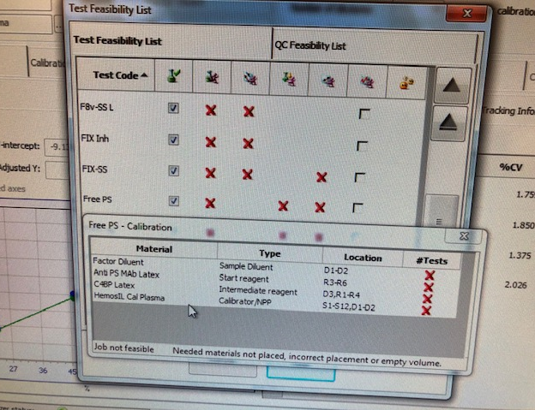

1. Select **Calibration, Status List**.
2. Double-click the FREE PS test to open the **Calibration Details** screen.
3. Choose the **Run** icon.
4. Select **OK** at the “Do you confirm the operation?” prompt.
5. Choose the **Previous Screen** icon to exit.
6. Verify the Job Status for the Free Protein S test code says **Active.**
7. Once the calibration is complete, review calibration results. The Instrument will fail the calibration if the r2 value is less than 0.980.
8. Choose the Calibration Information tab to ensure that no errors or warnings. If there are no errors/failures or flag and the calibration is acceptable, choose the Validate icon to validate the calibration curve.
9. Always **print Calibration Curve** and put it in the ACL TOP 2 Calibration binder with initial and date.
10. **Quality Control**
    1. Load Free Protein S Reagent (C4BP Latex and Anti PS MAb Latex), Factor Diluent and Calibration Plasma, and Diluted Clean B onto the instrument. Before loading the reagent rack, make sure the analyzer is in Ready mode.

**Refer to test feasibility screen for loading of reagents/ calibrator and controls.**

* 1. Place normal and abnormal controls with the barcodes facing out in a Diluent Rack and load on the instrument in a Diluent track D1 or D2.
  2. Choose **QC** from the Main Menu and select **Test Status List**.
  3. Double-click on a test code to reveal the Test Materials Definition tree in the **QC statistics screen**.
  4. Select the box in front of the FREE PS QC box test and choose the **Program QC** icon. This will run all QC levels for that test.
  5. To Review QC, single click on the **Previous screen (back arrow)**  will return to **QC Result list.**
  6. If the control is acceptable, click on the page5image3395804144**data** point, click on the **comment icon** page5image3395808928, and type your initials in the comment box. If control is outside the acceptable range, the Status of the QC in red ‘failed’ and QC alarm at the bottom will alert you. Take an appropriate QC corrective action below.
  7. Controls should be prepared and tested once each 8-hour shift and tested again whenever reagents are added or changed and after each new calibration curve. Tech has to review shift control and placed an initial in the comment box under each control.
  8. Controls should be run in the same manner as the test samples, and by all techs that perform special coagulation testing.
  9. Control tolerance limits--the range is calculated based on +/-2SD from the mean control value.

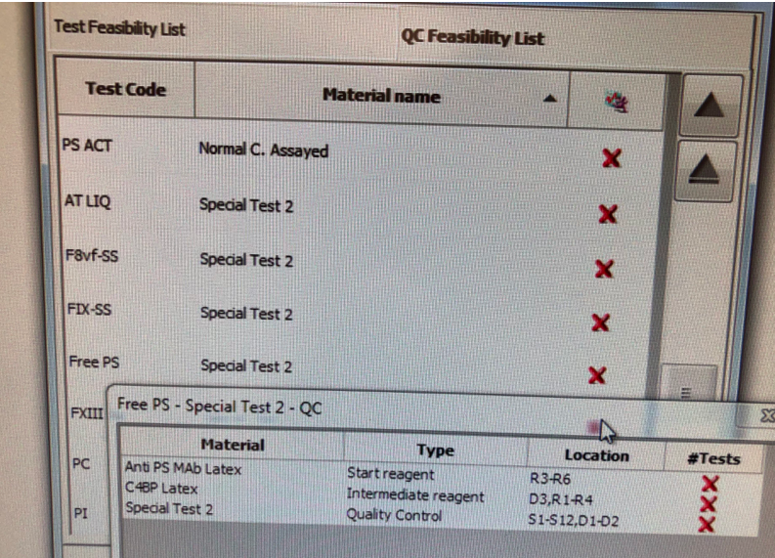

**Corrective action when tolerance limits are exceeded**:

* + 1. Rerun control after swirling QC and reagents.
    2. If still out, check reagent expirations; make new if indicated. Ensure fresh Factor Diluent is on-board and change if necessary (if not changed during set up). Perform Enhanced clean for all the probes.
    3. If control still out, prepare new controls or reagents depending on one level of QC is out or both levels, allow to sit for 20 minutes, mix gently, and rerun.
    4. If controls still out, Recalibrate the assay and notify the supervisor.
    5. Verify reagent performance.
    6. Check instrument performance
    7. Document actions are taken to identify and correct the problem before reporting any patient data.
    8. Remove the results that are outside the acceptable range by clicking on the unacceptable point and then clicking the omit icon. On the next data point**, indicate** the corrective action that was performed in the comment box along with your initials. The control results are recorded in the ACL TOP 750 QC files and are reviewed monthly by the supervisor.
    9. If the problem cannot be resolved, call for Service if necessary and properly document in troubleshooting log.Notify supervisor.

**Note: Free Protein S controls for the ACL TOP 750 are not formatted in the BEAKER QC program but set up and reviewed in the instrument QC Software file.**

1. **Procedure:**
2. Load reagents onto the instrument. Calibrate, if necessary (see calibration section of this procedure).
3. Place QC materials with the barcodes facing out in a Diluent Rack and load onto an instrument Diluent track.
4. Choose **QC** from the Main Menu and select **Test Status List.**
5. Double-click on the **FREE PS** test code item to reveal the **Test Materials Definition tree.**
6. Select the box in front of the **Free PS Controls** and choose the **Program QC** icon. This will run all QC levels for that test.
7. Place sample tubes in a sample rack with barcodes facing outwards.
8. Select an available sample track and load the sample rack when the barcode reader is in position.
9. Verify the samples **have been identified and have a test ordered. If not, program the sample ID manually** and order the test manually from the test and programming window.
10. Choose the **Run** icon if the instrument is not currently running.

**To Run Patient Samples without barcode**

* + - * Place sample cup in sample rack and label with sample name.
      * Click on the sample area icon. Double click on the rack to the left.
      * Enter the sample ID.
      * Double click on the box to the right. Choose the FREE **PS test under the Thrombophilia** tab in the Tests and Profiles box.

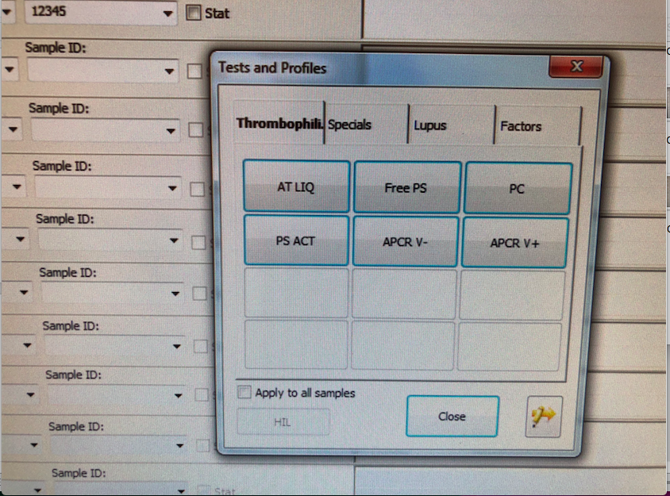

* + - * Click the **insert rack** icon. Load into an available track, S1-S12.
      * If the instrument is currently running and the run icon is greyed out, the sample(s) will be added to the active list and will be run. If the run icon is purple, click it to start the test(s).

1. **Reporting Results**

Free Protein S results are reported in % Activity.

Linearity for this assay is 11 - 150%.

If the result is greater than the reportable range (150%) the sample will be automatically repeated with a 1:2 dilution.

The upper limit of reporting is 300%; if the result is higher than >300%, it will flag as “result above linear range” report “>300%” and any result lower than 11 will be reported as <11%.

Record results in the computer system; Post results through the outstanding list / manual reporting referring to the Beaker bench manual as needed.

Hemolyzed, lipemic, or icteric samples must be noted with the result.

**Reference Interval:** Normal range data for the adult population was validated by the Hematology lab from the Hospital and Non-Hospital patients while the age-specific ranges are from the literature available by

“*Age dependency for coagulation parameters in paediatric populations-Pierre Toulon, Micheline Berruyer,Marie Brionne-Francois Grand, Dominique Lasne, Caroline Telion, Julien Arcizet, Roberta Giacomello, Neila De poote:Thromb Haeosmt 2016; 116; 9-16”*

*Development of the hemostatic system in the neonate and infants. Am J pediatr Hematol Oncol 12:95.1990*

**Adult Normal Range: 47 – 121%**

**Age-specific reference ranges from Literature;**



**Reflex Criteria**: All abnormal results reflex to MD Interpretation.

Free Protein S auto reflexed if Protein S Activity <50%.

1. **Critical Results:** No critical result for the procedure.
2. **Procedural note:**

The overall performance of Free Protein S testing is dependent on reagent and instrument performance. Acceptable variability (imprecision) should be such that the total coefficient of variation (CV) of the analytic system is less than <=10% on the same lot of Normal control plasma and <=12% on the same lot of Special test control level 2.

The measuring range is defined by the concentration of the calibrators used and the extrapolation limits set

1. **Specific Performance Characteristics**

Within-run and total (run to run and day to day) precision was assessed over multiple runs using both normal and abnormal control samples with a specific lot of Free Protein S reagents.

Please refer to the package insert for precision study results.

1. **Limitations and Interference substances**

Free Protein S results on the ACL TOP are not affected by:

Heparin (UF heparin or LMW heparin) up to 1.5 IU/mL,

Hemoglobin up to 200 mg/dL,

Bilirubin up to 25 mg/dL,

Triglycerides up to 1500 mg/dL,

Platelets up to 1010/L

Rheumatoid Factor up to 900 IU/mL

1. **References**
2. HemosIL Free Protein S package insert
3. ACL TOP® Family On-Line Help Manual
4. Clinical and Laboratory Standards Institute. Collection, Transport, and Processing of Blood Specimens for Testing Plasma-Based Coagulation and Molecular Hemostasis Assays; Approved Guideline - Fifth Edition, CLSI Document H21-A5; Vol. 28 No. 5
5. HemosIL Calibration Plasma Insert Sheet
6. Age dependency for coagulation parameters in paediatric populations-Pierre Toulon, Micheline Berruyer,Marie Brionne-Francois Grand, Dominique Lasne, Caroline Telion, Julien Arcizet, Roberta Giacomello, Neila De pooter, Thromb Haemost 2016; 116; 9-16
7. Development of the hemostatic system in the neonate and infants. Am J pediatr Hematol Oncol 12:95.1990
8. **History**

This procedure was written by P Bahel on 9/29/2019