|  |  |  |  |
| --- | --- | --- | --- |
|  | TITLE:  **Alpha-2-Antiplasmin (Plasmin Inhibitor) ACL TOP 750** | | **DEPT OF LAB MEDICINE**  **CLINICAL HEMATOLOGY**  **Policy and Procedure Manual** |
| **DOCUMENT # HEM220** |
| **WRITTEN BY:**  Parveen Bahel, MT(ASCP) | **EFFECTIVE DATE:** | **REVIEW/REVISION**  H-1;(New)-10/2019 | **Pages 1-11** |

1. **Intended Use**

Automated chromogenic assay for the quantitative determination of Plasmin Inhibitor (also known Alpha2-Antiplasmin) as in human citrated plasma on IL Coagulation Systems

1. **Purpose**

This procedure provides instructions for the quantitative determination of as Alpha-2-Antiplasmin (also known as Plasmin Inhibitor) in human citrated plasma using HemosIL Plasmin Inhibitor on the ACL TOP.

1. **Summary and Principles**

Alpha2-Antiplasmin, the major fast-acting inhibitor of the fibrinolytic system, also known as Plasmin Inhibitor, is an important regulator of the fibrinolytic system. Congenital deficiencies are associated with hemorrhagic problems.2 Decreased levels of Plasmin Inhibitor are observed in liver diseases and DIC. Increased levels have been reported during postoperative episodes.

The Plasmin Inhibitor kit is an assay based on synthetic chromogenic substrate and on plasmin inactivation.

Plasmin Inhibitor levels in patient plasma are measured automatically on IL Coagulation Systems in two stages:

1. Incubation of the plasma with the plasmin reagent in the presence of methylamine.
2. Quantification of the residual plasmin activity with a synthetic chromogenic substrate. The paranitroaniline released is monitored kinetically at 405 nm and is inversely proportional to the Plasmin

Inhibitor level in the test sample

1. **Interpretation of Results**

Alpha2-Antiplasmin, also known as Plasmin Inhibitor is the primary inhibitor of the fibrinolytic system. Congenital deficiencies are associated with hemorrhagic problems. Decreased levels are observed in liver diseases and DIC. Increased levels have been reported during postoperative episodes.

1. **Specimen Type**

Mix nine parts of freshly collected blood with one part of 3.2% sodium citrate anticoagulant.

Invert the tube gently three or four times immediately after venipuncture to ensure proper mixing of blood and anticoagulant.

A syringe or evacuated tubes (blue top) may be used for collection. If multiple specimens are collected; the coagulation sample should be the second or third tube collected. If only coagulation testing is to be performed, a red-top tube, which has no additives, should be drawn first and discarded prior to drawing the blue-top coagulation tube.

The patient cannot be on anti-coagulants when the test specimen is collected. Sufficient time after discontinuance of heparin should be allowed for heparin to be cleared from the patient’s blood, usually 6 hours.

If blood is drawn from an indwelling catheter, the line should be flushed with 5.0 mL saline and the first 5 mL of blood or six dead space volumes of the catheter discarded or used for other laboratory tests.

The citrate concentration must be adjusted in patients who have hematocrit values above 55%.

Specimens that are clotted, collected in the wrong tube or serum, overfilled or have less than the 90% expected fill should be rejected.

1. **Handling Condition and Stability**

The whole blood specimen is checked for clot formation by gentle inversion and observation. Centrifuge the capped blood specimen to produce platelet-poor plasma (platelet count <10x109/L for **10 minutes at 4000 g.** Patient plasma should be tested within 4 hours. If immediate testing is to be done, the plasma may remain on the packed cells. For special coagulation testing, spin samples 20 minutes at 4000 g, separate plasma into plastic tubes, label and freeze all aliquots at –70C located in the Special coag area until ready to use. Always check samples for clots after aliquoting. Always track aliquots in BEAKER under YH Coag Hold before freezing them. A frost-free freezer should not be used. Frozen plasma samples must be rapidly thawed at 37°C while gently mixing and tested immediately after thawing. If testing is delayed, the sample may be held for 2 hours at 4°C until tested immediately after thawing. If testing is delayed, the sample may be held for 2 hours at 4°C until tested.

**Specimen stability** at ambient temperature: 4 hours; Frozen at -70° C 6 months.

**Specimen Labelling:** Specimen should be properly labelled with at least 2 unique patient identifiers

1. **Environmental Operating Conditions**

The instrument functions correctly in an ambient temperature of 15° C to 32° C (59° F to 89° F) with a relative humidity of 15% to 85% (non-condensing).

In accordance with the IEC regulations, no instrument failures occur in the presence of short-term ambient temperatures as low as 5° C or as high as 40° C.

The ACL TOP Family 50 Series is compliant with IEC 60068-2-40 to 2000 meters. The instrument should not be used at an altitude greater than 2000 meters.

The instrument should be placed in an area free from dust, fumes, vibrations and excessive variations of temperature.

The heat generated by the instrument during normal operation is exhausted from the bottom, the front-right and the left side of the unit.

According to IEC 61010-1, the maximum audible noise emission should be 80 dBA. The ACL TOP Family 50 Series is compliant with IEC 61010-1 Third Edition.

The room temperature and humidity percent are monitored and documented on the Routine Coagulation checklist.

1. **Equipment and Materials**
   1. **Supplies**
      * Nerl Water: pH 7.0
      * Gauze
      * Citrated blue top tubes
      * Frosted tubes for aliquots
      * Cuvettes
      * ACL Top sample cups
      * ACL TOP 750
   2. **Reagents**
      * HemosIL Calibrator Plasma
      * HemosIL Normal control Assayed
      * HemosIL test Control level 2
      * HemosIL Plasminogen Inhibitor Kit which contain Chromogenic Substrate, Plasmin Reagent, and Buffer
      * HemosIL Cleaning solution Clean A and Clean B
      * HemosIL Rinse and waste
      * HemosIL factor Diluent
2. **Product Information**

The **HemosIL Plasmin Inhibitor** kit (PN 0020009200) consists of:

**Chromogenic Substrate:** 1 vial of a lyophilized chromogenic substrate S-2403, pyroGlu-Phe-Lys-pNA∙HCl (8 mg/vial) and bulking agent.

**Plasmin Reagent:** 2 vials of a lyophilized preparation of containing human plasmin (2.5 nkat/vial), buffer, human serum albumin, stabilizers and bulking agent.

**Buffer:** 2 vials of a concentrated buffer solution containing sodium chloride, methylamine and surfactant

**HemosIL Calibrator Plasma** (Lyophilized)

**HemosIL Normal control Assayed** (Lyophilized)

**HemosIL Special control level 2 (**Lyophilized)

1. **Reagent Preparation**

**Buffer:** Dilute the necessary quantity of the concentrated buffer 1:10 (1+9) with Nerl water. Mix before use.

**Plasmin Reagent:**  Dissolve the vial contents with 2.5 mL of Diluted Buffer. Replace the stopper and swirl gently. Ensure complete reconstitution.

Keep the reagent at 15-25˚C for 30 minutes and mix gently before use.

**Chromogenic substrate:** Dissolve the vial contents with 4 mL of Nerl water. Replace the stopper and swirl gently. Ensure complete reconstitution.

Keep at 15-25˚C for 30 minutes and mix gently before use.

**Cleaning Agent** (Clean B Diluted): Make fresh Clean B Diluted every day, 1 Part Clean B + 7 parts of Nerl water.

**HemosIL Calibrator Plasma (Lyophilized):** Reconstitute with 1 mL of Nerl water. Used for calibration, if needed.

**HemosIL Normal control Assayed** **(Lyophilized):** Reconstitute with 1 mL of Nerl water.

**HemosIL Test control Level 2 (Lyophilized):** Reconstitute with 1mL of Nerl water.

1. **Reagent Storage and Stability**

Unopened reagents are stable until the expiration date shown on the vial when stored at 2-8°C.

For optimum stability, remove reagents and calibrator from the system and store them at 2-8oC in the original vial.

**Buffer:** Opened reagent should be kept at 2-8ºC in the original vial.

**Diluted Buffer:** Stability after dilution is 24 hours at 15ºC.

**Plasmin Reagent**: Stability after reconstitution:

5 days at 15˚C and at 2-8˚C

3 months at -20°C in original vial

24 hours at 15˚C on the ACL TOP

**Substrate:** Stability after reconstitution:

5 days at 15˚C and at 2-8˚C,

3 months at -20°C in original vial

24 hours at 15˚C on the ACL TOP

**Calibrator, Control Storage:** Unopened calibration plasma and controls are stable until the expiration date shown on the vial when stored at 2-8˚C.

Stability of HemosIL Calibrator after reconstitution is 8 hours at 2-8˚C in the original vial. Use reconstituted calibrator within 2 hours for assay calibration

Stability of Normal and abnormal controls after reconstitution are 24 hours at 15°C on the instrument.

1. **Calibration Details**

Calibration or recalibration frequency is based on Policy # HEM 179 (Calibration and Analytical measurement Policy).

Calibration and storage of a valid Alpha-2-Antiplasmin (Plasminogen Inhibitor) calibration curve are required to obtain AP results. Calibration is performed:

* With a change of reagent lot numbers
* With a change of major instrument components
* To satisfy local regulatory requirements
* At laboratory discretion

**Refer to test feasibility screen for loading of reagents, calibrators, and controls.**

**Steps to follow calibration:**

1. **ALWAYS** check maintenance log before calibration and make sure all maintenance is current (not overdue) and replace Factor diluent with fresh from a new bottle.
2. Choose **Setup, Materials List, Click Scan** and Scan to 2D barcode on the top of the box of the calibrator if a new lot. This will upload all the information about lot number, expiration date, and assay values **(Skip step c – g below).** Repeat for all reagents.If the 2D barcode is not on the box, double-click on the PI calibrator to open the **Materials** **Definition** screen.
3. Choose the **Lot Specific Information** tab and enter the Calibrator Lot Number and Expiration Date.
4. Enable **Lot Management** from the Lot Specific Information tab.
5. Select the **Save** icon to store the lot number. Once the lot number is saved, the **Assign Values** icon becomes available.
6. Select the **Assign Values** icon.
7. Enter the calibration value from the package insert. Press **OK**.
8. Choose the **Previous Screen** icon to exit.
9. Load the Chromogenic Substrate and Streptokinase Reagent, Calibration Plasma, Factor Diluent, and Diluted Clean B onto the instrument.

**Note: Always use fresh Factor Diluent on-board while calibrating assay.**

**Refer to test feasibility screen for loading of reagents/ calibrator and controls.**

1. Select **Calibration, Status List**.
2. Double-click on the PI test code to be calibrated to open the **Calibration Details** screen.
3. Choose the **Run** icon.
4. Select **OK** at the “Do you confirm the operation?” prompt.
5. Choose the **Previous Screen** icon to exit.
6. Verify the Job Status for the **PI** test code says **Active.**
7. Once the calibration is complete, review calibration results. The Instrument will fail the calibration if the r2 value is less than 0.980.
8. Choose the Calibration Information tab to ensure that no errors or warnings. If there are no errors/failures or flags, and the calibration is acceptable, choose the Validate icon to validate the calibration curve.
9. Always **print Calibration Curve** and put it in the ACL TOP 2 Calibration binder with initial and date.

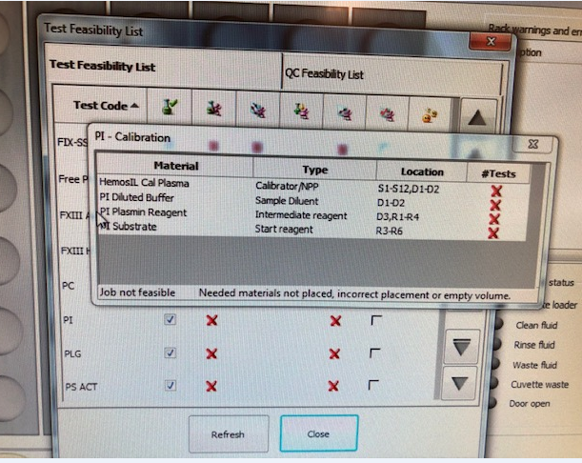

1. **Quality Control**
   1. Load all appropriate PI Reagent, Substrate, diluted PI Buffer along with Diluted Clean B onto the instrument. Before loading the reagent rack, make sure the analyzer is in Ready mode.

**Refer to test feasibility screen for loading of reagents/ calibrator and controls.**

* 1. Place HemosIL Normal control Assayed, HemosIL test Control level 2 with the barcodes facing out in a Diluent Rack and load on the instrument in a Diluent track D1 or D2.
  2. Choose **QC** from the Main Menu and select **Test Status List**.
  3. Double-click on a test code PI to reveal the Test Materials Definition tree in the **QC statistics screen**.
  4. Select the box in front of the PI QC box test and choose the **Program QC** icon. This will run all QC levels for that test.
  5. To Review QC, single click on **Previous screen (back arrow)**  will return to **QC Result list.**
  6. If the control is acceptable, click on the page5image3395804144**data** point, click on the **comment icon** page5image3395808928, and type your initials in the comment box. If control is outside the acceptable range, the Status of the QC in red ‘failed’ and QC alarm at the bottom will alert you. Take an appropriate QC corrective action below.
  7. Controls should be prepared and tested once each 8-hour shift and tested again whenever reagents are added or changed and after each new calibration curve. Tech has to review shift control and placed an initial in the comment box under each control.
  8. Controls should be run in the same manner as the test samples, and by all techs that perform special coagulation testing.
  9. Control tolerance limits--the range is calculated based on +/-2SD from the mean control value.

**Corrective action when tolerance limits are exceeded**:

* + 1. Rerun control after swirling QC and reagents.
    2. If still out, check reagent expirations; make new if indicated. Ensure fresh Factor Diluent is on-board and change if necessary (if not changed during set up). Perform Enhanced clean for all the probes.
    3. If control still out, prepare new controls or reagents depending on one level of QC is out or both levels, allow to sit for 20 minutes, mix gently, and rerun.
    4. If controls still out, Recalibrate the assay and notify the supervisor.
    5. Verify reagent performance.
    6. Check instrument performance
    7. Document actions taken to identify and correct the problem before reporting any patient data.
    8. Remove the results that are outside the acceptable range by clicking on the unacceptable point and then clicking the omit icon. On the next data point**, indicate** the corrective action that was performed in the comment box along with your initials. The control results are recorded in the ACL TOP 750 QC files and are reviewed monthly by the supervisor.
    9. If the problem cannot be resolved, call for Service if necessary and properly document in troubleshooting log.Notify supervisor.

**Note: Alpha-2-Antiplasmin (PI) controls for the ACL TOP 750 are not formatted in the BEAKER QC program but set up and reviewed in the instrument QC Software file.**

1. **Procedure:**
2. Load reagents onto the instrument. Calibrate, if necessary (see calibration section of this procedure).
3. Place QC materials with the barcodes facing out in a Diluent Rack and load onto an instrument Diluent track.
4. Choose **QC** from the Main Menu and select **Test Status List.**
5. Double-click on the **PI** test code item to reveal the **Test Materials Definition tree.**
6. Select the box in front of the PI QC Control and choose the **Program QC** icon. This will run all QC levels for that test. See
7. Place sample tubes in a sample rack with barcodes facing outwards.
8. Select an available sample track and load the sample rack when the barcode reader is in position.
9. Verify the samples **have been identified and have a test ordered. If not, program the sample ID** manually and/or order the test manually from the test and programming window.
10. Choose the **Run** icon if the instrument is not currently running.

**To Run Patient Samples without barcode**

* + - * Place sample cup in sample rack and label with sample name.
      * Click on the sample area icon. Double click on the rack to the left.
      * Enter the sample ID.
      * Double click on the box to the right. Choose the PI test under **SpeciaIs** tab in the Tests and Profiles box.

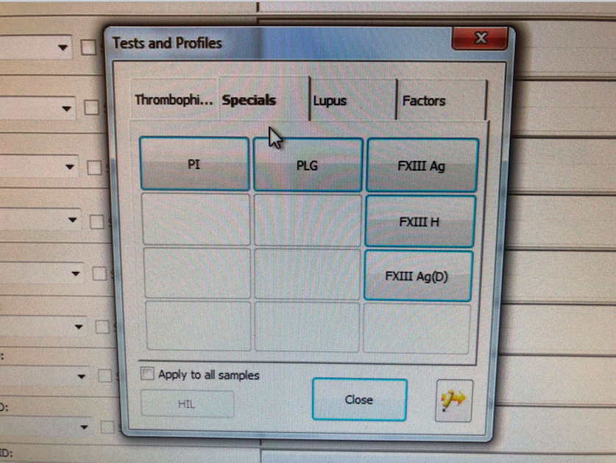

* + - * Click the **insert rack** icon. Load into an available track, S1-S12.
      * If the instrument is currently running and the run icon is greyed out, the sample(s) will be added to the active list and will be run. If the run icon is purple, click it to start the test(s).

1. **Reporting Results**

Plasminogen results are reported in activity (%).

Linearity for this assay is 10-150%.

The upper limit of reporting is 150%; if the result is higher than 150%, it will flag as “result above linear range” report “>150%,” and any result lower than 10 will be reported as <10%.

Record results in the computer system; Post results through the outstanding list / manual reporting referring to the Beaker bench manual as needed.

Hemolyzed, lipemic, or icteric samples must be noted with the result.

1. **Reference Interval:** Normal range data for adult population was validated by the Hematology lab from hospital and non-hospital patients.

**Adult Normal Range: 72 – 122%**

**Reflex Criteria**: All abnormal results reflex MD Interpretation.

1. **Critical Results:** No critical result for the procedure.
2. **Procedural note:**

The overall performance of Plasminogen testing is dependent on reagent and instrument performance. Acceptable variability (imprecision) should be such that the total coefficient of variation (CV) of the analytic system is less than <=8% on the same lot of Normal control plasma and <=12% on the same lot of abnormal control plasma.

1. **Specific Performance Characteristics**

Within-run and total (run to run and day to day) precision was assessed over multiple runs using both normal and abnormal control samples with a specific lot of Plasminogen reagents.

1. **Limitations and Interference substances**

Alpha2-Antiplasmin (also known as Plasmin Inhibitor) results on the ACL TOP are not affected by:

Heparin (UF or LMW) up to 2.0 U/mL

Hemoglobin up to 500 mg/dL

Bilirubin up to 24 mg/dL

Triglyceride up to 2320 mg/dL

Alpha2-macroglobulin up to 3.5 mg/mL, within the Plasmin Inhibitor normal range.

1. **References**
2. HemosIL Plasmin Inhibitor (PN 0020009200) package insert
3. ACL TOP® Family On-Line Help Manual
4. Clinical and Laboratory Standards Institute. Collection, Transport, and Processing of Blood Specimens for Testing Plasma-Based Coagulation and Molecular Hemostasis Assays; Approved Guideline - Fifth Edition, CLSI Document H21-A5; Vol. 28 No. 5
5. HemosIL Calibration plasma (PN 0020003700) package insert.
6. Clinical and Laboratory Standards Institute. Preparation and Testing of Reagent Water in the Clinical Laboratory, Fourth Edition, CLSI Document C3-A4; Vol. 26 No. 22
7. Westgard JO and Barry PL. Cost-Effective Quality Control: Managing the Quality and Productivity of Analytical Process, AACC Press 1986
8. Age dependency for coagulation parameters in paediatric populations-Pierre Toulon, Micheline Berruyer,Marie Brionne-Francois Grand, Dominique Lasne, Caroline Telion, Julien Arcizet, Roberta Giacomello, Neila De pooter, Thromb Haemost 2016; 116; 9-16
9. Development of the hemostatic system in the neonate and infants. Am J pediatr Hematol Oncol 12:95.1990
10. **History**

This procedure was written by P Bahel on 10/9/2019