|  |  |  |  |
| --- | --- | --- | --- |
| https://www.ynhh.org/~/media/images/Email/signature/ynhhs_ynhh_esignature_logo.png | TITLE:  **Lupus Anticoagulant Assay: dRVVT Screen / dRVVT Confirm - ACL TOP 750** | | **DEPT OF LAB MEDICINE**  **CLINICAL HEMATOLOGY**  **Policy and Procedure Manual** |
| **DOCUMENT #**  **HEM 227** |
| **WRITTEN BY:**  Parveen Bahel, MLS (ASCP)CM | **EFFECTIVE DATE:** | **REVIEW/REVISION:**  H-1(New); 10/2019 | **SUPERCEDES:**  Page 1 of 12 |

1. **INTENDED USE:**

The dRVVT Screen and HemosIL dRVVT Confirm assays are qualitative in-vitro diagnostic products to aid in the detection of lupus anticoagulants

in human citrated plasma by the diluted Russell’s Viper Venom method, on IL Coagulation Systems. The HemosIL dRVVT Screen and HemosIL

dRVVT Confirm assays are intended to evaluate patients who have unexplained prolonged APTT test results. The HemosIL dRVVT Screen and

HemosIL dRVVT Confirm assays should be used in parallel as an integrated test for Lupus Anticoagulant detection.

1. **PURPOSE**

This procedure provides instructions for the analysis of Lupus Anticoagulant (LA) using the HemosIL dRVVT Screen and dRVVT Confirm Kits on the ACL TOP® Family.

1. **SUMMARY AND PRINCIPLE OF THE PROCEDURE**

Lupus Anticoagulants (LA) belong to the group of antiphospholipid antibodies which are directed against negatively-charged phospholipids or complexes between phospholipids and proteins (either ß-2-glycoprotein I or clotting factors such as prothrombin). When determined by their ability to prolong phospholipid-dependent tests (APTT, SCT, dRVVT), these antibodies are referred as LA. Patients with LA are at increased risk of clinical complications such as thrombosis and recurrent miscarriages. The dRVVT Screen and dRVVT Confirm assays are improved dRVVT reagents and intended to simplify and standardize the detection of LA in clinical evaluations.

The dRVVT Screen assay is poor in phospholipid, making it sensitive to LA. The additional amount of phospholipid (bi-layers) in dRVVT Confirm neutralizes LA to give shorter clotting times.

Russell’s Viper Venom, in the presence of calcium, directly activates factor X (in the test sample). The dRVVT Screen and dRVVT Confirm assays are therefore unaffected by contact factor abnormalities, factor VII, VIII and IX deficiencies or inhibitors. Heparin interference up to 1 U/mL is neutralized by polybrene. As a result, dRVVT Screen and dRVVT Confirm are more specific tests for the evaluation of LA than APTT.

dRVVT Screen and Confirm are an integrated test as referenced in the ISTH 2009 committee recommendation for Lupus Anticoagulant detection.

1. **SPECIMEN**
2. **Type:**

Mix nine parts of freshly collected blood with one part of 3.2% sodium citrate anticoagulant.

Invert the tube gently three or four times immediately after venipuncture to ensure proper mixing of blood and anticoagulant.

A syringe or evacuated tubes (blue top) may be used for collection. If multiple specimens are collected; the coagulation sample should be the second or third tube collected. If only coagulation testing is to be performed, a red-top tube, which has no additives, should be drawn first and discarded prior to drawing the blue-top coagulation tube.

The patient cannot be on anti-coagulants when the test specimen is collected. Sufficient time after discontinuance of heparin should be allowed for heparin to be cleared from the patient’s blood, usually 6 hours.

If blood is drawn from an indwelling catheter, the line should be flushed with 5.0 mL saline and the first 5 mL of blood or six dead space volumes of the catheter discarded or used for other laboratory tests.

The citrate concentration must be adjusted in patients who have hematocrit values above 55%.

1. **Handling Condition and Stability:**

The whole blood specimen is checked for clot formation by gentle inversion and observation. Centrifuge the capped blood specimen to produce platelet-poor plasma (platelet count <10x109/L for 10 minutes at 4000 g. Patient plasma should be tested within 4 hours. If immediate testing is to be done, the plasma may remain on the packed cells.

For special coagulation testing, spin samples 20 minutes at 4000 g, separate plasma into plastic tubes, label and freeze all aliquots at –70C located in Special coag area until ready to use. Always track aliquots in BEAKER under YH Coag Hold before freezing them.

A frost-free freezer should not be used. Frozen plasma samples must be rapidly thawed at 37°C while gently mixing and tested immediately after thawing. If testing is delayed, the sample may be held for 2 hours at 4°C until tested.

Specimen stability at ambient temperature: 4 hours; Frozen at -70° C: 6 months.

**C.** **Specimen Labelling:** Specimen should be properly labeled with at least 2 unique patient identifiers - the Patient's full name and medical record number (MRN) and should have the date and time of collection. The patient's birth date may substitute for the MRN if the MRN is not available.

**D.** **Safety Precautions:** Follow specimen handling, use of standard precautions; proper PPE wear gloves and a lab coat. Wear safety glasses if there is a risk of splashing.

1. **ENVIRONMENTAL OPERATING CONDITIONS**

The instrument functions correctly in an ambient temperature of 15° C to 32° C (59° F to 89° F) with a relative humidity of 15% to 85% (non-condensing).

In accordance with the IEC regulations, no instrument failures occur in the presence of short-term ambient temperatures as low as 5° C or as high as 40° C.

The ACL TOP Family 50 Series is compliant with IEC 60068-2-40 to 2000 meters. The instrument should not be used at an altitude greater than 2000 meters.

The instrument should be placed in an area free from dust, fumes, vibrations and excessive variations of temperature.

The heat generated by the instrument during normal operation is exhausted from the bottom, the front-right, and the left side of the unit.

According to IEC 61010-1, the maximum audible noise emission should be 80 dBA. The ACL TOP Family 50 Series is compliant with IEC 61010-1 Third Edition.

The room temperature and humidity percent are monitored and documented on the Routine Coagulation checklist.

1. **EQUIPMENT AND MATERIAL**
   1. **Supplies**
      * Nerl Water: pH 7.0
      * Gauze
      * Citrated blue top tubes
      * Frosted tubes for aliquots
      * Cuvettes
      * ACL Top sample cups
      * HemosIL Cleaning solution Clean A and Clean B
      * HemosIL Rinse and waste
      * HemosIL factor Diluent
   2. **Reagents**
      * HemosIL dRVVT Screen
      * HemosIL dRVVT Confirm
      * HemosIL LA Positive Control
      * HemosIL LA Negative Control
2. **PRODUCT INFORMATION**

**HemosIL dRVVT Screen** Kit and **HemosIL dRVVT Confirm** Kit consist of:

**dRVVT Screen Kit:** 10 x 2 mL vials of a lyophilized preparation containing Russell’s Viper Venom, phospholipids, calcium, polybrene, buffers, stabilizers, dyes, and preservative.

**dRVVT Confirm Kit:** 10 x 2 mL vials of a lyophilized preparation containing Russell’s Viper Venom, phospholipids, calcium, polybrene, buffers, stabilizers, dyes and preservative.

HemosIL LA Positive Control

HemosIL LA Negative Control

1. **REAGENT PREPARATION**
2. Reconstitute each vial of DRVV Screen and DRVV Confirm with 2 mL of Nerl water. Keep the reagent at 15-25˚C for 30 minutes and Mix by gentle inversion to ensure complete resuspension of the lyophilized material. Do not shake.
3. HemosIL LA Positive Control: Reconstitute with 1mL of Nerl water.
4. HemosIL LA Negative Control: Reconstitute with 1mL of Nerl water.
5. **Cleaning Agent** (Clean B Diluted): Make fresh Clean B Diluted every day, 1 Part Clean B + 7 parts of Nerl water).
6. **REAGENT STORAGE AND STABILITY**

**NOTE: After opening any vial to place onto the instrument, label that vial with the open and expiration date, referring to the stability information provided here. Discard reagent when expired.**

Unopened reagents are stable until the expiration date shown on the vial when stored at 2-8°C.

For optimal stability, remove reagents from the system and store them, closed, at 2-8°C in their original vials. Do not freeze.

**Stability after reconstitution of DRV Screen and Confirm reagents**

15 days at 2-8˚C or

3 days at 15˚C in their original vials on the ACL TOP. No stirring is required.

**Stability after reconstitution of LA positive and LA Negative controls:** 24 hours onboard stability

1. **CALIBRATION DETAIL**

No calibration of the system is necessary for performing DRVVT-Screen / DRVVT Confirm tests

1. **QUALITY CONTROL**

Lupus controls LA negative and LA Positive are unassayed controls.

1. **To program new Lots of LA positive and Negative Controls as an Alternate lot onto the instrument:**

Choose **Setup, Materials List, Select** Control (e.g. LA NEG control).

Choose the **Lot Specific Information tab** and **enter the control (s) Lot number and expiration date and save it.** Click enable an alternate lot.

1. **Sample procedure to Establish QC range for dRVVT Assay:**

All new lots of LA QC are validated by testing QC material for dRVVT-S and dRVVT-C tests at least twice daily analytical runs on ACL TOP 2 over 10 days. Alternatively, if time doesn't allow, analyze 4 times a day in a 5-day period.  At least four different bottles of controls at each level should be used to compensate for the bottle to bottle variation and reconstitution issues. Try to begin evaluating new lots at least 4-6 weeks before switching or even earlier.

1. **Calculate QC range (Mean+/- 2SD)** using the above data: Combine data point to find the Mean, SD. Our QC range is defined as the mean +/- 2SD. Evaluate QC ranges and should be signed off by the Medical Lab director.

Continue run the first 2 to 3 months of new QC lot to add QC data to re-establish QC range at 1,2 and 3 months of usage and has to be re-evaluated and signed off by the Medical Lab director.

1. **To enter Mean and SD:**  Goto **Setup, Click QC List,** and select **test code for each QC** (e.g. dRVVT–S for LA Postive and Negative control, dRVVT-C for both controls), and enter Mean and SD and save it. Print the screen and file it in LUPUS QC binder.
2. **How to Activate New Lot: Choose Setup, Materials List,** Select Control (e.g. LA NEG control).

Choose the **Lot Specific Information tab,** click **Activate Lot** icon (salt and pepper shaker shape).

* 1. Load Reagents DRVV S and DRVV C along with Diluted Clean B onto the instrument. Before loading the reagent rack, make sure the analyzer is in Ready mode.

**Refer to the test feasibility screen for the loading of reagents and controls.**

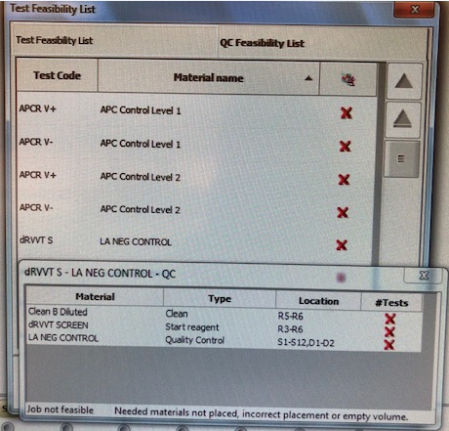

* 1. Place LA Positive and LA negative controls with the barcodes facing out in a Diluent Rack and load on the instrument in a Diluent track D1 or D2.
  2. Choose **QC** from the Main Menu and select **Test Status List**.
  3. Double-click any test code to show **Test Materials Definition tree.**
  4. Select the box in front of dRVVT-S and dRVVT C control and choose the Program QC icon. This will run LA NEG Control and LA POS Control for both Screen and Confirm.
  5. To Review QC, single click on the **Previous screen (back arrow)**   will return to **QC Result list**.
  6. If the control is acceptable, click on the page5image3395804144**data** point, click on the **comment icon** page5image3395808928, and type your initials in the comment box. If control is outside the acceptable range, Status of the QC in red ‘failed’ and QC alarm at the bottom will alert you. Take an appropriate QC corrective action below.
  7. Controls should be prepared and tested once each 8-hour shift and tested again whenever reagents are added or changed. Tech has to review shift control and placed an initial in the comment box under each control.
  8. Controls should be run in the same manner as the test samples, and by all techs that perform special coagulation testing.
  9. Control tolerance limits--the range is calculated based on +/-2SD from the mean control value.

**Corrective action when tolerance limits are exceeded**:

* + 1. Rerun control after swirling QC and reagents.
    2. If control still out, prepare new controls or reagents depending on one level of QC is out or both levels, allow to sit for 20 minutes, mix gently, and rerun.
    3. Verify reagent performance.
    4. Check instrument performance
    5. Document actions are taken to identify and correct the problem before reporting any patient data.
    6. Remove the results that are outside the acceptable range by clicking on the unacceptable point and then clicking the omit icon. On the next data point**, indicate** the corrective action that was performed in the comment box along with your initials. The control results are recorded in the ACL TOP 750 QC files and are reviewed monthly by the supervisor.
    7. If the problem cannot be resolved.Call for Service if necessary and properly document in troubleshooting log.Notify supervisor

**Note: LA positive and Negative controls for the ACL TOP 750 are not formatted in the BEAKER QC program but set up and reviewed in the instrument QC Software file.**

1. **PROCEDURE:**

**Procedure to Calculate NPP Value for each new lot of dRVVT Screen and dRVVT Confirm**

* 1. For each new lot of dRVVT Screen and dRVVT Confirm kits, a new Normal Range should be determined according to CLSI C28-A31.
  2. Over 2-3 weeks, while a single lot # of DRVVT S and/or DRVV C reagent is being used, approximately 15-20 normal samples from individuals should be collected to calculate the NPP Value.
  3. After a new lot number of reagent has been obtained from the manufacturer, pick a day to run normal samples. This should be a day when the instruments are working well, controls are within acceptable ranges, and maintenance is up to date.
  4. Determine the Mean of each Normal Range (NPP) in seconds.
  5. The mean of each normal range will be used as a constant denominator in the calculations of ratios.
  6. The NPP values calculated for dRVVT S or dRVVT C are entered by **Setup, Test List,** **Select dRVVT S or dRVVT C, select Normal Pool Plasma, enable** **NPP**, enter a **value for NPP** in the box and save it. Print the screen and file it in the Reagent comparison binder.

**How to enter New Lot Number of Reagent and QC**

1. Choose **Setup, Materials List,** Click Scan and Scan to 2D barcode on the top of the box of the DRVV S and DRVV C reagents and LA negative and LA positive controls, if a new lot. This will upload all the information about lot number, expiration date, and assay values. Repeat for all reagents. If 2D barcode is not on the box, double-click on the DRVV S and DRVV C to open the **Materials Definition screen.**
2. Choose the **Lot Specific Information tab** and enter the reagent(s) Lot number and expiration date and save it.
3. Enable **Lot Management** from the Lot Specific Information tab.
4. Load the dRVVT Screen, and dRVVT Confirm materials, along with Clean B Diluted onto the ACL TOP.

**Refer to test feasibility screen for loading of reagents, and controls.**

1. Place QC materials in a Diluent Rack and load onto the ACL TOP in a Diluent track. Identify the controls.
2. Choose **QC from** the Main Menu and select **Test Status List.**
3. Double-click any test code to show **Test Materials Definition tree.**
4. Select the box in front of dRVVT-S and dRVVT C control and choose the **Program QC** icon. This will run LA NEG Control and LA POS Control for both Screen and Confirm.

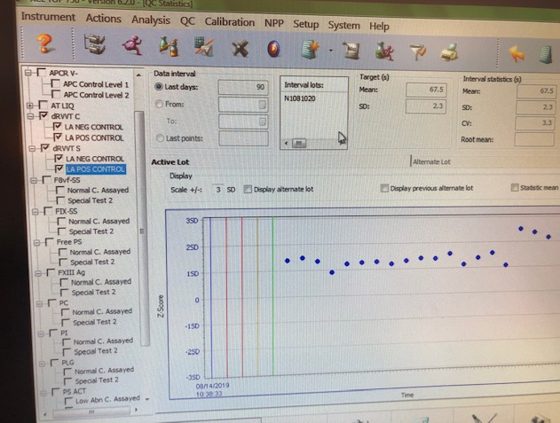

**To Run barcoded patients**

1. Place sample tubes in a sample rack with barcodes facing outwards.
2. Select an available sample track and load the sample rack when the barcode reader is in position.
3. Verify the samples have been identified and program the sample ID manually and add dRVVT-S and dRVVT-C from the Test and profile tab under Lupus panel in order to obtain dRVVT Screen and dRVVT Confirm ratio.
4. Choose the Run icon if the ACL TOP is not currently running.
5. Both dRVVT-Screen and dRVVT-Confirm ratios are required in order to obtain the Normalized DRV Ratio (DRV Total ratio).

**To Run Patient Samples without barcode**

1. Place sample cup in sample rack and label with sample name.
2. Click on the sample area icon. Double click on the rack to the left.
3. Enter the sample ID.
4. Double click on the box to the right. Choose the dRVVT S and dRVVT C **under LUPUS** tab in the Tests and Profiles box.

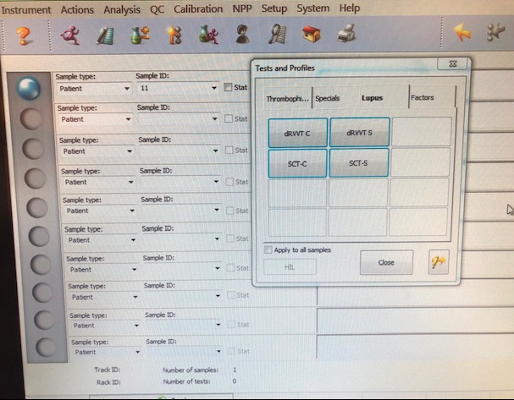

1. Click the **insert rack** icon. Load into an available track, S1-S12.
2. If the instrument is currently running and the run icon is greyed out, the sample(s) will be added to the active list and will be run. If the run icon is purple, click it to start the test(s).

**NOTES: Reflex Criteria:**

PT/PTT tests will be auto reflexed when LUPUS anticoagulant work-up requested.

Abnormal PTT will reflex to Mixing study if LUPUS positive (Refer to Mixing study procedure HEM#34).

The presence of standard heparin must be ruled out before performing a mixing study. Repeat the patient PTT with added polybrene, according to the separate Polybrene procedure.

1. **REFERENCE INTERVAL:** Normal range cut-off was validated by the Hematology lab from the Hospital and Non-Hospital patients.

DRV Normalized ratio (DRV Total Ratio) <=1.20

1. **REPORTING RESULTS:** Patient results are reported in DRV Normalized ratios: NR which is a ratio of DRV Screen ratio and DRV Confirm ratio.

**To Determine dRVVT Screen and dRVVT Confirm Ratios:** The following procedure should be used to calculate dRVVT Screen and dRVVT Confirm

1. For each new lot of dRVVT Screen and dRVVT Confirm kits, a new Normal Range should be determined according to CLSI C28-A3.
2. Determine the Mean of each Normal Range in seconds (See above in section XII)
3. The mean of each normal range will be used as a constant denominator in the calculations of ratios.

**dRVVT Screen**

1. The patient sample result in seconds is divided by the Mean of the

dRVVT Screen normal range.

dRVVT Screen Ratio = Patient dRVVT Screen results (in seconds)

Mean of dRVVT Screen Normal Range (in seconds)

**dRVVT Confirm**

1. The patient sample result in seconds is divided by the Mean of the dRVVT Confirm normal range.

dRVVT Confirm Ratio = Patient dRVVT Confirm results (in seconds)

Mean of dRVVT Confirm Normal Range (in seconds)

1. The ratio results from the dRVVT Screen is divided by the ratio result from dRVVT Confirm.

**DRV Normalized Ratio =** dRVVT Screen Ratio

dRVVT Confirm Ratio

1. **INTERPRETATION OF RESULTS:**

[a] DRV Normalized Ratio <=1.20, report this value

This would go for SCINT only if SCT positive

[b] DRV Normalized Ratio >1.20, report this value

This would go for SCINT no matter the SCT result

1. **CRITICAL RESULTS**: No critical result for the procedure.
2. **LIMITATIONS OF THE PROCEDURE**

Icteric, lipemic and hemolyzed specimens may give false results. Results on ACL TOP® Family are not affected by:

Hemoglobin up to 200 mg/dL

Bilirubin up to 10 mg/dL

Triglycerides up to 500 mg/dL

Heparin (UF and LMW) up to 1 U/mL

LA assays based on different properties appear to be more or less sensitive to certain subgroups of LAs. Therefore at least two screening assays, based on different properties, should be performed before the possibility of LA is excluded.1

The dRVVT ratios may be elevated in patients on anti-vitamin K therapy. Additional confirmatory tests prior to diagnosing or repeating dRVVT testing might be indicated when the patient is off anti-vitamin K therapy.1

Note: If the dRVVT Screen is run by itself, only the dRVVT-Screen ratio can be obtained. Both dRVVT-Screen and dRVVT-Confirm ratios are required in order to obtain the Normalized Test Ratio (TR).

1. **REFERENCES**
2. HemosIL dRVVT Screen / dRVVT Confirm, PN 0020301500/0020301600 package insert
3. ACL TOP® Family On-Line Help Manual
4. Clinical and Laboratory Standards Institute. Collection, Transport, and Processing of Blood Specimens for Testing Plasma-Based Coagulation and Molecular Hemostasis Assays; Approved Guideline - Fifth Edition, CLSI Document H21-A5; Vol. 28 No. 5
5. Westgard JO, and Barry PL. Cost-Effective Quality Control; Managing the Quality and Productivity of Analytical Process, AACC Press, 1986.

Clinical and Laboratory Standards Institute. Preparation and Testing of Reagent Water in the Clinical Laboratory, Fourth Edition, CLSI Document C3-A4; Vol. 26 No.

1. **HISTORY:**

H-1 This procedure is written by P Bahel on 10/9/2019