 | TITLE:  Prothrombin Time –CS 5100  (Dade_Innovin) |  | DEPT OF LAB MEDICINE  CLINICAL HEMATOLOGY  Policy and Procedure Manual
DOCUMENT #
HEM #216 - 1 -
WRITTEN BY:  Parveen Bahel  H(ASCP) | EFFECTIVE DATE:  7/14/2020 | REVIEW/REVISION:  H-1 (New) | Pages 1 of 18
- INTENDED USE:

For use in Prothrombin time (PT) determinations and prothrombin time-based assays in citrated human plasma.

- SUMMARY AND EXPLANATION:

Dade® Innovin Reagent is prepared from purified recombinant human tissue factor produced in E. coli, combined with synthetic phospholipids (thromboplastin), calcium, buffers and stabilizers. The reagent initiates clotting via the extrinsic and common pathways in a global screening test, the prothrombin time (PT). Dade Innovin Reagent has three major applications based upon the PT2:
1. as a rapid screening test to detect single or combined deficiencies of the extrinsic coagulation system indicative of hereditary and acquired coagulation disorders, liver disease or vitamin K deficiency;
2. as a sensitive monitoring test for oral anticoagulant therapy with vitamin K antagonists; and
3. as an assay for specific coagulation factors.

Additionally, various photo-optical coagulation analyzers are able to derive the fibrinogen value from the determination of the prothrombin time.
Dade® Innovin Reagent is manufactured using recombinant human tissue factor and synthetic phospholipids which do not contain any other clotting factors such as prothrombin, F VII and F X. Therefore, it is highly sensitive to factor deficiencies and oral anti-coagulant treated patient plasma samples. The sensitivity of Dade® Innovin® Reagent is very similar to the WHO human brain reference thromboplastin3. Dade® Innovin® Reagent is insensitive to therapeutic levels of heparin. The high sensitivity of Dade Innovin Reagent to coagulation factors and its insensitivity to therapeutic heparin make it beneficial in monitoring oral anticoagulant therapy with vitamin K antagonists3. In addition, its high sensitivity (i.e. the responsiveness of the reagent to moderately depleted factor activity) allows differentiation of abnormal plasmas, even in the mildly pathological range.

II. PRINCIPLE:
A. The prothrombin time test (PT) is a global screening test with three major applications. These include:
B. Detection of single or combined deficiencies of the extrinsic coagulation pathway indicative of hereditary and acquired coagulation disorders, liver disease or vitamin K deficiency.
C. Monitoring test for oral anticoagulant therapy and
D. Assay for specific extrinsic coagulation factors.
Recombinant thromboplastin and calcium ions are combined with test plasma at 37°C; the PT is the time, in seconds, required for a fibrin clot to form.

III SPECIMEN REQUIREMENT:
The only acceptable sample for routine coagulation is plasma, from whole blood drawn into blue-stoppered tubes containing 3.2% sodium citrate (nine parts of freshly collected blood with one part of 3.2% sodium citrate anticoagulant).
- 4.5 ml-draw tube must have a MINIMUM ACCEPTABLE VOLUME of 4.0 ml total (3.5 ml blood +0.5 ml anticoagulant).
- 2.7 ml-draw tube must have a MINIMUM of 2.5 ml (2.2 ml blood + 0.3 ml anticoagulant).
- A “micro method” sample (newborn PT/PTT/FIB only) must be a full 1.0 ml specimen (0.9 ml of whole blood drawn with a syringe added to 0.1 ml 3.2% sodium citrate anticoagulant.)
Invert the tube gently three or four times immediately after venipuncture to ensure proper mixing of blood and anticoagulant.
A syringe or evacuated tubes (blue top) may be used for collection. If multiple specimens are collected; the coagulation sample should be the second or third tube collected. If only coagulation testing is to be performed, a red-top tube, which has no additives, should be drawn first and discarded prior to drawing the blue-top coagulation tube.
The patient cannot be on anti-coagulants when the test specimen is collected. Sufficient time after discontinuance of heparin should be allowed for heparin to be cleared from the patient’s blood, usually 6 hours.
If blood is drawn from an indwelling catheter, the line should be flushed with 5.0 mL saline and the first 5 mL of blood or six dead space volumes of the catheter discarded or used for other laboratory tests.
The citrate concentration must be adjusted in patients who have hematocrit values above 55%.
Specimens that are clotted, collected in the wrong tube or serum, or have less than the 90% expected fill should be rejected, the floor must be notified, a comment entered into the computer.

Handling Condition and Stability
The whole blood specimen is checked for clot formation by gentle inversion and observation. Centrifuge the capped blood specimen to produce platelet-poor plasma (platelet count <10x10 9/L for 10 minutes at 4000 g or 3 minutes at 8000 rpm (STAT centrifuge) for STAT samples and 7 minutes at 5200 RPM (DAS centrifuges) as soon as possible after collection. If immediate testing is to be done, the plasma may remain on the packed cells or separated.

Patient plasma should be tested within 4 hours. If immediate testing is to be done, the plasma may remain on the packed cells. For special coagulation testing, spin samples 20 minutes at 4000 g, separate plasma into plastic tubes, label and freeze all aliquots at –70C located in the Special coag area until ready to use. Always check for clots after aliquoting with applicator sticks. Always tracks aliquots in BEAKER under YH Coag Hold before freezing them. A frost-free freezer should not be used. Frozen plasma samples must be rapidly thawed at 37°C while gently mixing and tested immediately after thawing. If testing is delayed, the sample may be held for 2 hours at 4°C until tested immediately after thawing. If testing is delayed, the sample may be held for 2 hours at 4°C until tested.
Specimen stability at ambient temperature: 4 hours; Frozen at -70° C 6 months.
Specimen Labelling Specimen should be properly labeled with at least 2 unique patient identifiers. Patient's full name and medical record number (MRN) and should have the date and time of collection. The patient's birth date may substitute for the MRN if the MRN is not available.

- ENVIRONMENTAL OPERATING CONDITIONS:

The room temperature and humidity percent are monitored and documented on the Routine Coagulation checklist.

- EQUIPMENT AND MATERIALS:

A. Equipment:
    - Nerl Water: pH 7.0
    - Gauze
    - Citrated blue top tubes
    - Frosted tubes for aliquots
    - Cuvettes
    - SLD Mini - cups
    - CS5100 sample cups – 4 mL
    - CA Clean I – 50 mL (On-board stability – 5 days)
    - CA Clean II – 5 L (On-board stability – 2 months)
    - OVB (Buffer) (On-board stability – 24 hours)
    - Trash bags

B. Materials:
1. Dade Innovin
2. Control material: Ci-Trol® Coagulation Controls, Levels 1 and

- REAGENTS/ Preparation:

NOTE: After opening any vial to place onto the instrument, label that vial with the open and expiration date, referring to the stability information provided here. Discard reagent when expired.

- Siemens Dade Innovin— A lyophilized reagent consisting of recombinant human tissue factor and synthetic phospholipids (thromboplastin); calcium ions; a heparin-neutralizing compound; buffer; and stabilizers (bovine serum albumin).
- Reconstitute each vial of lyophilized Innovin with 10 mL NERL water; add water gently down the side of the vial to prevent foaming
- Immediately after addition of water, invert vial gently uses to ensure complete dissolution. If left to stand, Innovin Reagent should be re-mixed before use in order to ensure a homogeneous solution. Continuous mixing is not necessary.
- Store at 2-8°C. Do not freeze.
- Stability after reconstitution: 72 hours on board (10°C) the CS 5100 instrument and 10 days at 2-8°C.

B. Siemens Ci-Trol Level 1 (Normal control) -Lyophilized preparation of fresh human, normal citrated plasma. Used for Quality Control.
C. Siemens Ci-Trol Level 3 (Abnormal control)-Lyophilized preparation of fresh human, abnormal citrated plasma. Used for Quality Control.
- Reconstitute Ci-Trols 1 and 3 with 1 mL NERL water.
- Re stopper vial and allow to stand 15 minutes until dissolved.
- Invert gently to mix. Do not shake.
- Stability after reconstitution of Citrol 1 and 3—72 hours on board (10 °C) the CS 5100 instrument.

- Performance Parameters:

Indication of deterioration: no evidence of vacuum in vial upon opening, difficulty in reconstituting reagent, control values outside of determined range

- LOADING REAGENTS and QC

- Reagent table loading:
Note: Always load reagent in the orange racks (A racks) and the control and calibrators in the yellow racks (C racks).
Reagents cannot be loaded while running the patients.
- Press Reagent on the toolbar.
- Verify system is in solid green ready status.
- Open light shield lid.
- Open reagent table cover.
- Remove expired or empty reagent vials by pressing Change/Add icon. It will bring the rack in front you want to remove reagents.
- Place new reagents in a rack with barcode facing out.
- Load the reagent rack.
- Press and lock reagent table cover.
- Press OK on screen to barcode read.
- Wait for barcode reading to read the barcode.
- On Reagent screen, touch reagent position just loaded, and press Change to update the Set Time.
B. Loading the Buffer
1. Press Reagent on the toolbar.
2. Verify buffer table cover LED is green.
3. Open buffer table cover.
4. Place OVB (buffer) in an adaptor with barcode facing out.
5. Place into the buffer table and close the cover.
6. Press OK on the barcode reading screen.
7. On Reagent screen, touch reagent position just loaded, and press Change to update the Set Time.
C. Loading QC
C-rack and SLD mini cup
- Reconstitute Citrol 1 and Citrol 3 with 1 mL of nerl water and allow to stand for 15 minutes.
- Aspirate entire content of QC vial (GW5) using transferring pipette.
- Slowly dispense the entire volume into a new SLD mini cup, avoiding any air bubble formation.
- After QC transfer, carefully check for bubbles and, if required, remove using smaller pipette tip.
- Set SLD mini cup into corresponding GW5 vial.
- Set GW5 with SLD into yellow-handled C-rack. Push down on vial to ensure proper seating in position.
- Place the rack back in reagent table and close lid.
- Lock lever and Press OK to read barcode.
- On Reagent screen, highlight vial just loaded and press Change to update date/time.
Note the SLD mini cups are for controls and calibrators only.
- How to order QC

Processing from the reagent table: Control lot
1. Load QC onto a C-rack.
Refer to the Loading Reagents tab to load QC
material in a C-rack using a SLD mini cup.
2. Select Order.
3. Select Switch Order.
4. Select Holder QC Order

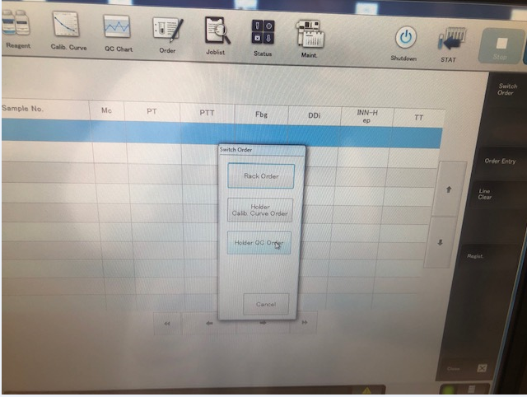

5. Press Order Entry.
6. Select control material from the list, Citrol 1
7. Place cursor in the Lot No. field and select lot from list.

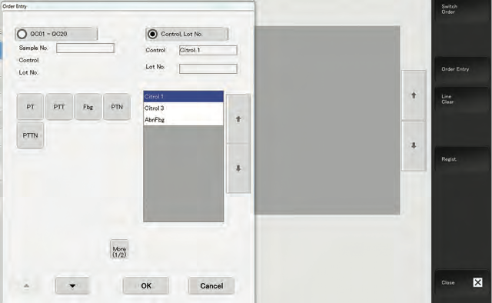

8. Select the appropriate assay(s) – PT
9. Press the down arrow to order the next control – Citrol 3 for PT.
10. Press OK once controls have been ordered.
11. Press Start.

- How to review qc and add a comment or initial to a point:

1. Press QC Chart.
2. Highlight specific QC Chart.
3. Place cursor on point.
4. Press Confirm Data key.
5. Enter your initial or comment in field if there is any qc issue.
6. To exclude point: check box.
7. Press Update.

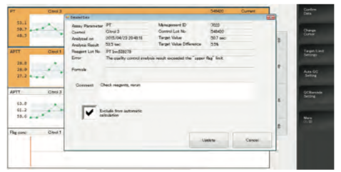

Controls should be tested once each 8-hour shift, and after reagent changes / additions. Tech has to review shift control and placed an initial in QC Software under each control.
2. Controls should be run in the same manner as the test samples and by the same technologists who work in the routine coagulation area.
3. Control tolerance limits--the range is calculated based on +/- 2 SD (Standard deviations) from the mean control value.
4. Corrective action when tolerance limits are exceeded (results will be flagged with error message):
a. Swirl reagent and QC well and rerun out-of-range control
b. If still out, Check reagent/QC for bubbles and turbidity.
c. Check reagents/ change if expired, ensure fresh OVB buffer is on-board and change if necessary (if not changed during set up). Prime the instrument.
d. Make fresh reagent or QC if needed and rerun again
e. Document actions taken to identify in QC Software and correct the problem before reporting any patient data.

NOTE: If QC is out of range after running twice, corrective action and an evaluation need to be performed. Up to 5 patient samples when QC was acceptable will need to be rerun to determine if there is a significant clinical difference in the patient results. Documentation is to print results from the Instrument of the repeated run of the patient samples, fill out corrective action log; print Beaker sample label and file in Corrective Action notebook. Acceptable agreement should be +/- 10% of the original results. If significant clinical changes have been determined, there will be an amended report with corrected data and a caregiver will be notified promptly. In these circumstances, the analyzer will be put out of service and troubleshooting/service dispatched. Continue to run samples on the other functional instrument, if needed set up CS 5100-3 instrument for routine coag tests.

- If this occurs during off-shifts and the immediate concern is to determine if patient data has been compromised, the patient samples from the problem instrument should be rerun on the other functioning instrument and results compared. See corrective action log for acceptable criteria. Troubleshooting will then be performed timely on the problem instrument, QC run and evaluated and patient comparisons performed before instrument is put back into service.

- Loading patient samples on the cs 5100

- LIS order processing

- Load bar-coded samples into any sample rack (7-20) with the bar-code label visible through the window of the rack position and Place rack on the sampler.
- Check host connection (HC) status. HC status icon must be green or orange.
- Press Start.

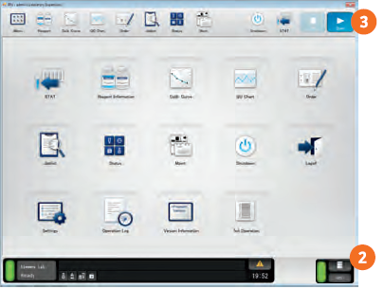

- After barcode reading, confirm sample order status and progress on the Joblist screen.

- Manual order processing

- Place rack with sample tubes on sampler.
- Press Order.
- Enter rack number
- Select tube position to input an order.
- Press Order Entry.
- Press Ordinary Sample.
- Place cursor in Sample No. and input sample ID if the sample does not contain a barcode.
- Select PT test to be analyzed.
- Press the down arrow to order the next sample.
- Press OK.
- Press Start.
- Confirm sample order status on the Joblist.

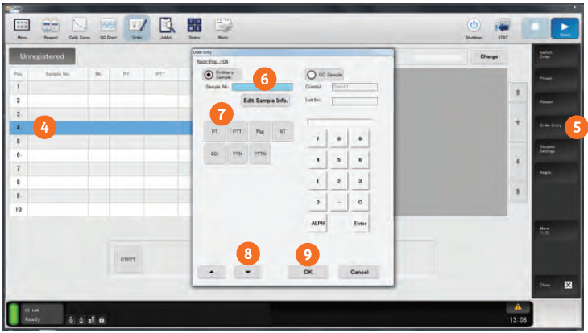

- Micro mode

- Follow Manual Order Processing steps on page 11 to ID sample and order test.
- Press in Mc column on Order screen.
- Load uncapped tube on to system.
- Select Start.
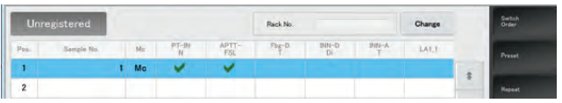

- Change to longer measurement time

- Follow Manual Order Processing steps on page 11 to ID sample and order test.
- Press Detailed Settings button.
- Click box below Measurement Time.
- Select measurement time
- Select OK.
- Select Start.

- Joblist information: Status

Status | Meaning
Pending | Orders are registered but analysis is not yet started
Processing | Assay groups are being analyzed
On Hold | All assay groups have been analyzed but a validated calibration curve is missing
(Blank) | All assays are normal
Review | Analysis completed but needs a review of the results
Error | Hardware error has occurred.

- Joblist information: Symbols

Result flags

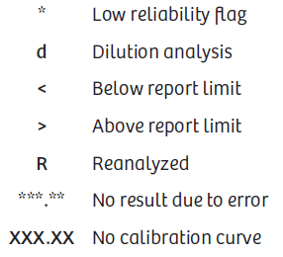

Analysis Flags

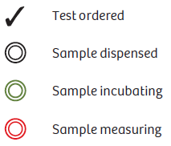

XII. RESULTS MANAGEMENT

The initial PT result with errors- Analysis Time over, Flat curve, Slight Coagulation or No Coagulation will auto-reflex to sub wavelength 320 seconds allowing that samples extra time for clot formation. It will create a second line on the Joblist. The final result will populate in the third line with all the tests results with (F) along the line.

Refer to Sysmex 5100 Operational procedure for auto verification guidelines, reporting normal and flagged results.

- PT results are reported in seconds, and may be auto- or manually verified, or direct entered, in rare circumstances.
- INR results for patients on oral anticoagulation MUST be reported along with the PT. The PT value obtained with Innovin is NOT to be used to monitor Coumadin therapy. The INR is calculated by the CS 5100 using the ISI (Lot specific package insert value) of Innovin, the patient PT, and the geometric mean of the reference interval for the PT.

- Hemolyzed, lipemic, samples must be noted with the result.

- Reference Ranges:

Reference interval values are verified for each new lot number of Innovin (+/- 2.0 SD) of the mean put in use and varied with the lot#. Manufacturer recommended reference range is 9.6 – 12.3 seconds. If the verified range mean falls in the manufacturer recommended range, lab will accept the manufacturer range. If not follow the procedure to establish the reference range. The current ranges are found in the reagent rollover data binder on supervisor’s desk and are updated in BEAKER by IT personnel prior to putting the new reagents in use.
Reference range for the current lot of Innovin = 9.6 – 12.3 seconds.

Procedure for validating new lot of PT reagent for reference range and lot to lot comparisons refer to “New Reagent Lot Number --Correlation with Old Lot Number and Validation of Reference Range”.

- Critical results:
Greater than 5.0 INR must be phoned to the patient’s nursing unit or physician as a critical value. This must be documented in the computer according to established protocol.

- PROCEDURE NOTES:

Overall performance of PT testing is dependent on reagent and instrument performance. Acceptable variability (imprecision) should be such that the total day-to-day coefficient of variation (CV) of the analytic system is less than 5% on the same lot of control plasma.

- Analytical Measuring Range: 8.7 – 90 seconds

- CLINICAL REPORTABLE RANGE: PT is >90.0 seconds, and for INR is >10.3

- Dilutions: N/A

- Sensitivity: Functional Sensitivity: Dade Innovin Reagent is insensitive to concentrations of unfractionated heparin up to approximately 2.0 units per mL.

- INTERFERing substances:

- Many commonly administered drugs may affect the PT results. Thrombin inhibitors, activated Factor VII, large amount of heparin from an in-dwelling catheter, etc, should be considered when unusual or unexpected abnormal results are obtained. Unexpected abnormal results may have to be followed up by further coagulation studies as indicated, to determine the source of the abnormality.
Turbidity of lipemic samples, e.g. with parenteral feeding, may preclude accuracy in the derived fibrinogen determination.

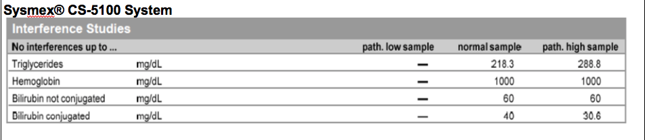

Dade® Innovin® Reagent is insensitive to concentrations of unfractionated heparin up to approximately 2.0 units per mL.
Inhibitors such as lupus anticoagulant may interfere with the prothrombin time and result for example in INRs that do not reflect the exact degree of anticoagulation.
Hirudin or other direct thrombin inhibitors in therapeutic dose result in prolonged prothrombin times.
According to the manufacturer of ORBACTIV, the drug oritavancin has been shown to artificially prolong PT and INR for up to 24 hours. The monitoring of the anticoagulation effect of warfarin may be unreliable for up to 24 hours after an ORBACTIV dose.
Some blood collection tubes may contain Mg2+ ions, which have been shown to interfere with recombinant thromboplastins.
Blood plasma substitutes that contain hydroxyethyl starch (HES) may interfere with the analysis. Therefore, it is advised that plasma samples that contain such substitutes should not be analyzed with the PT derived fibrinogen method.

- LIMITATIONS OF THE PROCEDURE:

There are no other clotting factors in recombinant human tissue factor. Factor assay curves
using Dade Innovin Reagent may therefore give longer clotting times at the lowest levels of the deficient factor than with other reagents. This may result in clotting times greater than 100 seconds for low factor levels in factor assay curves.
Dade® Innovin® 4/7 2018-08 10873566GU11 Rev. 03 – en – USA only
Derived fibrinogen results within the reference range can be directly reported. Results outside the reference range should be re-measured by a standard fibrinogen determination method, e.g. Fibrinogen method with Dade Thrombin Reagent or with Multifibren® U Reagent. Derived fibrinogen testing is not suitable in patients with dysfibrinogenemia6 or patients with prolonged PT, e.g. under oral anticoagulation.

Lipoglycopeptide antibacterial drugs (such as oritavancin or telavancin) may interfere with PT based assays. Consult Instructions for Use of respective drugs.
Results of this test should always be interpreted in conjunction with the patient’s medical history, clinical presentation and other findings.

XVII. REFERENCES:

  - Sysmex CS5100 Reference Guide
  - Sysmex CS 5100System Evaluation and Algorithm
  - Sysmex CS5100 Instruction for Use.
  - Siemens CS 5100® Operator’s Manual

XVIII. HISTORY
H-1 This procedure was written by P Bahel on 6/30/2020

