Immunology, Flow and Molecular Meeting
Apr 18, 2012
1:00 PM
PS230

- Job Postings
  - Flow Coordinator
  - Per Diem – HR to schedule interview
  - Evening
    - Jimmy D. will take the position.
    - Tentative transfer date 5/21/12

- Email
  - MTS

- Lab Week Events
  - See Attached Schedule
  - Friday – 2pm Immunology Party.

- EPIC
  - Greenwich Go-Live is Apr 20.

- Pharmacy Social

- Security
  - Question regarding having a phone in the lounge – referred to Voula G. for the Safety Committee.
  - TAL to follow up w/ PM regarding the status of Panic Alarms and swipers for the 4th Floor Lounge.

- HIPAA
  - Mandatory Training Sessions
  - Do’s and Don’ts

- Accessioning – make sure the right collected date is on there. For example. Sample#1 accessioned in CoreLab on 2/14. Sample#2 gets to Flow the next day at 8 am. The Collection date needs to be change to 2/14 since this is the ACTUAL collection date and not 2/15.
  - Add-ons or reflexed tests– make sure to change collected date to the original collection date

- Use of Cellphones

- Saturday Couriers
  - Call by 9 am Sat. or Fri pm.
  - Carroll’s – 860-673-2241 and Val – 860-856-0696 (if Carroll can’t be reached)

- Rich Torres – June 2012 –New position as Director of Flow Cytometry.

- Repeat Diagnostics Requisitions – see attachment below for example of the requistion
  - Refer the samples to Penny, JR, or Front Processing Staff.
    - Basic Procedure (telomere length measurement) = TBLA
    - Detailed Procedure (telomere length measurement) = TDLA
  - Information is available in the Core Lab.

- SmartWeb to text physicians
  - Intranet – Select Smart Web All
  - Type in Last Name and/or First Name – click Search
  - Click Beeper to send Alphanumeric page
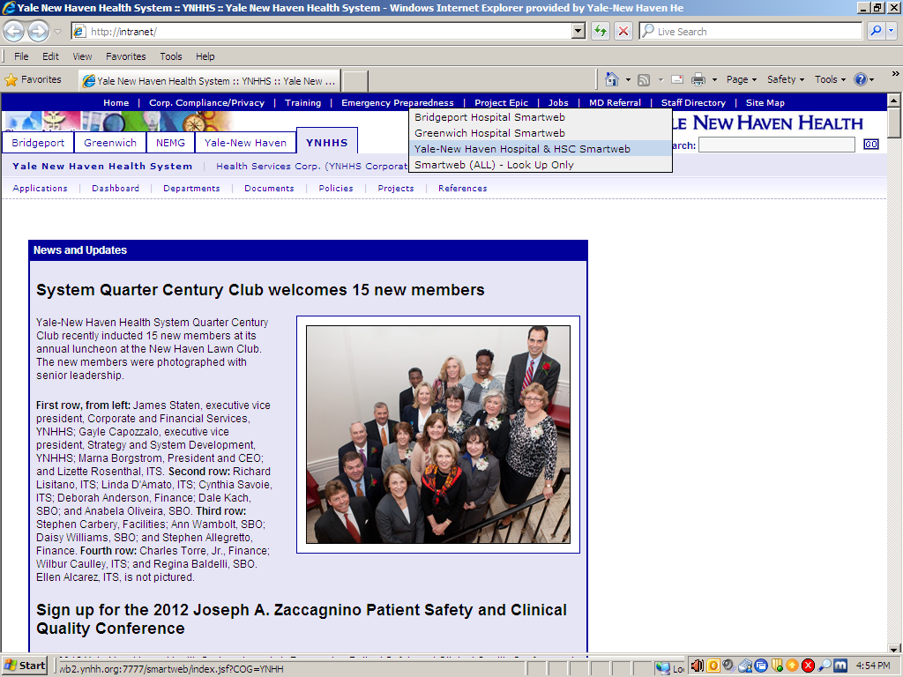
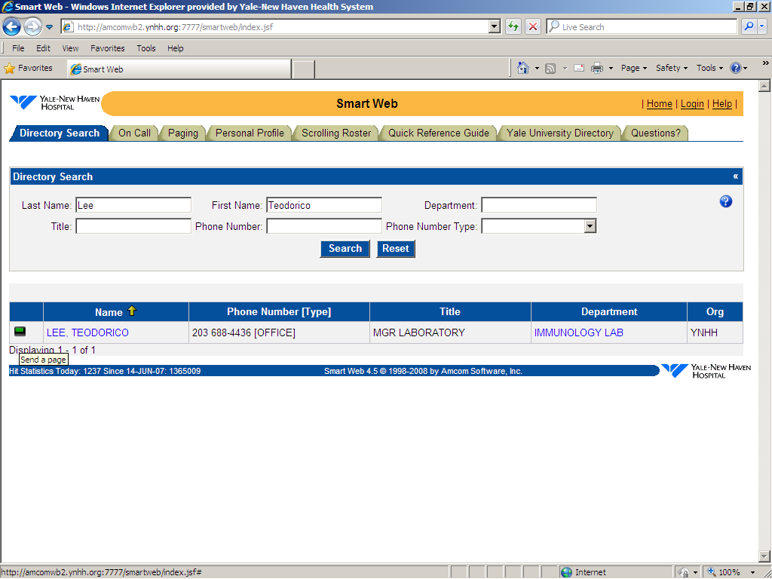
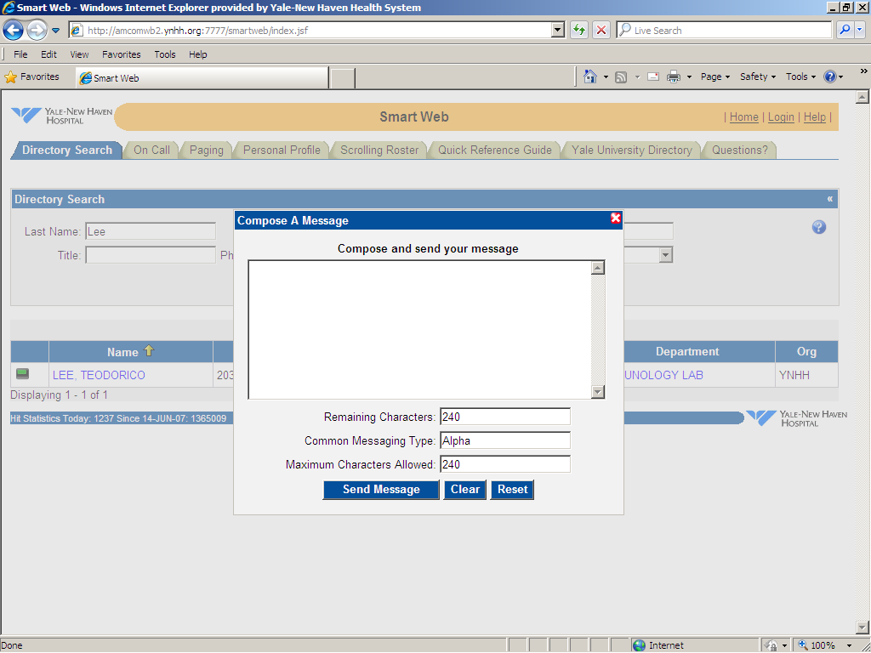

- JR’s Vacation
  - Apr 30 – May 4th

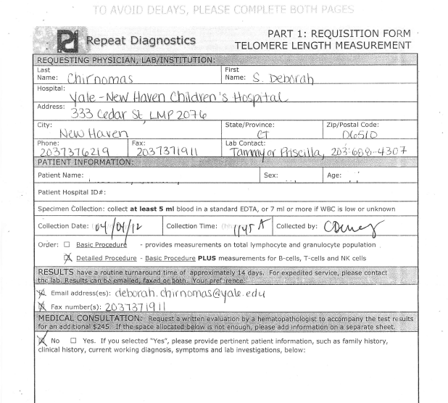

Immunology, Flow and Molecular Meeting

___________________________
(date)

11:00 AM.
PS230

SIGN UP SHEET

________________________ ________________________
________________________ ________________________
________________________ ________________________
_______________________ ________________________
________________________ ________________________
________________________ ________________________
________________________ ________________________
________________________ ________________________
________________________ ________________________
________________________ ________________________
________________________ ________________________
________________________ ________________________
________________________ ________________________

