Immunology, Flow and Molecular Meeting
Aug 22, 2012
1:00 PM
PS230

- Announcements:
  - Welcome New Employees – Lori, Monique, and Sri.
  - RSVP with Berni – Happy Hour Bar
  - Welcome Alina P. back

- Job Openings
  - Flow Coordinator
    - Aug 15th interview – Betty Sun – offering Per Diem
  - 2 Positions from Flex
    - 1 Evening Position – offered & accepted to/by Monique
    - 1 Day Shift Position – offered & accepted to/by Rose

- Lab Liason
  - Nominations – Navin Trivedi.
    - 1 more volunteer/selection needed
      - Linda Grunwald volunteered
      - Part-time OK

- Vacation
  - Vacation Selection Due Now

- Slippery
  - Rugs in place for PS Lobby
  - Lab Medicine employee slip and fell
    - JR contacted Pat G. – YNHH will begin the process for remediation.

- 3rd Floor Lockers
  - Please lock
  - #145 – illegal occupant. Security to cut lock by Aug 27th
  - Clean lab coat – please claim and put them in your locker

- Scales –Special Chem
  - Keep them clean

- Fire Drill
  - Leslie Lang, Alina Parker, Karyn Ronski, Rose Scroggins and new employees
  - 1 more fire drill for 2012
  - If a person misses the last fire drill, Voula Golfis will conduct a “virtual” fire drill

- EPIC training
  - Schedule to be determined
  - EPIC Lab and EPIC Lab Plus
  - Superusers - # of superusers to be determined.

- New Equipment
  - Qiacube
  - Assist
  - New Centrifuges

- New Tests
  - Interferon beta 1a Antibodies (IFNBA)
  - Interferon beta 1b Antibodies (IFNBB)

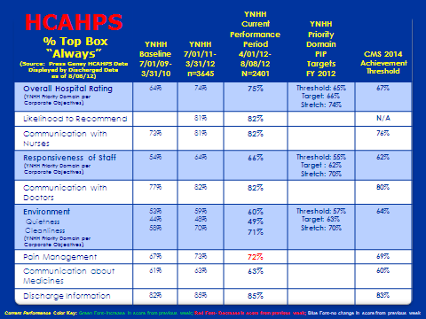

Questions:
- Security – no update
- Safety issues – Safety Committee, JR, & Pete
- BioFlash/NovoView – no update

Recognition:

- Kate Marreiros – Teamwork – ran Immage, ImmunoCap and Thyroglobulin Ab
- Mike Teel – doing a great job with cleaning the lab
- George?? – doing a great job filling in for Terry

Immunology, Flow and Molecular Meeting

___________________________
(date)

1 PM
PS230

SIGN UP SHEET

________________________ ________________________
________________________ ________________________
________________________ ________________________
_______________________ ________________________
________________________ ________________________
________________________ ________________________
________________________ ________________________
________________________ ________________________
________________________ ________________________
________________________ ________________________
________________________ ________________________
________________________ ________________________
________________________ ________________________

