Immunology, Flow and Molecular Meeting
Sept 19, 2012
1:00 PM
PS230

- Announcements:
  - Susan Richardson – Oct 8 and Jeanne Savalonis – Oct 4 = start date.
  - Jimmy - OK

- HSR Update – Manager Buddy System,
  - Everything went well
  - Chris O’Connor
    - YNHHS as Executive Vice President and Chief Operating Officer
      - Development of shared System services and programs - Northeast Medical Group, Supply Chain and Corporate Procurement, Facilities, and HR
    - Alan Kliger
      - Chief Quality Officer for System directing system-wide performance management and coordinating safety and quality initiatives across the Delivery Networks and NEMG
    - Joseph Bison
      - VP of Business Development

- PIP
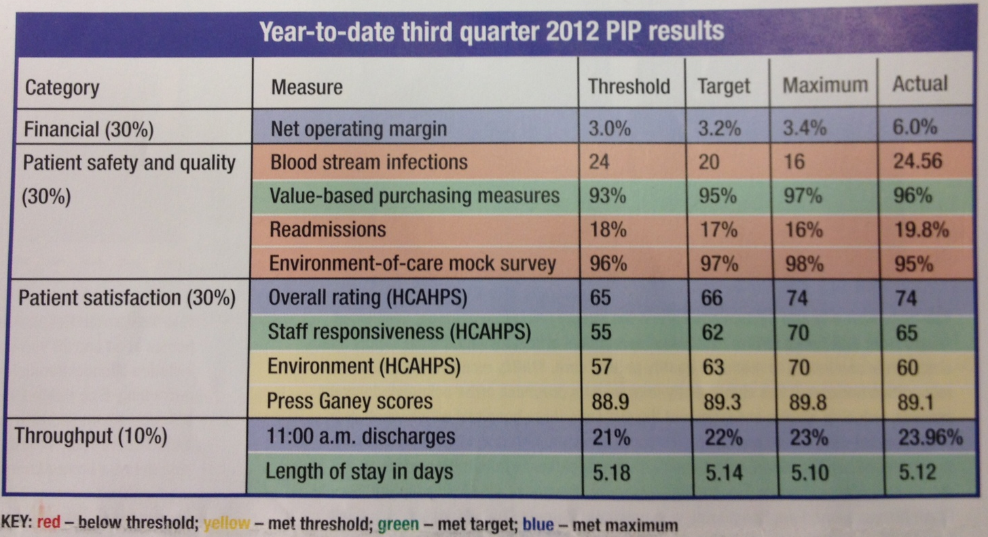

- Physician Recruits
  - Physician Recruits – Michael Bennick – Medical Director of Patient Experience
  - Georget Lester – Children’s Hospital
  - Peter Schulam – Dept of Urology

- Healthier Together T-shirts
  - Name & Size to provide to marketing in order to get T-shirts

- YNHH Safety Cards

- Fairwarning
  - Privacy breach detection solution
  - It is a computer application that watches electronic medical record systems to identify potentially inappropriate access to protected health and other confidential information.

- Job Openings
  - Per Diem Position – interview scheduled next Monday.

- Vacation
  - Immunology & Molecular completed
  - Immunology Eve and Flow coming soon

- Medical Leave for any reason
  - Approvals have to the manager
  - Doctor note required

- ESS
  - FAQ – attached
  - ESS Login – Link to use employee # and old password otherwise use network ID and password
  - IE8 – As of Sept 21, 2012 – ESS will automatically detect which version of IE you switch to one that works w/ that specific browser version.
  - Access from home http://portal.ynhh.org
    - Available to all exempt & non-exempt employees – W4, paystubs, etc.

- Lockers – 145 has been cut
  - Lab Medicine initiating locker inventory audit

- EPIC training – coming soon.
  - L:\EPIC\Lab Medicine EPIC training list revised.xlsx to find out what classes you are assigned and room #
  - SuperUsers – Voula Golfis and Jimmy Debevoise

- The 2012 YNHH Employee InFLUenza Vaccination Fair is scheduled for Tuesday, October 23, Wednesday, October 24 and Thursday, October 25 in Max Taffel A/B/C/D.
  - List will be generated and tracked by Dept.

- United Way Back to School Drive has been extended to Sept 21 – contact Navin for any questions.

- Security – Lounge
  - Locksmith

- Employee Opinion Survey
  - 2012 Employee Engagement Survey beginning next Monday, September 24, 2012 – Oct 8, 2012.
  - Ambassador – Regina Smith
  - http://www.ynhh.org/survey
  - 20-25 mins
  - Daily Drawing

- Min/Max Thermometers – will be purchased Oct 1, 2012. Eliminates the need to Immunology checking the Molecular refrigerators/freezers.

- Space
  - Tosoh900 – temporarily location TBD
  - Artwork – will be moved to accommodate new refrigerators in Flow

- File Room
  - Phase 1 – stop generating paperwork
  - Phase 2 – elimination of files in the file room
  - Phase 3 – elimination of files in Iron Mt.
  - Phase 4 – elimination of slide storage after 10 years

- Volunteer Services
  - Navin attended a dinner recognition for the volunteers
  - Volunteer office looking for adult volunteers

- Quantiferon Tubes
  - Check daily.

- Clinton Drawstation Picture
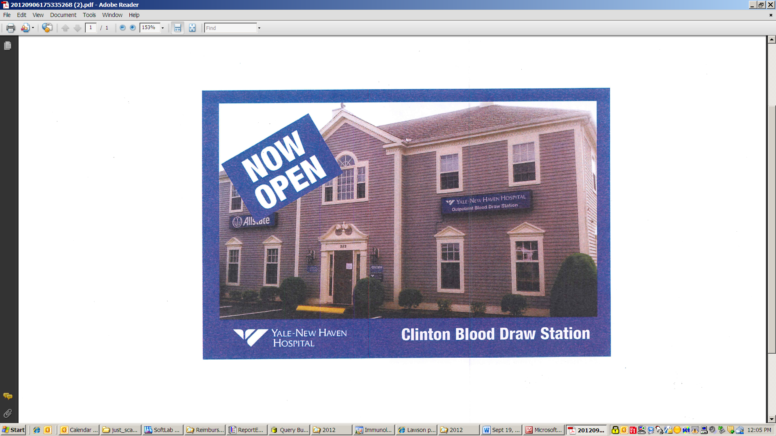

Question:
- How is readmission defined?

Recognition:
- Penny – Scheduling
- Sridevi – Great Trainee
- Monique – Great Trainee
- Kathy Radziunas – Great Trainer
- Regina Smith – Great Trainer
- Alina Parker – Great Trainer
- Susan Goettlich – Great Trainer
- Katelyn Marreiros – Great Trainer
- Navinchandra Trivedi – Great Trainer
- Kathy Rodgers – Teamwork

