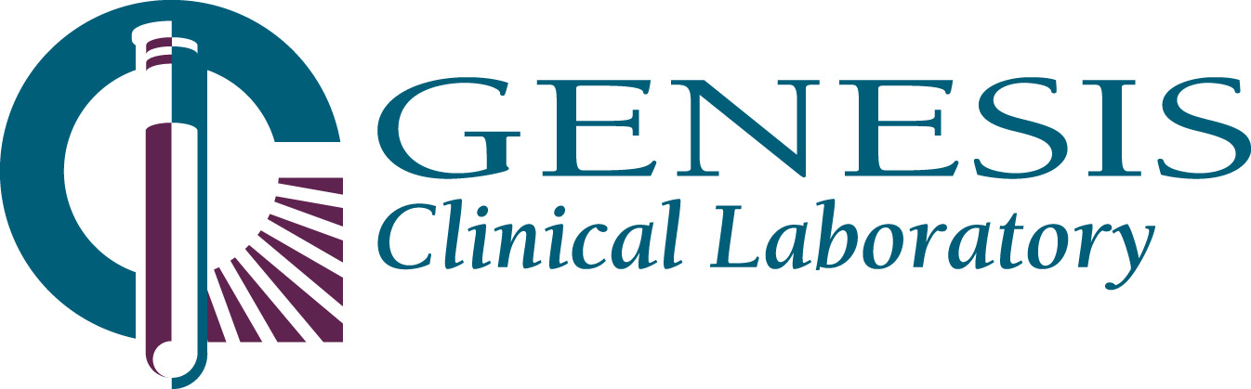

GENESIS CLINICAL LABORATORY
URGENT NOTICE
CHANGE IN ACCEPTANCE OF SAMPLES FOR BORDETELLA PERTUSSIS PCR

August 3, 2012

Dear Colleagues:

Traditionally, testing for suspected Pertussis has been performed at the Illinois Department of Public Health. A memorandum was issued, effective August 1, 2012, stating that new criteria must to be met before they will accept these samples.

Excerpt from IDPH memo, dated July 27, 2012:
Hospitals and other health care providers seeking approval for specimen submission as detailed in the memo “Notice of plan to discontinue or decrease selected Public Health Laboratory tests” dated 7/2/12 should contact their local health department with information about onset, symptoms, and exposures. The local health department can then contact the IDPH CD Section to determine if the testing is appropriate.

Local health departments (LHDs) must call CD staff at 217-782-2016 to request approval to submit specimens to IDPH Labs for testing or to obtain specimen collection and submission kits for testing. Specific information must be provided to CD staff about the demographics of the current suspect case(s), onset and clinical presentation, probability for outbreak conditions, and other epidemiologic criteria that could mandate the need for solitary or expanded specimen submission.
Upon approval, IDPH CD staff will provide an outbreak/incident number that will need to be added to IDPH laboratory submission forms signifying approval to submit specimen(s).

If the physician is able to obtain an Outbreak number from IDPH, he/she may still collect the nasopharyngeal swab on the Regan/Lowe media provided by the laboratory. Use current ordering/collecting procedures.

In anticipation that these new guidelines will pose issues in the clinical setting, particularly in the Emergency Department, Genesis will offer the following alternative.

- If the physician is not able to obtain an Outbreak number from IDPH, and still wishes to order testing by PCR, this testing will go to a commercial laboratory, currently Quest Diagnostics. This test will be added to the HIS/EMR ordering menu as soon as possible, and a second notice will be sent when it is available. Until that time, for orders on hospital patients, please use manual requisitions. For those physician offices with Atlas access, please use Miscellaneous, test code 7020.

Proper sample for the Quest PCR test;
  - Nasopharyngeal swab in M4 or Amies media. DO NOT use a calcium alginate swab. The laboratory will supply this media.
  - Nasopharyngeal wash in a sterile tube, such as a Red top evacuated container.

It is our goal to alleviate any confusion that is a consequence of this change. Please feel free to contact Judy Holmquist, Microbiology Supervisor at 708-783-0144 if you have any questions.

3231 S. Euclid Ave., Berwyn, IL 60402 708-484-3280/1-800-522-1425 Fax 708-783-0381 www.genesislab.com

