Purpose
This procedure provides instructions for issuing uncrossmatched red cells in emergency situations and for performing the post issue crossmatch.

Specimen
The specimen of choice is fresh EDTA plasma and red blood cells.
Refer to Specimen Requirements, Labeling and Storage Procedure.

Procedure:

All units issued before type and screen completed will be issued following this procedure

- Transfuse o negative red blood cells and ab plasma

- Send secureline blood-band with pickup person to be placed on patient

- Four o negative units will be issued to a single secureline blood-band

- If time permits check patient record for previous antibodies and/or other transfusion issues and notify physician immediately

issuing an emergency tagged unit (o negative only)
******When Trauma Team is Called******
Step | Action
1. | HBB→Open Patient/Order module
2. | Product→Emergency Issue→Known
Leave Computer Terminal Open
When ED calls or arrives to get blood→
3. | Remove unit from refrigerator
4. | Patient button on the right side of window  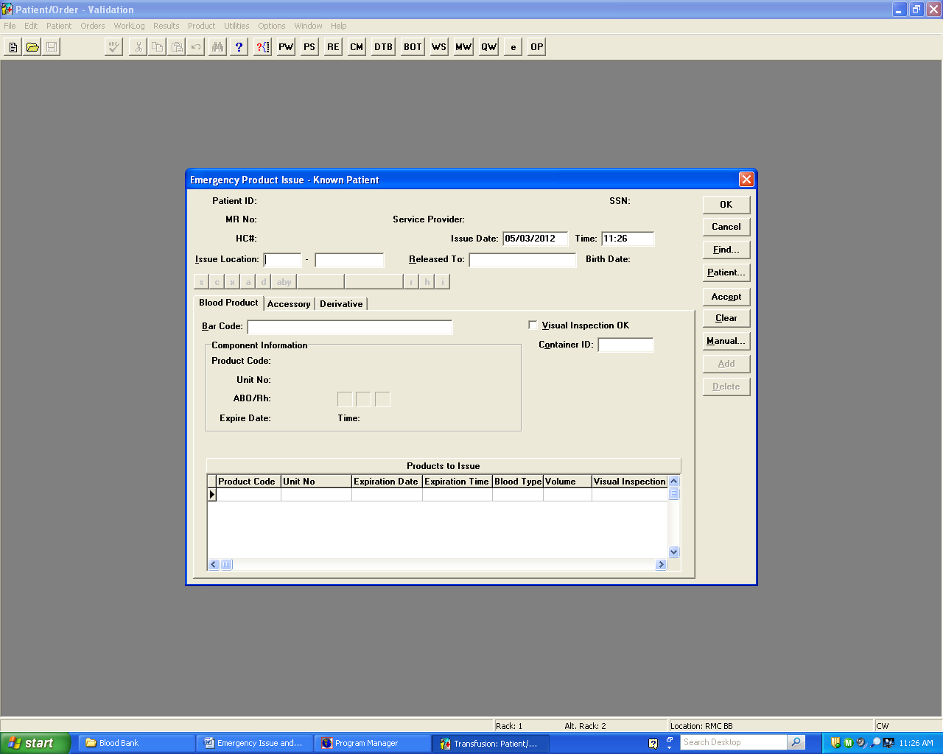 |  | Click
5. | MR# field |  | Enter the Secureline Number from the tag
6. | Query → Secureline Number will appear in bottom grid  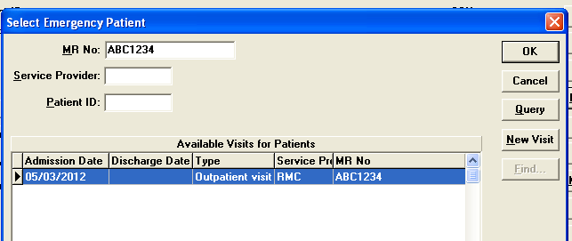 |  |  | OK
7. | Issue Location: |  |  | RMC
8. | Scan unit number and Standard Product Code  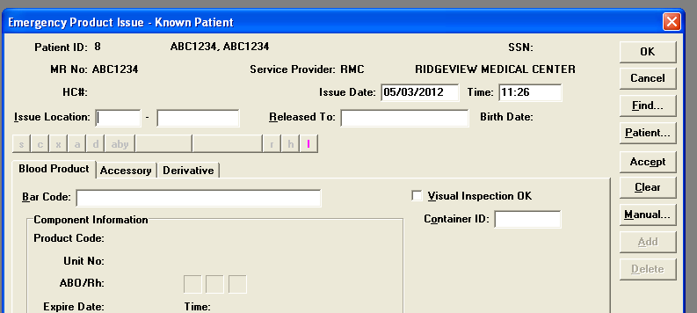
9. | Place a bar-coded unit number sticker on the pink pickup slip
10. | Retain vial with stickers and segments
11. | Blood Bank Tech states the following, with pickup person confirming the information being read:  - Secureline number on → Unit tag→ Unit- Pink Slip → Computer(name,Mr.#)  - O Negative on → Unit tag→ Unit→ Computer  - Unit Number → Unit tag→ Unit→Computer  - Crossmatch test Interpretation→ Crossmatch Not Performed
12. | Visually inspect unit and check box | Visual Inspection Box  - Outdate  - Color  - Appearance-hemolysis,aggregates, fibrin strands, clots, flocculent matter, bacterial contamination
13. | Accept | Accept to lower grid.
additional units assigned to this secureline armband number
can be scanned if needed

14. | Released to: | Transport person signs: first initial, last name, title
15. | Date/Time stamp both copies of unit tag, the pink slip, and the Emergency Issue Worksheet
16. | remind transport person to place secureline armband on patient before transfusion
17. | Place unit in biohazard bag with armband and unit tag in side pocket.
18. | Click OK to issue unit.
19. | check patient record for previous antibodies and/or problems asap  and notify physician if there are any issues
20. | Fill out Emergency Issue Worksheet as completely as possible.
21. | Complete the type and screen and the post issue crossmatch as soon as the specimen is collected.
Physician signature on unit tags
is required within 24 hours of emergency issue

POST ISSUE CROSSMATCH
FOR EMERGENCY UNITS ISSUED UNCROSSMATCHED

If you have received a specimen and order on patient during or after emergency issue, record that specimen and record Securline number in External ID, then complete Type and Screen orders only.

Two Twelve specimens must be received following RMC Transfer procedure.
Step | Action
1. | Record specimen | Click Patient (top tool bar) →Record Specimen
2. | Enter Secureline number for MR No:→Query  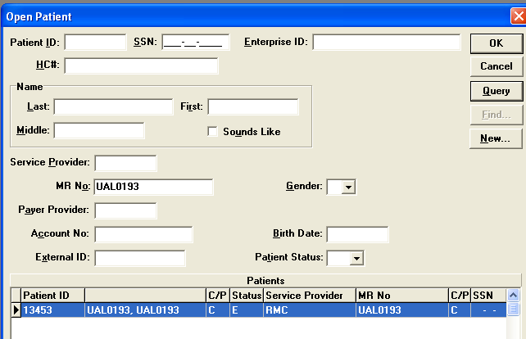  Emergency issue appears at bottom of grid→OK
3. | Click on Generate button (on the right) to generate accession number  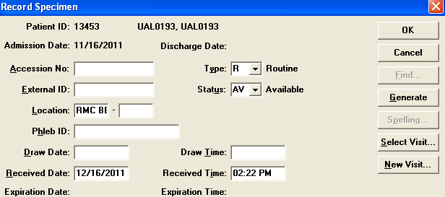
4. | Enter Fields: | External ID→Secureline Blood-Band number  Phleb ID→Initials  Draw Date:→ Draw Time→  OK
Open Emergency order
5. | File→Open→Order
6. | Enter Secureline Blood Band number for MR# →Query→Select Order (priority will be STAT)→OK
Emergency Order appears →RBC will be present →Add XM (and if necessary a TSG1) as follows:

7. | Change status from completed to ordered as follows:  Orders (top tool bar) →Change Status to Ordered  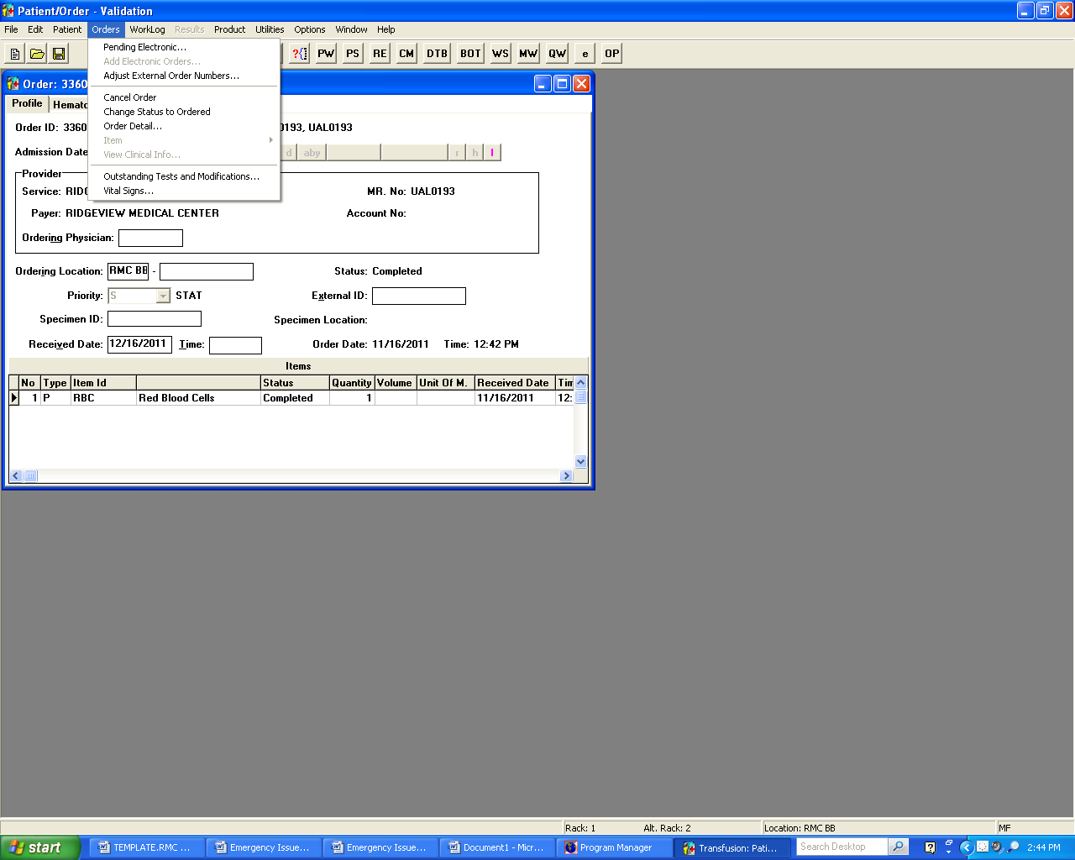
8. | Priority→will already be filled with S for STAT
9. | Specimen ID: →  Double click on field to find or click on binoculars (choose the generated accession #)
10. | Time: →Enter T for current time
11. | Add XM orders as follows:  Click Orders (top tool bar) →Item→Test Battery  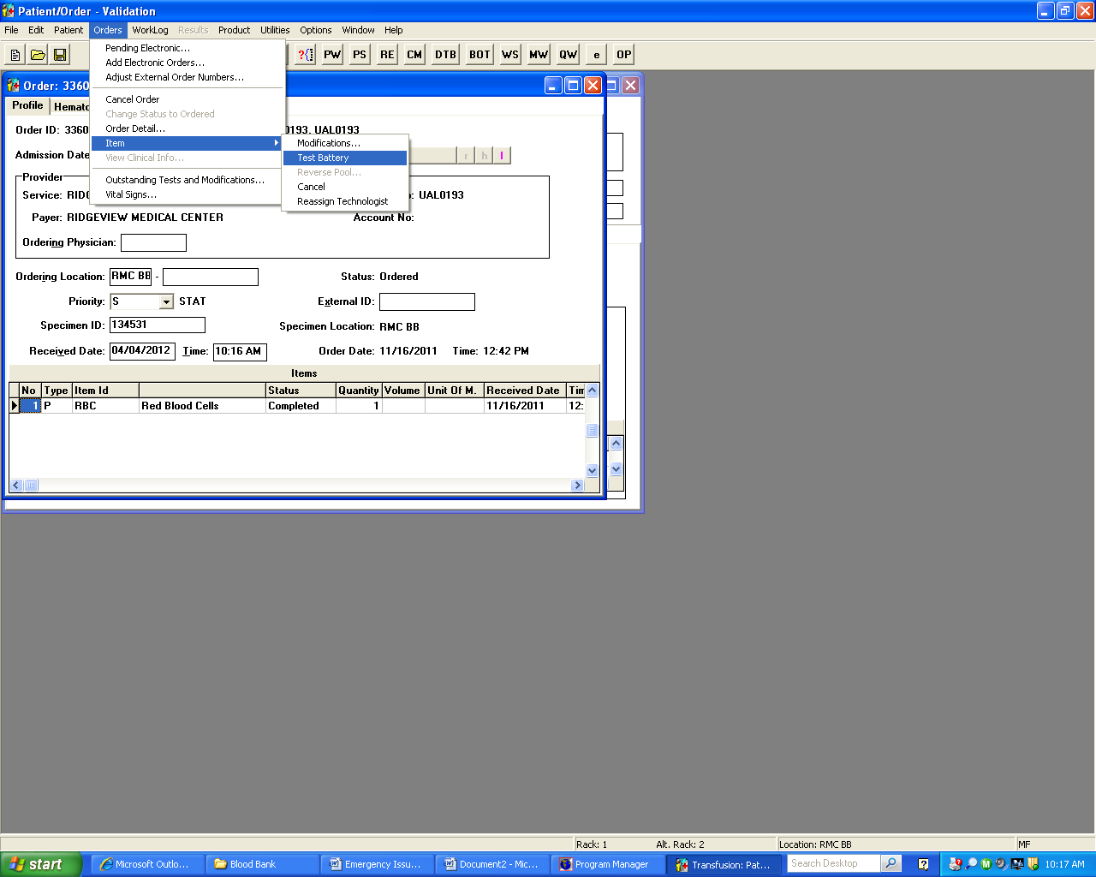
12. | XM will appear on grid →click OK  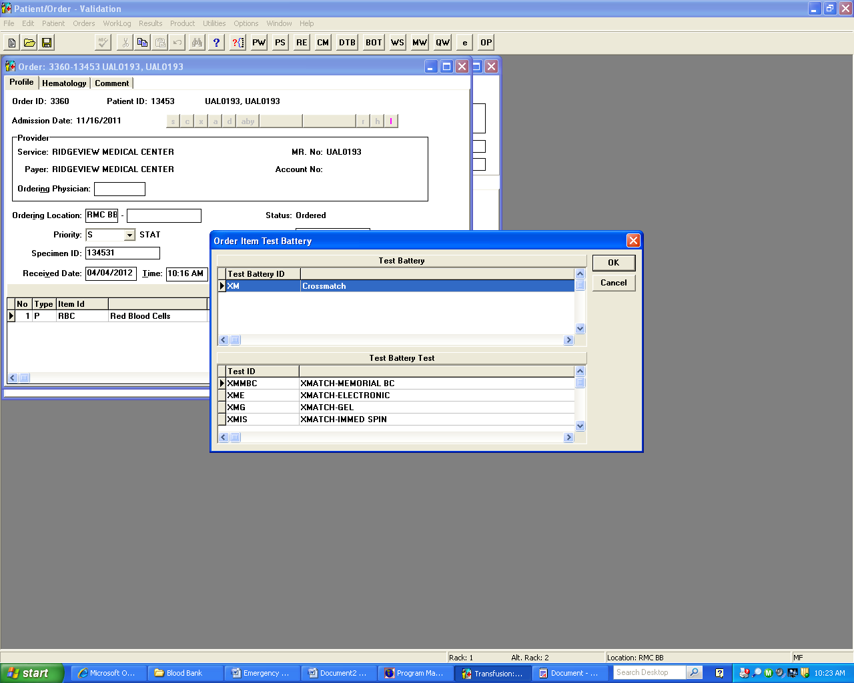
XM order now exists for Issued Red Blood Cells
13. | SAVE and close
Complete all Testing on Pending Worklog
14. | PW→Query?→RE | Verify specimen ID using Generated accession#
15. | Record results and interpretations following RMC procedures.
16. | SAVE →Click and Close
If incompatibility is detected at any phase of testing, the technologist must immediately notify the attending physician and the on call pathologist.
Document calls in comment section of the incompatible test.
17. | Cancel any extra RBC orders in HLAB
18. | Add additional information to Emergency Issue Worksheet as completed.

***Lead tech or designate will merge the two patient IDs and charge units when all testing is complete***

1. | To Merge patient IDs → | Utilities→Patient→Merge
2. | To charge for emergency units in HLab | Order entry→Patient MR#→order 41550 for RBCs and  41483 for XM for each unit.
3. | Initial tasks as completed on the Emergency Issue Worksheet

Note:
- The immediate risk of transfusing RBCs prior to pretransfusion testing being done is a hemolytic transfusion reaction caused by circulating alloantibody in the patient.
- A label with all required recipient identifiers is securely attached to the component after crossmatching and retained with the unit until the transfusion is completed.

Safety
Refer to Laboratory Procedure #4002-1: Infection Control and Laboratory Safety Hygiene Procedure and all other safety policies of the laboratory.

Related Documents
ABO Forward and Reverse, Rh-Gel Card
Crossmatch-Electronic, Immediate Spin (Gel), IgG (Gel)
Emergency Issue Worksheet
Indirect Antiglobulin Test, Gel Method
Issuing Products
Product and Specimen Transfer
Resulting Testing from the Pending Worklog
Specimen Requirements, Labeling, and Storage

References
AABB Technical Manual, Sixteenth Edition.

Date: | Author: |  |  |  |  |  | Date: |  | Validated by: |  |  |  |  | Date: |  | Approved by:
12/29/11 | Mary Farlow MT(ASCP)SBB |  |  |  |  |  | 4/9/12 |  | Cheryl Webster, MLS(ASCP)^{CM}
Annual Review
Date:
Initials:
Date: |  | Initials: |  | Revision and Reason

