Weekly Updates
November 8, 2012
Test | Description of Change(s) | Affected Individuals
Sendouts | I have updated the sendouts pickup schedule and hung this in sendouts. The delivery driver MAY come early. Please do not send the cooler more than 5 minutes before or after the scheduled pick-up so we can send all patient specimens in a timely fashion. | All Staff
Expected Dates for orders in EPIC | Please be aware that some providers put orders in that should not be drawn until the expected date:  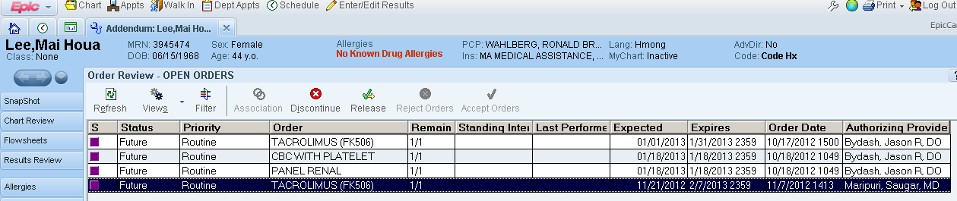 | All Staff
2nd Reminder: Identifying patients | Always identify the patient using two identifiers prior to giving any specimen cup/stool cup/etc or before drawing blood. This includes also all urine cups.  - Full Name (first and last)  - DOB  We need to confirm the patient’s identity because, as we know, yellow sheets are often wrong or misidentified. Within the last week a lab labeled stool culture and O&P were mislabeled. | All Staff
Understanding Cerner labels | 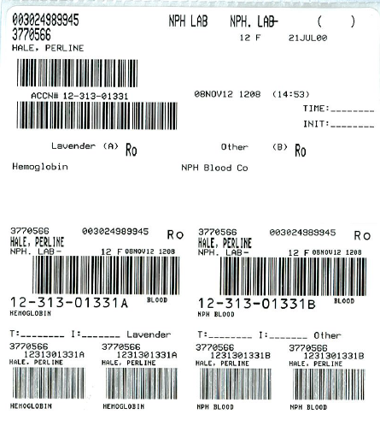  Some of our tests require that 2 tubes of blood are drawn. The test will have an “A” and a “B” label. Here are examples of the Cerner label:  This label has an A label for hgb, but the B label has a different test code meaning that the hgb needs only 1 tube of blood  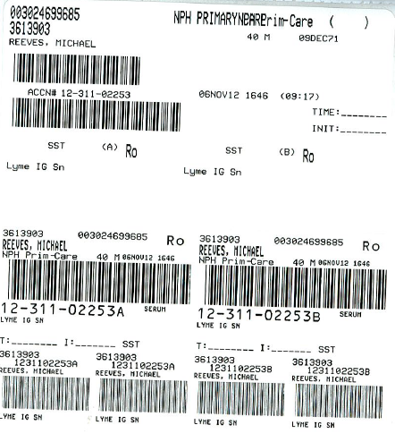  An example where this is an A tube for a test and a B tube for the same test – this test needs 2 tubes of blood | All Staff
Urine centrifuge | We have a new urine centrifuge. Please use program 1 (memory 1) for a 5 minute spin with low braking. Ask Denelle if you need a tutorial. | All Staff
Breaks | Please sign up on the bulletin board for your break. Be sure to communicate when you leave with your co-workers so they can cover your area. | All Staff
Staff Meeting Reminder | We are CLOSED on Monday for Veteran’s Day. On Tuesday 11/13/2012 we have a lab staff meeting over the lunch break. | All Staff
Sofia QC | Please remember to run the Sofia Pos and Neg controls on all days we are open, including Saturdays, until we have run for 30 consecutive days. | Bench Techs
ACE Alera ALT | - The new ALT reagent on the ACE Alera now has 2 bottles.  - This new reagent will run MUCH LOWER than the previous reagent.  - A result of 0 is now common for this test.  - The lower reportable range is now <5 and will hopefully be changed in Cerner ASAP. (If the lower limit is <10 when you are resulting do not verify – see Denelle.)  - For the next 60 days, all results will also have the following comment attached: “Due to manufacturer reagent redesign results will run lower than previously. Use caution when comparing this result value to results prior to 11/6/2012.” | Bench Techs

Procedure Additions, Updates and Changes:
- None

