Weekly Updates
November 15, 2012
Test | Description of Change(s) | Affected Individuals
Slides for Heme | Only pencil on the frosted end of the slide is acceptable for identification purposes. Label the slide with patient name, MRN and the date. Permanent marker, ink pen or a handwritten paper label is not acceptable as it is removed by the methanol during staining. Labels are also destroyed by the methanol during staining. | All Staff
High A1C | A reminder of the ranges for A1C’s, as described in the procedure.  Linear Range  4.0%-15.0%  - A result displayed as information code “105” indicates a concentration below the lower limit (4.0%). Result should be reported as <4.0% HbA1c.  - A result displayed as information code “106” indicates a concentration above the upper limit (15.0%). Result should be reported as >15.0% HbA1c. | Bench Techs
Cerner Changes | - The collection time MUST be before the receive time. The receive time defaults to the current time when you are logging specimens in. The easiest way to fix this is to decrease the collection time by several minutes by hitting the down arrow when logging specimens in. See Denelle or Sue Johnson if you have questions.  - If you get a “netting error”, this means the accession number has assigned right in the middle of logging the specimen in. To proceed, select ok. Then hit the button with the “glasses” to refresh. The accession number will populate the field, print the labels and then proceed to log in the specimen as usual.  - Using a coded comment in the cancel field does not translate using F9 anymore. Instead search for the cancel comment using F2. Make sure activity type is General Lab and in the name field type NPH. Then highlight the code you want and select OK.  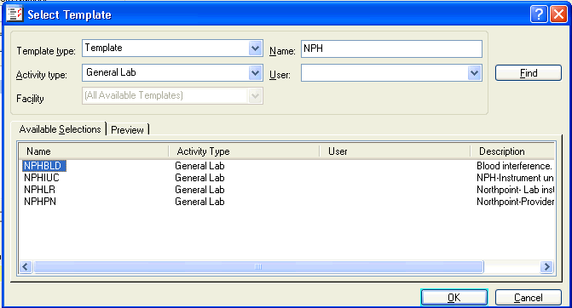  - You are now able to add a cancel comment in the man. But you must also select the canceling provider, which is the ordering provider unless otherwise specified.  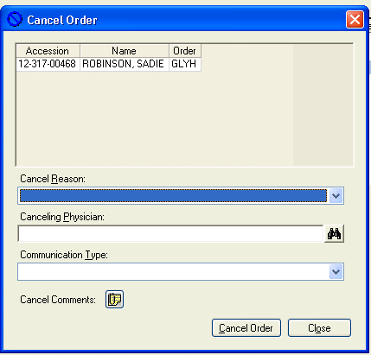 | All Staff
Cerner labels | The Cerner labels formerly stored in the back in the bottom drawer have been moved to the open shelf above the Microalbumin Afinion instrument. | All Staff
Add-ons and Extra tubes | These orders must have the COLLECTION TIME match the original collection time to match and display correctly in EPIC. If the time does not match it may also adversely affect billing. See Denelle if you have questions or concerns. | All Staff
INR’s using INRatio2 | The INRatio2 must always be performed using blood from a capillary stick. It is not acceptable to use an extra drop of blood from a venipuncture to perform this test. If the patient REFUSES a fingerstick, instead draw a coag tube and transfer the INR to HCMC for testing. There is no need to call the pharmacist, as there will be no results for them to review. See attached procedure below. | All Staff

Procedure Additions, Updates and Changes:
- INR Procedure

