Weekly Updates
January 17, 2013
Test | Description of Change(s) | Affected Individuals
CF Sweat Test | When a patient has an order for this test. We call HCMC toxicology lab (873-3018) and work with them and the patient to schedule the test. The testing is performed on Tuesdays. | All Staff
New Tests | - Cl POC INR – used for NP point-of-care INR’s for patients on Coumadin. Only the INR is resulted.  - PTandINR – used for non-coumadin testing. Test needs a coag tube drawn. Will be sent to HCMC for testing. No longer needs to be “transferred” to HCMC.  - CCP – Hemogram and platelet, no diff. Performed at NPH.  - Plyte – electrolyte panel; performed here on the Ace Alera as the “lytes” panel | All Staff
Reordering INR’s | The plan is to reorder the old INR orders as patients present to the lab. Choose the correct INR order in EPIC. Use the same provider and diagnosis code as the original INR order. Discontinue the old(wrong) INR order in EPIC.  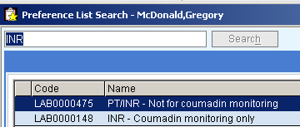 | All Staff
Ictotest | Once the last ictotest has been used, our process will change as follows:  - When a urine Bilirubin result of Trace, Small, Moderate or Large is obtained result Urine Bilirubin as POSITIVE.  - Attach this comment to urine bilirubin result: Unable to confirm true presence of bilirubin in urine. Recommend performing liver function testing if indicated. | T1 Bench Techs
All Staff Meeting | Thursday 1/24/13 from 8:30-10 in the Urban League Building across the street. | All Staff

Procedure Additions, Updates and Changes:
- None

