**Sysmex Training**

1. If you do not already have an account, follow the instructions below to register:  
   a. Go to www.sysmex.com/usa
2. Click on "Log in" at the top right of the screen.
3. Click on "Register" under the Customer Resource Center section.
4. Enter your CRC Site ID and the zip code of your lab location. Then click on "Lookup".

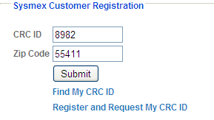

1. Select your location from the dropdown list, fill in the rest of the form and click on "Submit".
2. A registration confirmation will be sent to the email address you registered.
3. Click on the link in your e-mail and log in with your password from your registration e-mail.
4. You will then need to click **“My Instrument Courses”** under Center for Learning:



1. Complete the following classes:

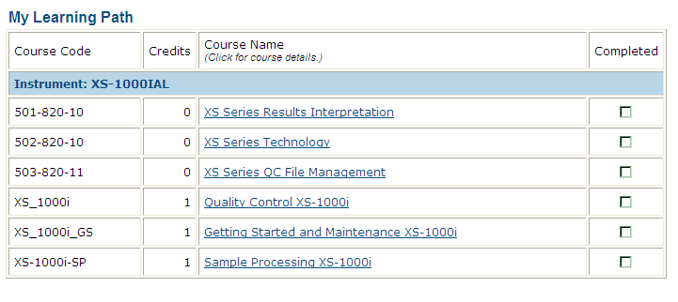

**This is due by March 19, 2013.**