Weekly Updates
April 25, 2013
Test | Description of Change(s) | Affected Individuals
Resulting CBC Plt Df | You need to enter all the results on the Sysmex printout – through Basophil absolute.  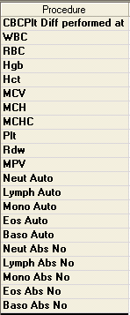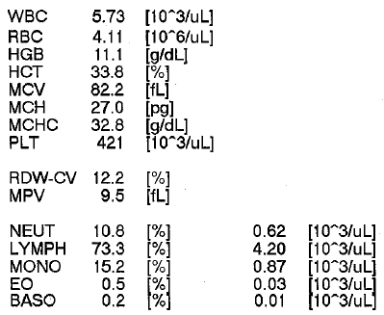  Result through this result | All Staff
Lab Windows | Please remember to close all the lab windows at the end of each night. During the warmer months, our AC unit will run excessively if the windows are not shut. –A friendly reminder from Property Services Ray & Jay | All Staff
Pediatric Phlebotomy | Our process is to attempt one venipuncture. If this is a miss, we will then perform a fingerstick for patients. | All Staff
Kova Tubes Caps | Please cap kova tubes during centrifugation. Caps are stored in the same cupboard as Multistix. | Bench Techs
Lipid Panel Change | Effective Wednesday May 1… we will only run direct (measured) LDL’s on patients that have trigs ≥ 300. See attachment below.  - Program LIPID on ACE  - Add ‘fasting’ or ‘non-fasting’ as comment on ACE  - If ACE triggers panic trig (trig ≥ 300), then add LDLDIR  - Result Chol, Trig & HDL in Cerner  - Press perform  - Then go back into accession #.  - Depending on results either a) or b) will happen  - Calculated LDL and VLDL will auto-fill  - Calculated LDL and VLDL will ‘NA’ and the mLDL result field will appear. Enter mLDL result.  - Verify results  ** Please still label all non-fasting patients with stickers  ** Please continue to attach a fasting or non-fasting comment on all Glucose results | All Staff
Competencies | I am working on getting the April competencies posted to MTS. Please stay tuned. I expect to post the April competencies within the next week. These will be followed a week or so later by May competencies. Thanks for your patience! | All Staff
Coded Comments | Please check the work stations for updated coded comments. Several new comments were created for our new Sysmex. | All Staff
New Cancel Code | Effective as of Monday April 22, we have a new cancel code –  Patient unable to void  Use this when we don’t get a urine specimen on a patient. | All Staff
Critical Values | Please see updated critical values at each workstation.  ** Only the ANC values changed for NPH criticals. | All Staff
Procedure Additions, Updates and Changes:
- LDL Flow Sheet – Revised Effective May 1, 2013

