Weekly Updates
May 16, 2013
Test | Description of Change(s) | Affected Individuals
Sysmex CellPack Labeling Change | 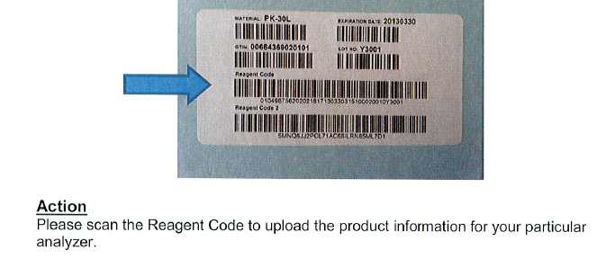  When you get reagent with a new label – scan the label with the arrow pointing at it. | Bench Techs
NP Blood Collect Charges | Here is when it is NOT appropriate to order this test:  - When a fingerstick/heelstick is performed  - Baby bilirubins  - INR’s using the INRatio2  - When no blood is drawn  - Only urine testing is ordered  - When we do not draw the blood in our lab  - Home Health draws the specimen  - PCY draws the specimen  Note: You can not charge for a blood draw more than once in a 24 hour period even if you do draw more than once. | All Staff
Semen Analysis | Check the file drawer – we now have a direction letter for our patients. Please explain the process and then follow up with a letter and map of HCMC.  - Collect on site at HCMC lab  - Hours of operation for HCMC lab  - M-F 7-7p  - Sa/Su 8-7:30p | All Staff
Vacation | FYI: Denelle is on vacation the week of Memorial Day. | All Staff
Procedure Additions, Updates and Changes:

